PROJECT SUMMARY REPORT
Predicting Property Prices in a Specific Location Using Machine Learning

Capstone Project – 1
Prepared by: Akash Srivastava
Technology: Python & Machine Learning
Dataset: Property_data
Target Variable: PropPrice

1. Introduction to the Project
The project, titled “Predicting Property Prices in a Specific Location Using Machine Learning”, focuses on developing a machine learning solution to estimate property sale prices from a wide range of property characteristics. The real-estate market is influenced by factors such as property size, quality, condition, construction year, location, amenities, and other structural attributes. The project uses the Property_data dataset and PropPrice as the target variable.
The dataset used for the analysis contains 1460 records and 81 columns. The workflow covers data understanding, data cleaning, exploratory data analysis, feature engineering, categorical encoding, scaling, PCA, model building, model comparison, and final prediction.
The project follows the capstone instructions, which specifically require separate handling of ordinal and nominal variables, use of fillna(), scaling and PCA, EDA, comparison of machine-learning algorithms, and evaluation of the final model.

2. Objectives of the Project
- To understand and clean the real-estate property dataset.
- To identify and separately handle ordinal and nominal categorical variables using the provided metadata.
- To handle missing values using appropriate fillna() techniques.
- To perform Exploratory Data Analysis (EDA) to identify important variables affecting property prices.
- To encode ordinal variables while preserving their order and one-hot encode nominal variables.
- To scale the numerical feature set before applying dimensionality reduction.
- To apply Principal Component Analysis (PCA) to reduce dimensionality while retaining important information.
- To train and compare machine-learning regression models.
- To evaluate models using Mean Absolute Error (MAE) and select the model with the best performance.
- To produce predictions and communicate the results clearly.

3. Flow Chart of Operations
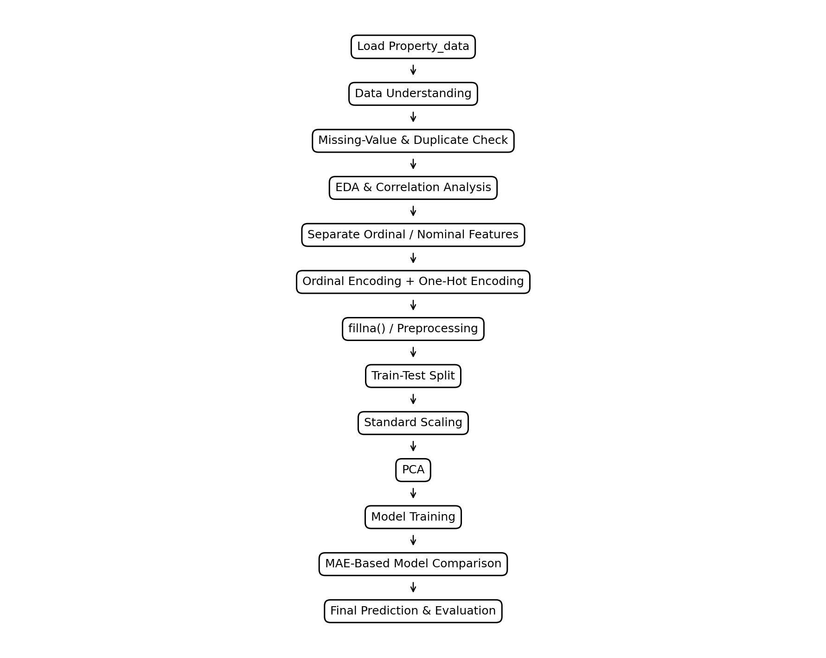
The flow chart represents the complete project pipeline from loading the dataset to final model evaluation and prediction.

4. Python Codes
The following are the major Python code blocks used in the project. The complete Jupyter Notebook contains the detailed implementation and intermediate outputs.

Dataset loading and initial inspection
# Load dataset
import pandas as pd
df = pd.read_csv("Property_data.csv")
print(df.shape)
print(df.head())
print(df.info())

Data-quality checks
# Missing-value check
missing_values = df.isnull().sum()
print(missing_values[missing_values > 0])
# Duplicate check
print("Duplicates:", df.duplicated().sum())

Target separation and categorical classification
# Separate target and predictors
X = df.drop("PropPrice", axis=1)
y = df["PropPrice"]
# Separate ordinal and nominal columns using project metadata
ordinal_cols = [...]
nominal_cols = [...]

Ordinal and nominal encoding
# Ordinal encoding example
quality_map = {"Po": 1, "Fa": 2, "Ta": 3, "Gd": 4, "Ex": 5}
df["ExterQual"] = df["ExterQual"].map(quality_map)
# One-hot encoding for nominal variables
df_encoded = pd.get_dummies(
df,
columns=nominal_cols,
drop_first=False
)

Train-test split and standardization
# Train-test split and scaling
from sklearn.model_selection import train_test_split
from sklearn.preprocessing import StandardScaler
X_train, X_test, y_train, y_test = train_test_split(
X, y, test_size=0.2, random_state=42
)
scaler = StandardScaler()
X_train_scaled = scaler.fit_transform(X_train)
X_test_scaled = scaler.transform(X_test)

Dimensionality reduction using PCA
# PCA
from sklearn.decomposition import PCA
pca = PCA(n_components=n_components)
X_train_pca = pca.fit_transform(X_train_scaled)
X_test_pca = pca.transform(X_test_scaled)
print("Original features:", X_train_scaled.shape[1])
print("PCA features:", X_train_pca.shape[1])

Model training and evaluation
# Model training and MAE evaluation
from sklearn.linear_model import LinearRegression
from sklearn.tree import DecisionTreeRegressor
from sklearn.ensemble import RandomForestRegressor
from sklearn.metrics import mean_absolute_error
models = {
"Linear Regression": LinearRegression(),
"Decision Tree": DecisionTreeRegressor(random_state=42),
"Random Forest": RandomForestRegressor(random_state=42)
}
for name, model in models.items():
model.fit(X_train_pca, y_train)
pred = model.predict(X_test_pca)
mae = mean_absolute_error(y_test, pred)
print(name, "MAE:", mae)

5. Screenshot of the Outputs
The following output summaries are reproduced from the project results. They are included in report format so that the important model-comparison outputs are visible even when the Jupyter Notebook is submitted separately.
Model | MAE
Linear Regression | 21,157.31
Decision Tree | 28,905.46
Random Forest | 19,345.93

Output interpretation: Random Forest produced the lowest MAE among the three evaluated models, indicating the smallest average absolute prediction error and making it the preferred model in this comparison.

6. Report on EDA
Exploratory Data Analysis was performed to understand the distribution of the target variable, relationships between numerical features and property prices, and the presence of useful predictive patterns.

Property Price Distribution
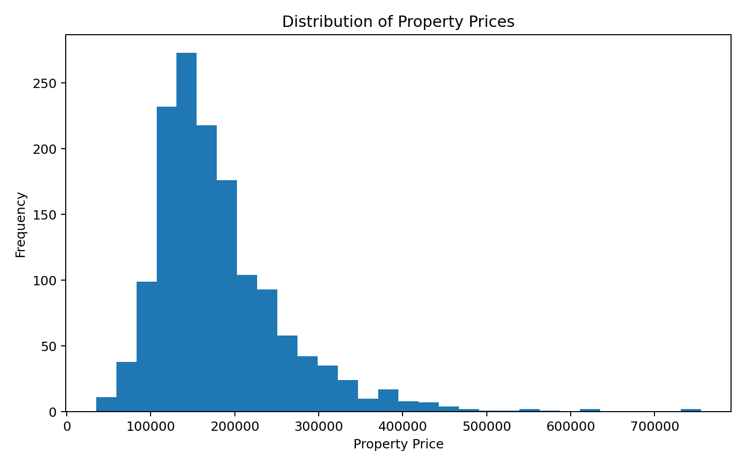
The target variable shows variation in property prices. The distribution helps identify the overall price range and potential skewness.

Top Numerical Correlations
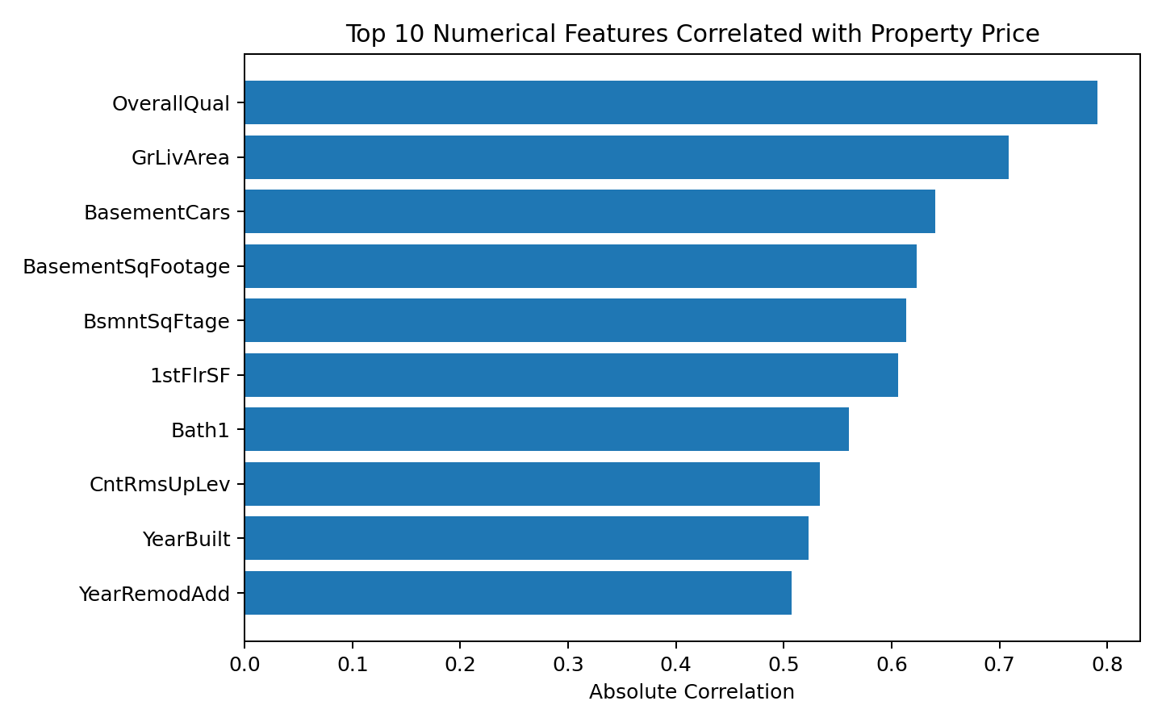
The correlation analysis highlights numerical variables with stronger relationships to property price. These variables are useful candidates for further modelling and interpretation.

Overall Quality vs Property Price
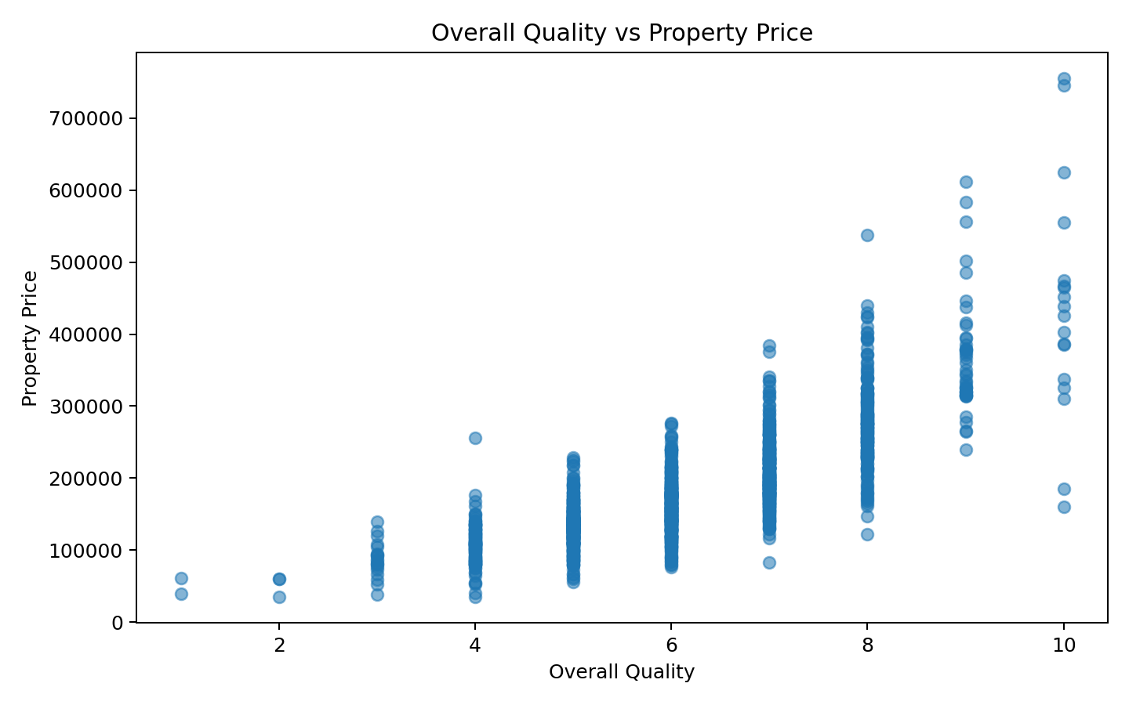
Higher overall quality is associated with higher property prices, showing that property quality is an important predictive factor.

Living Area vs Property Price
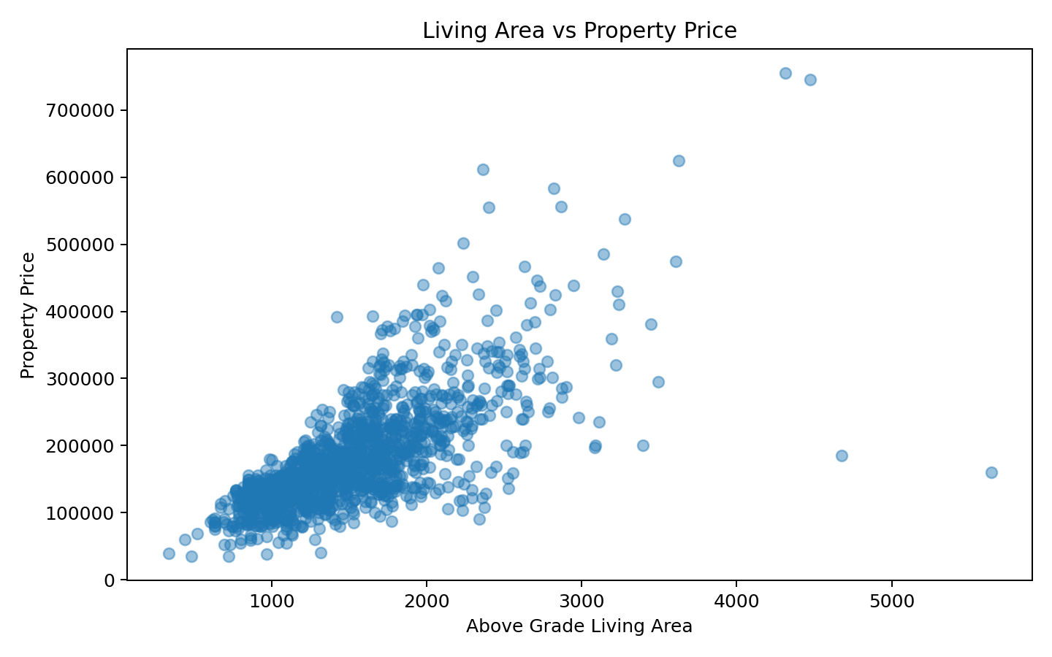
Larger above-grade living areas generally correspond to higher property prices, although the relationship is not perfectly linear.

Year Built vs Property Price
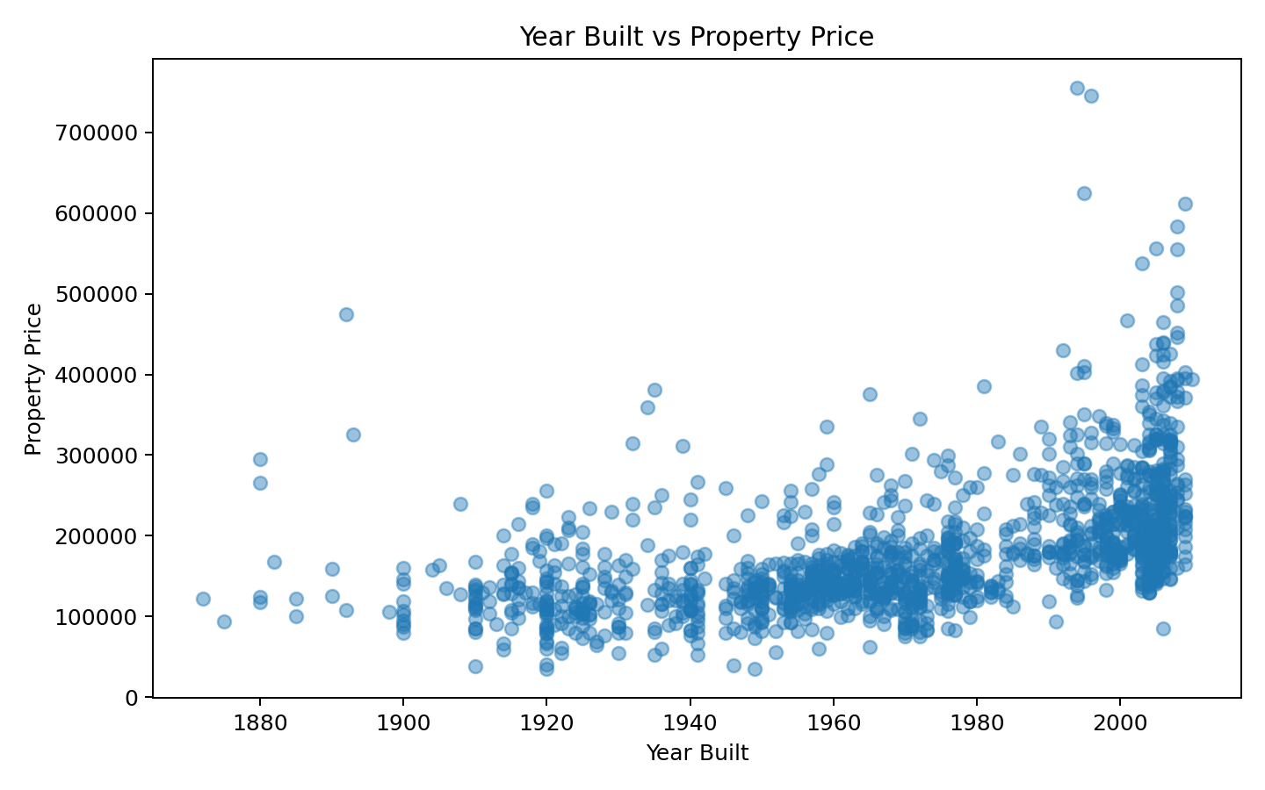
The relationship between construction year and price shows that newer properties can command higher prices, while price also depends on other property characteristics.

Key EDA Observations
- Property price is influenced by multiple numerical and categorical characteristics rather than a single variable.
- Overall quality and living-area-related features show useful relationships with property price.
- Correlation analysis helps identify potentially important numerical predictors.
- Categorical features require suitable encoding before they can be used by standard machine-learning algorithms.
- EDA supports feature selection, preprocessing decisions, and interpretation of model results.

7. Learning Outcomes
- Learned how to understand a real-world property-price dataset and identify its target variable.
- Learned how to inspect missing values, duplicates, data types, and feature distributions.
- Learned the difference between ordinal and nominal categorical variables and why they need different encoding strategies.
- Practiced ordinal encoding and one-hot encoding for categorical features.
- Learned how standard scaling prepares numerical features for machine-learning and PCA.
- Learned how PCA reduces a high-dimensional feature space while retaining major information.
- Learned how to train regression models and compare their performance using MAE.
- Learned how EDA and visualizations can support machine-learning decisions.
- Improved ability to interpret model performance and select a suitable final model.

8. Conclusion
This capstone project developed an end-to-end machine-learning workflow for predicting property prices. The project covered data understanding, cleaning, EDA, categorical encoding, scaling, PCA, model training, and evaluation. The work followed the project requirement to handle ordinal and nominal variables separately and to use fillna(), scaling, and PCA as part of preprocessing.
Three regression models were compared using Mean Absolute Error. The recorded results were 21,157.31 for Linear Regression, 28,905.46 for Decision Tree, and 19,345.93 for Random Forest. Therefore, Random Forest was the best-performing model among the evaluated models because it achieved the lowest MAE.
The project demonstrates how machine learning can be used to support property-price estimation and how data preprocessing and EDA contribute to building a more reliable predictive solution.

9. Citations – Books and Websites Used for Research
- Capstone Project – 1: “Predicting Property Prices in a Specific Location Using Machine Learning” – project instructions and dataset description.
- De Cock, D. (2011). Ames, Iowa: Alternative to the Boston Housing Data as an End of Semester Regression Project.
- McKinney, W. – Python for Data Analysis: Data Wrangling with Pandas, NumPy, and Jupyter.
- Géron, A. – Hands-On Machine Learning with Scikit-Learn, Keras, and TensorFlow.
- Pandas Documentation – documentation for data manipulation and analysis.
- Scikit-learn Documentation – documentation for preprocessing, PCA, regression models, and evaluation metrics.
- Matplotlib Documentation – documentation for data visualization.

Source note: The project-specific requirements, methodology, target variable definition, and required report format were taken from the provided Capstone Project – 1 instructions.

