**PROJECT REPORT ON**

**Unused Medicine donation System**

SUBMITTED TO THE SAVITRIBAI PHULE PUNE UNIVERSITY, PUNE IN THE PARTIAL FULFILLMENT FOR THE AWARD OF THE DEGREE



**BACHELOR OF ENGINEERING**

**IN**

**INFORMATION TECHNOLOGY**

**BY**

Mr. Sushant Kokate Exam No: B190428543

Mr. Aryan Shingan Exam No: B190428568

Mr. Akash Chavan Exam No: B190428510

Mr. Shreyash Ramteke Exam No: B190428560

**Under The Guidance of**

Dr. R. V. Babar



**DEPARTMENT OF INFORMATION TECHNOLOGY**

**STES’s**

**SINHGAD INSTITUTE OF TECHNOLOGY, LONAVALA**

### Lonavala, 410401

### 2023-24



**SINHGAD INSTITUTE OF TECHNOLOGY, LONAVALA DEPARTMENT OF INFORMATION TECHNOLOGY**

**CERTIFICATE**

This is to certify that the Project Entitled

**Unused Medicine donation System**

Submitted by

Mr. Sushant Kokate Exam No: B190428543

Mr. Aryan Shingan Exam No: B190428568

Mr. Akash Chavan Exam No: B190428510

Mr. Shreyash Ramteke Exam No: B190428560

is a Bonafede work carried out by them under the supervision of Dr. R. V. Babar and it is approved for the partial fulfillment of the requirement of Savitribai Phule Pune University for the award of the Degree of Bachelor of Engineering (Information Technology).

This project report has not been earlier submitted to any other Institute or University for the award of any degree or diploma*.*

Dr. R. V. Babar Dr. R. V. Babar

Internal Guide H.O.D

Dept. of Information Technology Dept. of Information Technology

Dr. M. S. Gaikwad

External Examiner Principal

Date: Sinhgad Institute of Technology, Lonavala

Place:

Date:

**Abstract**

This development aims to contribute treatments (medicines) that are either fresh or stale in nature. The new treatments can be handed to a poor individual who will be able to use them in the future. This programme assists the user in donating any unused medicines to a non-profit organisation. There are three people that make up this body: the administrator, the non-governmental organisation, and the user. A system administrator will log in and manage users, including deleting and barring users who are giving incorrect or expired drugs. In addition, the administration has a consultant, similar to the appointment requested by the NGO. The administration receives a monthly noise of remedies that have been contributed. Authorizations are used to register and login for non-profit organisations. They can promote a request for an appointment, which will be added to a more appropriate and comprehensive list by the administrator. The standard is managed by an NGO, which aids in the preservation of the history of the current medicines. In the event of a safety issue, an NGO can also modify their PIN. Authorizations are used to allow users to register and log in. They can provide remedies by providing remedy details and generating demand; once this has been agreed upon by the administration and the NGO, they will plan a date for the donation to take place. Also available to consumers is a history of their previous remedial transactions.

**Acknowledgment**

It gives us great pleasure in presenting the preliminary project report on **‘**Unused Medicine donation System.

We would like to take this opportunity to thank my internal guide **Dr. R. V. Babar** for giving us all the help and guidance we needed. We are really grateful to him for his kind support. His valuable suggestions were very helpful.

We are also grateful to **Dr. R. V. Babar**, Head of Department, Information Technology, Sinhgad Institute of Technology, for his indispensable support and suggestions.

In the end our special thanks to **Dr. M. S. Gaikwad**, Principal, Sinhgad Institute of Technology, STES Campus, Lonavala, for his constant support throughout this project.

Thank you all for your encouragement!

Sushant Kokate

Aryan Shingan

Akash Chavan

Shreyash Ramteke

(B.E. Information Technology)

# INDEX

1. Introduction 1
   1. Overview………………………………………………………………….2
   2. Motivation ………………………………………………………………..2
   3. Objective………………………………………………………………….2
2. Literature Survey 3

2.1 Study of Research Paper…………………………………………………. 4

1. Problem Statement 7
   1. Problem Statement 8
2. Project Requirement 9
   1. Hardware Requirement 10
   2. Software Requirement 10
3. System Analysis 11
   1. System Architecture 12
      1. Use Case Diagram 13
   2. UML Diagram 14
   3. Component Diagram…………………………………………………….15
   4. Deployment Diagram……………………………………………………16
4. Software Information 17

**7 Project Plan** **20**

**8 Results** **22**

**9 Conclusion** **28**

|  |  |  |
| --- | --- | --- |
| 9.1 Conclusion…… | …………………………………………………… | ……..29 |

**10 References 30**

|  |  |  |  |
| --- | --- | --- | --- |
|  |  |  |  |
|  |  |  |  |

# List of Figures

* 1. System Architecture 12
  2. Use case Diagram 14
  3. Activity Diagram 15
  4. Sequence Diagram 16
  5. Project Timeline Chart…………………………………………………..21
  6. Home Page…………………………………………………....................23
  7. Login Page……………………………………..….…………………….24
  8. Register as Donar……………..….…………………………………....25
  9. Register as NGO………………………………………………………...26
  10. Register as Doctor………………………………………………….........27

## CHAPTER 1 INTRODUCTION

### OVERVIEW

When properly managed and controlled, a donation of tablets has the potential to save lives and alleviate suffering. Actual donation practices can result in savings in budgets for development funds, allowing these buildings to be used for other reasons instead of being decommissioned. The "Online Medicine Donation System" acts as a link between a vast network of pharmaceutical contributions and non-governmental organizations (NGOs), such as an old age home. A non-profit organization (NGO) is a non-profit organization that is self-governing of the state and all general administrative organizations. They are typically sponsored by blessings, while others are fully independent of government funding and are run entirely by volunteers in their hearts. Users of the Internet have expanded dramatically in the last one or two years, and the number is continually growing. As a result, it has become quite simple for users to access and utilize the website. We are aware that there are a number of existing donation sites for pharmaceutical items, but they are not up to the criteria and necessitate the use of additional manual data processing. We can overcome this challenge in the future by inventing new and emerging image processing technology. With this technology, we can overcome all of the challenges described above and create a website that is extremely user-friendly.

### Motivation

The motivation behind our project stems from a pressing need for action. Globally, millions of people suffer from health conditions that could be managed or treated with the right medications, yet the reality is far from ideal. In the same world where tons of unused, unexpired medicine sit idle in homes and healthcare facilities countless individuals, particularly in underserved communities, face the harsh reality of medication scarcity or unaffordability. This stark contrast fuels our motivation to advocate for and participate in the unused medicine donation movement.

### Objective

Our objectives for this project are straightforward. Firstly, we aim to offer medicine to individuals who are unable to afford it, extending a helping hand to those in need. Secondly, we want to prevent valuable medicine from being discarded and wasted, promoting sustainability.

## CHAPTER 2 LITERATURE SURVEY

This website makes use of leftover materials or items that can be repurposed to benefit the less fortunate. This website contains a large number of depressed from a large number of non-governmental organizations (NGOs) that will acknowledge our client's generosity. The client will be able to see the entire history of their file. Guidelines for Donating Remedies, Revised 2010, World Health Organization Library Cataloguing in Publication, World Health Organization The 2010 revision of the Data Guidelines for Remedies Donations. 1. Preparations for the supply and distribution of pharmaceutical products. 2. The supply and distribution of essential medications. 3. Disaster relief efforts. 4. Emergencies. 5. Inter-institutional ties are important. 6. Recommendations Rating: 330 for the World Health Organization ISBN 978 92 4 150198 9. The first edition was published in 1996, the second edition in 1999, and the third edition in 2011. It was in collaboration with major international organizations involved in humanitarian relief and development assistance that the World Health Organization (WHO) developed this third version of the Guidelines for Remedies Donation in collaboration with major international organizations involved in humanitarian relief and development assistance. The Guidelines have been developed with the goal of improving the quality of drug donations in international development assistance and disaster relief. Donation preparation is of interest to both donors and recipients since it involves the use of good remedies.AD, 97.81% for EMCI versus AD, 94.8% for LMCI versus EMCI. The results show that the DCNN outperforms existing methods.

|  |  |  |  |  |  |
| --- | --- | --- | --- | --- | --- |
| Name of the paper | Author Name | Advantages | Disadvantages | Publisher | Year |
| A Web portal for Medicine Distribution among Poverty-stricken People | ChowdhuryNawrinFerdous | 1. Many needy people will get cured. | 1. Does not have authorized verification   of medicine | 7 IEEE Region 10 Humanitarian Technology Conference | 2020 |
| Online Medicine Donation System | Nitesh A. Godhichor | 1. It will help to maintain records of medicines. | 1. user does not get the doctor’s approval. | International Journal of Creative Research Thoughts (IJCRT) | 2021 |
| A Web Portal for Medicine Donation to NGO’s and Check availability of Medicine in NGO’s | Shivaraman | 1. It helps poor people for medication. | 1. Does not have the option to sell the medicine | International Journal of Research in Engineering. | 2021 |
| Online Medicine Donation Portal | Sanket Rajendrakumar More | 1. It will help to maintain records of medicines. | 1. User needs to put correct data or else it behaves abnormally. | International Journal of Advance Research, Ideas and Innovations in Technology. | 2021 |

## CHAPTER 3 PROBLEM STATEMENT

### 3.1 PROBLEM STATEMENT

* To build and implement unused medicine donation system

## CHAPTER 4 PROJECT REQUIREMENT

### 

To build and implement web based unused medicine donation system.

**4.1 Hardware Requirements:**

# Processor - Intel i3/i5/i7

1. Speed - 3.1 GHz
2. RAM - 4 GB(min)
3. Hard Disk - 40 GB
4. Key Board - Standard Windows Keyboard
5. Mouse - Two or Three Button Mouse
6. Monitor - SVGA

**4.2 Software Requirements:**

1. Operating System - Windows 7/8/10
2. Front End - HTML, CSS, Bootstrap
3. Database - MySQL
4. IDE - VS Code
5. Language - Python

## CHAPTER 5 SYSTEM ANALYSIS

### SYSTEM ARCHITECTURE

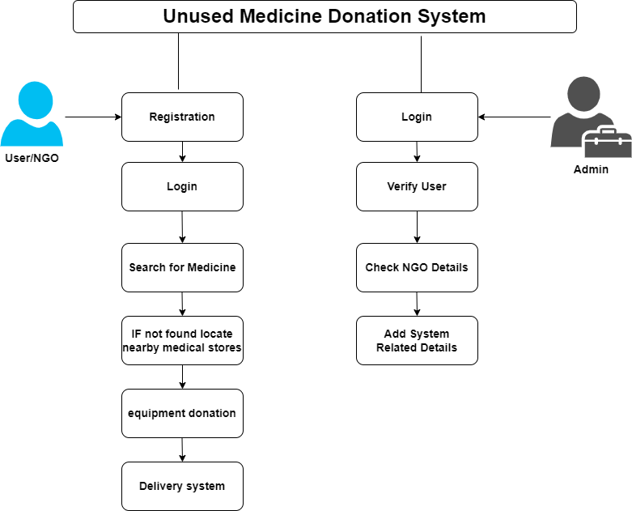

Figure 5.1: System Architecture

**5.2 Use Case Diagram:**

A use case diagram is a graphical representation of a user's interaction with the system and depicting the specifications of a use case. A use case diagram can show the different types of users of a system and the various ways in which they interact with the system. Use case diagrams are used to gather the requirements of a system including internal and external influences. These requirements are mostly design requirements. So when a system is analyzed to gather its functionality use cases are prepared and actors are identified. The purposes of use case diagrams can be as follows:

* Used to gather requirements of a system.
* Used to get an outside view of a system.
* Identify external and internal factors influencing the system.
* Show the interaction among the actors.
  + - * s step, the algorithm will detect if the person has Alzheimer’s or not based on their MRI image.
      * After this detection, the system will then display the output to the user.



Fig.5.2 Use Case Diagram

**5.3 Component Diagram**

A Component Diagram displays the structural relationship of components of a software system. These are mostly used when working with complex systems that have many components. Components communicate with each other using interfaces. The interfaces are linked using connectors.

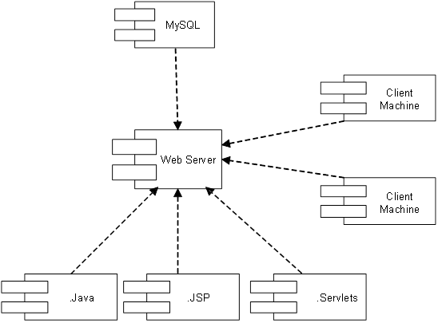

**5.4 Deployment Diagram**

Deployment diagrams are used to visualize the topology of the physical components of a system where the software components are deployed. So deployment diagrams are used to describe the static deployment view of a system. Deployment diagrams consist of nodes and their relationships.

## CHAPTER 6 SOFTWARE INFORMATION

### Python:

Python is an interpreted, high-level and general-purpose programming language. Created by Guido van Rossum and first released in 1991, Python’s design philosophy emphasizes code readability with its notable use of significant whitespace. Its language constructs and object-oriented approach aim to help programmers write clear, logical code for small and large-scale projects.

Python is dynamically typed and garbage-collected. It supports multiple programming paradigms, including structured (particularly, procedural), object- oriented, and functional programming. Python is often described as a “batteries included” language due to its comprehensive standard library.

Python was created in the late 1980s as a successor to the ABC language. Python 2.0, released in 2000, introduced features like list comprehensions and a garbage collection system with reference counting.

Python 3.0, released in 2008, was a major revision of the language that is not completely backward-compatible, and much Python 2 code does not run unmodified on Python 3.

The Python 2 language was officially discontinued in 2020 (first planned for 2015), and “Python 2.7.18 is the last Python 2.7 release and therefore the last Python 2 release. No more security patches or other improvements will be released for it. With Python 2’s end-of-life, only Python 3.6.x and later are supported.

Python interpreters are available for many operating systems. A global com- munity of programmers develops and maintains CPython, a free and open-source reference implementation. A non-profit organization, the Python Software Foundation, manages and directs resources for Python and CPython development.

Python was conceived in the late 1980s by Guido van Rossum at Centrum Wiskunde Informatica (CWI) in the Netherlands as a successor to the ABC language (itself inspired by SETL), capable of exception handling and interfacing with the Amoeba operating system. Its implementation began in December 1989. Van Rossum shouldered sole responsibility for the project, as the lead developer, until 12 July 2018, when he announced his “permanent vacation” from his responsibilities as Python’s Benevolent Dictator for Life, a title the Python community bestowed upon him to reflect his long-term commitment as the project’s chief decision-maker. He now shares his leadership as a member of a five-person steering council. In January 2019, active Python core developers elected Brett Cannon, Nick Coghlan, Barry Warsaw, Carol Willing and Van Rossum to a five-member “Steering Council” to lead the project

## CHAPTER 7

## PROJECT PLAN

The project timeline chart shows the report of the tasks completed in each month from the start of the project up to the final submission date.

Figure 7.1: Project Timeline

## CHAPTER 8

## RESULTS

8.1 HOME PAGE

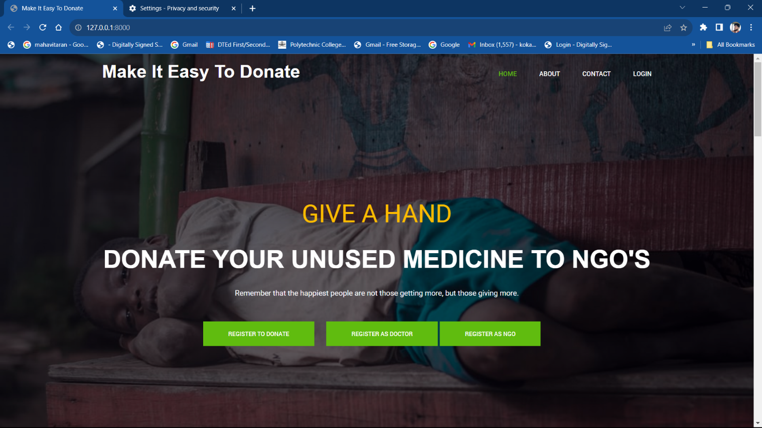

Figure 8.1: Home Page

Fig. 8.1 This screenshot depicts a webpage of the website titled "Make It Easy to Donate". The website features a blue navigation bar at the top, containing links such as "Home", "About Us", "Contact Us", and "Login". The main section of the webpage has a green header displaying a large, yellow text message that reads "Give a Hand, Donate your unused medicine to NGOs". This central message is followed by a motivational phrase that reads "Remember that the happiest people are not those getting more, but those giving more.". Near the bottom of the interface, there are two registration buttons - "Register to Donate" and "Register as NGO". The overall layout of the website promotes the act of donating unused medicines, urging the viewers to engage with the noble cause.

8.2 Log In page

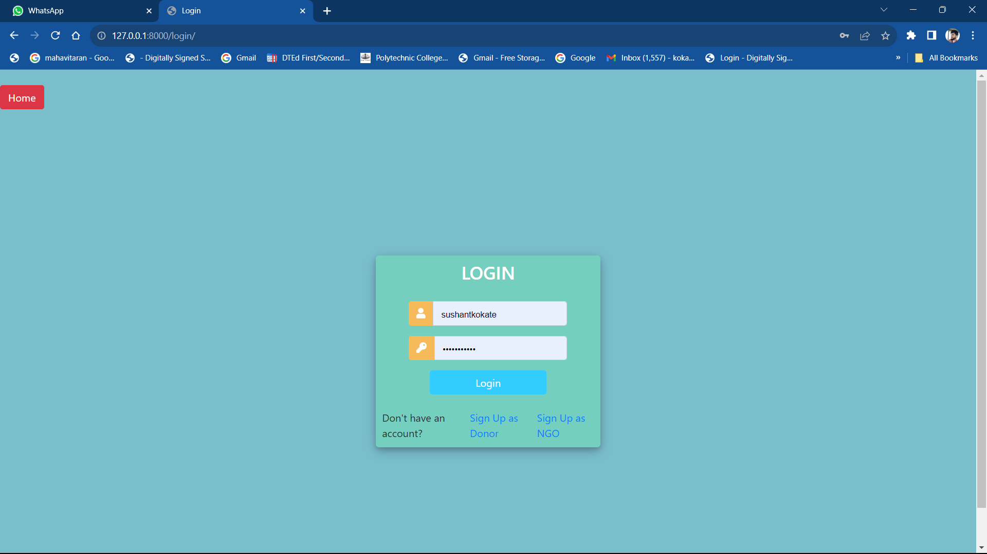

Fig. 8.2 The background of the page is light blue. It contains two text input fields labeled for username and password details. Both fields happen to be populated. There are buttons labeled "Login" and "Sign up". Text near the Sign-up button says "Don't have an account? Sign Up as." followed by options to sign up either as "Donor" or "NGO".

8.3 Registration as doner

Fig.8.3 This is the log in form for the doner It will help to donate the medicine .

8.4 registration as Ngo

Fig. 8.4 A form titled "Register Account" appears in the center of the screen, with fields for "Username", "Email", and "Password", and a "Register Account" button. There's a separate button labeled "As NGO". In the top corner of the webpage

8.5 Registration as doctor

Fig.8.5 This Log In form for the doctors. it will help to verify the medicines.

## CHAPTER 9

## CONCLUSION

**CONCLUSION**

* 1. **Conclusion**
* Our portal aims to provide the unused medicine to the NGO and Hospitals.
* Our portal is aimed at being available for users, with the latest features added at the moment.
* By having an easy navigation system for users, the portal will become friendly, which will also make the users comfortable for donating and receiving medicines from NGO's.

## CHAPTER 10 REFERENCES

## 

[1] UNUSED MEDICINE DONATION PLATFORM Ms. Rutuja Satish Vathare*1, Ms. Rupali Rajesh Koravi*2,Ms. Vaishnavi Vijaykumar Sanade*3, Mr. Ketan Ramesh Patil*4, Ms. S. B. Ketkale*5*1,2,3,4,5Compute Department, D.K.T.E. Society’s Yashwantrao Chavan Polytechnic, Icalkaranji, India.Volume:05/Issue:04/April-2023

[2] An Online Unused Medicine Donation System for NGOsHarendra Raghav1, Ayush Singh Chauhan2, Tanya Yadav3,Ankit Kumar Gupta4,Ankur Bhardwaj5 International Journal of Engineering and Techniques - Volume 8 Issue 3, May 2022

[3] An Online Web Portal for Donating Unused Medicine to NGOs Conference Paper · June 2022author profiles for this publication at: <https://www.researchgate.net/publication/361389050>

[4] Unused Medicine Donation System for NGOsProf. Sunil Sangale1, Rahil Khan2, Spandan Marathe3, Pratik Yeole4, Kaveri Khairnar5 Lecturer, Department of Computer Technology1Students, Department of Computer Technology2,3,4,5K. K. Wagh Polytechic, Nashik, Maharashtra, India Volume 2, Issue 2, February 2022

[5] "Online Medicine Donation System", International Journal of Emerging Technologies and Innovative Research (www.jetir.org), ISSN:2349-5162, Vol.8, Issue 5, page no.e306-e308, May-2021, Available :http://www.jetir.org/papers/JETIR2105580.pdf

[6] Online Medicine Donation Portal, International Journal of Advance Research, Ideas and Innovations in Technology, Sanket Rajendrakumar More,2021

[7] A Web Portal for Medicine Donation to NGO’s and Check availability of Medicine in NGO’s. International Journal of Research in Engineering. Shivam Ramanvar,2021

[8] Online Medicine Donation System, International Journal of Creative Research Thoughts (IJCRT), Nitesh A. Godhichor,2021

[9] A Webportal for Medicine Distribution among Poverty-stricken People, 7 IEEE Region 10 Humanitarian Technology Conference,Chowdary Narwin Ferdous,2020

[10] Worldometers.info, Bangladesh Population (2017)-Worldometers, 2017 (accessed June 22, 2017). [Online]. Available: http: //www.worldometers.info/world-population/bangladesh-population/

[11]Who.int, WHO—Bangladesh, 2017 (accessed June 22, 2017). [Online]. Available:

http://www.who.int/workforcealliance/countries/bgd/en/ .

[12] Opinion.bdnews24.com, Health Workforce in Bangladesh, 2013 (accessed June 22, 2017).

[13] [Online]. Available: http://http: //opinion.bdnews24.com/2013/03/24/health-workforce-in-bangladesh/ .

[14] WHO Guidelines for Medicine Donations. 3rd ed. 2011. http://whqlibdoc.who.int/publications/2011/9789241501989 _eng.pdf. Accessed 2014 Dec .

[15] Dory J. Donation of medical device technologies. In: Dior J, ed. Clinical engineering handbook. Burlington, Elsevier Academic Press, 2004:155– 158