Roll Number: CB.EN.U4CSE17105

Data:

[['a','b','d','e'],

['b','c','d'],

['a','b','d','e'],

['a','c','d','e'],

['b','c','d','e'],

['b','d','e'],

['c','d'],

['a','b','c'],

['a','d','e'],

['b','d']]

Minimum support: 3

Frequency:

[[{'d'}, 9],

[{'b'}, 7],

[{'e'}, 6],

[{'d', 'e'}, 6],

[{'d', 'b'}, 6],

[{'c'}, 5], [{'a'}, 5],

[{'d', 'c'}, 4],

[{'a', 'e'}, 4],

[{'a', 'd', 'e'}, 4],

[{'a', 'd'}, 4],

[{'b', 'e'}, 4],

[{'d', 'b', 'e'}, 4],

[{'b', 'c'}, 3],

[{'a', 'b'}, 3]]

ARM:

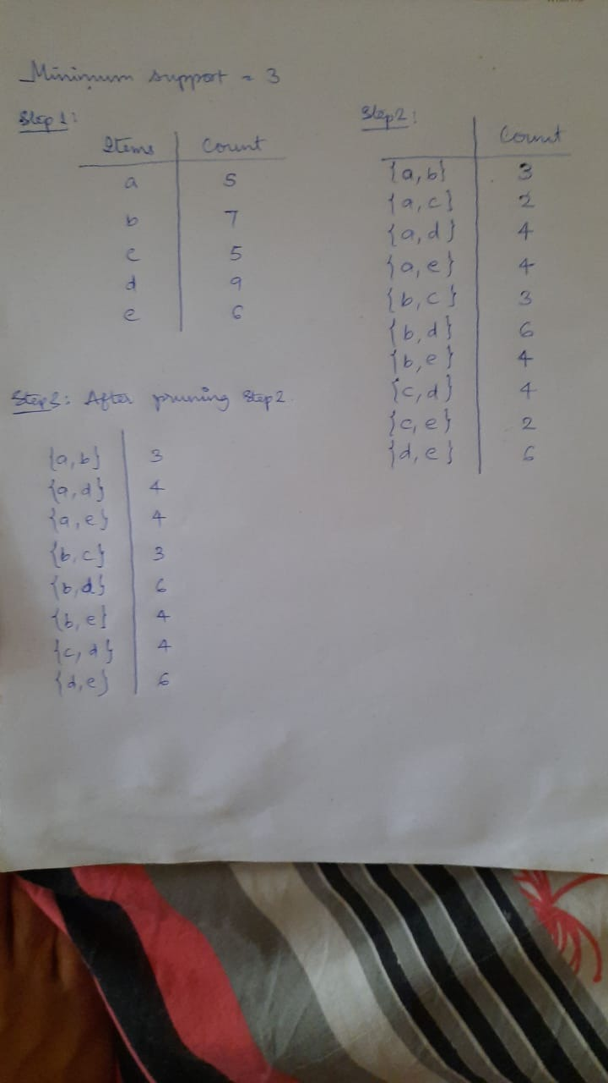

FP Tree:

