Show the communication between
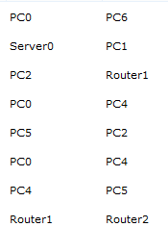to be successful..

First Network is 192.168.1.0/24--- left side in the initial configuration
Second Network is 192.168.3.0/24- right side

