T Akash

192011005

1. Demonstrate Infrastructure as a Service (IaaS) by creating a resources group using a Public Cloud Service Provider (Azure), configure with minimum CPU, RAM, and Storage.

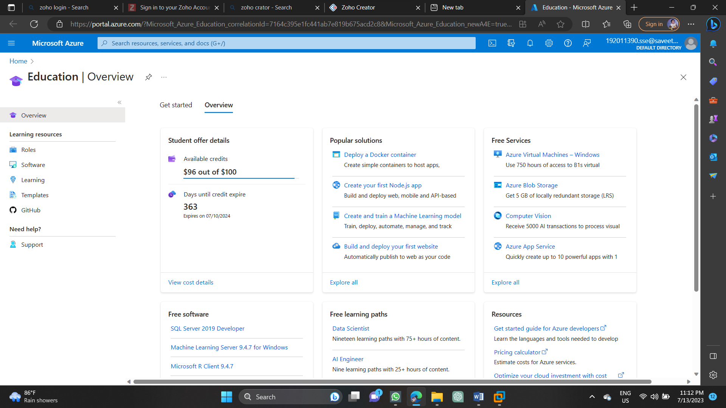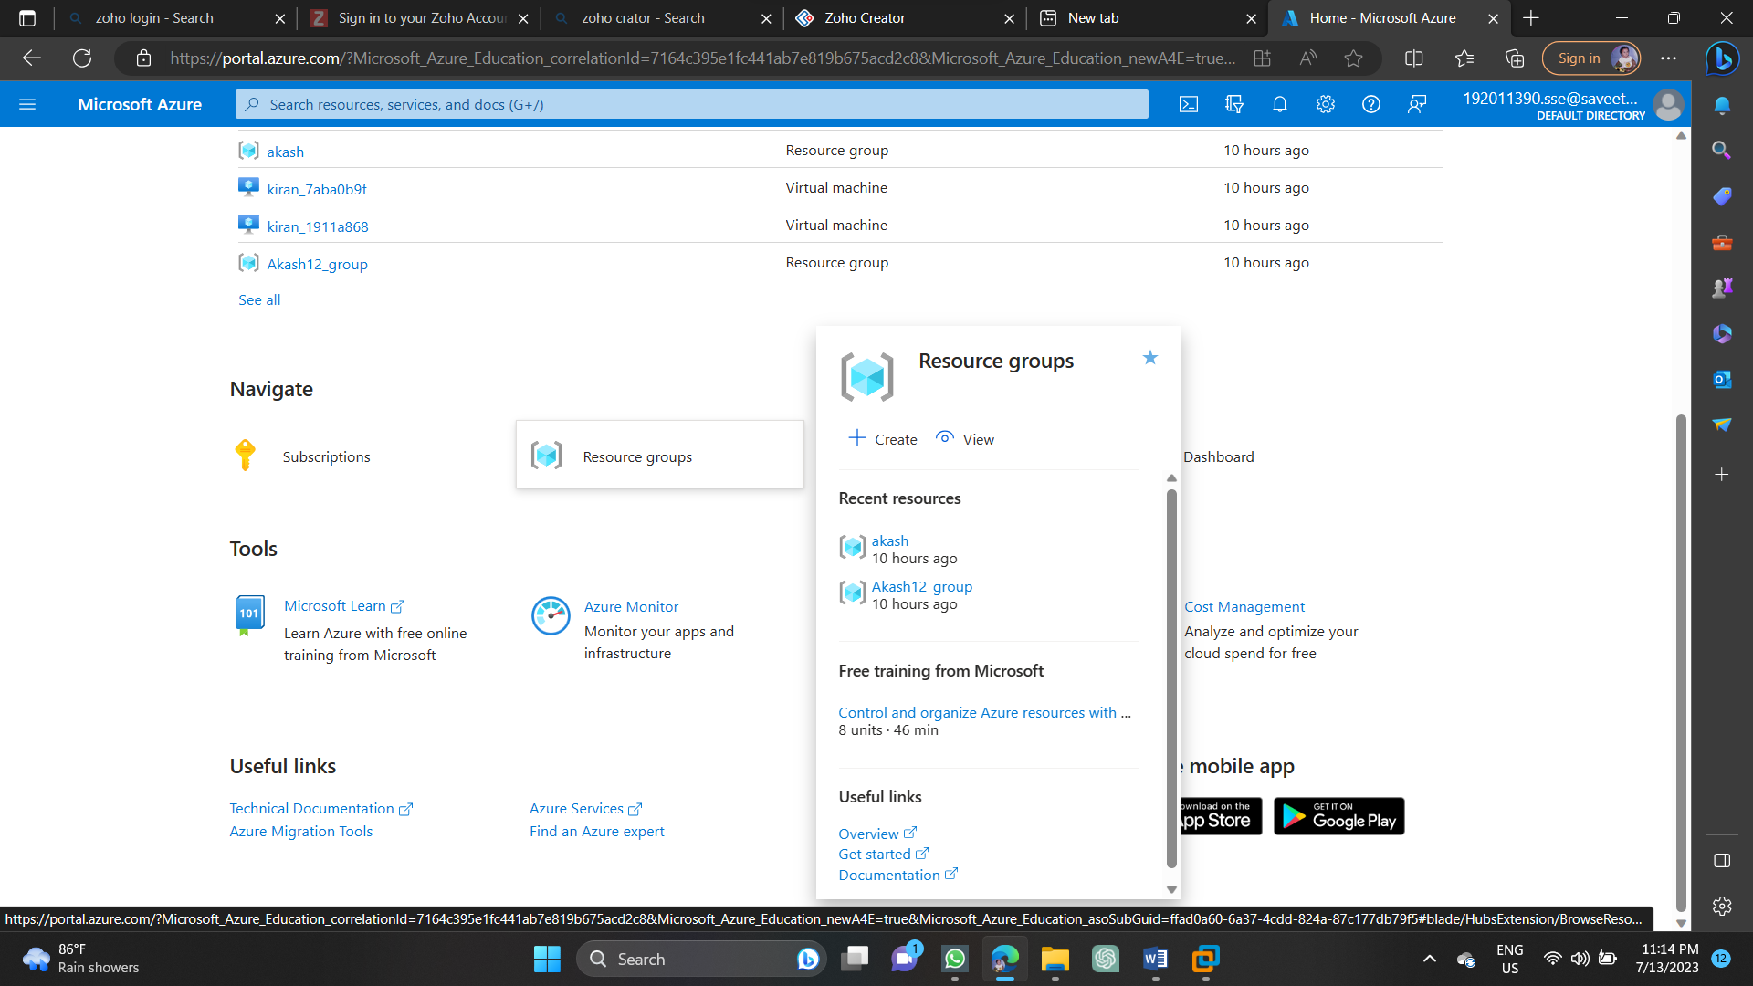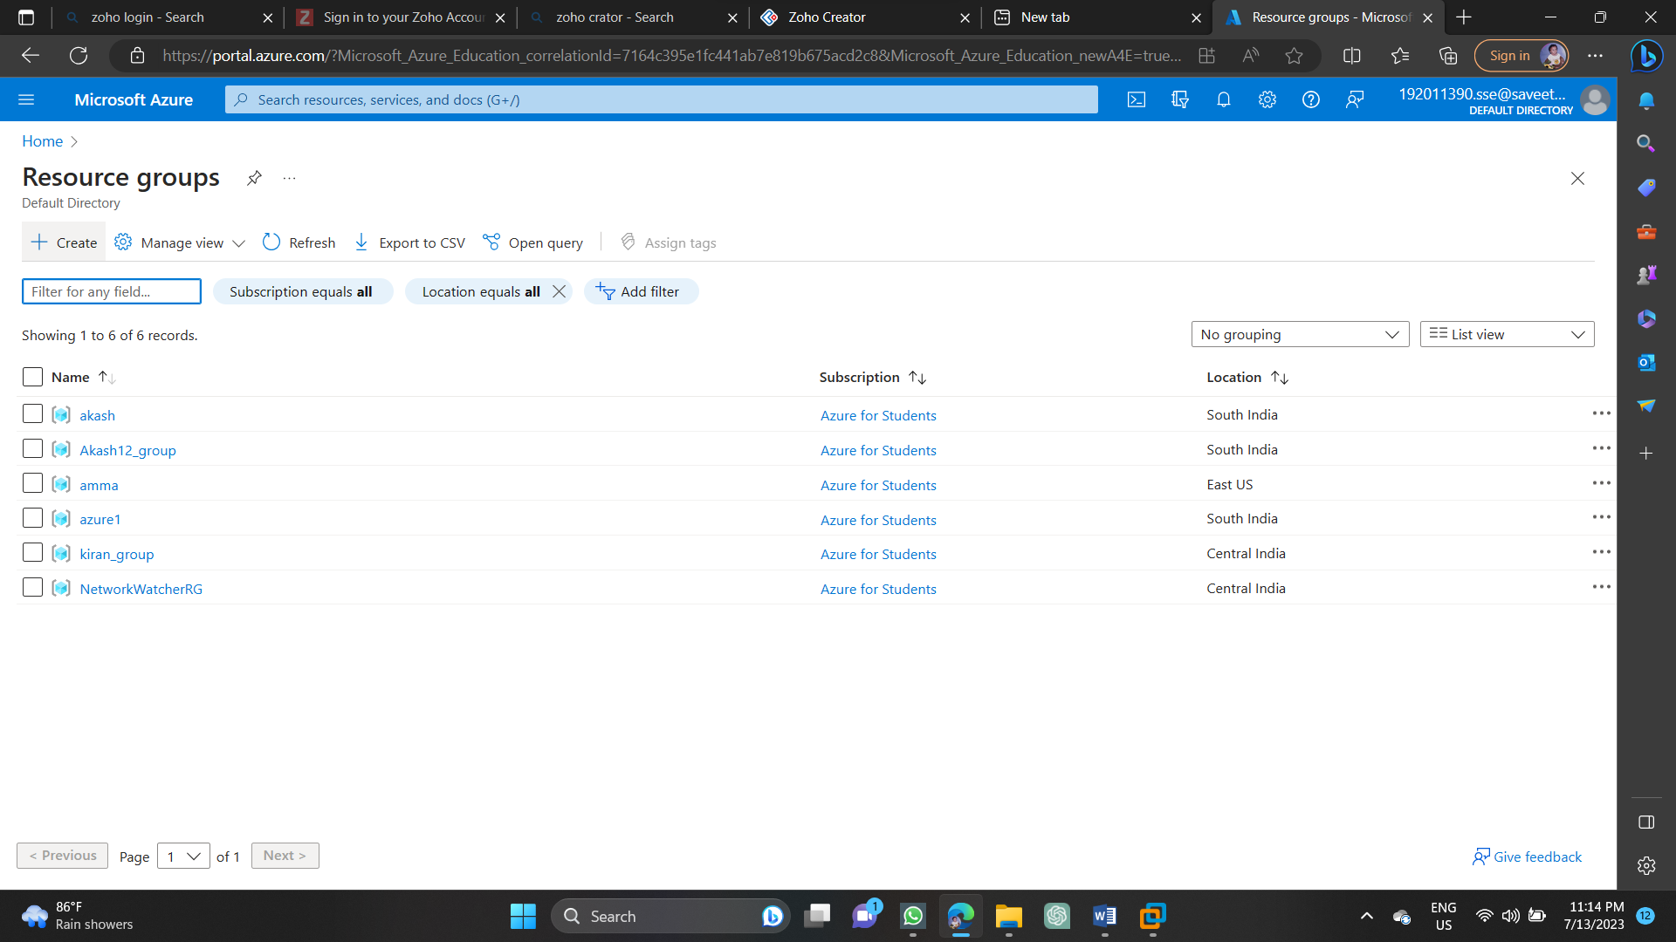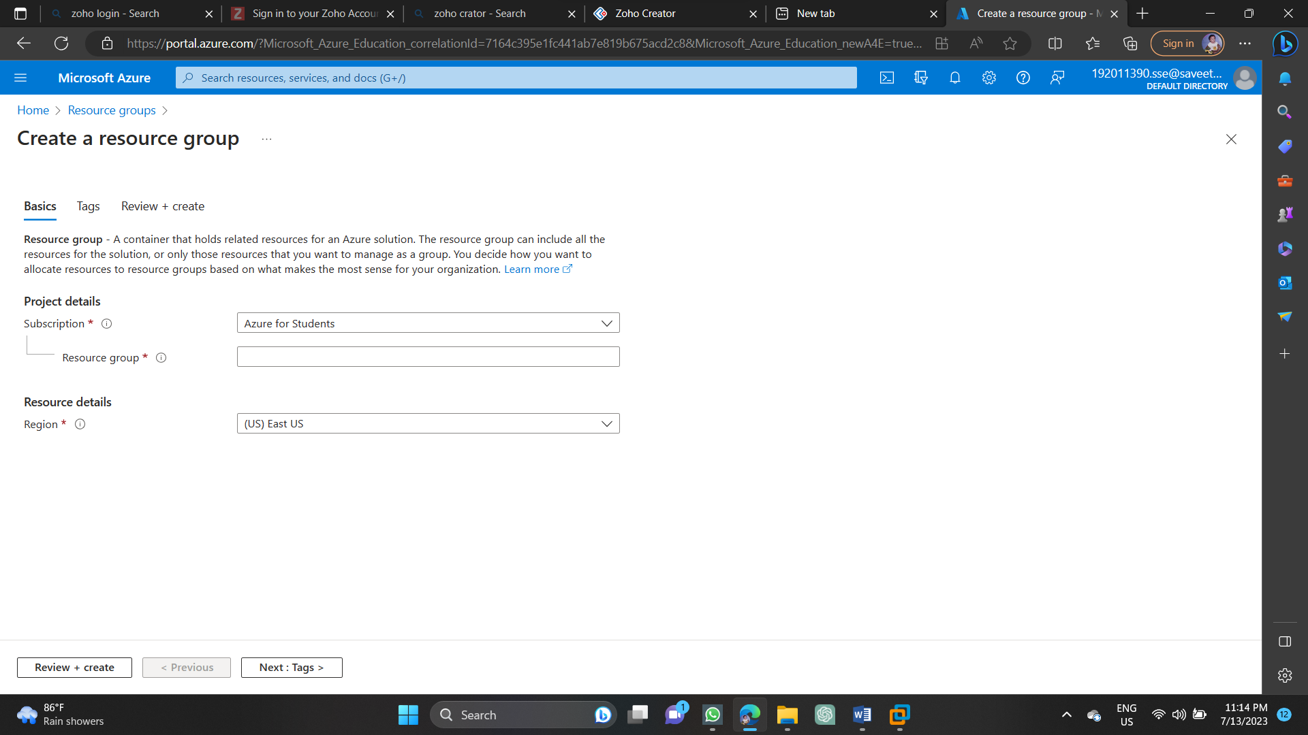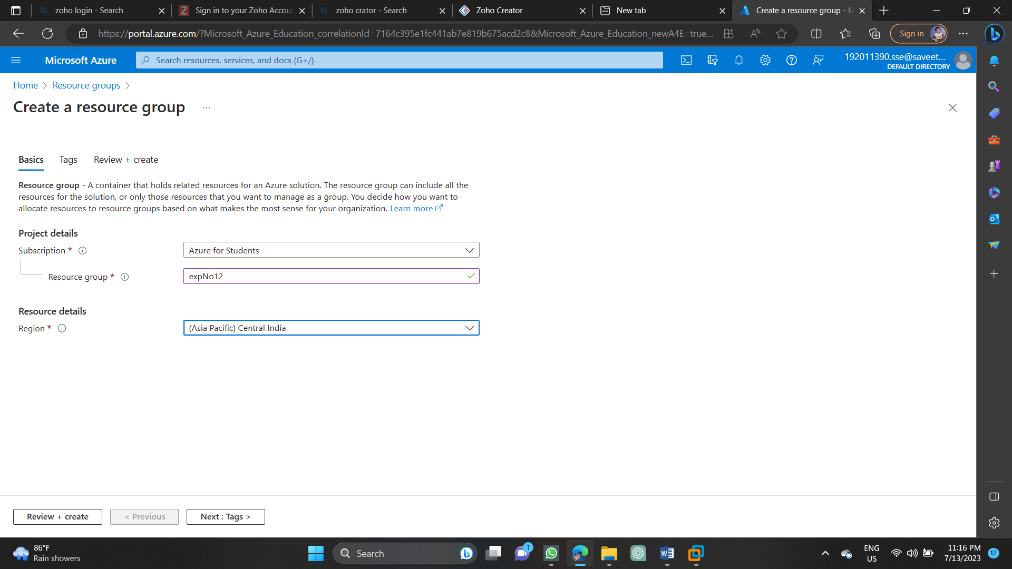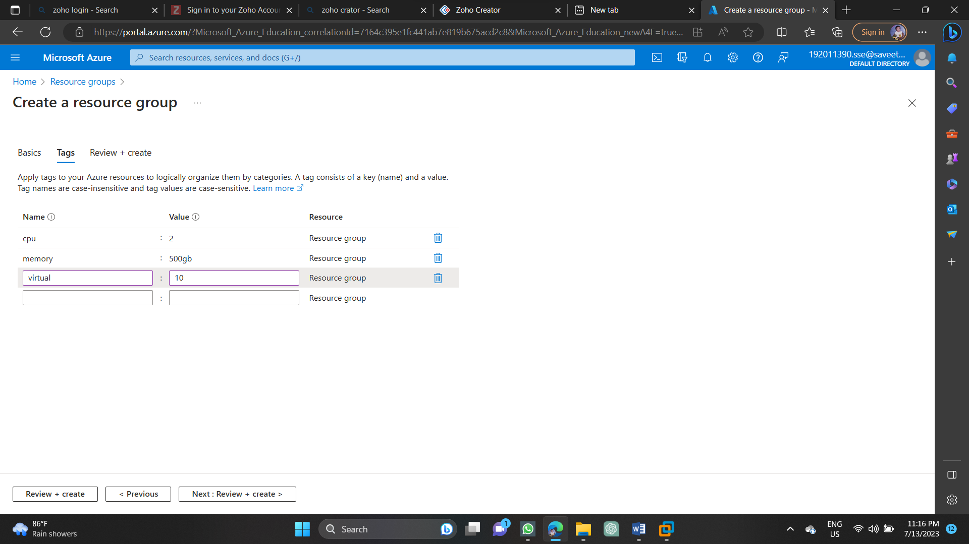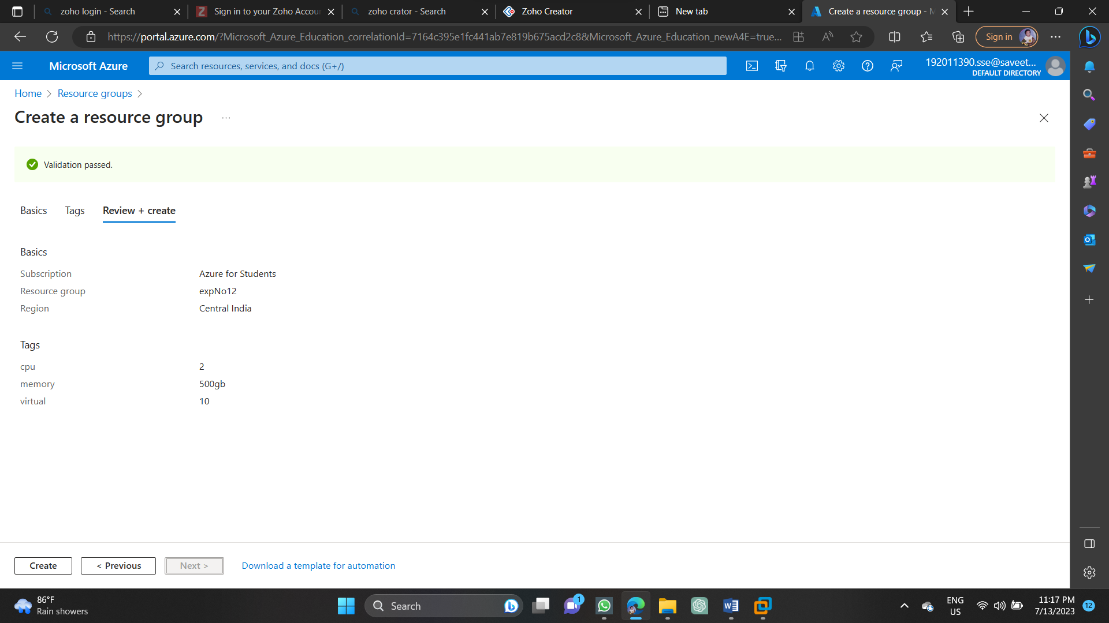

1. Demonstrate Infrastructure as a Service (IaaS) by creating a Virtual Machine using a Public Cloud Service Provider (Azure), configure with required memory and CPU.

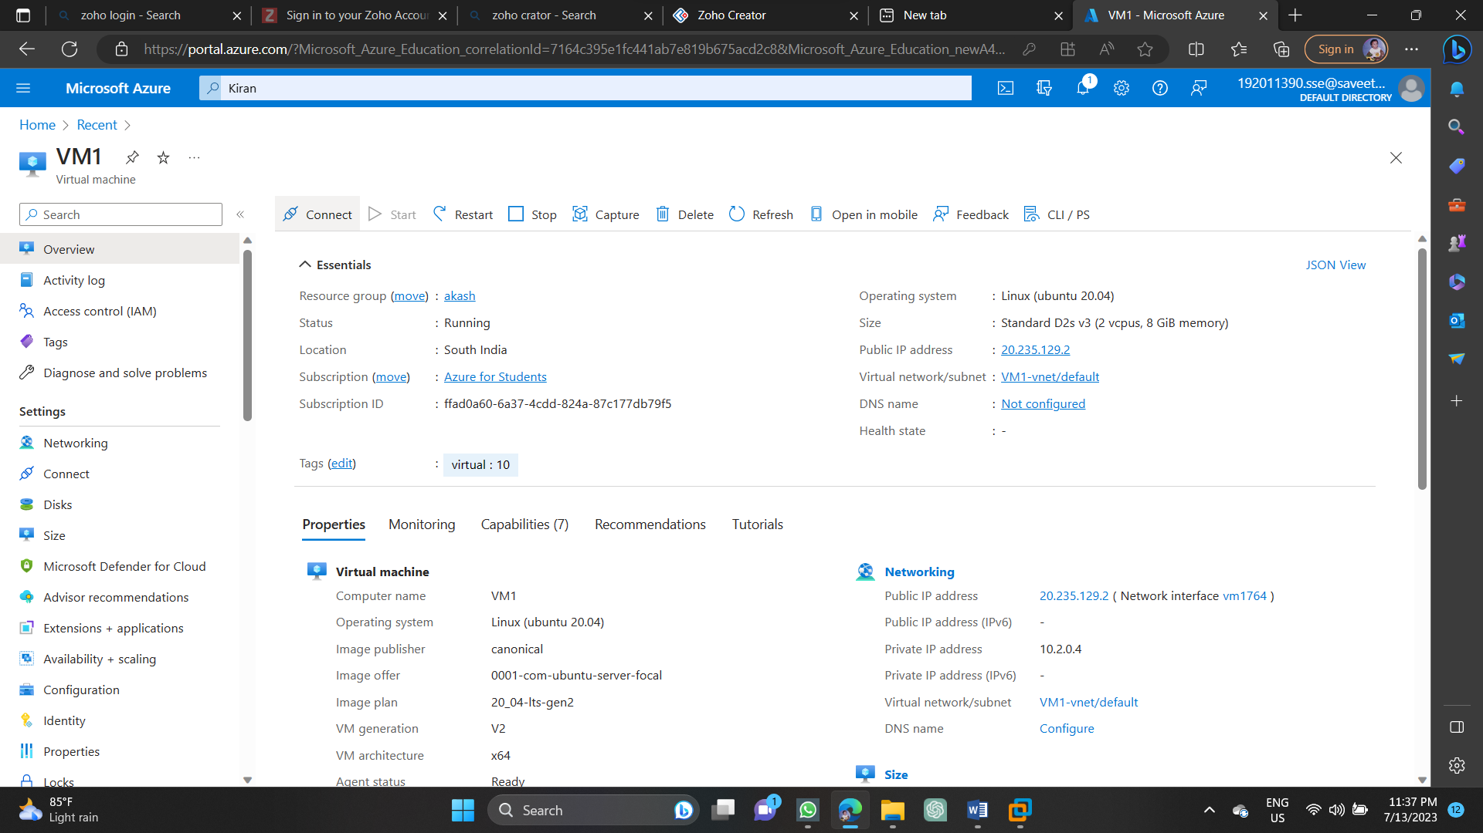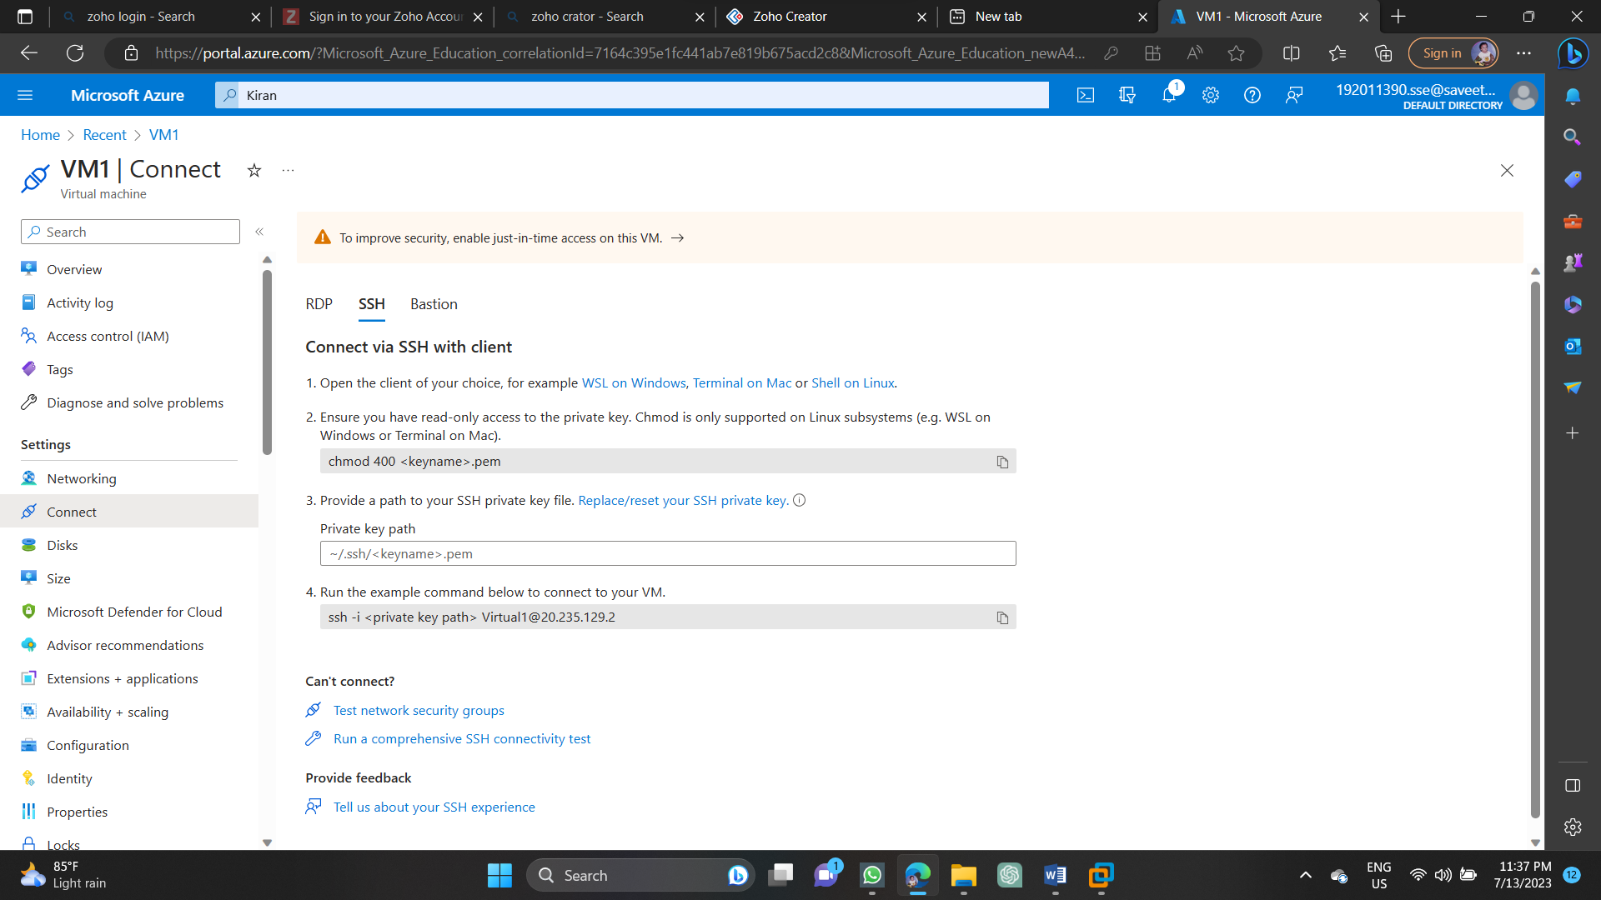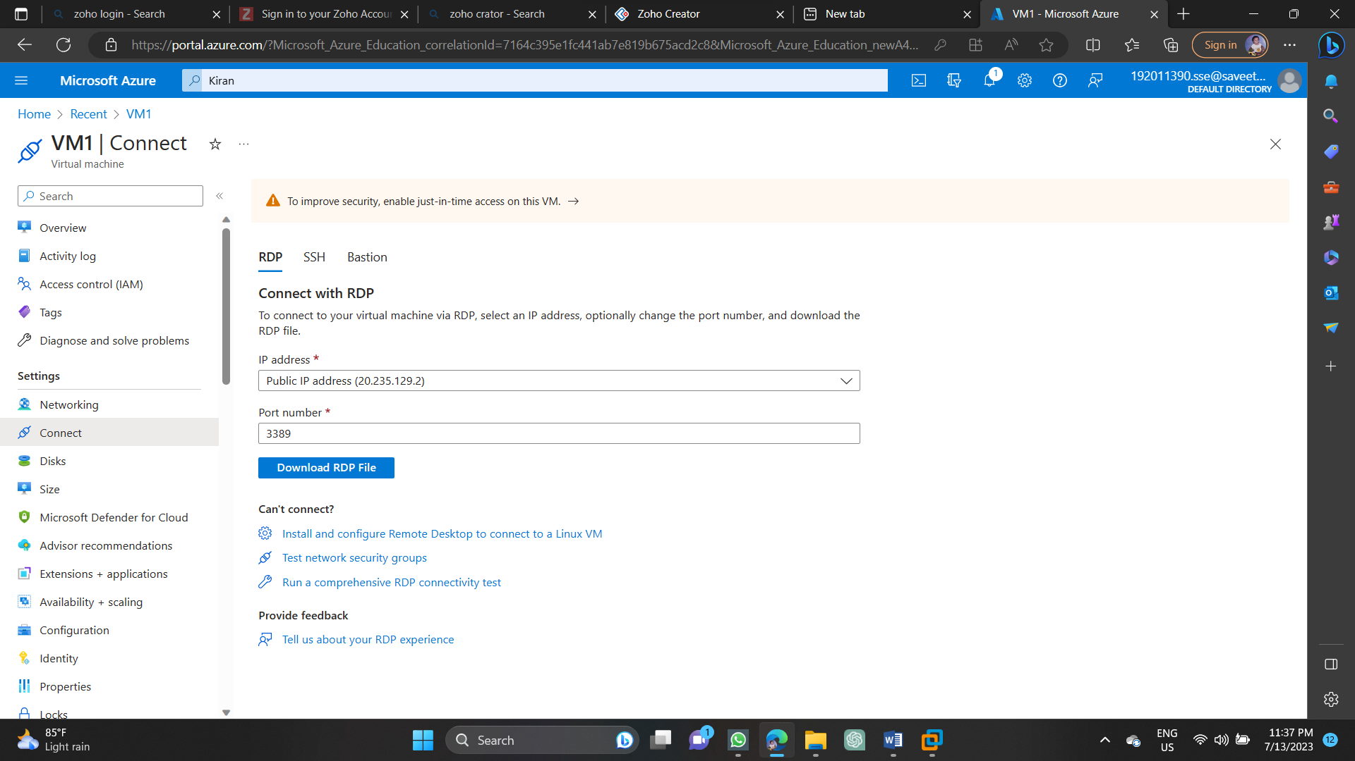

1. Demonstrate Infrastructure as a Service (IaaS) by establishing the remote connection, launch the created VM image and run in your desktop.



1. Demonstrate Platform as a Service (PaaS) create and configure a new VM Image in any Public Cloud Service Provider

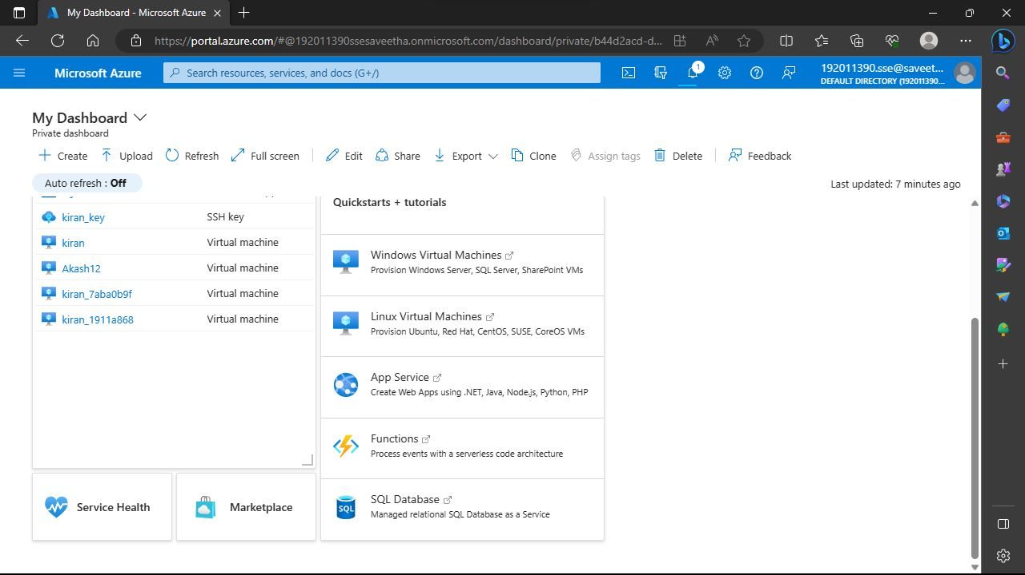

1. Create a Simple Web Application using Java or Python and host it in any Public Cloud Service Provider (Azure/GCP/AWS) to demonstrate Platform as a Service (PaaS).
2. Demonstrate Storage as a Service (SaaS) create and configure a new VM Image in any Public Cloud Service Provider

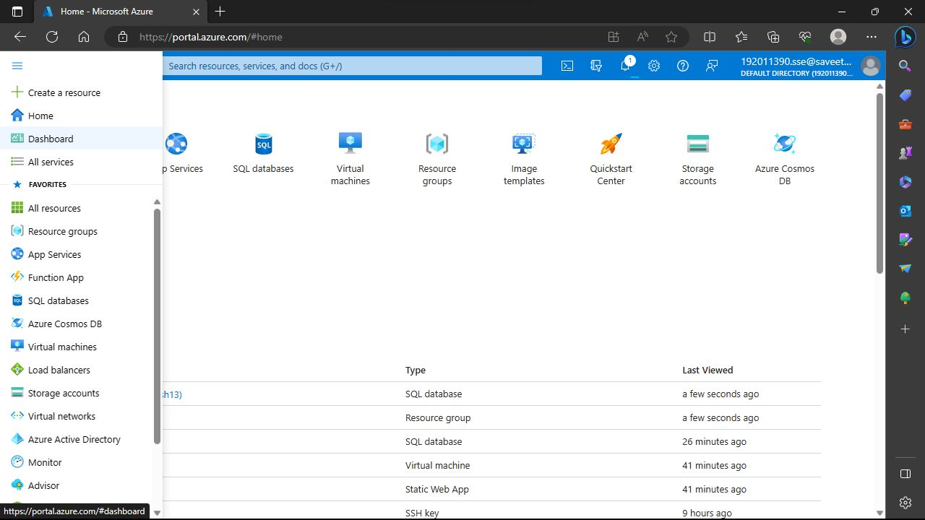

1. Create a Storage service using any Public Cloud Service Provider (Azure/GCP/AWS) and check the public accessibility of the stored file to demonstrate Storage as a Service.
2. Database as a Service (DaaS) create and configure a new VM Image in any Public Cloud Service Provider
3. Create a SQL storage service and perform a basic query using any Public Cloud Service Provider (Azure/GCP/AWS) to demonstrate Database as a Service (DaaS)

