

**MUTHAYAMMAL COLLEGE OF ENGINEERING**

(Approved by AICTE, New Delhi and Affiliated to Anna University)

Rasipuram - 637 408, Namakkal Dist., Tamil Nadu.

STOCK PRICE PREDICTION

**Department Of**

**B.TECH(Artificial Intelligence And Data Science)**

**BY :**

AKASH E

III-YEAR(AI&DS)

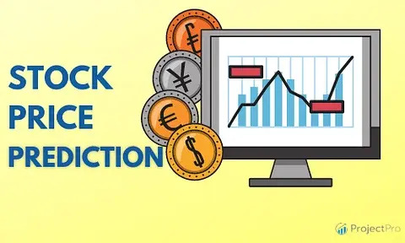

**MY UNDERSTANDING :**

My understanding on this project **“STOCK PRICE PREDICTION”** involves using historical data, market analysis, and various models to forecast future stock price movements. It aids investors and traders in making informed decisions about buying or selling stocks.

**AIM OF MY PROJECT :**

The primary aims of stock price prediction are to assist users in making investment decisions, managing risk, and enhancing trading strategies.

**OBJECTIVES OF MY PROJECT:**

* Audience Understanding
* Facilitate Informed Investment Decisions
* Risk Mitigation
* Optimized Portfolio Management
* Long-Term Planning
* Enhance Trading Strategies
* Improve Returns
* Research and Insights

**AUDIENCE UNDERSTANDING:**

Stock price predictions to your audience's knowledge level, whether they are individual investors, professional traders, or policymakers.

**FACILITATE INFORMED INVESTMENT DECISIONS:**

The primary objective is to provide investors with insights and information to make well-informed decisions regarding buying, holding, or selling stocks.

**RISK MITIGATION:**

By predicting stock price movements, investors can identify potential risks and take measures to mitigate them, reducing the likelihood of financial losses.

**OPTIMIZE PORTFOLIO MANAGEMENT:**

Stock price predictions aid in optimizing investment portfolios by helping investors allocate assets effectively to achieve their financial goals.

**ENHANCE TRADING STRATEGIES**:

Traders use stock price predictions to refine their trading strategies, enabling them to make more precise entries and exits in the market.

**IMPROVE RETURNS**:

By making accurate predictions, investors and traders aim to improve the overall returns on their investments and trading activities.

**LONG-TERM PLANNING**:

Investors can use predictions to make long-term financial plans, such as retirement planning or saving for major life events.

**RESEARCH AND INSIGHTS**:

Analysts and researchers aim to gain insights into market dynamics, helping them understand the forces driving stock price movements.