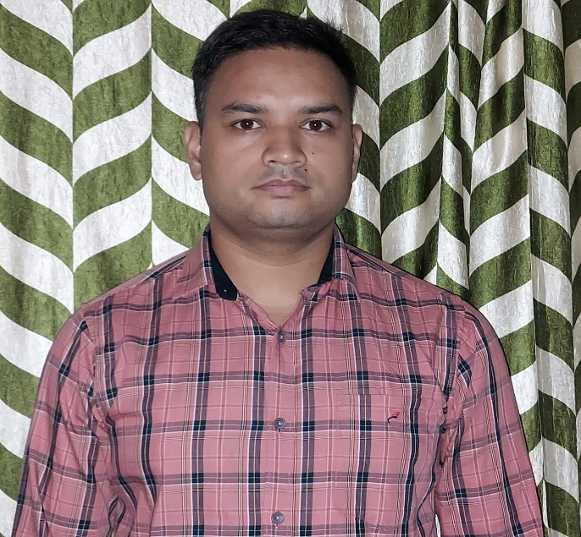

# Responsibilities

Nov-2018 to till now

**Sr. Engineer - Evalueserve Pvt. Ltd., Gurgaon**

* Worked Python, Pandas, NumPy, Scrapy, BeautifulSoup, Excel Wings, File I/O, SQL
* Developed Web Scrapping using by BeautifulSoup, Scrapy, and Requests
* Created Add-Ins (Custom Tab) for Excel, Word, and PowerPoint using custom UI Editor Application by XML Code
* Developed micro automation tool for all MS Office Applications
* Created requirement details documentation, implementation documentation, user acceptance testing documentation, support documentation, user manuals, and technical documentation throughout the application development
* Developed GUI from UserForm in Excel, Word, Access, and PowerPoint using VBA.
* Analysis and Design, Excellent at solving complex problems under strict deadlines.
* Regular interaction with clients, develop strong client relations.

Apr-2016 to Sep-2017

**MIS Executive - Easy Source HR Solution PVT LTD, Delhi**

* Using a Complex excel formula for creating a Report
* Worked on VBA to develop a tool for creating Reports.
* Daily/Weekly/Monthly preparing Data/Dashboard and Adhoc Reports as per company & client requirements.
* Developed the Excel Add-ins for the operations team to do easier work

**Personal Dossier**

* Date of Birth: 1st June 1993
* Language: Hindi, English
* Address: Varanasi

**Total 6 years of experience in programing language and 4.6 Years of experience** in Python. Worked on Web scraping projects and automation projects in Python. Worked on Pandas, Scrapy, BeautifulSoup, Pyodbc, Sqlalchemy and Pymongo. Having knowledge in Django and Djangorestframework.

**Phone:**

+91 7042009885

**E-Mail:**

[akash.misexcel@gmail.com](mailto:akash.misexcel@gmail.com)

**LinkedIn:**

https://www.linkedin.com/in/akash-vishwakarma-1775691b1/

# **Skill Highlights**

* Project management
* Strong decision maker
* Complex problem solver
* Innovative

# **Technical Skill**

* Python, Web Scraping
* Selenium, BeautifulSoup, Scrapy
* Pandas
* Pymongo, Pyodbc, Sqlalchemy
* MongoDB, MySQL, SQL Server

# **Education**

* B.A from M.G.K.V.P – 2014
* 12th from UP Board – 2010
* 10th from UP Board – 2008

Akash Vishwakarma