Data Structure can be defined as a way of storing and organizing data in the computer so that it can be used efficiently.

**Linear Data Structures:** A data structure is called linear if all of its elements are arranged in the linear order.

**Arrays,** **Linked List,** **Stack,** **Queue**

**Non Linear Data Structures:** The data elements are not arranged in sequential structure.

**Trees,** **Graphs.**

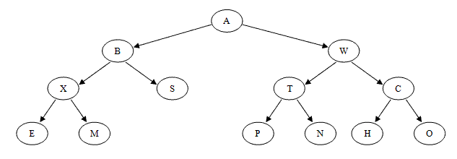

* The number of sub trees of a node is called the *degree* of the node. In a binary tree, all nodes have degree 0, 1, or 2.
* A node of degree zero is called a *terminal node* or *leaf node*.
* A non-leaf node is often called a *branch node*.
* The *degree of a tree* is the maximum degree of a node in the tree. A binary tree is degree 2.
* The *height* of *ni* is the length of the longest path from *ni* to a leaf. Thus all leaves in the tree are at height 0.
* The *height of a tree* is equal to the height of the root. The *depth of a tree* is equal to the level or depth of the deepest leaf; this is always equal to the height of the tree.
* If there is a directed path from *n1* to *n2*, then *n1* is an ancestor of *n2* and *n2* is a descendant of *n1*.

The **depth** of a node is the number of edges from the root to that node. The height of a node is the number of edges from that node to the deepest leaf. The height of a **tree** is a height of the root. A full **binary tree**.is a **binary tree** in which each node has exactly zero or two children.

the level of the root is zero; and the level of any other node is one higher than that of its parent. Or to put it another way, the level or depth of a node ni is the length of the unique path from the root to ni.

* Subtype polymorphism is also known as **runtime polymorphism**.
* Parametric polymorphism is also known as **compile-time polymorphism**.
* Ad-hoc polymorphism is also known as **overloading**.
* Coercion is also known as (implicit or explicit) **casting**.

[27. What are HEAP tables in MySQL?](https://www.onlineinterviewquestions.com/mysql-interview-questions/" \l "collapseUnfiled27)

**HEAP tables** are in-memory. They are usually used for high-speed temporary storage. No TEXT or BLOB fields are allowed within HEAP tables. You can only use the comparison operators = and < =>. HEAP tables do not support **AUTO_INCREMENT**. Indexes must be **NOT NULL**.

[How many values can the SET function of MySQL take?](https://www.onlineinterviewquestions.com/mysql-interview-questions/" \l "collapseUnfiled28)

MySQL set can take zero or more values but at the maximum it can take 64 values.

The following table describes the maximum length for each type of identifier.

* **Database**64 bytes
* **Table**64 bytes
* **Column**64 bytes
* **Index**64 bytes
* **Alias**255 bytes

MySql does not support COMMIT and STORED PROCEDURES functions version less than 5.0.

Wildcards are commonly used in computer programming, database [SQL](https://techterms.com/definition/sql) search queries, and when navigating through [DOS](https://techterms.com/definition/dos) or [Unix](https://techterms.com/definition/unix) directories via the [command prompt](https://techterms.com/definition/commandprompt).

Below are some popular uses for wildcards:

* **Regular Expressions** - A period (.) matches a single character, while .* matches zero or more characters and .+ matches one or more characters.  
  Example: $pattern = "Mac(.*)"
* **SQL Queries** - A percent symbol (%) matches zero or more characters, while an underscore (_) matches a single character.  
  Example: SELECT * FROM Computers WHERE Platform LIKE 'Mac%'
* **Directory Navigation** - An asterisk (*) matches zero or more characters, while a question mark (?) matches a single character.  
  Example: dir *.exe

Palm OS uses [multitasking](https://whatis.techtarget.com/definition/multitasking), but only one task is for applications. The user uses one application at a time, one application program must finish before the next can be selected.