**Statement coverage** = One true possible statement which leads to truth in each statement, block, branch. From start to end : " 1A-2C-3D-E-4G-5H" only one possible way.

**Branch coverage** = One true possible statement + one false possible statement. Each branch,condition.

**Path coverage** = All possible path in each branch,condition.

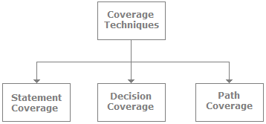

Refer Two links with simultaneausly

Link:1:- <https://www.javatpoint.com/branch-coverage-testing-in-white-box-testing>

Link:2:- <https://www.guru99.com/code-coverage.html>

# **Question on** Equivalence Partitioning And Boundary Value Analysis

<https://www.softwaretestinghelp.com/istqb-exam-questions-equivalence-partitioning-boundary-value-analysis/>

**Decision coverage**

Decision coverage covers all possible outcomes of each and every Boolean condition of the code by using control flow graph or chart.

Generally, a decision point has two decision values one is true, and another is false that's why most of the times the total number of outcomes is two. T

Decision Coverage technique in whitebox testing link

**Scenario 1:**  
**Value of a is 7 (a=7)**

1. Test (**int** a=7)
2. { **if** (a>4)
3. a=a*3
4. print (a)
5. }

Decision Coverage technique in whitebox testing link

Decision Coverage technique in whitebox testing link

1. Decision Coverage = ½*100  (Only "True" is exercised)
2. =100/2
3. = 50
4. Decision Coverage is 50%

**Statement Coverage**

Statement Coverage 

**Scenario 1:**  
**If a = 5, b = 4**

1. print (**int** a, **int** b)
2. {
3. **int** sum = a+b;
4. **if** (sum>0)
5. print ("This is a positive result")
6. **else**
7. print ("This is negative result")
8. }

Statement coverage = 5/7*100

= 500/7

= 71%

**Decision/Branch Coverage**

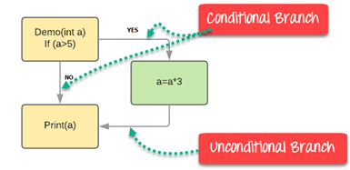

Branch Coverage will consider unconditional branch as well

|  |  |  |  |  |
| --- | --- | --- | --- | --- |
| Test Case | Value of A | Output | Decision Coverage | Branch Coverage |
| 1 | 2 | 2 | 50% | **33%** |
| 2 | 6 | 18 | 50% | **67%** |

\

## Condition Coverage

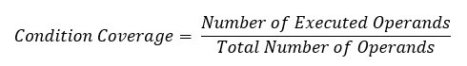

Example:

[https://www.guru99.com/images/1/102518_1122_CodeCoverag11.png](https://www.guru99.com/images/1/102518_1122_CodeCoverag11.png)

For the above expression, we have 4 possible combinations

* TT
* FF
* TF
* FT

Consider the following input

Consider the following input

|  |  |  |  |
| --- | --- | --- | --- |
| X=3  Y=4 | (x<y) | TRUE | Condition Coverage is ¼ = 25% |
| A=3  B=4 | (a>b) | FALSE |