**Life Cycle of a Servlet (Servlet Life Cycle)**

The web container maintains the **life cycle of a servlet** instance. Let's see the life cycle of the servlet:

1. Servlet class is loaded.
2. Servlet instance is created.
3. init method is invoked.
4. service method is invoked.
5. destroy method is invoked.

# How Servlet works? <https://www.javatpoint.com/how-servlet-works>

### **directory structures**

The **directory structure** defines that where to put the different types of files so that web container may get the information and respond to the client.

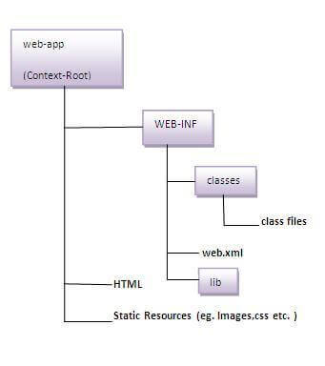

As you can see that the servlet class file must be in the classes folder. The web.xml file must be under the WEB-INF folder.