Unti 1

1. What is Operating system? Describe the function of O.S.

Ans: An Operating System is a system software that manages computer hardware and software resources and provides common services for computer program.

Some of the man function of Operating System are:

1. Process Management:

Process Management helps Operating System to create and delete processes. It also provides mechanism for synchronization and communication among processer.

1. Memory Management :

Memory Management modules performs the task of allocation and de-allocation of memory space to program in need of this resources.

1. File Management:

It manage all the file related activities such as organization storage, retrival, naming, sharing and protection of files.

1. Device Management:

Device Management keeps tracks of all the devices. This modules also responsible for this task is known as the I/O controller. It also perform the task of allocation and de-allocation of the devices.

1. Security:

Security modules protect the data and information of a computer system against malware threat and authorized access.

1. Job Accounting:

Keeping track of time and resources used by various job and users. This data can be used to monitor how much of each resources is being used by a specific user or group of users.

1. Networking:

The operating system provides networking capabilities such as establishing and managing network connection , handaling, network protocol and sharing resources such as printer and file over a network.

1. Detecting and Correcting error:

If the supporting hardware or software does not work properly, then the operating system tries to rectify it and also guides the user to take the necessary step.

1. Explain the type of Operating System with the advantages and disadvantages.

Ans: The different type of operating system with their advantage and disadvantage are:

1. Batch Operating System:

This type of operating system does not interact with the computer directly. There is an individual operator which takes similar kind of jobs having the same needs and requirements and then group them into different batches.

CPU

Batch

Job 3

Job 2

Job 1ob 1

Batch

Batch

Advantage:

* Multiple users can share the batch system.
* It is easy to manage large work repeatedly in batch system.
* The idle time for the batch system is very less.
* It is very difficult to guide or know the time required for any job to complete .

Disadvantage:

* Batch system are hard to debug.
* It proves to be costly sometimes.
* The other job will have to wait for any unknown time if any job fails.
* The computer operators should be well known with batch system.

1. Multi-Programming Operating System:

Multi-programming operating system can be simply illustrated as more than one program is present in the main memory and any one of them can be kept in execution. This is basically used for better execution of resources.

Memory

partition

Job 1

Job 2

Job3

Operating system

Advantage:

* It increases the Throughput of the system
* It helps in reducing the response time.
* The CPU is always busy and never idle.

Disadvantage:

* Requires a high level of memory management.
* Management all processing and tasks is tricky.
* Requires CPU scheduling.

1. Time –Sharing Operating System:

A time-sharing operating system is also called a Multi-tasking system. In this each task is given some time to execute so that all the tasks work smoothly. Each user gets the time of the CPU as they use a single system.

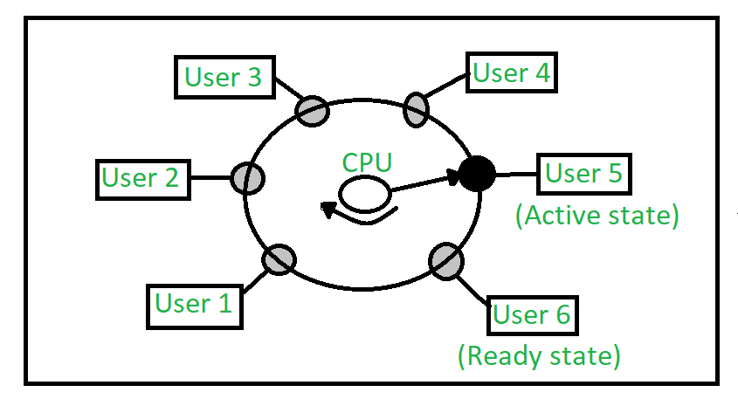

Advantage:

* Each task gets an equal opportunity.
* CPU idle time can be reduced.
* Quick response time.
* Simple and user- friendly.

Disadvantage:

* Consumes a lot of resources.
* Requires high-quality hardware.
* Data communication problem .

1. Networking Operating System:

Networking operating systems run on a server and perform various networking functions, such as managing data, users, groups, security, and applications. These allows shared access to networking functions on small private network or LAN.

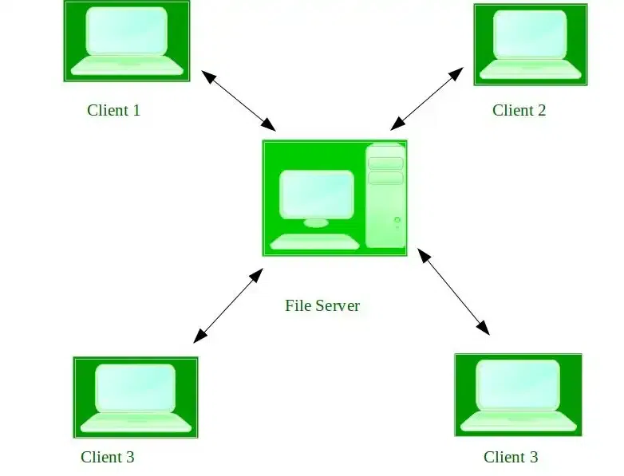

Advantage:

* We can easily access servers from different location.
* Any changes or up-gradation is easy to manage.
* Highly stable centralized servers

Disadvantage:

* Requires high mantenance.
* Set up is costly.
* Depended on central location.

1. Real-Time Operating System:

These type of operating system serve real-time system. The time interval required to process and respond to inputs is very small. This time interval is called response time.

There is 2 type of real-time system:

1. Hard real-time:

These system time is counted in terms of microseconds and if they are not followed the whole system fails.

1. Soft real-time:

They are still critical to time but a small delay may not cause a major failure to the system.

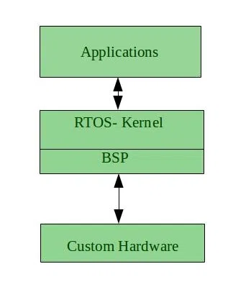

Advantage:

* Due to their small size, they can be easily added to other system.
* Provides the best memory management.
* They have no error.

Disadvantage:

* Algorithm are complex.
* System resources are expensive.
* Low-priority tasks need to wait for a long time

3. What are the operating system components explain?

Ans: The components of operating system are as follows:

1. Process Management:

The process management components of an operating system is generally used to monitor as well as handle various processes that are executing on the operating system at the same time. it also makes use of the memory allocate to them and turns them off as necessary.

1. File Management:

A file is defined as a collection of data that represents programmers, source form, object forms, as well as data. Numerical, alphabetical or, alphanumeric data files are also all supported.

1. i/O Device Management:

The I/O device management components is an i/O manager that hides the details of hardware devices and manages the main memory for devices using cache and spooling.

1. Network Management:

Network management is the process of administering and managing computer networks. It includes performance management, fault analysis, network provisioning, and maintaining the quality of service.

1. Main Memory Management:

Main memory is a flexible and volatile type of storage device. It is a large sequence of bytes and addresses used to store volatile data. Main memory is also called Random Access Memory (RAM).

1. Secondary-Storage Management:

Secondary storage device is used to store data permanently and the user can retrieve it easily when needed. The primary memory is insufficient to retain all of the data and application indefinitely so, secondary storage serves as a backup for main memory.

1. Security Management:

The security mechanisms in an operating system ensure that authorized program have access to resources, and unauthorized program have no access to restricted resources.

1. Signals:

Signals are used in the operating system to notify a process that a particular event have occurred. Signals are the software and hardware interrupt that suspend the current execution of the task.

4. Operating system services: (short notes)

1. System call:

A system call is a programmatic way in which a computer program request a service from the kernel of the operating system it is executed on. A system call is a way for programs to interact with the operating system. It provides the service of the operating system to the user program via API ( Application Program Interface.

1. Shell:

Shell is a computer application software that the servers of an operating system to an external user or another program. Depending on the computer particular operation and role , its shell may have either a Command Line Interface (CLI) or Graphical User Interface (GUI).

Unit -2

1. Define Process, Program, Thread. Different between Process and Program.

Ans: Process:

A process is a program in execution, which has its own address space, program counter, and resources.

Program:

A program is a collection of instructions that are used to complete a specific task.

Thread:

A thread refers to a single sequential activity that are being executed, these activities are also known as thread of execution or thread control.

|  |  |
| --- | --- |
| Process | Program |
| A process is a program that is being executed. | A program is a set of instructions that are used to perform a certain task. |
| Process is a dynamic entity. | Program is a static entity. |
| It has its own control block called Process Control Block. | It does not have any control block. |
| It is a active entity as it is created during execution and loaded into the main memory. | It is a passive entity as it resides in the secondary memory. |
| Process holds resources like CPU, memory address, disk, I/O, etc. | The program is stored on disk in some file and does not required any other resources. |
| It has considerable overhead | It does not have a significant overhead |
| Many processes may execute a single program. | Program does not change itself. |

1. Difference between Process and Thread

Ans:

|  |  |
| --- | --- |
| Process | Thread |
| When a pro |  |
|  |  |
|  |  |
|  |  |
|  |  |
|  |  |
|  |  |