A Project Report On

Linked Dictionary

Submitted in partial fulfillment of the requirement for the award of the degree

MASTER OF COMPUTER APPLICATIONS (INTEGRATED)

from
Gujarat Technological University



Academic Year 2018 – 19

Derlin Daniel (175220686005)
Surojeet Mandal (175220686026)

Internal Guide
(Prof. Nootan Padia)


Marwadi Education Foundation’sGroup of Institutions
(MEFGI)
Rajkot-Morbi Road, At & PO : Gauridad, Rajkot 360 003. Gujarat. India.

Faculty of Computer Applications (FCA)



This is to certify that the project work entitled

Linked Dictionary

submitted in partial fulfillment of the requirement for

the award of the degree of

Master of Computer Applications (Integrated)

of the

Gujarat Technological University

is a result of the bonafide work carried out by

Derlin Daniel (175220686005)

Surojeet Mandal (175220686026)

during the academic year 2018 – 2019

Faculty Guide |  | HOD |  | Dean

External Viva

Name of the Examiners |  | Signature with Date
DECLARATION

We hereby declare that this project work entitled Linked Dictionary is a record done by us.

We also declare that the matter embodied in this project is genuine work done by us and has not been submitted whether to this University or to any other University / Institute for the fulfillment of the requirement of any course of study.

Place : Rajkot
Date :

Derlin Daniel (175220686005) Signature :
Surojeet Mandal (175220686026) Signature :

ACKNOWLEDGEMENT

It is indeed a great pleasure to express our thanks and gratitude to all those who helped us. No serious and lasting achievement or success one can ever achieve without the help of friendly guidance and co-operation of so many people involved in the work.

We are very thankful to our guide Prof.Nootan Padia, the person who made us to follow the right steps during a project work. We express our deep sense of gratitude to for her guidance, suggestions and expertise at every stage. A part from that her valuable and expertise suggestion during documentation of our report indeed helped us a lot.

Thanks to our friend and colleague who have been a source of inspiration and motivation that helped to us during our project work.

We would heartily thankful to Head and Dean of our department Dr. Sunil Bajeja and Dr. R. Sridaran to gave us an opportunity to work over this report and for their end-less and great support. And to all other people who directly or indirectly supported and helped us to fulfil our task.

Derlin Daniel (175220686005) Signature :
Surojeet Mandal (175220686026) Signature :

CONTENTS

Chapters | Particulars | Page No.
1 | SYNOPSIS | 1
2  2.1  2.2 | PREAMBLE  Project Description  Modules and Description | 2  2
3  3.1  3.2 | TECHNICAL DESCRIPTION  Hardware Requirement  Software Requirement | 3  3
4  4.1 | SYSTEM DESIGN AND DEVELOPMENT  Class Diagram & Activity Diagram  Database Design / File Structure with Description  Table Structure | 4  5
5 | SYSTEM TESTING | 6
6 | SCREEN SHOTS | 7-8
7 | SOURCE CODE | 9-12
8 | CONCLUSION | 13
9  9.1  9.2 | BIBLIOGRAPHY  Online References  Offline References | 14  14

FIGURE INDEX

Sr. No. | Figure No. | Particulars | Page No.
1 | 3.1 | Class diagram | 4
2 | 3.2 | Activity diagram | 5
3 | 6.1 | Main menu & add module | 7
4 | 6.2 | Display module | 7
5 | 6.3 | Search module | 8
TABLE INDEX

Sr. No. | Table No. | Particulars | Page No.
1 | 4.1 | Software requirements | 3
2 | 4.2 | Hardware requirments | 3

Chapter-1 SYNOPSIS

Our project linked dictionary is about storing the newly learned or listened words.
It is like a personal dictionary not in the sense of the real dictionary which gives the explanation or meaning of the words, but it stores the inputted words by the user.
Our project LINKED DICTIONARY is about ‘The more you learn the more you improve in yourself’

It helps to complete the daily task of learning new words. This linked dictionary helps to recall all the words learned earlier.
Easy to maintain the words separately and in an ordered manner in our linked dictionary.
Our linked dictionary contains the functions such as the user can add the learned words, search the stored words and display the words stored in it.

Our project of linked dictionary is mostly useful for the school students those who are curious in learning new words.
Our project is fully based on C++ as per the requirement of Software project. So, we have used some of the concepts of C++ language.

Chapter-2 PREAMBLE

2.1 Project Description
- We used C++ programming language which is the basic OOP language from all the computer languages and also we are using Linked, Arrays, File Handling which we are learning in C++ .
- “Linked Dictionary” is a record holding program which contains all the records of the words in a classified manner . It is prepared by both of the members in group and has poured equal efforts with different viewpoints and ideas. This project has been prepared keeping in mind that it should be user-friendly for the user.
- The Project Linked Dictionary has been made to automatically create the repeated steps which are common for all the students of the institutions.
2.2 Modules
- Add Words to Dictionary
- Search Words in Dictionary
- Display Words added in Dictionary
- Exit
2.2 Modules and Description
- Add Words:-The User can add words to the Dictionary what he/she had learned in the school & colleges.
- Search Words:-The user can search the various words which he/she had entered in the Dictionary one by one.
- Display Words:-The User can have a instant look on what he/she had in the Dictionary. The words will be displayed

Chapter 3 TECHNICAL DESCRIPTION

3.1 Software Requirement

Software Requirements
Windows | 7,8,10, Server 2008, Server 2012, 64 bits PC.
CPU | Quad-core Intel i5 or i7/Xeon
GPU | Any GPU that is compatible with OpenGL 3.2  (Integrated Graphics card Intel HD 4000 or above)
Storage | 4 GB Ram, 10GB HDD Free Space
Google | Chrome(64.0,63.0.3239, 62.0.3202)

3.2 Hardware Requirement

Hardware Requirement
Monitor | Any Monitor with Resolution1366 X 768
Keyboard | Any Company QWERTY Keyboard
Mouse | Any Company Mouse with Two Keys and Scroll Button

Chapter 4:

SYSTEM DESIGN AND DEVELOPMENT

4.1 Class Diagram:

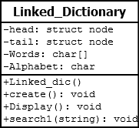

4.2 Activity Diagram:

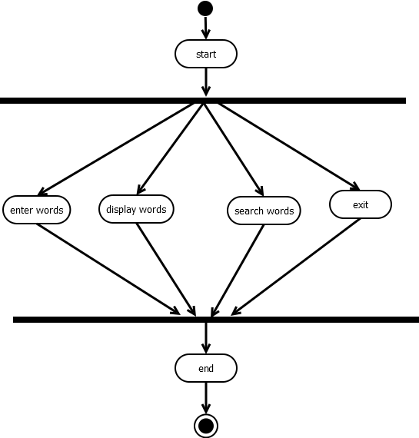

Chapter:5

SYSTEM TESTING
No. | Test case | Actual Output
1 | Diaplay menu  &  Add module | add some word in disctionary
2 | Display Module | Display words which is stored in your dictionary
3 | Search Module | Search words successfully

Chapter 6:

SCREENSHOTS

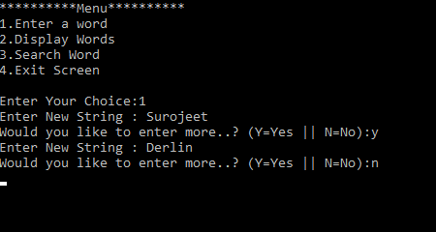

MAIN MENU & ADD MODULE

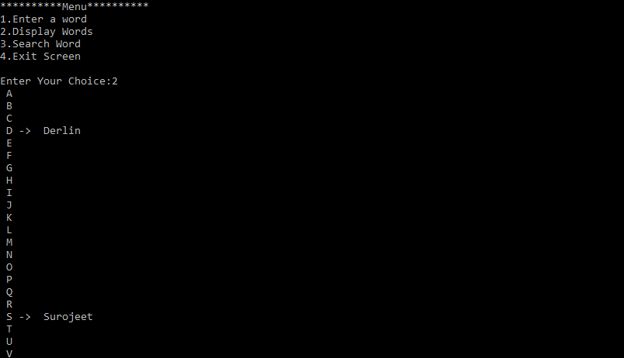

DISPLAY MODULE

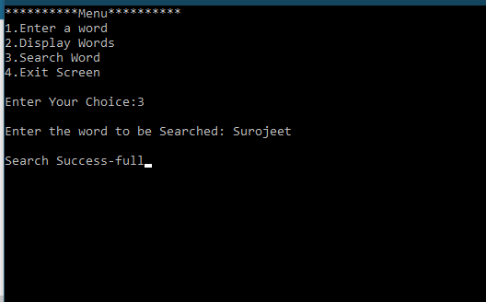

SEARCH MODULE

Chapter 7:
Source Code

#include<iostream>
#include<conio.h>
#include<fstream>
#include<windows.h>
using namespace std;

struct node
{
string data;
node * next;
}*start[52];

class linked_Dic
{
private:
node *head, *tail;
char words[50];
public:
linked_Dic();//for Linked List Creation
void create();
void display();//Display Linked List
void search1(string);
};

linked_Dic::linked_Dic()//Alphabet Linked list creation
{
char alphabet='A';
for(int i=0; i<51; i++)//Capital+Small Alphabets
{
start[i]=new struct node;
start[i]->data=alphabet;
start[i]->next=NULL;
alphabet++;
if(i==25)
{
alphabet='a';
}
}
}

void linked_Dic::create()
{
int i=0;
char input='y';
struct node *ptr_data, *ptr_trav;
while(input=='y' || input=='Y')
{
cout<<"Enter New String : ";
ptr_data=new struct node;
cin>>ptr_data->data;
ptr_data->next=NULL;

char file_name[6];
file_name[0]=ptr_data->data[0];
file_name[1]='.';
file_name[2]='t';
file_name[3]='x';
file_name[4]='t';
file_name[5]='\0';
struct node *link=NULL;
fstream file_object;
file_object.open(file_name,ios::out | ios::app);
file_object<<ptr_data->data<<endl;

while(start[i]->data[0]!=ptr_data->data[0])
{
i++;
}
ptr_trav=start[i];
while(ptr_trav->next!=NULL)
{
ptr_trav=ptr_trav->next;
}
ptr_trav->next=ptr_data;
ptr_trav=ptr_data;
cout<<"Would you like to enter more..? (Y=Yes || N=No):";
cin>>input;
i=0;
}
}

void linked_Dic::search1(string arg1)
{
string readString;
char file_name[6];
file_name[0]=arg1[0];
file_name[1]='.';
file_name[2]='t';
file_name[3]='x';
file_name[4]='t';
file_name[5]='\0';
fstream file_object;
file_object.open(file_name,ios::in);
if(file_object)
{
do
{
file_object>>readString;
if(readString==arg1)
{
cout<<endl<<"Search Success-full";
break;
}
}
while(!file_object.eof());
if(file_object.eof())
{
cout<<endl<<"No such word saved in the Dictionary...";
}
}
else
{
cout<<endl<<"No such word saved in the Dictionary...";
}
getch();
}
void linked_Dic::display()//display the Linked List.
{
int i=0;
struct node *ptr_tra=NULL;

while(i<51)
{
ptr_tra=start[i];
if(ptr_tra==NULL)
{
cout<<"Nothing to Display";
}
else
{
do
{
cout<<" "<<ptr_tra->data;
}
while((ptr_tra->next!=NULL) && (cout<<" -> ") && (ptr_tra=ptr_tra->next));
}
cout<<endl;
i++;
}
}

int main()
{
linked_Dic obj;
string input_string, value, strInput;
int choice;
do
{
cout<<"**********Menu**********";
cout<<"\n1.Enter a word";
cout<<"\n2.Display Words";
cout<<"\n3.Search Word";
cout<<"\n4.Exit Screen";
cout<<"\n\nEnter Your Choice:";
cin>>choice;

switch(choice)
{
case 1:
obj.create();
getch();
break;
case 2:
obj.display();
getch();
break;
case 3:
cout<<endl<<"Enter the word to be Searched: ";cin>>strInput;
obj.search1(strInput);
getch();
break;
}
system("CLS");
}while(choice!=4);
}

Chapter 8:

CONCLUSION:

This easy program can easily store huge data in the files. This program uses file handling and working with it. By working in this type of programs we can make it easy for reading as well as writing to it. We have learned file handling, pointer, structure and many more other functions in C++ while working in this project.

Chapter 9:

BIBLIOGRAPHY

  - Offline References:
- Programming With ANSI C++”, Bhushan Trivedi, Publisher: OXFORD HIGHER EDUCATION

- “Object-Oriented Programming In C++”, Robert Lafore, Fourth Edition, Publisher: PEARSON

  - Online References:

- https://www.cppprogramming.com

- https://www.tutorialspoint.com

