# ITCS 6162: Knowledge Discovery in Databases

# Project Report

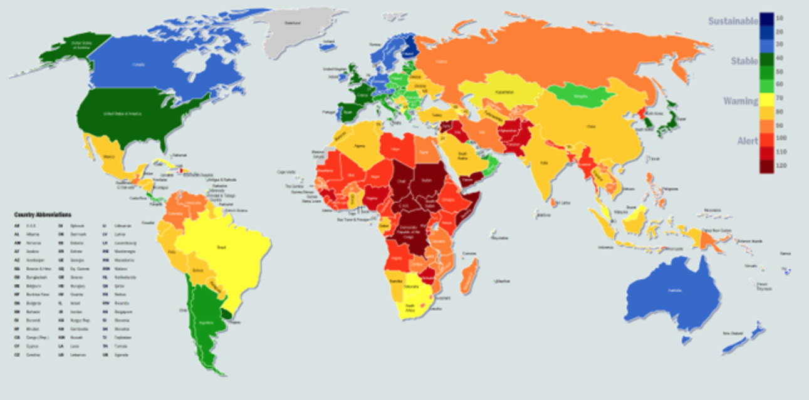

**Venkata Naga Akash Ungarala 800902992**

**Tejaswi Dumpala 800902462**

**Lavanya Ayila 800960067**

**Harini Vasudevan 800917793**

**Dataset**

Data for the years 2011-2014 is collected from the URL: <http://fsi.fundforpeace.org/>

**Tools Used**

Java Compiler

WEKA 3.6 (stable version)

**Data Extraction**

We have used web sources like Wikipedia and annually published global reports to extract values for few new attributes to consolidate with the data set.

**WEKA**

Weka is an open source and popular suite of machine learning workbench that contains a collection of visualization tools and algorithms for data analysis and predictive modeling, together with graphical user interfaces for easy access to this functionality. The original non-Java version of Weka was a TCL/TK front-end to (mostly third-party) modeling algorithms implemented in other programming languages, plus data preprocessing utilities in C, and a Make file-based system for running machine learning experiments. This original version was primarily designed as a tool for analyzing data from agricultural domains but the more recent fully Java-based version (Weka 3), is now used in many different application areas, in particular for educational purposes and research.

Weka supports several standard data mining tasks, more specifically, data preprocessing, clustering, classification, regression, visualization, and feature selection. All of Weka's techniques are predicated on the assumption that the data is available as a single flat file or relation, where each data point is described by a fixed number of attributes (normally, numeric or nominal attributes, but some other attribute types are also supported). Weka provides access to SQL databases using Java Database Connectivity and can process the result returned by a database query. It is not capable of multi-relational data mining, but there is separate software for converting a collection of linked database tables into a single table that is suitable for processing using Weka. Another important area that is currently not covered by the algorithms included in the Weka distribution is sequence modeling.

**Work Flow**

**Extraction of Structured Dataset and Pre-Processing**

* We have extracted data for 178 countries from the web data. The extracted data set is cleaned and refined by replacing undefined values and records having any special characters with 0.
* The final data set contains 178 countries. The first 12 features (Demographic Pressures, Refugees and IDPs, Group Grievance, Human Flight, Uneven Development, Poverty and Economic Decline, Legitimacy of the State, Public Services, Human Rights, Security Apparatus, Factionalized Elites, External Intervention) are mandatory for the project, the other 6 features (Air Quality Index, Happiness Index, Global Warming Index, Global Peace Index, Technology Usage Index, Global Slavery Index) are the additional features added.
* Once the data is clean, it is loaded into WEKA Explorer.

**Year 2011**

**Discretize**

We have Total as the decision feature. In the data set, the total column is sorted. Since we have to split the total into 4 intervals, we can split it as the levels Alert, Warning, Stable and Sustainable. We need to choose the split to get a maximum entropy gain for the decision feature considered.

Alert 38 Warning 83 Stable 33 Sustainable 23

**Entropy Gain for Total**

E(D) = -(((38/177) * log4(38/177)) + ((83/177) * log4(83/177)) + ((33/177) * log4(33/177)) + ((23/177) * log4(23/177)))

E(D) = -(0.214689266*(-1.109839018) + 0.468926554*(-0.546283059) + 0.186440678*(-1.211605715) + 0.129943503*(-1.472021797))

E(D) = 0.911609416

We have calculated the initial entropy and made the split based on the entropy gain of the split. We have chosen the split which has higher Entropy Gain and decided to have the total split into 4 intervals as below

(126.6 … +infinity) (94.1 … 126.6] (61.6 … 94.1] (-infinity … 61.6]

**Classification using WEKA**

Select Total as the decision feature and apply different algorithms to compare the results and choose the algorithm that gives the best number of correctly classified records.

**Visualize all the features**

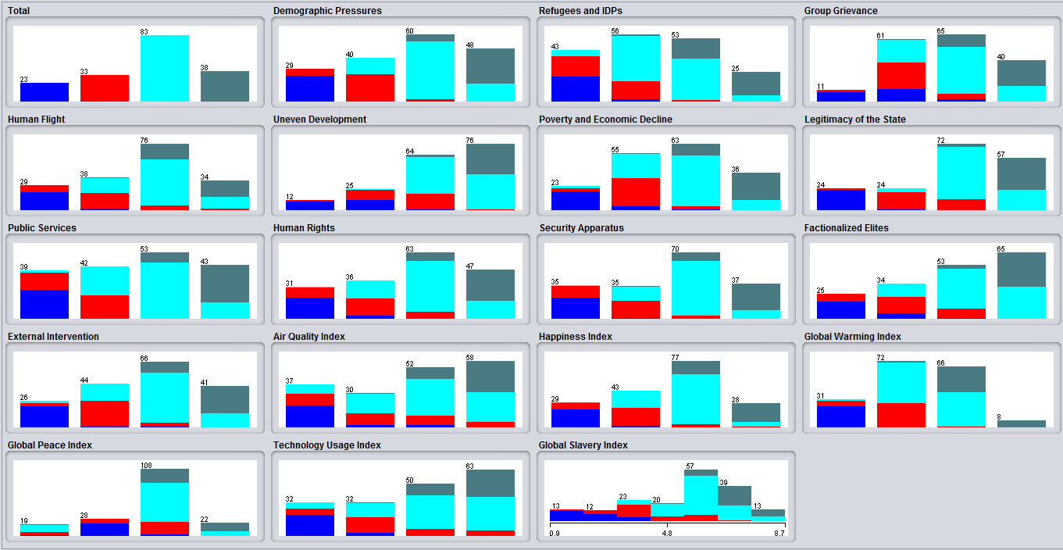

**Bayes - BayesNet Classifier**

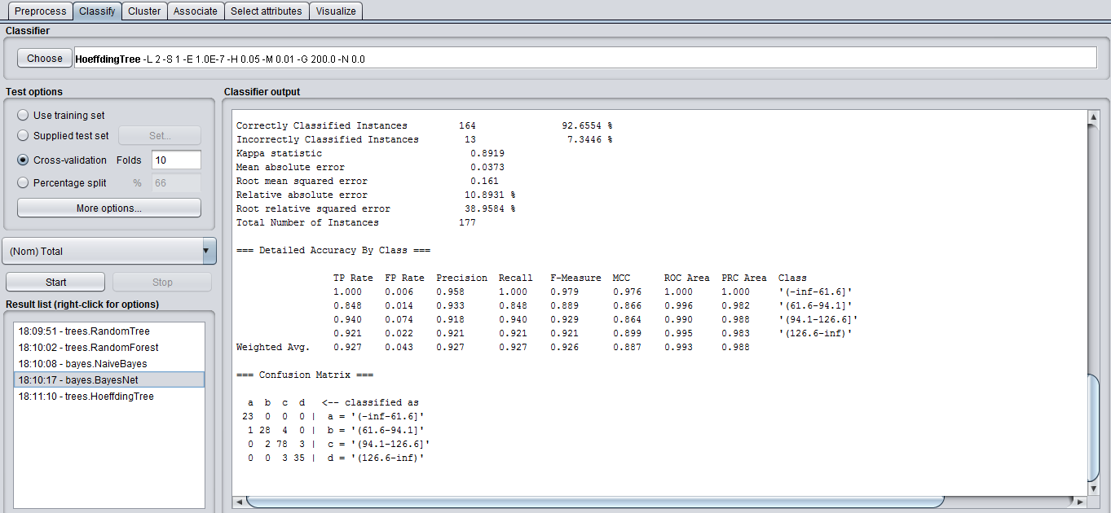

**Classifier Output**

Correctly Classified Instances 164 92.6554 %

Incorrectly Classified Instances 13 7.3446 %

Kappa statistic 0.8919

Mean absolute error 0.0373

Root mean squared error 0.161

Relative absolute error 10.8931 %

Root relative squared error 38.9584 %

Total Number of Instances 177

|  |  |  |  |  |  |  |  |  |
| --- | --- | --- | --- | --- | --- | --- | --- | --- |
| **TP Rate** | **FP Rate** | **Precision** | **Recall** | **F-Measure** | **MCC** | **ROC Area** | **PRC Area** | **Class** |
| 1.000 | 0.006 | 0.958 | 1.000 | 0.979 | 0.976 | 1.000 | 1.000 | '(-inf-61.6]' |
| 0.848 | 0.014 | 0.933 | 0.848 | 0.889 | 0.866 | 0.996 | 0.982 | '(61.6-94.1]' |
| 0.940 | 0.074 | 0.918 | 0.940 | 0.929 | 0.864 | 0.990 | 0.988 | '(94.1-126.6]' |
| 0.921 | 0.022 | 0.921 | 0.921 | 0.921 | 0.899 | 0.995 | 0.983 | '(126.6-inf)' |

Confusion Matrix

a b c d

**Bayes - Naive Bayes Classifier**

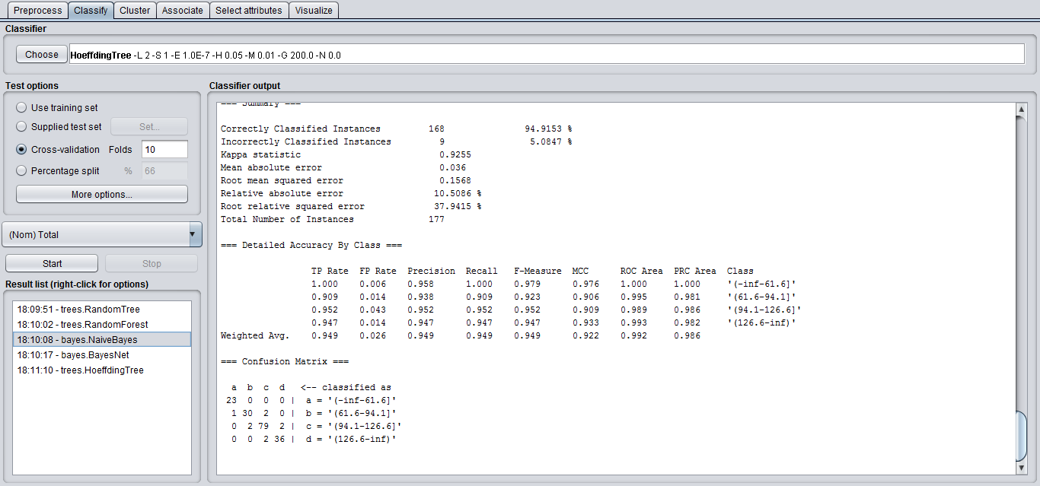

**Classifier Output**

Correctly Classified Instances 168 94.9153 %

Incorrectly Classified Instances 9 5.0847 %

Kappa statistic 0.9255

Mean absolute error 0.036

Root mean squared error 0.1568

Relative absolute error 10.5086 %

Root relative squared error 37.9415 %

Total Number of Instances 177

|  |  |  |  |  |  |  |  |  |
| --- | --- | --- | --- | --- | --- | --- | --- | --- |
| **TP Rate** | **FP Rate** | **Precision** | **Recall** | **F-Measure** | **MCC** | **ROC Area** | **PRC Area** | **Class** |
| 1.000 | 0.006 | 0.958 | 1.000 | 0.979 | 0.976 | 1.000 | 1.000 | '(-inf-61.6]' |
| 0.909 | 0.014 | 0.938 | 0.909 | 0.923 | 0.906 | 0.995 | 0.981 | '(61.6-94.1]' |
| 0.952 | 0.043 | 0.952 | 0.952 | 0.952 | 0.909 | 0.989 | 0.986 | '(94.1-126.6]' |
| 0.947 | 0.014 | 0.947 | 0.947 | 0.947 | 0.933 | 0.993 | 0.982 | '(126.6-inf)' |

Confusion Matrix

a b c d

**Trees - Random Forest Classifier**

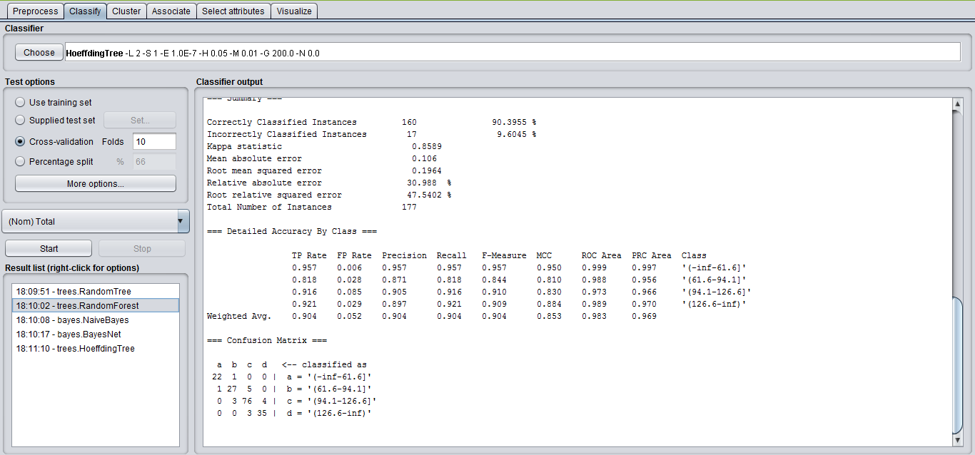

**Classifier Output**

Correctly Classified Instances 160 90.3955 %

Incorrectly Classified Instances 17 9.6045 %

Kappa statistic 0.8589

Mean absolute error 0.106

Root mean squared error 0.1964

Relative absolute error 30.988 %

Root relative squared error 47.5402 %

Total Number of Instances 177

|  |  |  |  |  |  |  |  |  |
| --- | --- | --- | --- | --- | --- | --- | --- | --- |
| **TP Rate** | **FP Rate** | **Precision** | **Recall** | **F-Measure** | **MCC** | **ROC Area** | **PRC Area** | **Class** |
| 0.957 | 0.006 | 0.957 | 0.957 | 0.957 | 0.950 | 0.999 | 0.997 | '(-inf-61.6]' |
| 0.818 | 0.028 | 0.871 | 0.818 | 0.844 | 0.810 | 0.988 | 0.956 | '(61.6-94.1]' |
| 0.916 | 0.085 | 0.905 | 0.916 | 0.910 | 0.830 | 0.973 | 0.966 | '(94.1-126.6]' |
| 0.921 | 0.029 | 0.897 | 0.921 | 0.909 | 0.884 | 0.989 | 0.970 | '(126.6-inf)' |

Confusion Matrix

a b c d

**Trees - Random Tree Classifier**

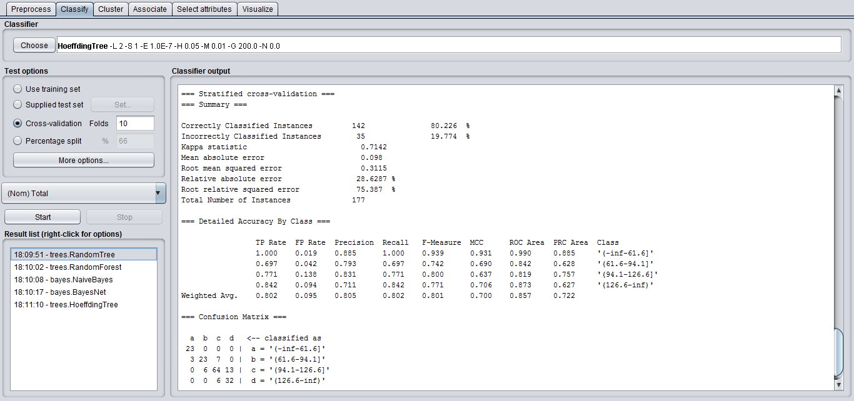

**Classifier Output**

Correctly Classified Instances 142 80.226 %

Incorrectly Classified Instances 35 19.774 %

Kappa statistic 0.7142

Mean absolute error 0.098

Root mean squared error 0.3115

Relative absolute error 18.6287 %

Root relative squared error 75.387 %

Total Number of Instances 177

|  |  |  |  |  |  |  |  |  |
| --- | --- | --- | --- | --- | --- | --- | --- | --- |
| **TP Rate** | **FP Rate** | **Precision** | **Recall** | **F-Measure** | **MCC** | **ROC Area** | **PRC Area** | **Class** |
| 1.000 | 0.019 | 0.885 | 1.000 | 0.939 | 0.931 | 0.990 | 0.885 | '(-inf-61.6]' |
| 0.697 | 0.042 | 0.793 | 0.697 | 0.742 | 0.690 | 0.842 | 0.628 | '(61.6-94.1]' |
| 0.771 | 0.138 | 0.831 | 0.771 | 0.800 | 0.637 | 0.819 | 0.757 | '(94.1-126.6]' |
| 0.842 | 0.094 | 0.711 | 0.842 | 0.771 | 0.706 | 0.873 | 0.627 | '(126.6-inf)' |

Confusion Matrix

a b c d

**Trees – Hoeffding Tree Classifier**

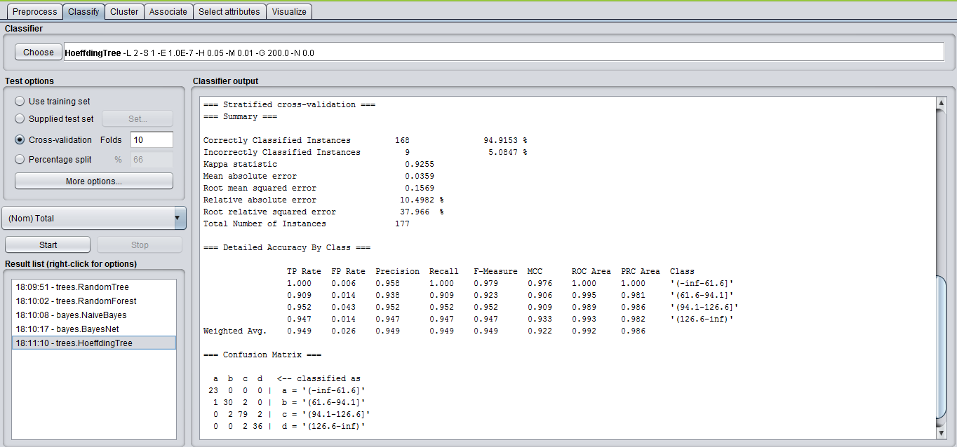

**Classifier Output**

Correctly Classified Instances 168 94.9153 %

Incorrectly Classified Instances 9 5.0847 %

Kappa statistic 0.9255

Mean absolute error 0.0359

Root mean squared error 0.1569

Relative absolute error 10.4982 %

Root relative squared error 37.966 %

Total Number of Instances 177

|  |  |  |  |  |  |  |  |  |
| --- | --- | --- | --- | --- | --- | --- | --- | --- |
| **TP Rate** | **FP Rate** | **Precision** | **Recall** | **F-Measure** | **MCC** | **ROC Area** | **PRC Area** | **Class** |
| 1.000 | 0.006 | 0.958 | 1.000 | 0.979 | 0.976 | 1.000 | 1.000 | '(-inf-61.6]' |
| 0.909 | 0.014 | 0.938 | 0.909 | 0.923 | 0.906 | 0.995 | 0.981 | '(61.6-94.1]' |
| 0.952 | 0.043 | 0.952 | 0.952 | 0.952 | 0.909 | 0.989 | 0.986 | '(94.1-126.6]' |
| 0.947 | 0.014 | 0.947 | 0.947 | 0.947 | 0.933 | 0.993 | 0.982 | '(126.6-inf)' |

Confusion Matrix

a b c d

**Tree Visualizer**

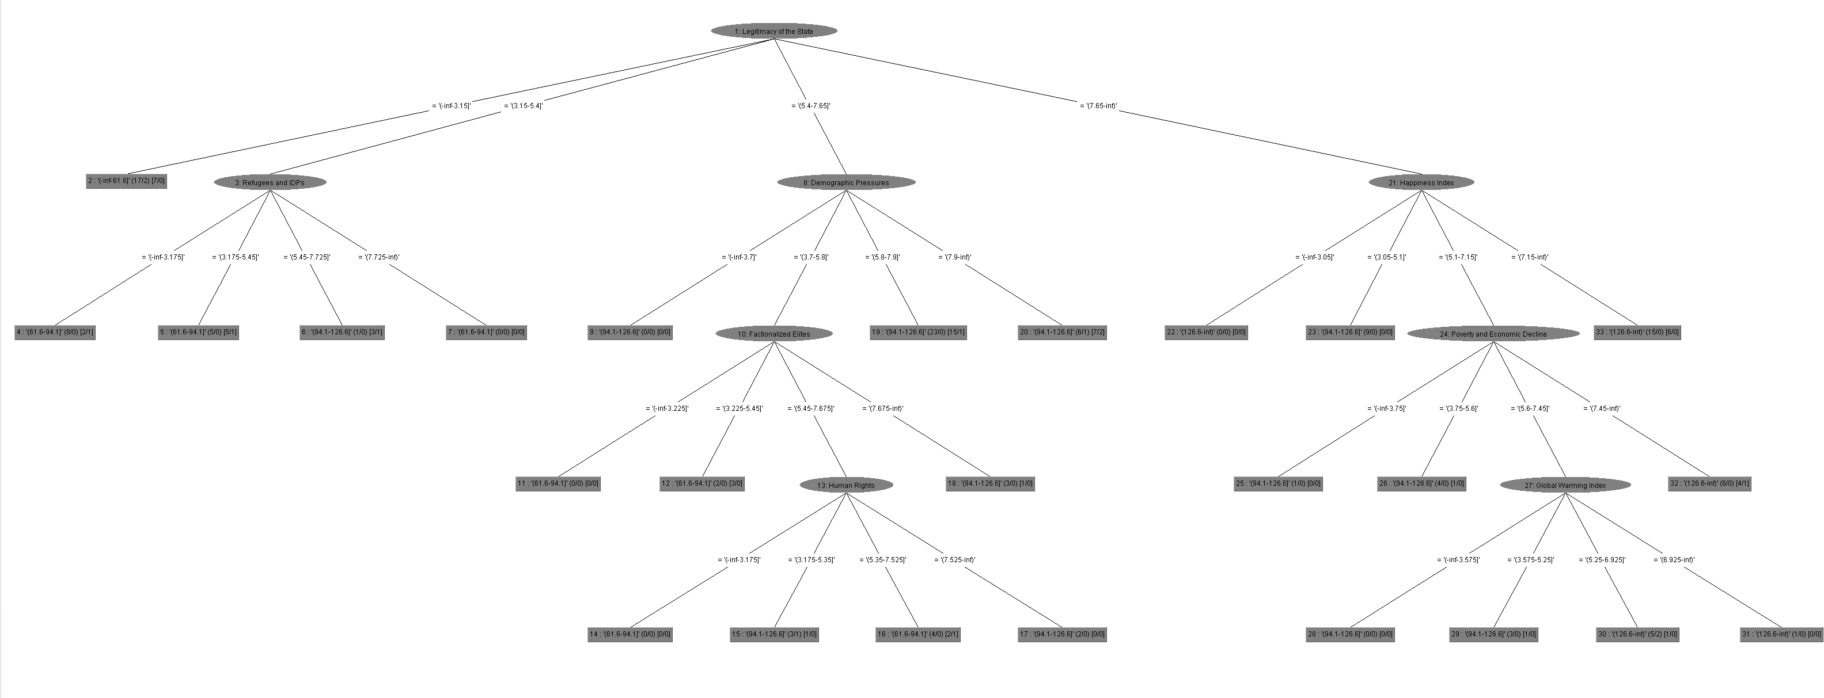

**Comparison of Algorithms and Result**

Since the percentage of correctly classified instances for Bayes Net, Naïve Bayes, Random Forest, Random Tree and Hoeffding Tree algorithms is 92.6554, 94.9153, 90.3955, 80.226 and 94.9153 respectively. This clearly shows that Naïve Bayes and Hoeffding Tree algorithms are best used to classify as it has high accuracy when compared with other algorithms.

**Determining Action Rules**

We have determined the action rules by using Weka by selecting the Rules-PART filter as the classifier and run for the data with total as the decision attribute. The rules are logged in a word document and the result screenshot is shown below.

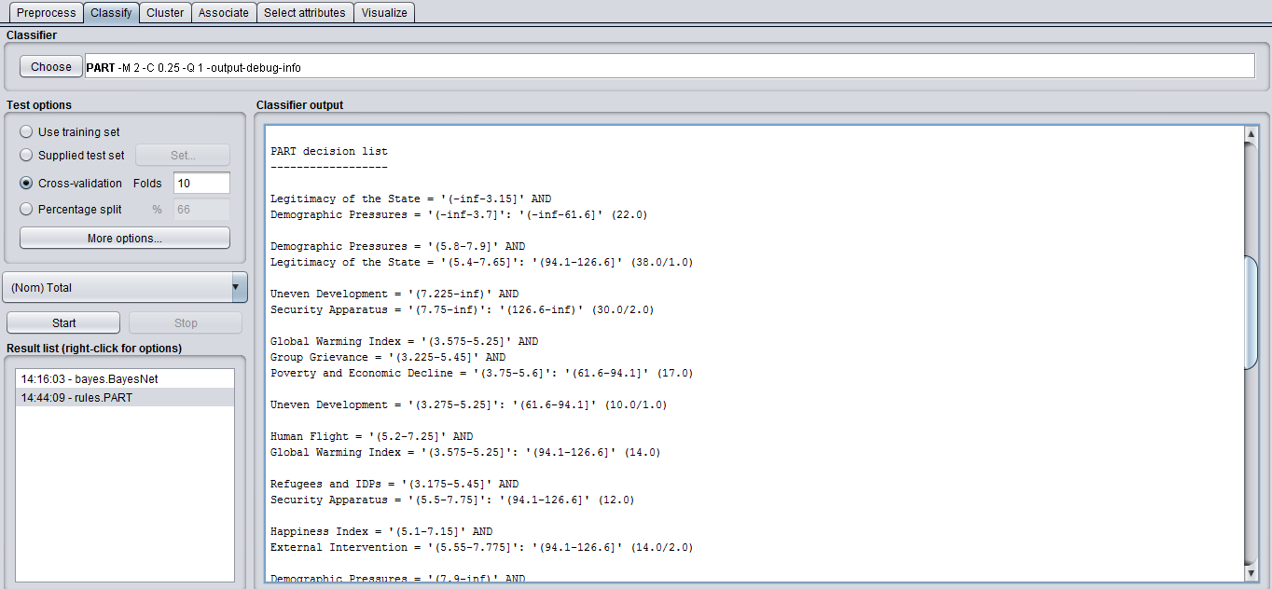

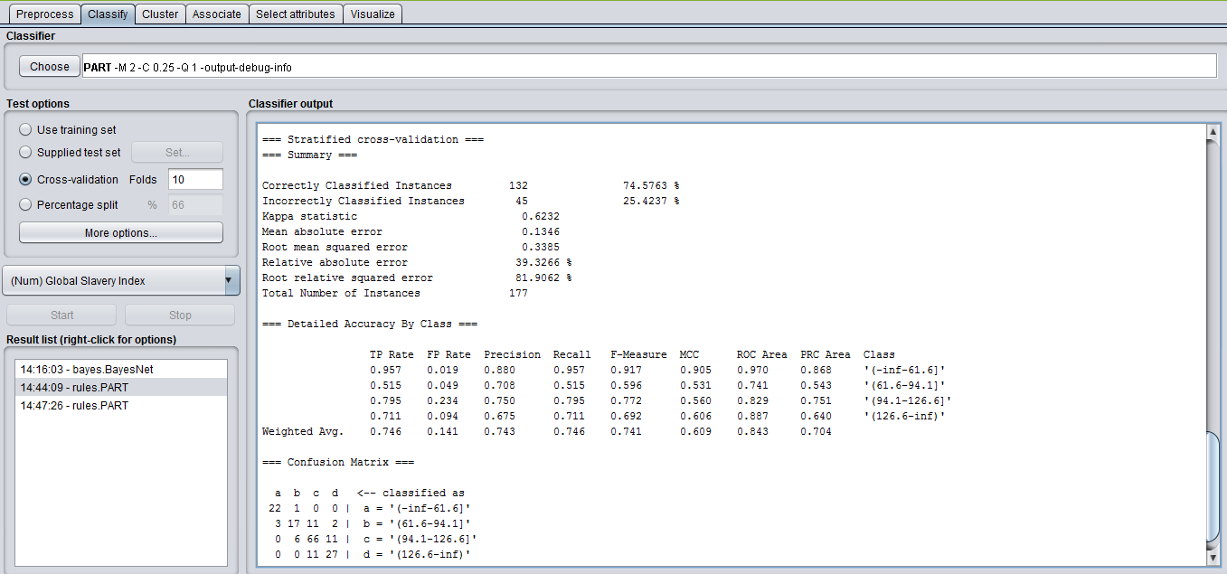

**Year 2012**

**Discretize**

We have Total as the decision feature. In the data set, the total column is sorted. Since we have to split the total into 4 intervals, we can split it as the levels Alert, Warning, Stable and Sustainable. We need to choose the split to get a maximum entropy gain for the decision feature considered.

Alert 33 Warning 80 Stable 41 Sustainable 24

**Entropy Gain for Total**

E(D) = -(((33/178) * log4(33/178)) + ((80/178) * log4(80/178)) + ((41/178) * log4(41/178)) + ((24/178) * log4(24/178)))

E(D) = -(0.185393258*(-1.215669656) + 0.449438202*(-0.576902668) + 0.230337079*(-1.059090713) + 0.134831461*(-1.445385465))

E(D) = 0.923490351

We have calculated the initial entropy and made the split based on the entropy gain of the split. We have chosen the split which has higher Entropy Gain and decided to have the total split into 4 intervals as below

(131.775 … +infinity) (97.65 … 131.775] (63.525 … 97.65] (-infinity … 63.525]

**Classification using WEKA**

Select Total as the decision feature and apply different algorithms to compare the results and choose the algorithm that gives the best number of correctly classified records.

**Visualize all the features**

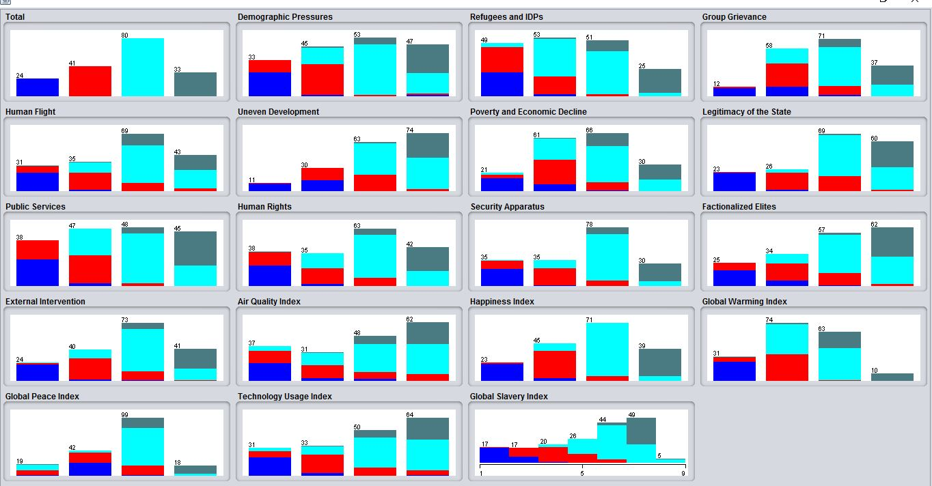

**Bayes - BayesNet Classifier**

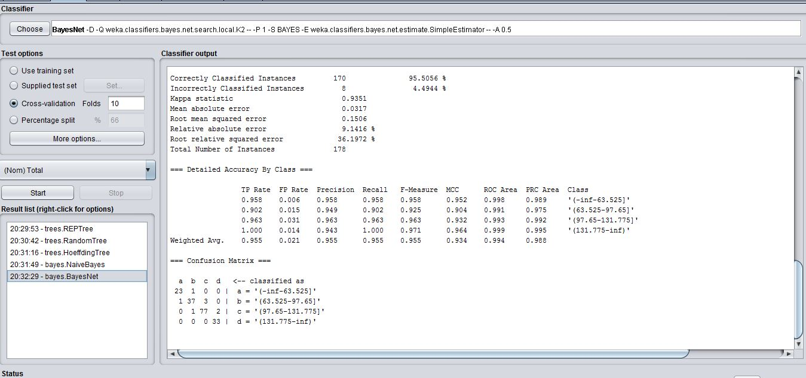

**Classifier Output**

Correctly Classified Instances 170 95.5056 %

Incorrectly Classified Instances 8 4.4944 %

Kappa statistic 0.9351

Mean absolute error 0.0317

Root mean squared error 0.1506

Relative absolute error 9.1416 %

Root relative squared error 36.1972 %

Total Number of Instances 178

|  |  |  |  |  |  |  |  |  |
| --- | --- | --- | --- | --- | --- | --- | --- | --- |
| **TP Rate** | **FP Rate** | **Precision** | **Recall** | **F-Measure** | **MCC** | **ROC Area** | **PRC Area** | **Class** |
| 0.958 | 0.006 | 0.958 | 0.958 | 0.958 | 0.952 | 0.998 | 0.989 | '(-inf-63.525]' |
| 0.902 | 0.015 | 0.949 | 0.902 | 0.925 | 0.904 | 0.991 | 0.975 | '(63.525-97.65]' |
| 0.963 | 0.031 | 0.963 | 0.963 | 0.963 | 0.932 | 0.993 | 0.992 | '(97.65-131.775]' |
| 1.000 | 0.014 | 0.943 | 1.000 | 0.971 | 0.964 | 0.999 | 0.995 | '(131.775-inf)' |

Confusion Matrix

a b c d

**Bayes - Naive Bayes Classifier**

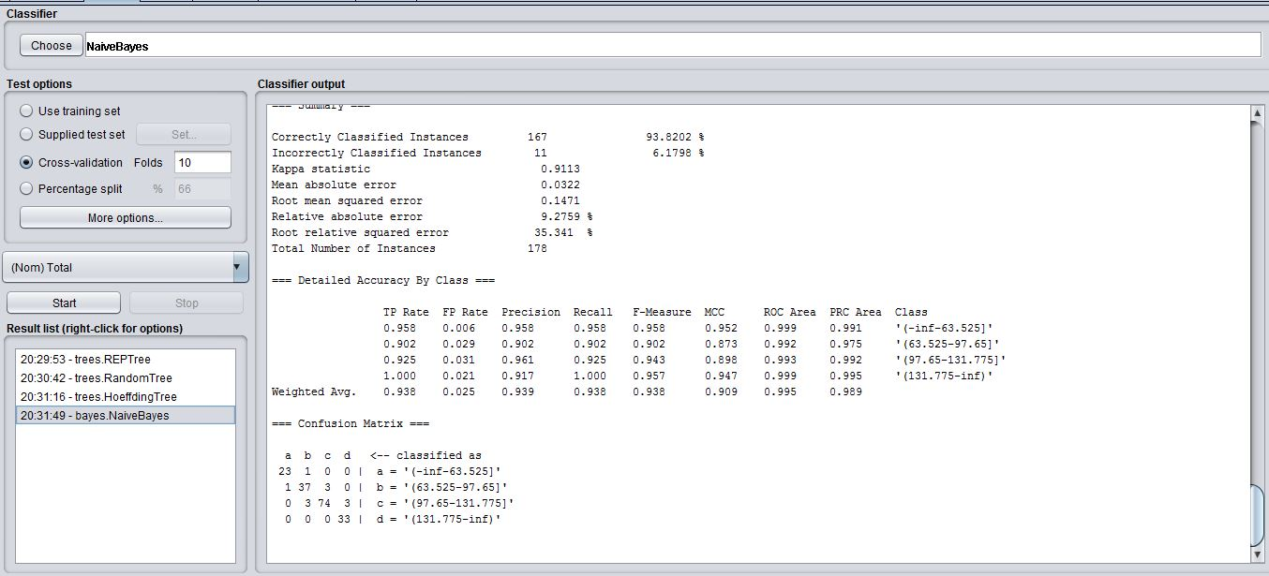

**Classifier Output**

Correctly Classified Instances 167 93.8202 %

Incorrectly Classified Instances 11 6.1798 %

Kappa statistic 0.9113

Mean absolute error 0.0322

Root mean squared error 0.1471

Relative absolute error 9.2759 %

Root relative squared error 35.341 %

Total Number of Instances 178

|  |  |  |  |  |  |  |  |  |
| --- | --- | --- | --- | --- | --- | --- | --- | --- |
| **TP Rate** | **FP Rate** | **Precision** | **Recall** | **F-Measure** | **MCC** | **ROC Area** | **PRC Area** | **Class** |
| 0.958 | 0.006 | 0.958 | 0.958 | 0.958 | 0.952 | 0.999 | 0.991 | '(-inf-63.525]' |
| 0.902 | 0.029 | 0.902 | 0.902 | 0.902 | 0.873 | 0.992 | 0.975 | '(63.525-97.65]' |
| 0.925 | 0.031 | 0.961 | 0.925 | 0.943 | 0.898 | 0.993 | 0.992 | '(97.65-131.775]' |
| 1.000 | 0.021 | 0.917 | 1.000 | 0.957 | 0.947 | 0.999 | 0.995 | '(131.775-inf)' |

Confusion Matrix

a b c d

**Trees – Random Tree Classifier**

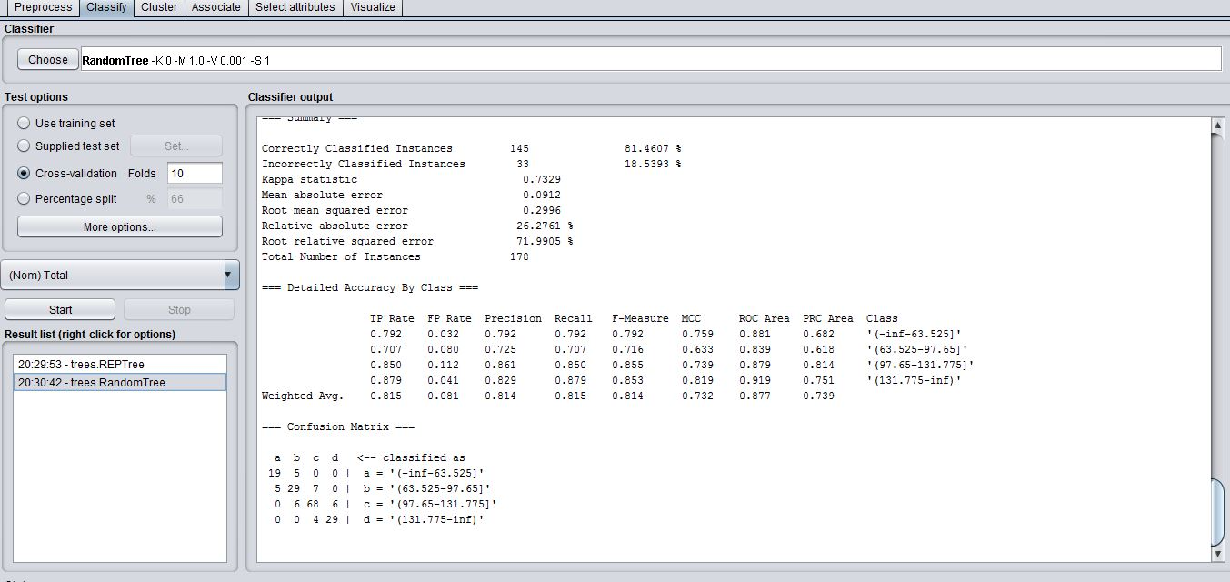

**Classifier Output**

Correctly Classified Instances 145 81.4607 %

Incorrectly Classified Instances 33 18.5393 %

Kappa statistic 0.7329

Mean absolute error 0.0912

Root mean squared error 0.2996

Relative absolute error 26.2761 %

Root relative squared error 71.9905 %

Total Number of Instances 178

|  |  |  |  |  |  |  |  |  |
| --- | --- | --- | --- | --- | --- | --- | --- | --- |
| **TP Rate** | **FP Rate** | **Precision** | **Recall** | **F-Measure** | **MCC** | **ROC Area** | **PRC Area** | **Class** |
| 0.792 | 0.032 | 0.792 | 0.792 | 0.792 | 0.759 | 0.881 | 0.682 | '(-inf-63.525]' |
| 0.707 | 0.080 | 0.725 | 0.707 | 0.716 | 0.633 | 0.839 | 0.618 | '(63.525-97.65]' |
| 0.850 | 0.112 | 0.861 | 0.850 | 0.855 | 0.739 | 0.879 | 0.814 | '(97.65-131.775]' |
| 0.879 | 0.041 | 0.829 | 0.879 | 0.853 | 0.819 | 0.919 | 0.751 | '(131.775-inf)' |

Confusion Matrix

a b c d

**Trees – REP Tree Classifier**

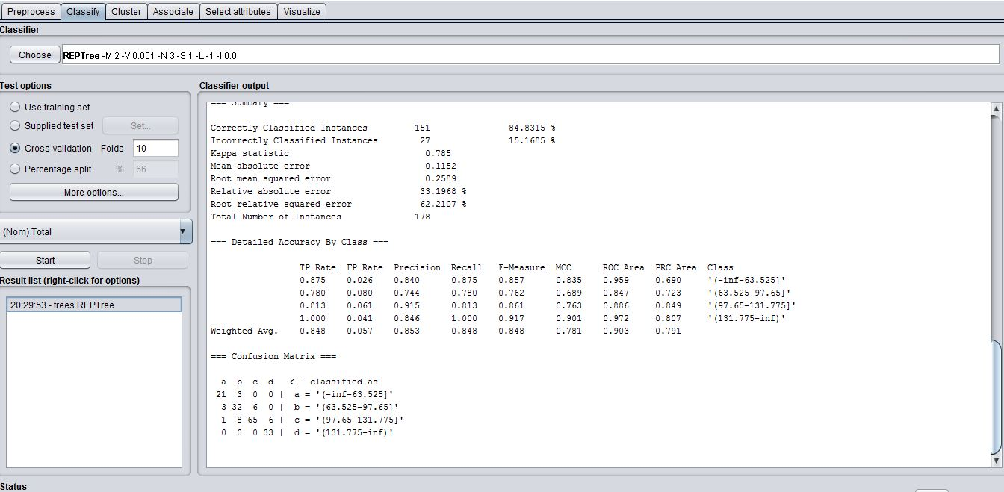

**Classifier Output**

Correctly Classified Instances 151 84.8315 %

Incorrectly Classified Instances 27 15.1685 %

Kappa statistic 0.785

Mean absolute error 0.1152

Root mean squared error 0.2589

Relative absolute error 33.1968 %

Root relative squared error 62.2107 %

Total Number of Instances 178

|  |  |  |  |  |  |  |  |  |
| --- | --- | --- | --- | --- | --- | --- | --- | --- |
| **TP Rate** | **FP Rate** | **Precision** | **Recall** | **F-Measure** | **MCC** | **ROC Area** | **PRC Area** | **Class** |
| 0.875 | 0.026 | 0.840 | 0.875 | 0.857 | 0.835 | 0.959 | 0.690 | '(-inf-63.525]' |
| 0.780 | 0.080 | 0.744 | 0.780 | 0.762 | 0.689 | 0.847 | 0.723 | '(63.525-97.65]' |
| 0.813 | 0.061 | 0.915 | 0.813 | 0.861 | 0.763 | 0.886 | 0.849 | '(97.65-131.775]' |
| 1.000 | 0.041 | 0.846 | 1.000 | 0.917 | 0.901 | 0.972 | 0.807 | '(131.775-inf)' |

Confusion Matrix

a b c d

**Trees – Hoeffding Tree Classifier**

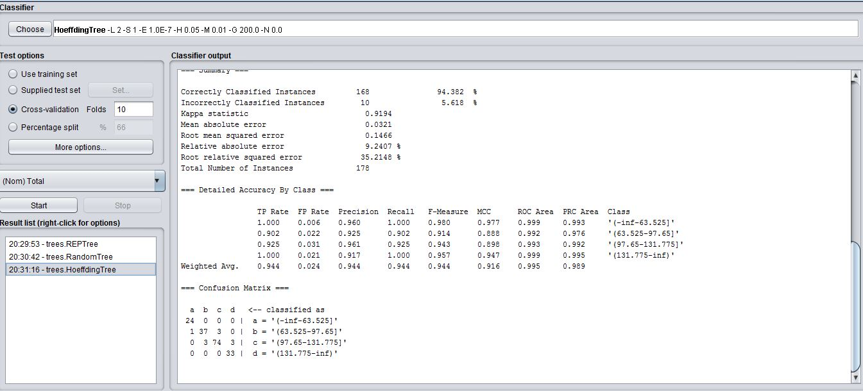

**Classifier Output**

Correctly Classified Instances 168 94.382 %

Incorrectly Classified Instances 10 5.618 %

Kappa statistic 0.9194

Mean absolute error 0.0321

Root mean squared error 0.1466

Relative absolute error 9.2407 %

Root relative squared error 35.2148 %

Total Number of Instances 178

|  |  |  |  |  |  |  |  |  |
| --- | --- | --- | --- | --- | --- | --- | --- | --- |
| **TP Rate** | **FP Rate** | **Precision** | **Recall** | **F-Measure** | **MCC** | **ROC Area** | **PRC Area** | **Class** |
| 1.000 | 0.006 | 0.960 | 1.000 | 0.980 | 0.977 | 0.999 | 0.993 | '(-inf-63.525]' |
| 0.902 | 0.022 | 0.925 | 0.902 | 0.914 | 0.888 | 0.992 | 0.976 | '(63.525-97.65]' |
| 0.925 | 0.031 | 0.961 | 0.925 | 0.943 | 0.898 | 0.993 | 0.992 | '(97.65-131.775]' |
| 1.000 | 0.021 | 0.917 | 1.000 | 0.957 | 0.947 | 0.999 | 0.995 | '(131.775-inf)' |

Confusion Matrix

a b c d

**Comparison of Algorithms and Result**

Since the percentage of correctly classified instances for Bayes Net, Naïve Bayes, Random Tree, REP Tree and Hoeffding Tree algorithms is 95.5056, 93.8202, 81.4607, 84.8315 and 94.382 respectively. This clearly shows that Bayes Net algorithm is best used to classify as it has high accuracy when compared with other algorithms.

**Determining Action Rules**

We have determined the action rules by using Weka by selecting the Rules-PART filter as the classifier and run for the data with total as the decision attribute. The rules are logged in a word document and the result screenshot is shown below.

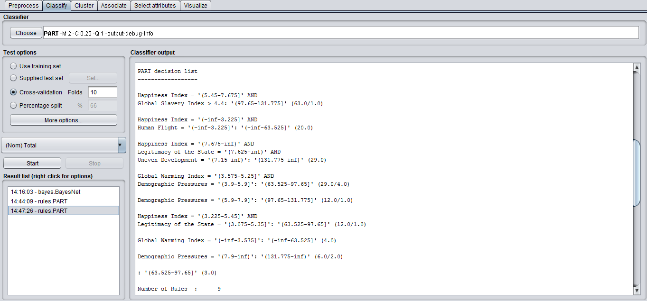

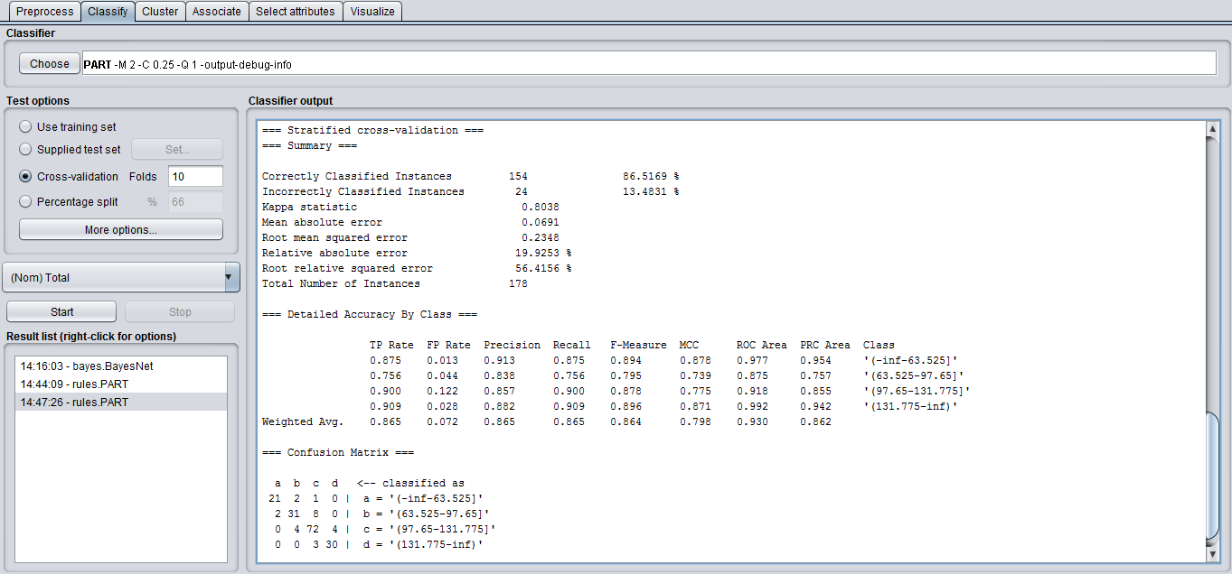

**Year 2013**

**Discretize**

We have Total as the decision feature. In the data set, the total column is sorted. Since we have to split the total into 4 intervals, we can split it as the levels Alert, Warning, Stable and Sustainable. We need to choose the split to get a maximum entropy gain for the decision feature considered.

Alert 35 Warning 78 Stable 42 Sustainable 23

**Entropy Gain for Total**

E(D) = -(((35/178) * log4(35/178)) + ((78/178) * log4(78/178)) + ((42/178) * log4(42/178)) + ((23/178) * log4(23/178)))

E(D) = -(0.196629213*(-1.173225207) + 0.438202247*(-0.595165606) + 0.235955056*(-1.041708004) + 0.129213483*(-1.476085737))

E(D) = 0.928019706

We have calculated the initial entropy and made the split based on the entropy gain of the split. We have chosen the split which has higher Entropy Gain and decided to have the total split into 4 intervals as below

(129.825 … +infinity) (95.65 … 129.825] (61.475 … 95.65] (-infinity … 61.475]

**Classification using WEKA**

Select Total as the decision feature and apply different algorithms to compare the results and choose the algorithm that gives the best number of correctly classified records.

**Visualize all the features**

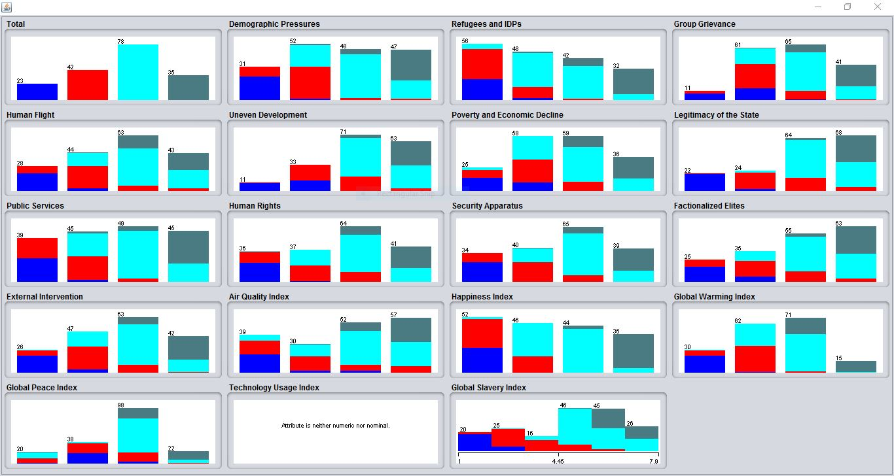

**Bayes – BayesNet Classifier**

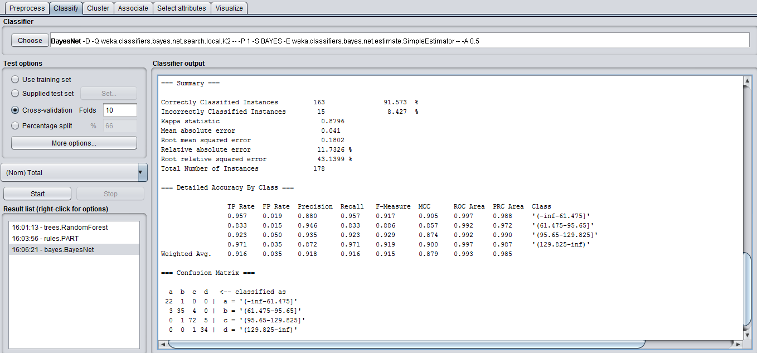

**Classifier Output**

Correctly Classified Instances 163 91.573 %

Incorrectly Classified Instances 15 8.427 %

Kappa statistic 0.8796

Mean absolute error 0.041

Root mean squared error 0.1802

Relative absolute error 11.7326 %

Root relative squared error 43.1399 %

Total Number of Instances 178

|  |  |  |  |  |  |  |  |  |
| --- | --- | --- | --- | --- | --- | --- | --- | --- |
| **TP Rate** | **FP Rate** | **Precision** | **Recall** | **F-Measure** | **MCC** | **ROC Area** | **PRC Area** | **Class** |
| 0.957 | 0.019 | 0.880 | 0.957 | 0.917 | 0.905 | 0.997 | 0.988 | '(-inf-61.475]' |
| 0.833 | 0.015 | 0.946 | 0.833 | 0.886 | 0.857 | 0.992 | 0.972 | '(61.475-95.65]' |
| 0.923 | 0.050 | 0.935 | 0.923 | 0.929 | 0.874 | 0.992 | 0.990 | '(95.65-129.825]' |
| 0.971 | 0.035 | 0.872 | 0.971 | 0.919 | 0.900 | 0.997 | 0.987 | '(129.825-inf)' |

Confusion Matrix

a b c d

**Bayes – Naive Bayes Classifier**

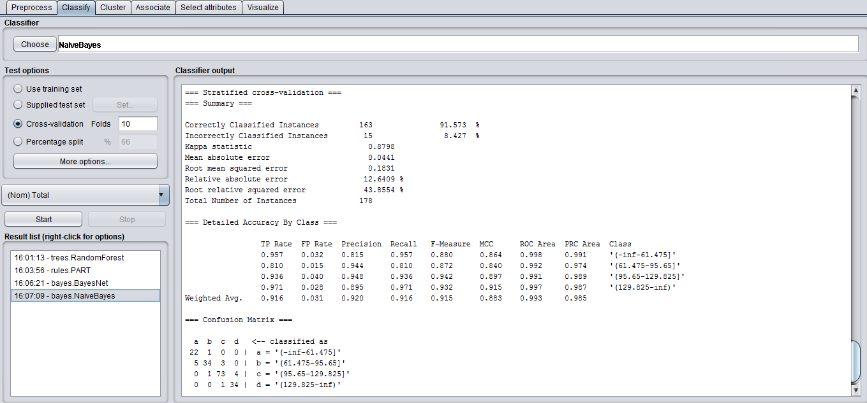

**Classifier Output**

Correctly Classified Instances 163 91.573 %

Incorrectly Classified Instances 15 8.427 %

Kappa statistic 0.8798

Mean absolute error 0.0441

Root mean squared error 0.1831

Relative absolute error 12.6409 %

Root relative squared error 43.8554 %

Total Number of Instances 178

|  |  |  |  |  |  |  |  |  |
| --- | --- | --- | --- | --- | --- | --- | --- | --- |
| **TP Rate** | **FP Rate** | **Precision** | **Recall** | **F-Measure** | **MCC** | **ROC Area** | **PRC Area** | **Class** |
| 0.957 | 0.032 | 0.815 | 0.957 | 0.880 | 0.864 | 0.998 | 0.991 | '(-inf-61.475]' |
| 0.810 | 0.015 | 0.944 | 0.810 | 0.872 | 0.840 | 0.992 | 0.974 | '(61.475-95.65]' |
| 0.936 | 0.040 | 0.948 | 0.936 | 0.942 | 0.897 | 0.991 | 0.989 | '(95.65-129.825]' |
| 0.971 | 0.028 | 0.895 | 0.971 | 0.932 | 0.915 | 0.997 | 0.987 | '(129.825-inf)' |

Confusion Matrix

a b c d

**Trees – Random Tree Classifier**

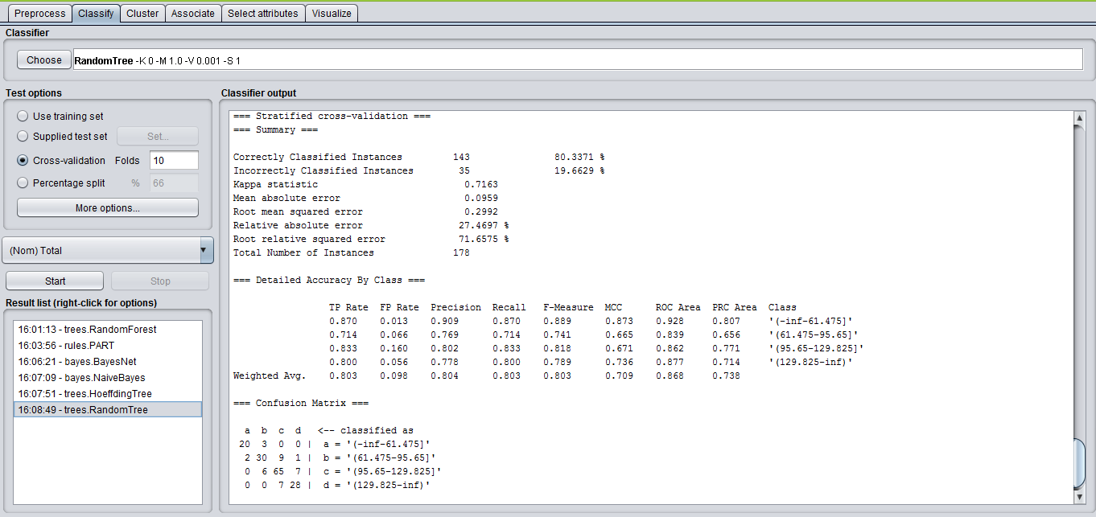

**Classifier Output**

Correctly Classified Instances 143 80.3371 %

Incorrectly Classified Instances 35 19.6629 %

Kappa statistic 0.7163

Mean absolute error 0.0959

Root mean squared error 0.2992

Relative absolute error 27.4697 %

Root relative squared error 71.6575 %

Total Number of Instances 178

|  |  |  |  |  |  |  |  |  |
| --- | --- | --- | --- | --- | --- | --- | --- | --- |
| **TP Rate** | **FP Rate** | **Precision** | **Recall** | **F-Measure** | **MCC** | **ROC Area** | **PRC Area** | **Class** |
| 0.870 | 0.013 | 0.909 | 0.870 | 0.889 | 0.873 | 0.928 | 0.807 | '(-inf-61.475]' |
| 0.714 | 0.066 | 0.769 | 0.714 | 0.741 | 0.665 | 0.839 | 0.656 | '(61.475-95.65]' |
| 0.833 | 0.160 | 0.802 | 0.833 | 0.818 | 0.671 | 0.862 | 0.771 | '(95.65-129.825]' |
| 0.800 | 0.056 | 0.778 | 0.800 | 0.789 | 0.736 | 0.877 | 0.714 | '(129.825-inf)' |

Confusion Matrix

a b c d

**Trees – Random Forest Classifier**

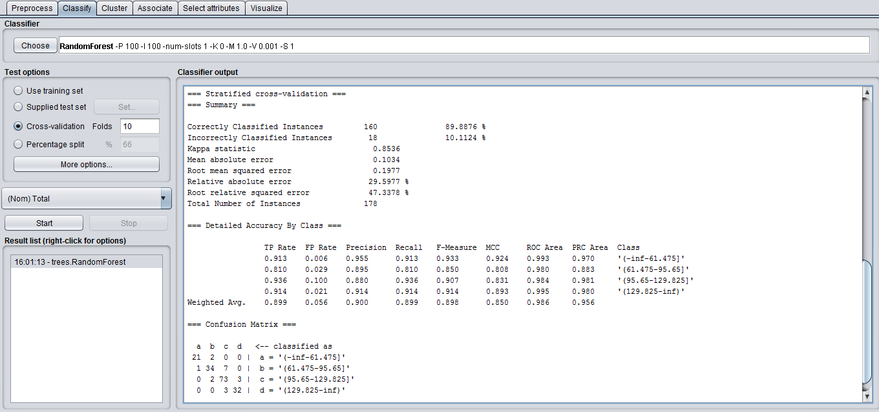

**Classifier Output**

Correctly Classified Instances 160 89.8876 %

Incorrectly Classified Instances 18 10.1124 %

Kappa statistic 0.8536

Mean absolute error 0.1034

Root mean squared error 0.1977

Relative absolute error 29.5977 %

Root relative squared error 47.3378 %

Total Number of Instances 178

|  |  |  |  |  |  |  |  |  |
| --- | --- | --- | --- | --- | --- | --- | --- | --- |
| **TP Rate** | **FP Rate** | **Precision** | **Recall** | **F-Measure** | **MCC** | **ROC Area** | **PRC Area** | **Class** |
| 0.913 | 0.006 | 0.955 | 0.913 | 0.933 | 0.924 | 0.993 | 0.970 | '(-inf-61.475]' |
| 0.810 | 0.029 | 0.895 | 0.810 | 0.850 | 0.808 | 0.980 | 0.883 | '(61.475-95.65]' |
| 0.936 | 0.100 | 0.880 | 0.936 | 0.907 | 0.831 | 0.984 | 0.981 | '(95.65-129.825]' |
| 0.914 | 0.021 | 0.914 | 0.914 | 0.914 | 0.893 | 0.995 | 0.980 | '(129.825-inf)' |

Confusion Matrix

a b c d

**Trees – Hoeffding Tree Classifier**

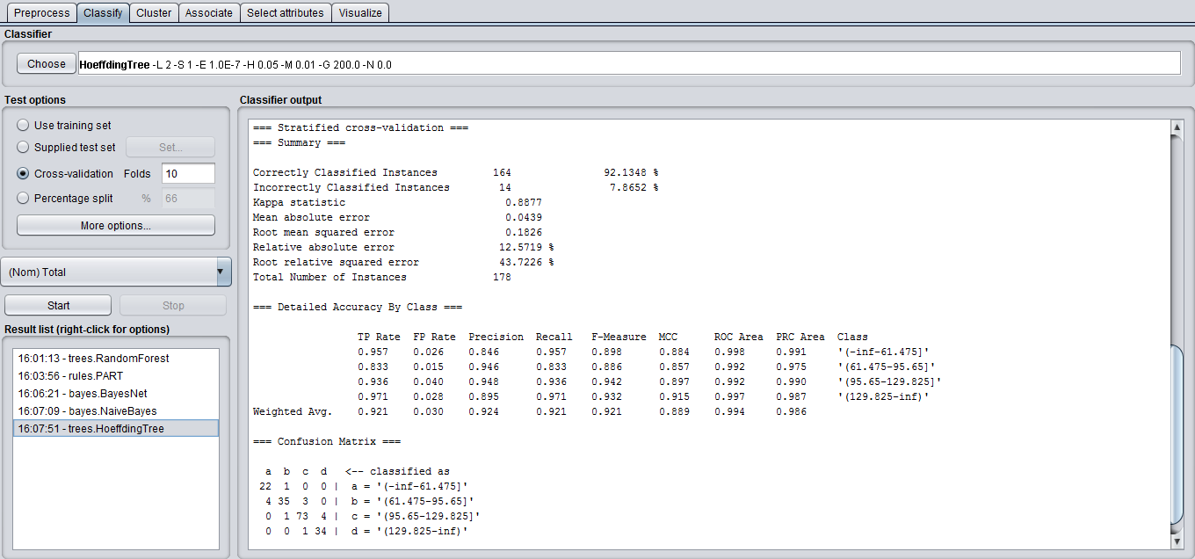

**Classifier Output**

Correctly Classified Instances 164 92.1348 %

Incorrectly Classified Instances 14 7.8652 %

Kappa statistic 0.8877

Mean absolute error 0.0439

Root mean squared error 0.1826

Relative absolute error 12.5719 %

Root relative squared error 43.7226 %

Total Number of Instances 178

|  |  |  |  |  |  |  |  |  |
| --- | --- | --- | --- | --- | --- | --- | --- | --- |
| **TP Rate** | **FP Rate** | **Precision** | **Recall** | **F-Measure** | **MCC** | **ROC Area** | **PRC Area** | **Class** |
| 0.957 | 0.026 | 0.846 | 0.957 | 0.898 | 0.884 | 0.998 | 0.991 | '(-inf-61.475]' |
| 0.833 | 0.015 | 0.946 | 0.833 | 0.886 | 0.857 | 0.992 | 0.975 | '(61.475-95.65]' |
| 0.936 | 0.040 | 0.948 | 0.936 | 0.942 | 0.897 | 0.992 | 0.990 | '(95.65-129.825]' |
| 0.971 | 0.028 | 0.895 | 0.971 | 0.932 | 0.915 | 0.997 | 0.987 | '(129.825-inf)' |

Confusion Matrix

a b c d

**Comparison of Algorithms and Result**

Since the percentage of correctly classified instances for Bayes Net, Naïve Bayes, Random Tree, Random Forest and Hoeffding Tree algorithms is 91.573, 91.573, 80.3371, 89.8876, 92.1348 respectively. This clearly shows that Hoeffding Tree algorithm is best used to classify as it has high accuracy when compared with other algorithms.

**Determining Action Rules**

We have determined the action rules by using Weka by selecting the Rules-PART filter as the classifier and run for the data with total as the decision attribute. The rules are logged in a word document and the result screenshot is shown below.

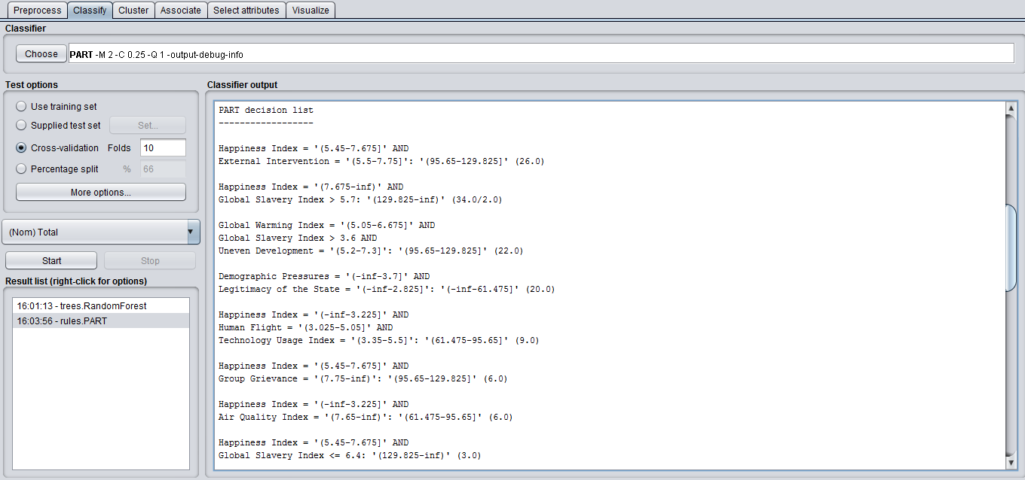

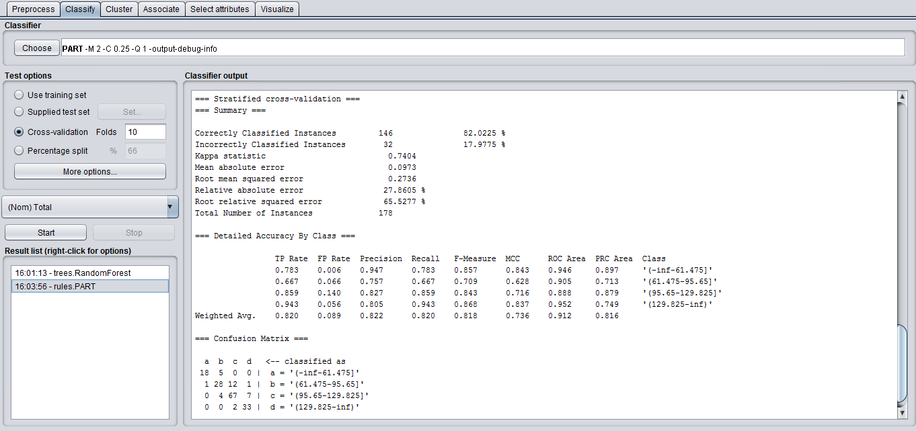

**Year 2014**

**Discretize**

We have Total as the decision feature. In the data set, the total column is sorted. Since we have to split the total into 4 intervals, we can split it as the levels Alert, Warning, Stable and Sustainable. We need to choose the split to get a maximum entropy gain for the decision feature considered.

Alert 36 Warning 79 Stable 38 Sustainable 25

**Entropy Gain for Total**

E(D) = -(((36/178) * log4(36/178)) + ((79/178) * log4(79/178)) + ((38/178) * log4(38/178)) + ((25/178) * log4(25/178)))

E(D) = -(0.202247191*(-1.152904215) + 0.443820225*(-0.585976341) + 0.213483146*(-1.113902959) + 0.140449438*(-1.415938621))

E(D) = 0.929907082

We have calculated the initial entropy and made the split based on the entropy gain of the split. We have chosen the split which has higher Entropy Gain and decided to have the total split into 4 intervals as below

(129.3 … +infinity) (95.6 … 129.3] (61.9 … 95.6] (-infinity … 61.9]

**Classification using WEKA**

Select Total as the decision feature and apply different algorithms to compare the results and choose the algorithm that gives the best number of correctly classified records.

**Visualize all the features**

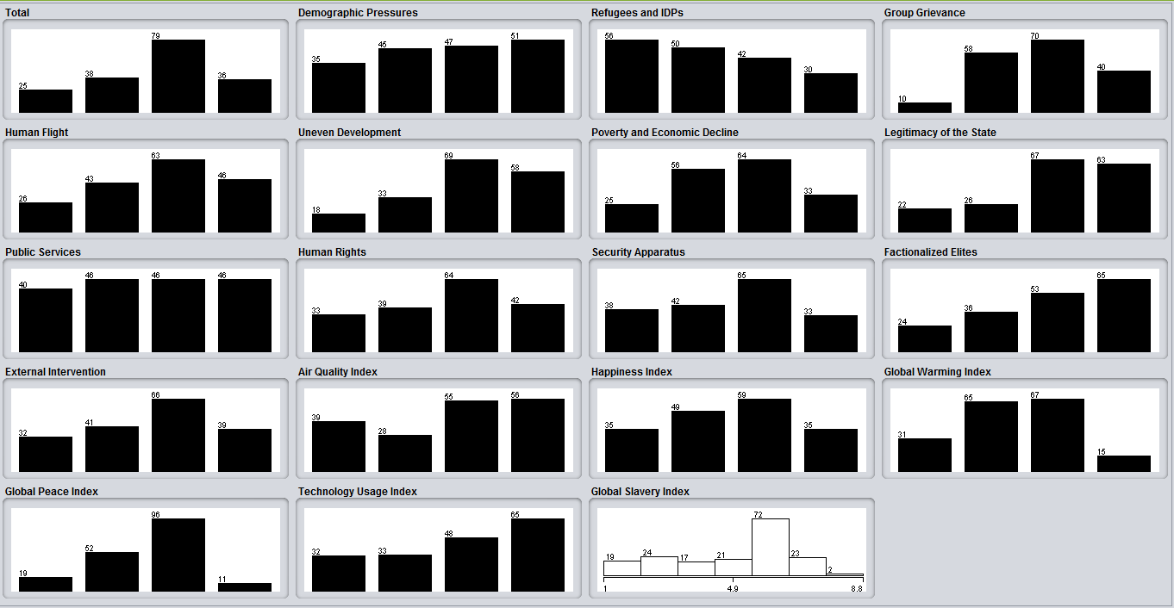

**Bayes - BayesNet Classifier**

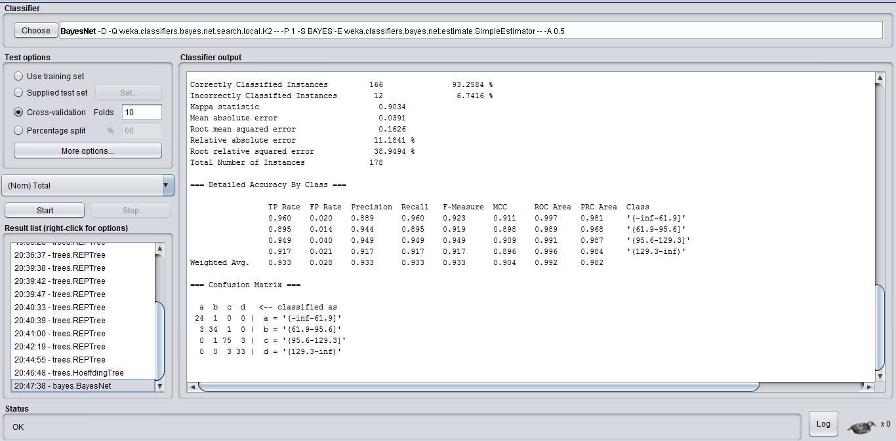

**Classifier Output**

Correctly Classified Instances 166 93.2548 %

Incorrectly Classified Instances 12 6.7416 %

Kappa statistic 0.9034

Mean absolute error 0.0391

Root mean squared error 0.1626

Relative absolute error 11.1841 %

Root relative squared error 38.9494 %

Total Number of Instances 178

|  |  |  |  |  |  |  |  |  |
| --- | --- | --- | --- | --- | --- | --- | --- | --- |
| **TP Rate** | **FP Rate** | **Precision** | **Recall** | **F-Measure** | **MCC** | **ROC Area** | **PRC Area** | **Class** |
| 0.960 | 0.020 | 0.889 | 0.960 | 0.923 | 0.911 | 0.997 | 0.981 | '(-inf-61.9]' |
| 0.895 | 0.014 | 0.944 | 0.895 | 0.919 | 0.898 | 0.989 | 0.968 | '(61.9-95.6]' |
| 0.949 | 0.040 | 0.949 | 0.949 | 0.949 | 0.909 | 0.991 | 0.987 | '(95.6-129.3]' |
| 0.917 | 0.021 | 0.917 | 0.917 | 0.917 | 0.896 | 0.996 | 0.984 | '(129.3-inf)' |

Confusion Matrix

a b c d

**Bayes - Naive Bayes Classifier**

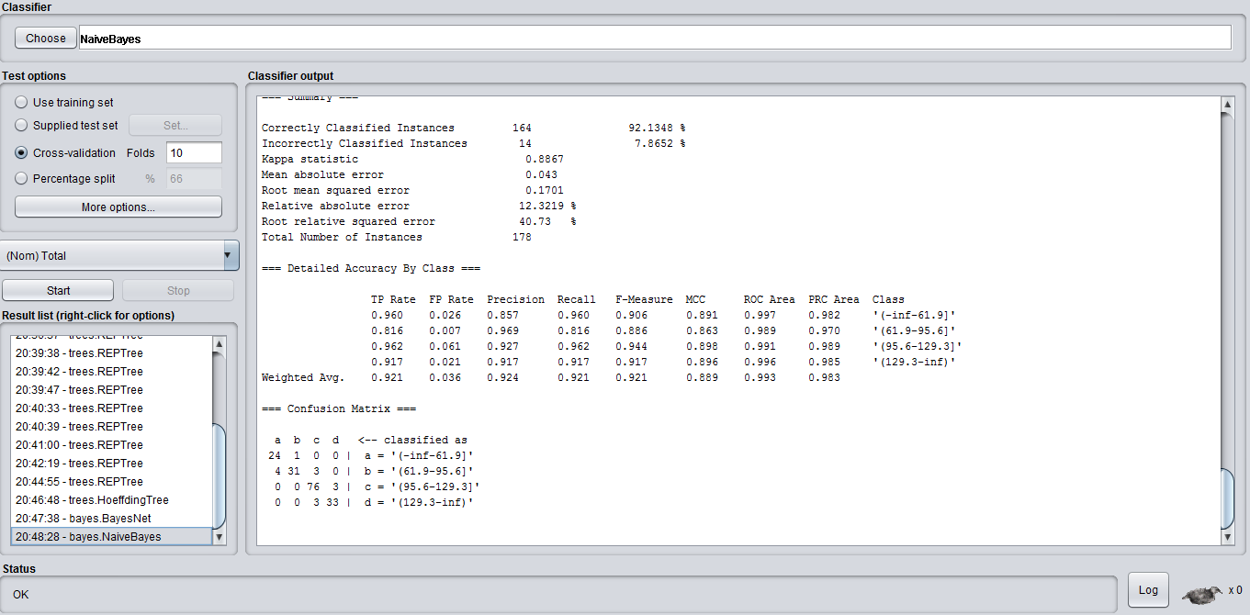

**Classifier Output**

Correctly Classified Instances 164 92.1348 %

Incorrectly Classified Instances 14 7.8652 %

Kappa statistic 0.8867

Mean absolute error 0.043

Root mean squared error 0.1701

Relative absolute error 12.3219 %

Root relative squared error 40.73 %

Total Number of Instances 178

|  |  |  |  |  |  |  |  |  |
| --- | --- | --- | --- | --- | --- | --- | --- | --- |
| **TP Rate** | **FP Rate** | **Precision** | **Recall** | **F-Measure** | **MCC** | **ROC Area** | **PRC Area** | **Class** |
| 0.960 | 0.026 | 0.857 | 0.958 | 0.960 | 0.891 | 0.997 | 0.982 | '(-inf-61.9]' |
| 0.816 | 0.007 | 0.969 | 0.902 | 0.886 | 0.863 | 0.989 | 0.970 | '(61.9-95.6]' |
| 0.962 | 0.061 | 0.927 | 0.963 | 0.944 | 0.898 | 0.993 | 0.989 | '(95.6-129.3]' |
| 0.917 | 0.021 | 0.917 | 1.000 | 0.917 | 0.896 | 0.999 | 0.985 | '(129.3-inf)' |

Confusion Matrix

a b c d

**Trees – Random Tree Classifier**

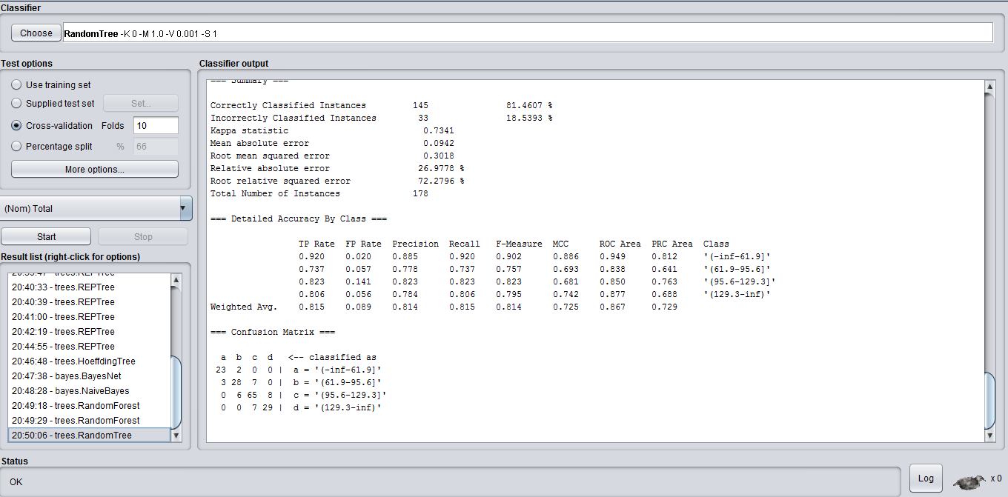

**Classifier Output**

Correctly Classified Instances 145 81.4607 %

Incorrectly Classified Instances 33 18.5393 %

Kappa statistic 0.7341

Mean absolute error 0.0942

Root mean squared error 0.3018

Relative absolute error 26.9778 %

Root relative squared error 72.2796 %

Total Number of Instances 178

|  |  |  |  |  |  |  |  |  |
| --- | --- | --- | --- | --- | --- | --- | --- | --- |
| **TP Rate** | **FP Rate** | **Precision** | **Recall** | **F-Measure** | **MCC** | **ROC Area** | **PRC Area** | **Class** |
| 0.920 | 0.020 | 0.885 | 0.920 | 0.902 | 0.886 | 0.949 | 0.812 | '(-inf-61.9]' |
| 0.737 | 0.057 | 0.778 | 0.737 | 0.757 | 0.693 | 0.838 | 0.641 | '(61.9-95.6]' |
| 0.823 | 0.141 | 0.823 | 0.823 | 0.823 | 0.681 | 0.850 | 0.763 | '(95.6-129.3]' |
| 0.806 | 0.056 | 0.784 | 0.795 | 0.795 | 0.742 | 0.877 | 0.688 | '(129.3-inf)' |

Confusion Matrix

a b c d

**Trees – Random Forest Classifier**

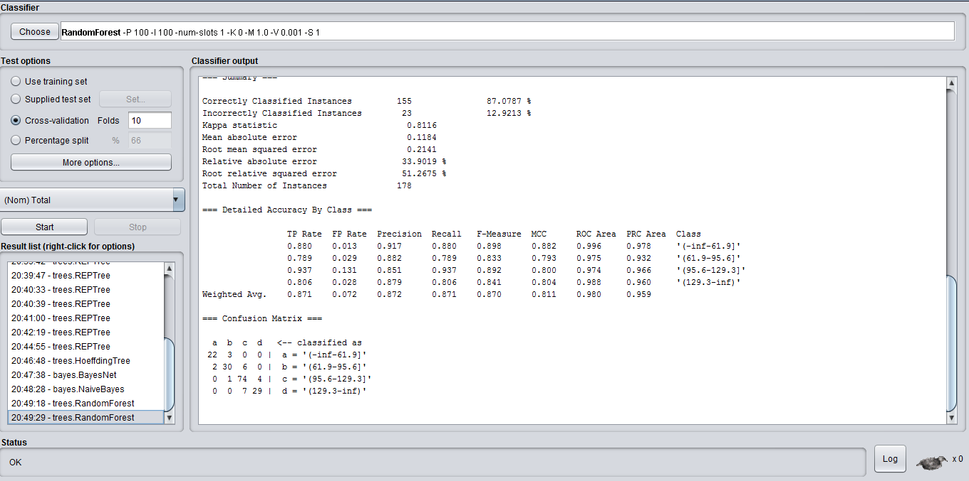

**Classifier Output**

Correctly Classified Instances 155 87.0787 %

Incorrectly Classified Instances 23 12.9213 %

Kappa statistic 0.8116

Mean absolute error 0.1184

Root mean squared error 0.2141

Relative absolute error 33.9019 %

Root relative squared error 51.2675 %

Total Number of Instances 178

|  |  |  |  |  |  |  |  |  |
| --- | --- | --- | --- | --- | --- | --- | --- | --- |
| **TP Rate** | **FP Rate** | **Precision** | **Recall** | **F-Measure** | **MCC** | **ROC Area** | **PRC Area** | **Class** |
| 0.880 | 0.013 | 0.917 | 0.880 | 0.898 | 0.882 | 0.996 | 0.978 | '(-inf-61.9]' |
| 0.789 | 0.029 | 0.882 | 0.789 | 0.833 | 0.793 | 0.975 | 0.932 | '(61.9-95.6]' |
| 0.937 | 0.0131 | 0.851 | 0.937 | 0.892 | 0.800 | 0.974 | 0.966 | '(95.6-129.3]' |
| 0.806 | 0.028 | 0.879 | 0.806 | 0.841 | 0.804 | 0.988 | 0.960 | '(129.3-inf)' |

Confusion Matrix

a b c d

**Trees – Hoeffding Tree Classifier**

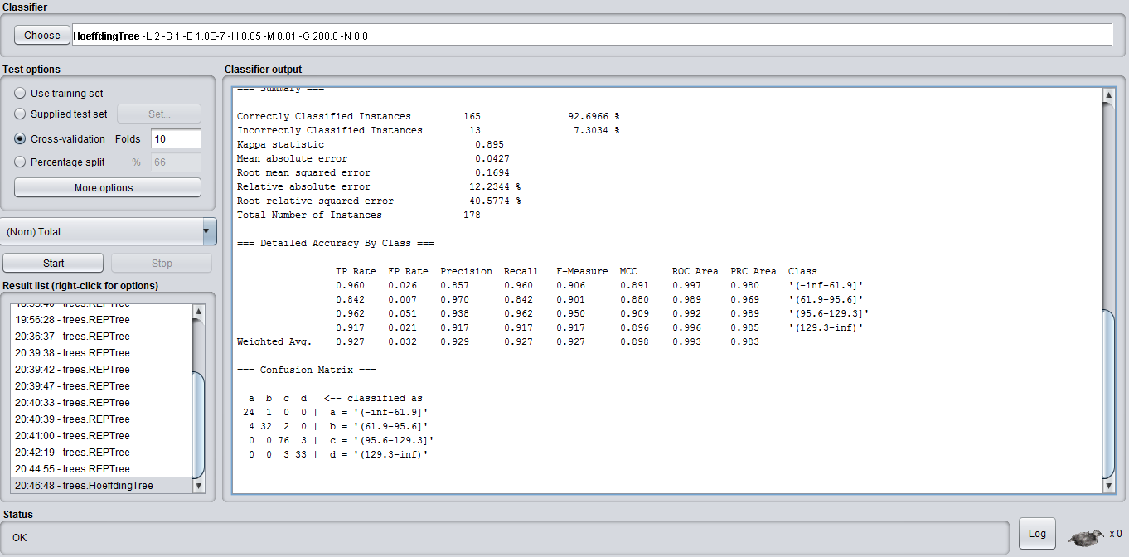

**Classifier Output**

Correctly Classified Instances 165 95.5056 %

Incorrectly Classified Instances 13 4.4944 %

Kappa statistic 0.895

Mean absolute error 0.0427

Root mean squared error 0.1694

Relative absolute error 12.2344 %

Root relative squared error 40.5774 %

Total Number of Instances 178

|  |  |  |  |  |  |  |  |  |
| --- | --- | --- | --- | --- | --- | --- | --- | --- |
| **TP Rate** | **FP Rate** | **Precision** | **Recall** | **F-Measure** | **MCC** | **ROC Area** | **PRC Area** | **Class** |
| 0.960 | 0.026 | 0.857 | 0.960 | 0.906 | 0.891 | 0.997 | 0.980 | '(-inf-61.9]' |
| 0.842 | 0.007 | 0.970 | 0.842 | 0.901 | 0.880 | 0.989 | 0.969 | '(61.9-95.6]' |
| 0.962 | 0.051 | 0.938 | 0.962 | 0.950 | 0.909 | 0.992 | 0.989 | '(95.6-129.3]' |
| 0.917 | 0.021 | 0.917 | 0.927 | 0.917 | 0.896 | 0.996 | 0.985 | '(129.3-inf)' |

Confusion Matrix

a b c d

**Comparison of Algorithms and Result**

Since the percentage of correctly classified instances for Bayes Net, Naïve Bayes, Random Tree, Random Forest and Hoeffding Tree algorithms is 93.2548, 92.1348, 81.4607, 87.0787, 95.5056 respectively. This clearly shows that Hoeffding Tree algorithm is best used to classify as it has high accuracy when compared with other algorithms.

**Determining Action Rules**

We have determined the action rules by using Weka by selecting the Rules-PART filter as the classifier and run for the data with total as the decision attribute. The rules are logged in a word document and the result screenshot is shown below.

