Name: Akash Ur Rehman Roll No: FA19-BSE-112

Name: Muhammad Abu Hurairah Roll No: FA19-BSE-033

Section: A

Assignment 1 (Group Assignment)

Enable the project using any IDE for code review. It would be better to use Eclipse or Netbeans. You may use VS Code too.

a) Explore your project and find all options discussed in lecture 2 from Chapter 2. You need to prepare a google doc that highlights the potential issue that your code has. You may identify these issues with the help of

i) Identify deprecated technology or APIs. Just report the diagram.

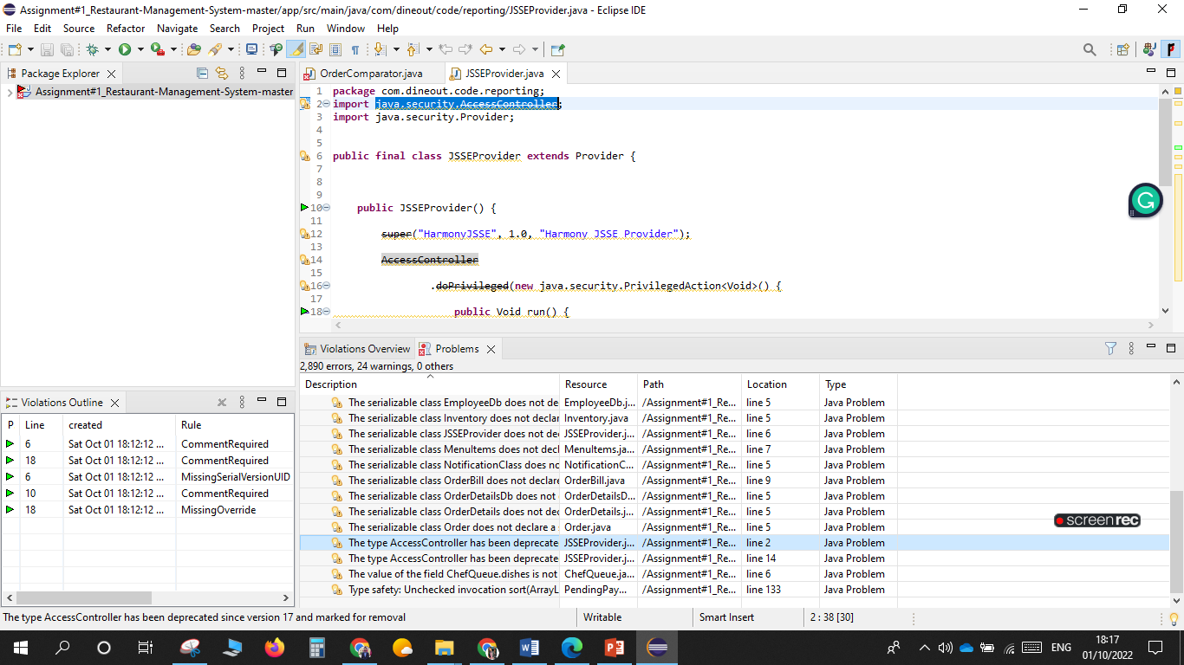

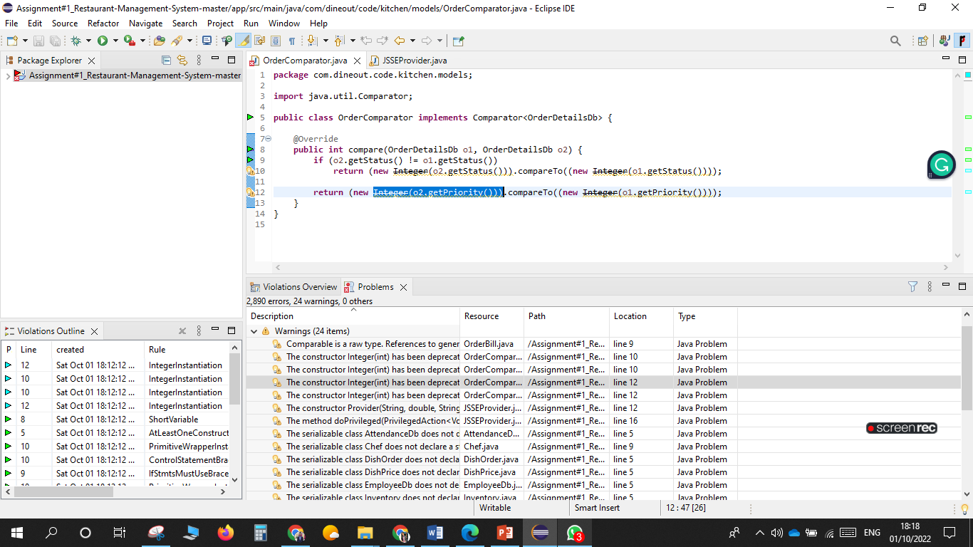

By Using compiler settings in the Ecllipse editor, we can identify the deprecated api or technologies in the code.

ii) Potential issues missing in the documentation but available in the code

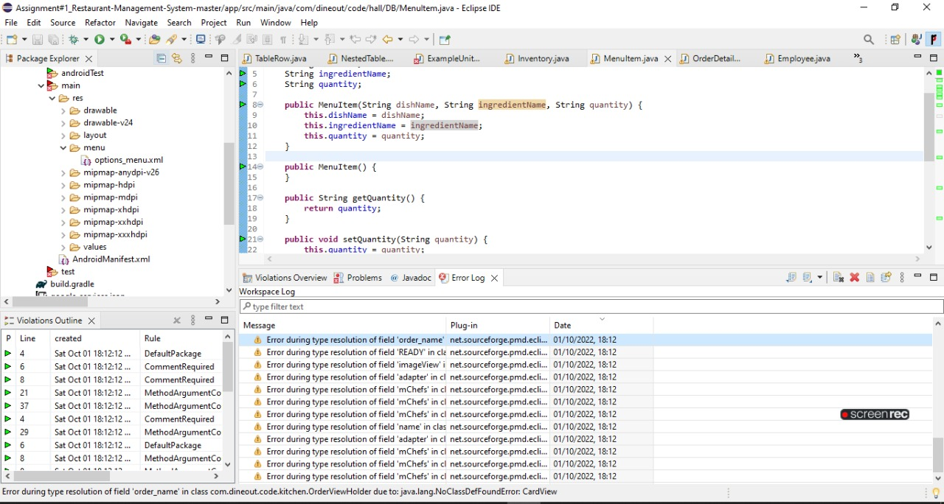

There were multiple issues in the code but not available in the documentation like too much abstraction or using the different data types for the variables. Also different parameters are declared in the code, but not used after declaring which can cause issues.

iii) missing of technical documentation ( if applicable )

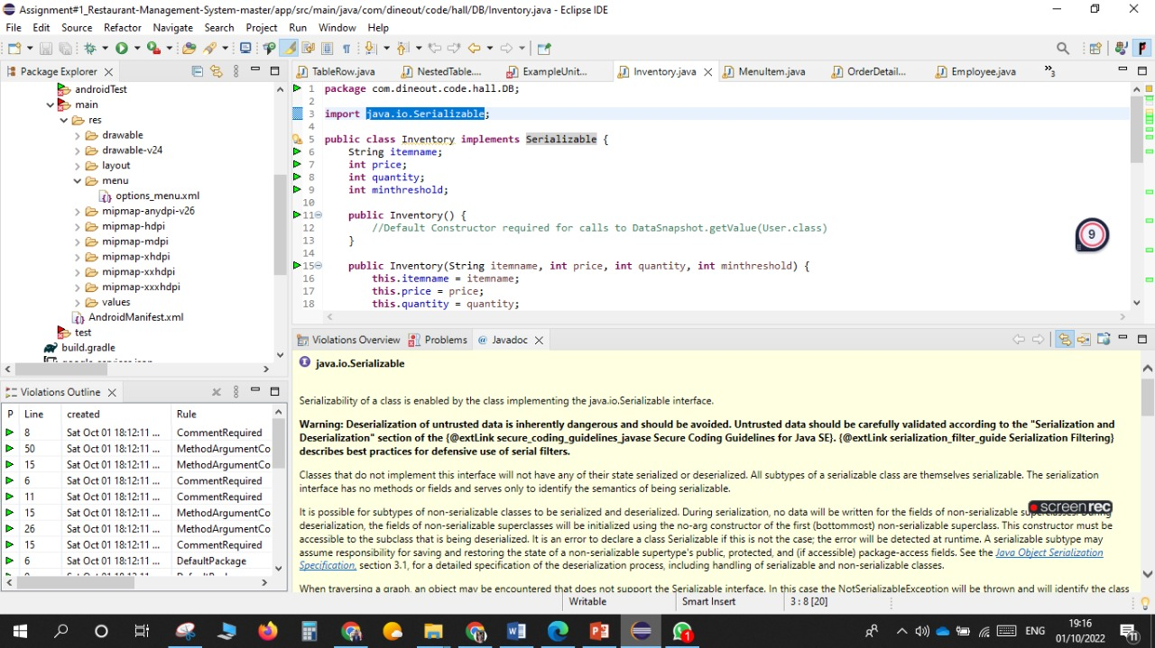

Through Eclipse editor, we can check technical documentation of the APIs and the methods through javadoc. For this code, only Software requirement specification document available, other than this no documentation available i.e, process documentation.

**b) Use PMD to help identify potential coding errors and customize the rules you use to make sure only pertinent rules are applied to your source code.**

**i) Create & view code issues directly from your editor**

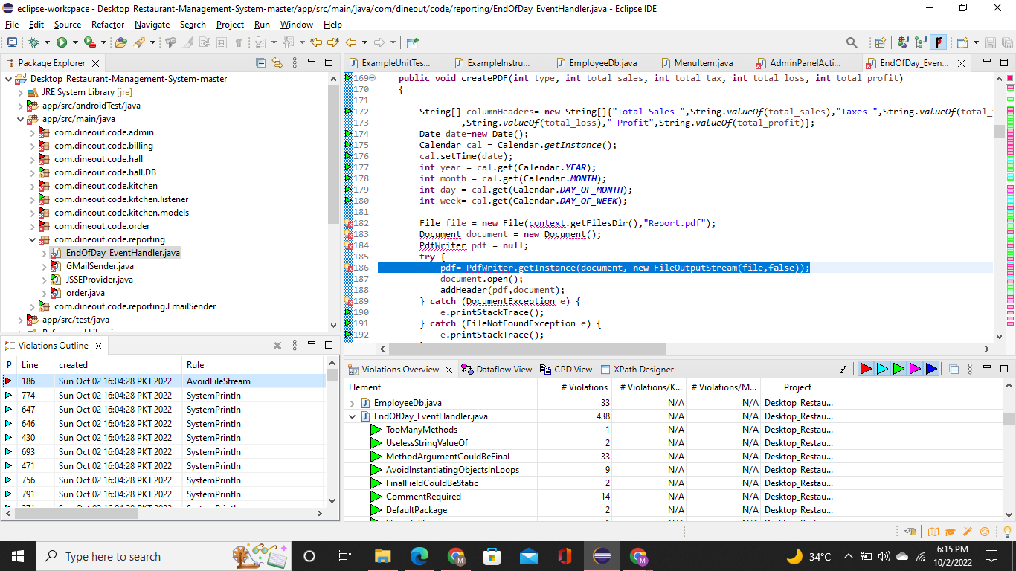

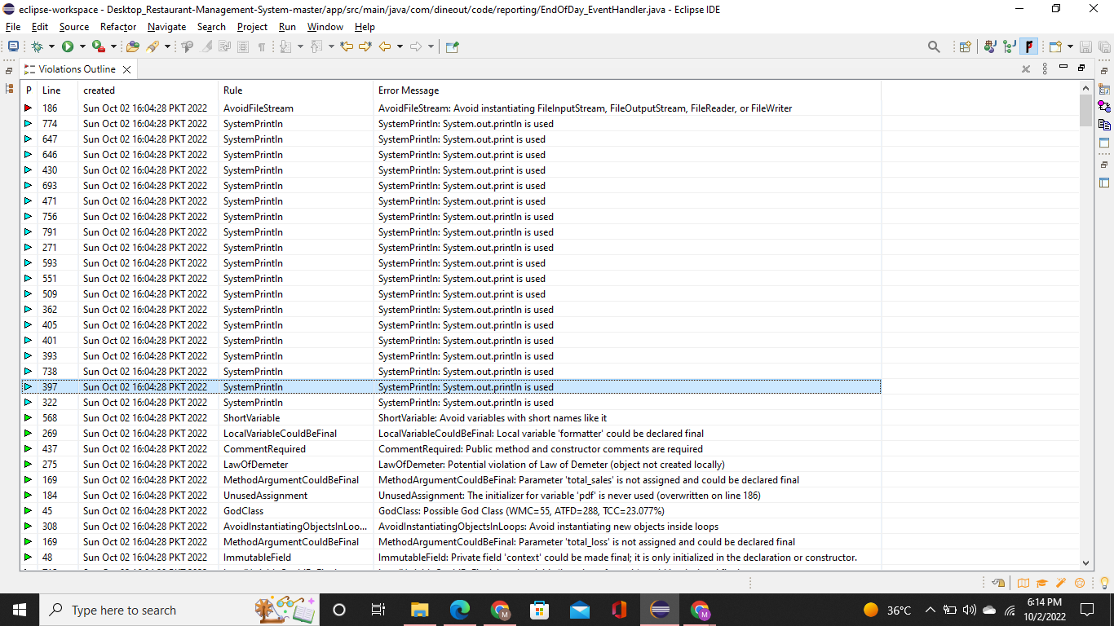

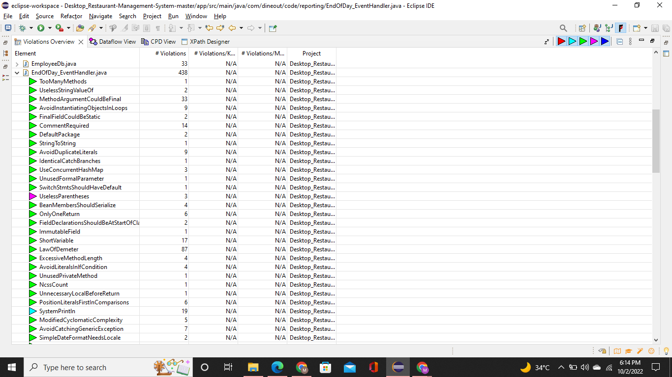

Code issues in this project are given below:

* Not follow variables naming conventions
* Not follow class naming conventions
* Use Short Variables
* Use short class name
* Unused local variables in the code
* Public methods and constructor required comment
* Comment size is too large
* Local Variables could be final
* Field declaration should not be at start of class
* Too many methods used
* Unused private methods
* Excessive (Too large) method length
* Unused assignment
* Not avoid catching generic exception like runtime exception
* Switch statement should not have default condition
* Useless parentheses are used in the code
* Use file stream
* Array is stored directly
* Unnecessary imports
* Use of Empty Constructor

**ii) Track & prioritize code improvements like technical debt**

Code improvements in this project are given below:

* Follow variables naming conventions
* Follow class naming conventions
* Do not use short variables names and class name
* Avoid unused local variables in the code
* Add comment before public methods and constructor
* Avoid large comment
* Do not declare local variables could be final
* Field declaration should be at start of class
* Avoid too many methods used
* Avoid unused private methods
* Avoid unused assignment
* Avoid catching generic exception like runtime exception
* Switch statement should have default condition
* Avoid useless parentheses in the code
* Avoid file stream
* Avoid use of empty constructor
* Array should not stored directly
* Avoid unnecessary imports

**iii) Check your code quality**

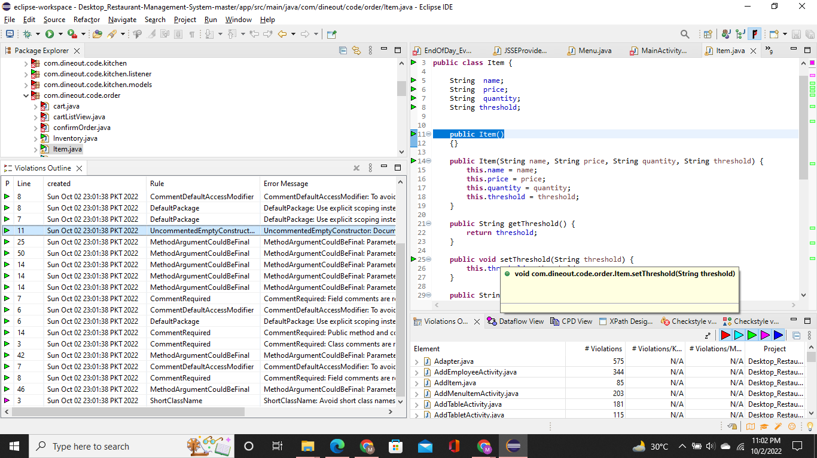

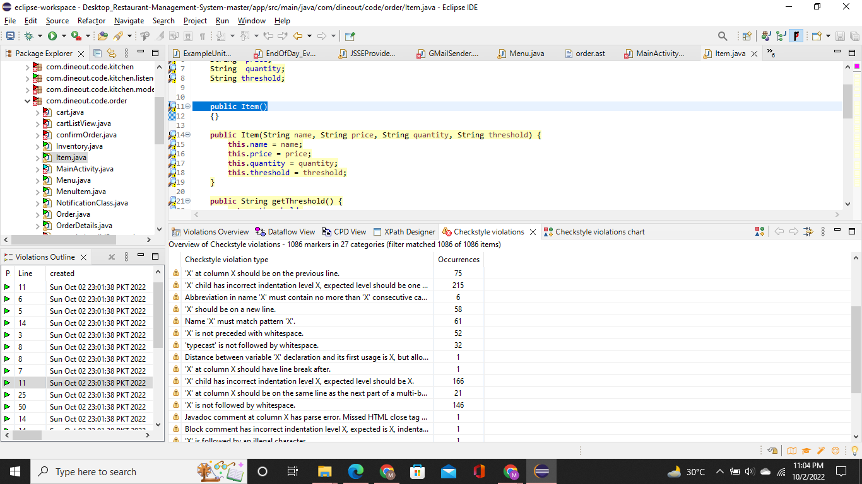

By using CheckStyle and PMD, we can check code quality in eclipse. Because it can easily identify issues of the code and can improve the quality of code by correcting the issues and errors.

**iv) Apply at least 3 PMD rules with the help of tools.**

PMD rules are given below:

* Class naming conventions
* Class has at least one constructor
* Field declaration should be at start of the class
* Short variables name
* Avoid generic exceptions
* Avoid extra parenthesis

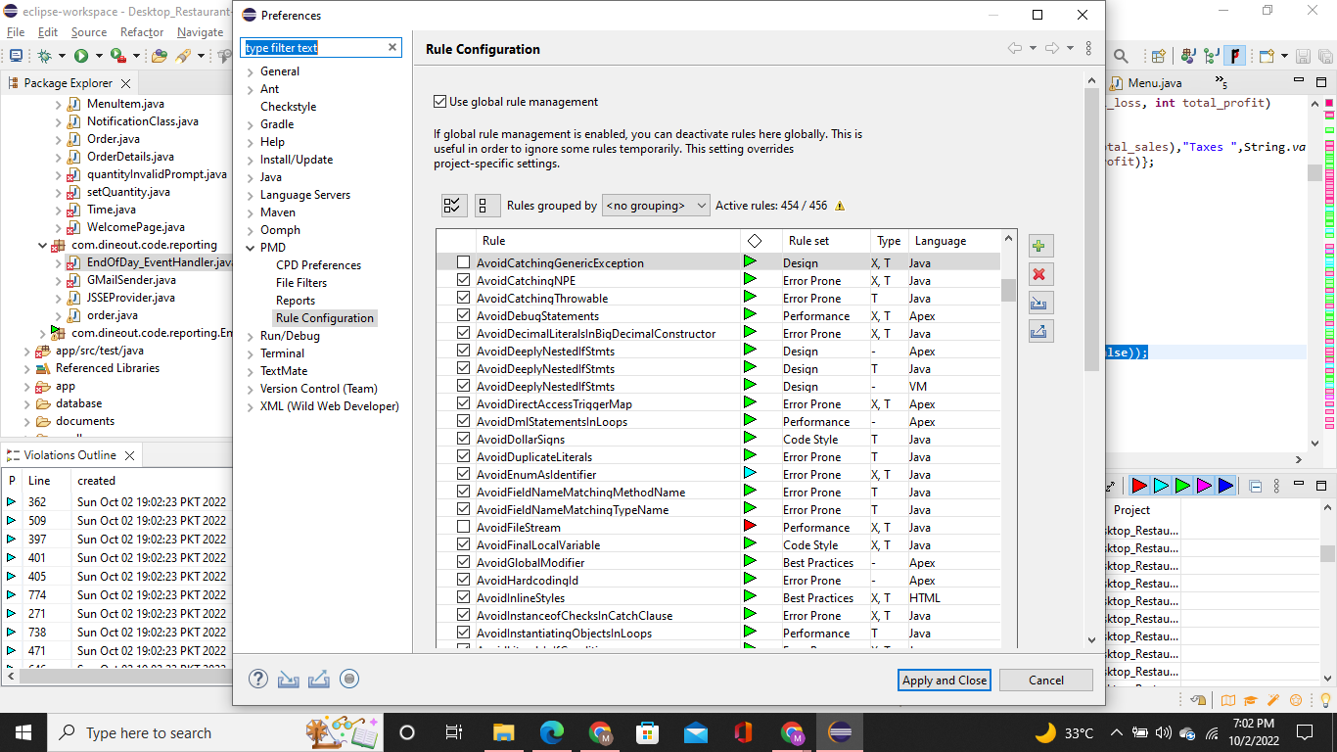

**v) Generate the Abstract Syntax Tree of your source code using PMD.**

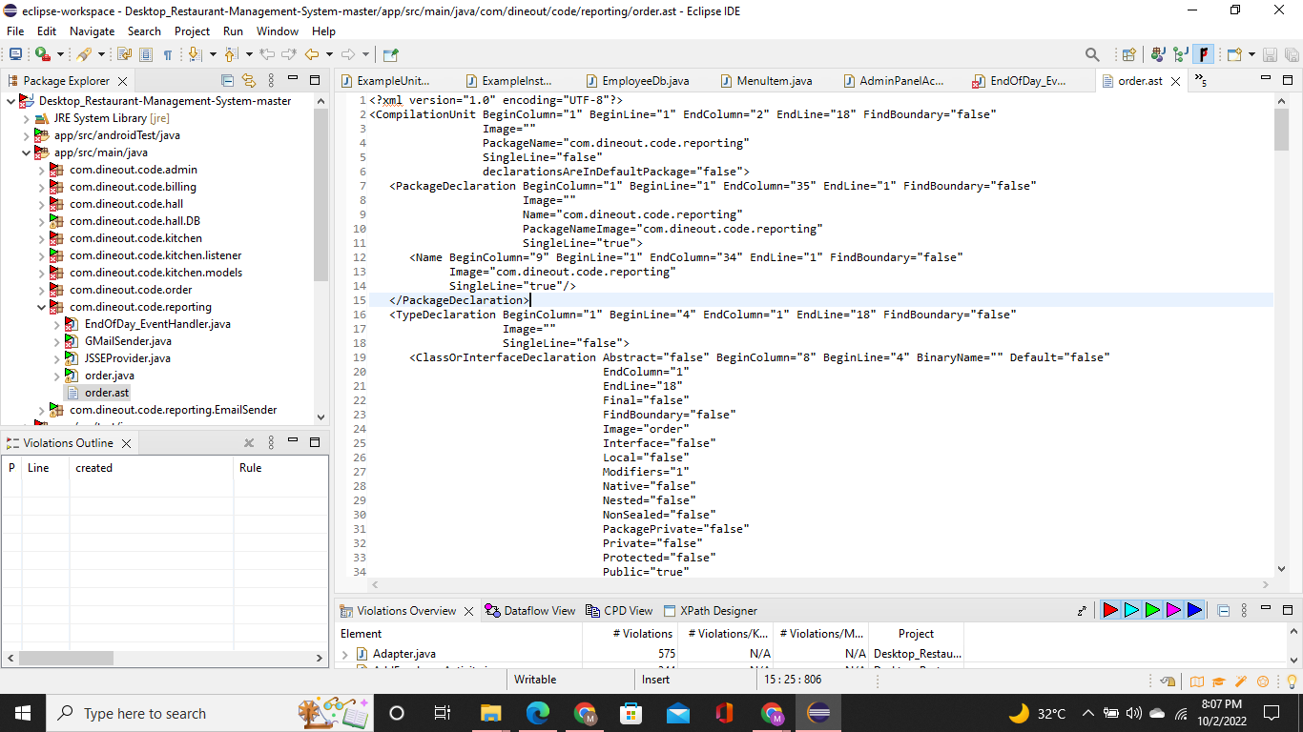

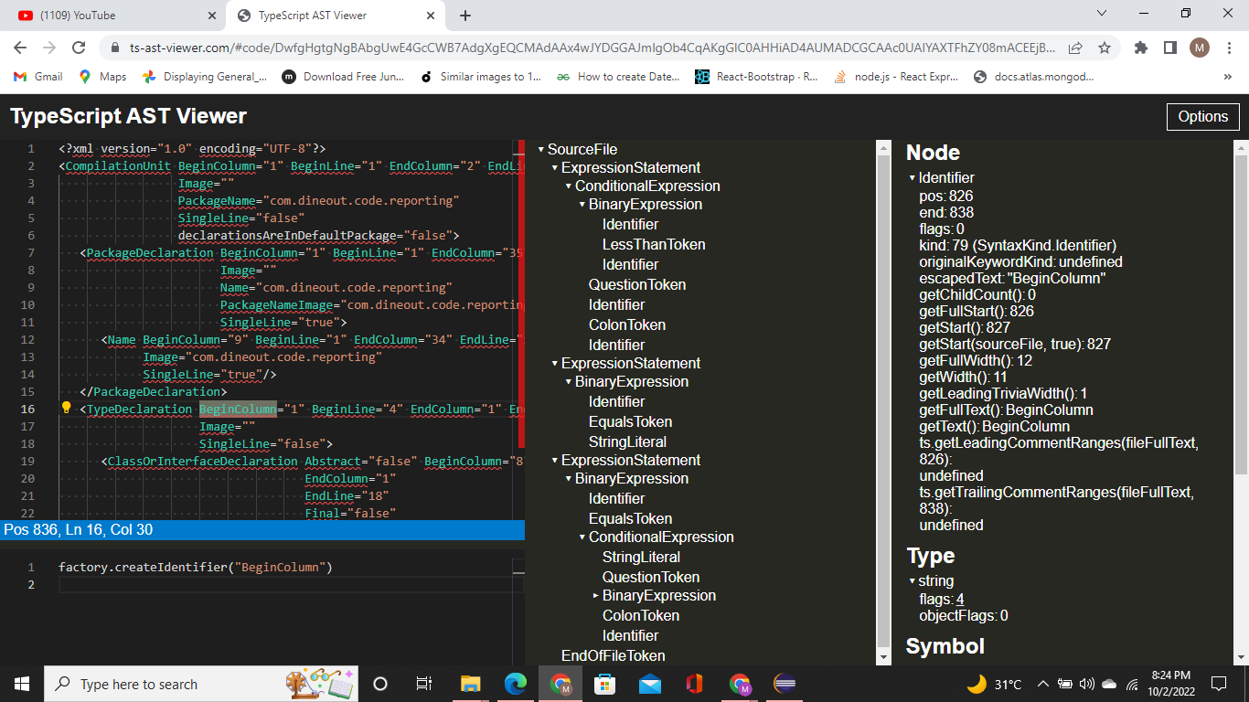

**c) Use the Check Style tool to review your code. At least apply 2 rules on your code using CheckStyle**

By using a check style tool there are some issues in code. These issues are given below:

* Switch without default clause
* Missing a javadoc comment
* Condition statement must use parentheses
* Typecast is not followed by the whitespace
* Imports order is incorrect

