**BLOCK DIAGRAM:**

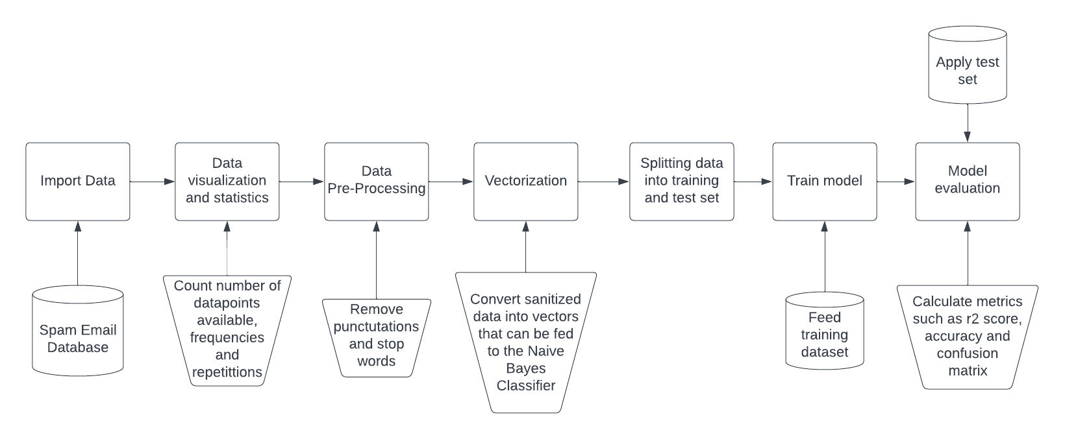

**SCREENSHOTS:**

Importing dataset and checking if it’s loaded properly

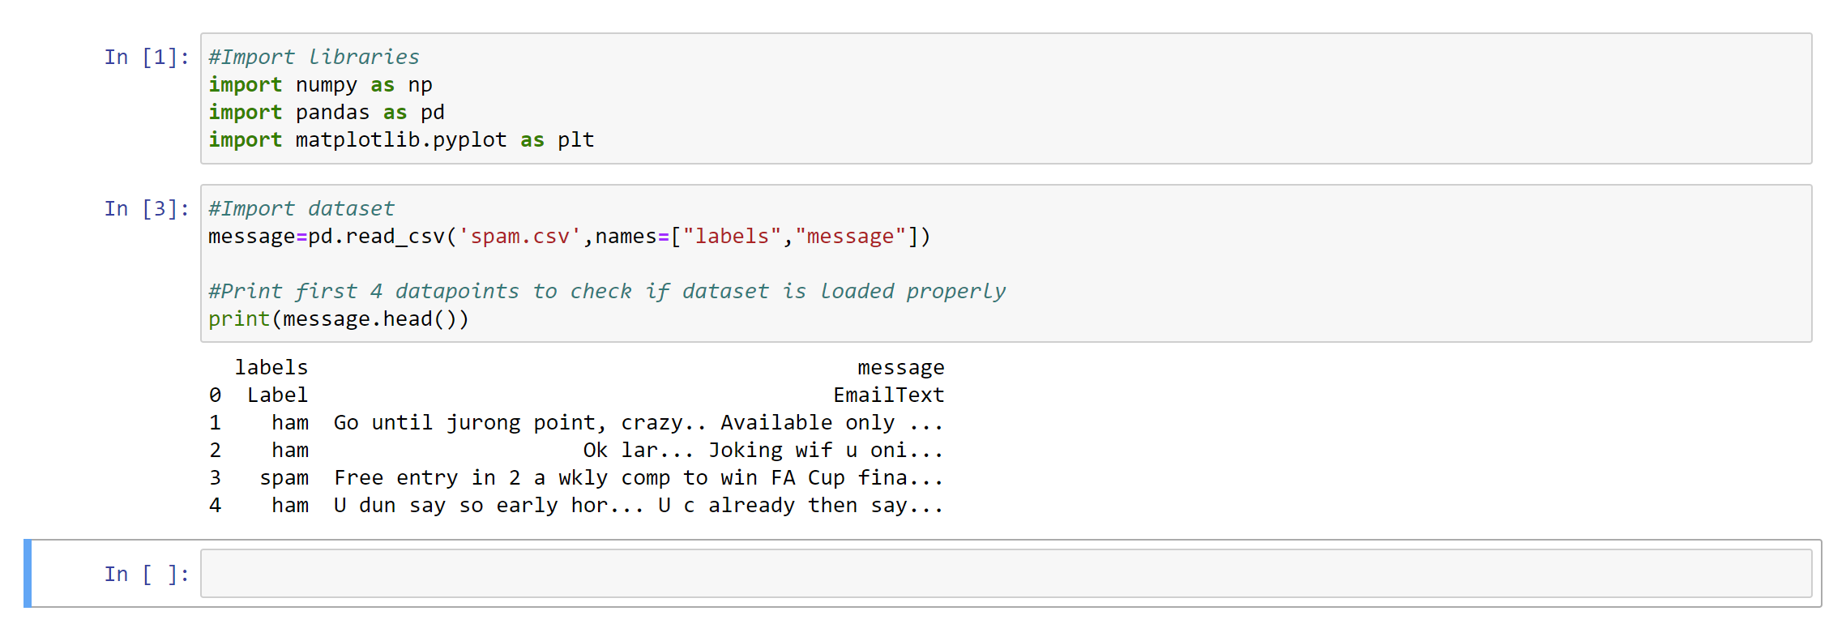

Data Statistics:

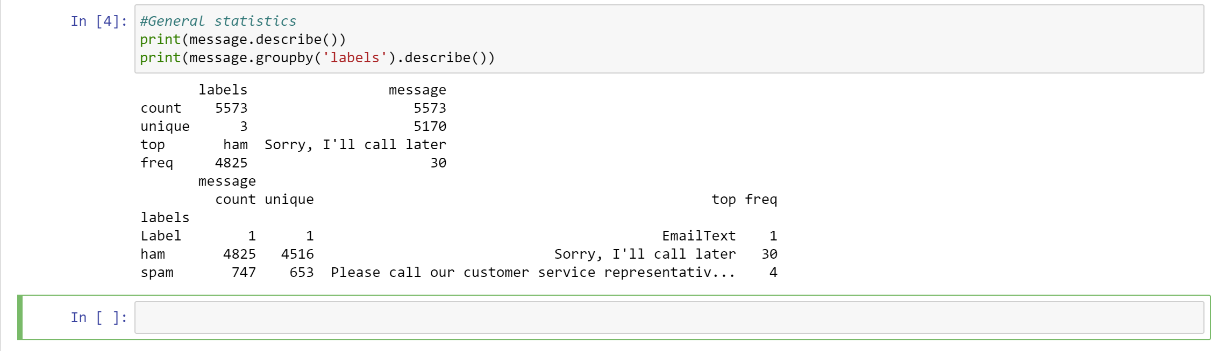

Creation of length column:

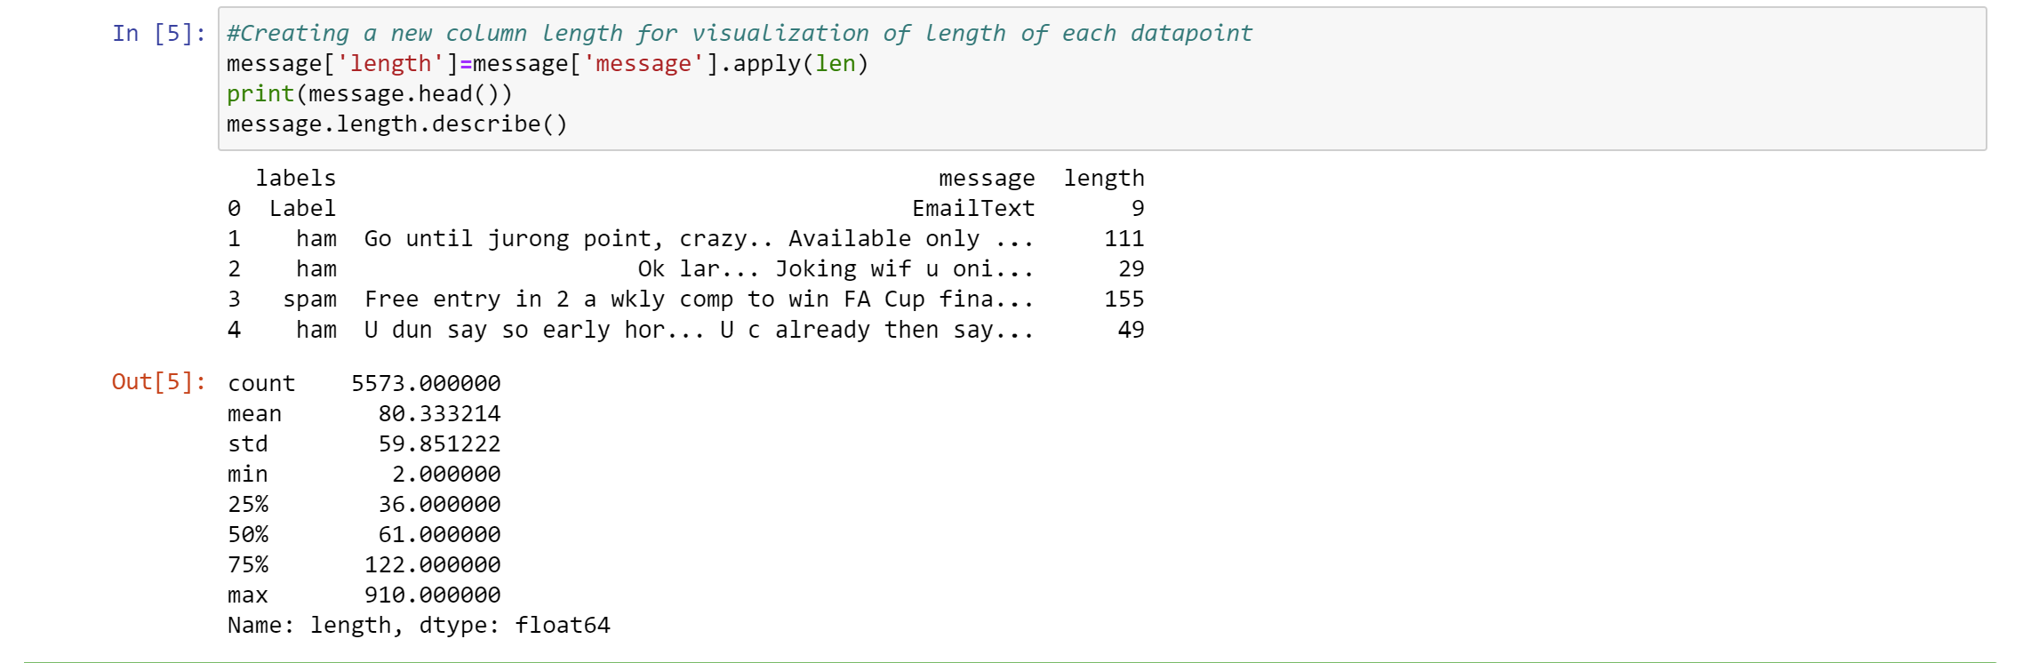

Histogram Plot:

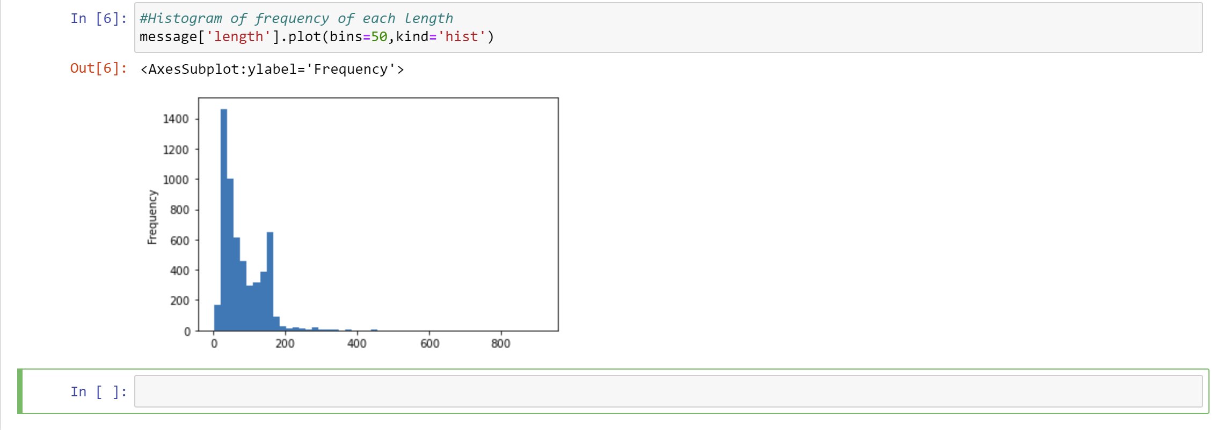

Data pre-processing:

Removing of punctuations:

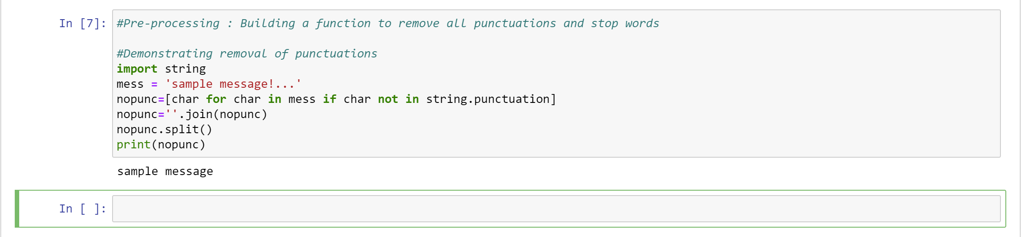

Using nltk library to access stopwords:

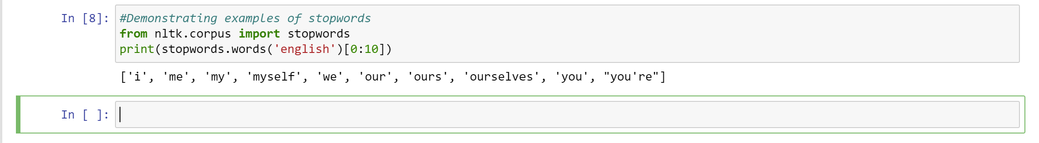

Creating the filter function:

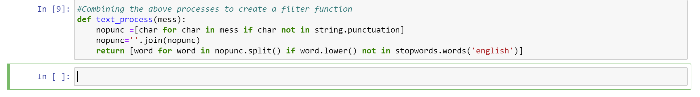

Applying it to dataset:

