Project Report

Analysis of Deodorant sales
Predictive Analytics Project
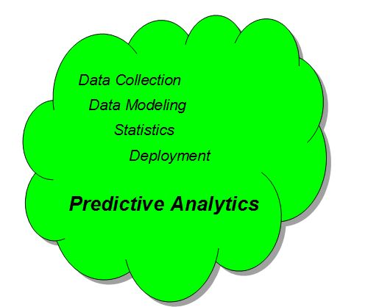

Table of Contents

Table of Contents ii
Group Members Details: iii
1. Executive Summary 1
1.1 Project Summary 1
1.2 Process 1
2. Descriptive Analytics 2
2.1 Data Description 2
3. Predictive Analytics 6
3.1. RFM Analysis 6
3.1.1 Data Description 6
3.1.2 Data Preprocessing 6
3.1.3 Interpretation 6
3.1.4 Recommendation: 7
3.2. Regression: 8
3.2.1 Data Description 8
3.2.2 Conclusion/ Interpretation 8
3.3. MDC Analysis 8
3.3.1 Data Description 8
3.3.2 Data Preprocessing 8
3.3.3 Conclusion/ Interpretation 9
3.3.4 Recommendation: 10
4. References 10

Group Members Details:

Name | Contact information
Hetul Patel | Hxp161630@utdallas.edu
Darshil Gohel | dxg163330@utdallas.edu
Akash Joshi | Avj160230@utdaals.edu
Poonam Malik | pxm164830@utdallas.edu
Rushab Shah | Rvs160130@utdallas.edu

Executive Summary
This is a marketing predictive analytics project using SAS, in which sales data of deodorant across grocery shops and medical stores is provided. Using predictive analytics, data is analyzed to find what influences the sales of the product and what are the top brands used among customers and the information about factors affecting the sales of deodorant. Multinomial Logit was used to achieve this goal. This section elucidates the overall outline of this project.

Project Summary
Scope

The project provides details about what influences the sales of deodorant and the results can be implied and executed for other areas too. This information can be used for monetary gains by the buyers and the dealers.

Goal /Business Solution

The business problem which can be solved with this data set is twofold:
- How does price, household income and family size and other factors impact sales within each household over time?
- What characteristics of a product matter the most in the determination of its utility/sales?

Process
Multinomial Logit Regression was used to test the dependency of the variable Price (outcome /target variable) on all the other independent or predictor variables. Other techniques are tested too, just to know which one of these is the best with least mean squared error and highest R square rate.

Descriptive Analytics
The main objective of this project was to gain a better understanding of the individual factors that contribute to the sales of a deodorant.

Data Description
Data files given for analysis contains the below information:
- Deodorant sales data for 52 weeks - Jan 1, 2001 till Dec 31, 2001
- Demographic/Customer information such as family size, education, annual income, age, Occupation, children etc.
- Scanner data which includes Deodorant category, Deodorant Levels, UPC code, package, strength etc.
- Customer level deodorant sales panel data consisting information such as customer id, selling week, total units sold, total price, from which store it has been bought, UPC code of deodorant
- Store level deodorant sales data consisting information such as store id, selling week, total units sold, total dollar amount, UPC code of product, display information, discount information etc.

With the help of reporting tool before graphs were generated:

- Top Brands
Market share of distinct brands is shown below which also helps us in determining the top brands

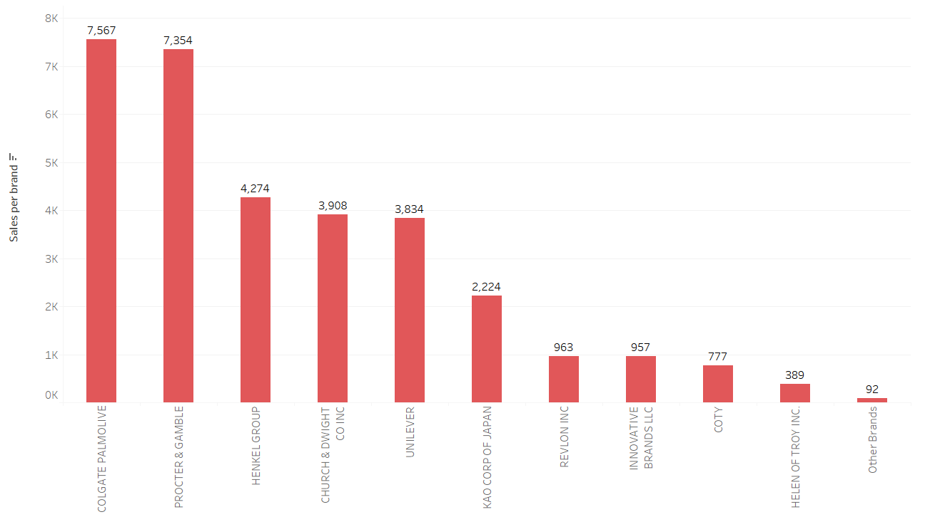
Figure 1: Top Brands
- Top Markets
Based on sales in dollars’ top stores were identified and shown below:

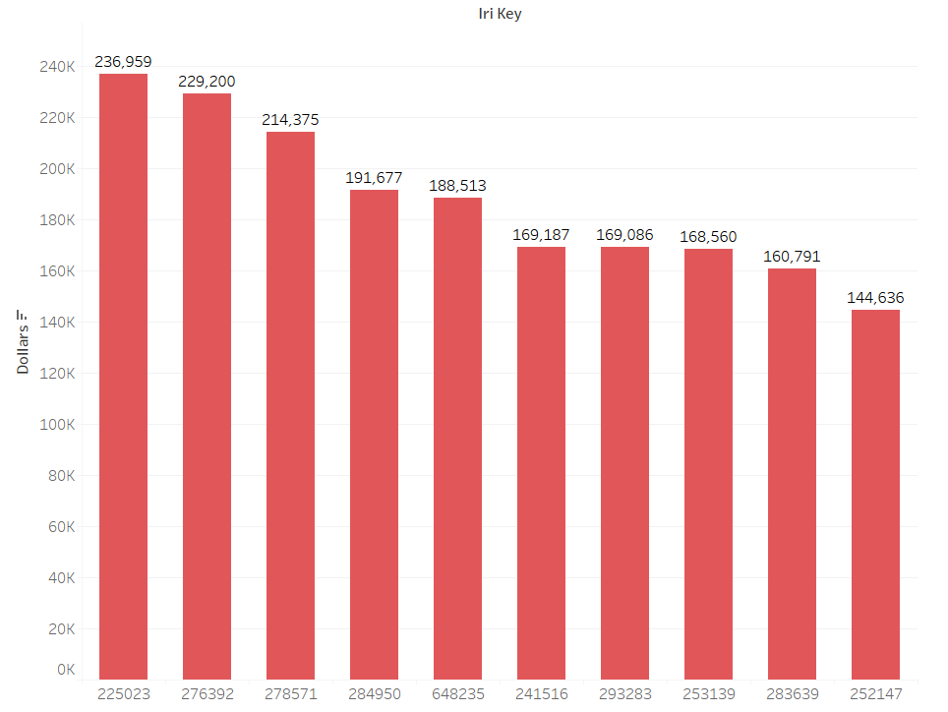
Figure 2: Sales per store

- Effect of different attributes on sales
- Price reduction

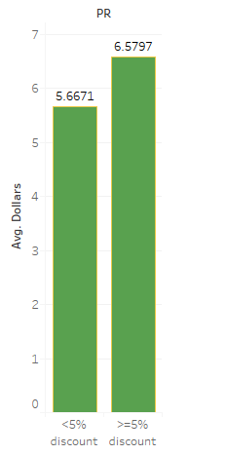
Figure 3: Price Effect

- Display effect

Figure 4: Display Effect

- Feature Effect

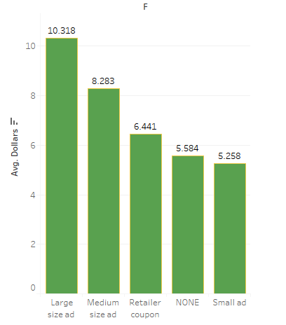
Figure 5: Feature Effect

- Monthly and weekly on sales

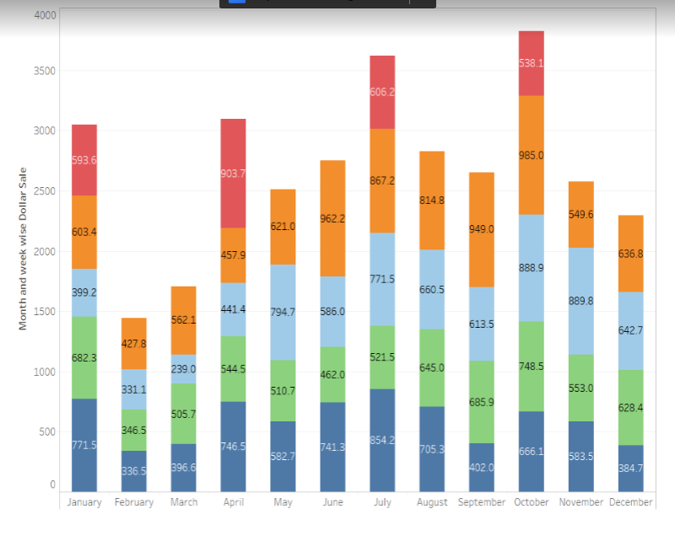
It is observed that the sales of deodorant are high in extreme summer as well winter season. In summer because of hot weather deodorant is a necessity and in extreme cold weather people would really not like to take bath on daily basis and would prefer use of a deodorant

Predictive Analytics

RFM Analysis
The objective of this analysis is to identify the target customer segment and their characteristics.

Data Description
Below files were used to for RFM Analysis
- deod_PANEL_GR_1114_1165.dat
- prod_deod.xls
- ads demo1.csv

Data Preprocessing
In RFM Analysis, R stands for Recency of the customer, F stands for frequency and M stands for Monetary amount
Below steps were performed for RFM analysis
- It is observed the range of weeks in which customers have purchased deodorant is 1112 to 1165. This entire range is divided into five quantiles and R score between 1 to 5 has been given to each PANID. R score of 5 indicates the most recent customers and R score 1 indicates the least recent customers.
- Frequency of customers was ranging from 1 to 45. This range has also been divided in five quantiles. The most frequent customers have been given a F value of 5 and least frequent customers have been given F value 1.
- Monetary amount ranges from 0.57 to 270.93 and it has been calculated using sum of dollar amounts for each customer. This entire range was divided in five different quantiles. The quantile with highest monetary amounts is given M value 5 and quantile with lowest monetary amounts is given M value 1.
- Using R, F and M values, RFM score was calculated for each PANID which is a combination of all three scores. These RFM scores have been observed and clustered to make five final clusters. We have prepared five final clusters which are based on RFM scores in it. All the customers are classified based on RFM score and placed in one of these five clusters.
- The final clusters have been built based on criteria like customers with recency score 4 and 3 are more likely to visit the store again rather than customers with recency 5. Similarly, frequency and monetary amount of 5 and 4 are more likely to buy deodorant compared to the customers with lower frequency and monetary amount scores.

Interpretation
From RFM analysis, it is observed that there were 21 clusters based on distinct RFM scores.
Target customer segments should be the ones with more number of customers in it. For such segments, it is observed that it has low monetary score of 1 and higher recency and frequency scores of 5 and 4 which implies that these customers would not like to buy the product in bulk in a single order, rather they will prefer more frequent visits to the store.
The important characteristics observed for such customers are as below:
- There are 2 to 3 members in their families.
- They are mostly not renters but they are house owners.
- The age of the male head of the household ranges from 45 to 54.
- Occupation identified for such customers is machine operators which might need more use of deodorants.
- Education level for such customers is identified that they have attended some technical school.
- The age group of their children is identified between 6-11 and 12-17

Recommendation:
The purpose of doing all this analysis is that we can decide the target customer segment and the demographic characteristics of these customers. If there are some customers which the store is planning to target, then it is highly recommended that those customers should have the above listed characteristics. There are high chances of getting positive response from such customers.

Regression:

Data Description
Regression is done on
- deod_groc_1114_1165.dat

Conclusion/ Interpretation
After performing regression on store level data using data of top four brands COLGATE PALMOLIVE, PROCTER & GAMBLE, CHURCH & DWIGHT CO INC and UNILEVER. The dependent variable of model is quantity sold and independent variables are price per oz., display, feature and promotion. We ran this model to find out whether price is significant or not at store level. The display, feature and promotion are the significant variables and have positive effect on quantity sold.

MDC Analysis
Multinomial logit was used on the data

Data Description
Below files were used to implement MDC
- deod_PANEL_GR_1114_1165.dat
- prod_deod.xls
- deod_groc_1114_1165.dat

Data Preprocessing
Below steps are performed on data before doing analysis.
- The data in column COLUPC in file deod_PANEL_GR_1114_1165.dat is appended with ‘00’ to make it of fixed length of 13.
- The datatype of data in column GE, VEND and Item in file prod_deod.xls is changed to numeric, appended with 0 to make fixed length and in last concatenated to make a key which is used as join key later.
- Then file PANEL_GR and PROD_DEO is joined based on key formed above
- The feature and display data present in deod_groc file is converted into binary from categorical. Also the datatype of SY, GE, VEND and Item is converted into numerical and then the data is concatenated to form a key column..
- The processed deod_groc file is joined with prod_deod based on key columns formed above.
- Based on top four brands in panel data we kept data of top four brands in panel and store level data.
- The top category within deodorant is “Anti-perspirant deo”. It has around 82% of total sale. So we analyze only Anti-perspirant deo data.
- The average price per ounce of four brand for each week and for each store were calculated along with binary values of feature, display and promotion
- Grocery store data was merged with panel data based on IRI_Key and week.
- The joined data above is transformed for MDC analysis.

Conclusion/ Interpretation
- AIC : In our case, from above table , the AIC for model with intercept and covariates are less compared to model with only intercept. Hence, out created model with intercept and covariates are good fit of the data.
- SC : In our case, from above table , the SC for model with intercept and covariates are less compared to model with only intercept. Hence, out created model with intercept and covariates are good fit of the data.

- -2logL: In our case, from above table , the -2logL for model with intercept and covariates are less compared to model with only intercept. Hence, out created model with intercept and covariates are good fit of the data.
- Below tables gives total share for the choice 1,choice 2,choice 3 and choice 4

Discrete Response Profile
Index | CHOICE | Frequency | Percent
0 | 1 | 1934 | 31.13
1 | 2 | 1641 | 26.41
2 | 3 | 1228 | 19.77
3 | 4 | 1410 | 22.69

- Coefficient Interpretation:
Br2,br3,br4 : Brand 1 and Brand 2 have same preference. Brand 3 have less preference than Brand 1 and brand 2. Brand 4 has highest preference amongst all brands. So, preference wise Brand 4>Brand 1=Brand 2>Brand 3 (keeping other factors constant)
Price : it is insignificant and negative → There is no effect of price in selling the deodorant as it is insignificant ( keeping other factors constant)
Display→ it is significant and positive → having the brand in display will increase the chances of going for decision in favor of that brand. (keeping another factors constant)
Feature→ it is significant and positive → Having the feature on particular brand will increase the probability of having decision in favor of that brand (keeping another factors constant)
Inc2, inc3 →All are insignificant → brand 2 and Brand 3 have same preference as brand 1 for particular income group (keeping another factors constant)
Inc4 → Negative and Significant → Lower income people will go for brand 4 compared to all other brands (Brand1, Brand2, Brand3) (keeping another factors constant)
Hierarchy → Brand 1=Brand 2 = Brand 3> Brand 4
Nmemb2, Nmemb3, Nmemb4 → All are insignificant → Family size doesn’t have any significant impact on choices of brands (keeping another factors constant)
Age_m2,Age_m4→ insignificant→ brand 2 and brand 4 have same preference of brand 1 irrespective of age of Male head of Household ( keeping other factors constant)
Age_m3→ Positive and significant → More aged male head of household families will prefer Brand 3 more than Brand 1, Brand 2, brand 4. (keeping another factors constant)
Hierarchy → Brand 3>Brand 1=Brand 2 = Brand 4>
Age_f2→Negative and significant→ Brand 1 is more preferred then brand 2
Age_f3→ Positive and significant → Families which have older female head of household will prefer brand 3 over brand 1
Age_f4→Negative and significant→ Families which have Younger female head of household Younger women will prefer brand 4 over brand 1
Hierarchy → Brand 3> Brand 1 > Brand 2> Brand 4

Recommendation:
From the above insights, Following recommendation can be drawn.
- To increase the sales and preference of the particular brand, Stores can focus more on display and feature.
- Brand 3 is more popular in old age people. Brand 3 should target this kind of customer.
- Brand 4 is more popular among young female and lower income people. Hence, Brand 4 should target this population.
- In online recommendation systems, we can add this insights as useful business decision.
e.g if the online customer is buying brand 3 then he must be older in age and hence, we can recommend items according to that particular age increasing selling.

References
- http://www.ats.ucla.edu

