**Exploratory Analysis**

Visualization on data:

This graph is a comparison between affordability of houses and the happiness of people if they have a house and people who are more satisfied with their lives are happier.

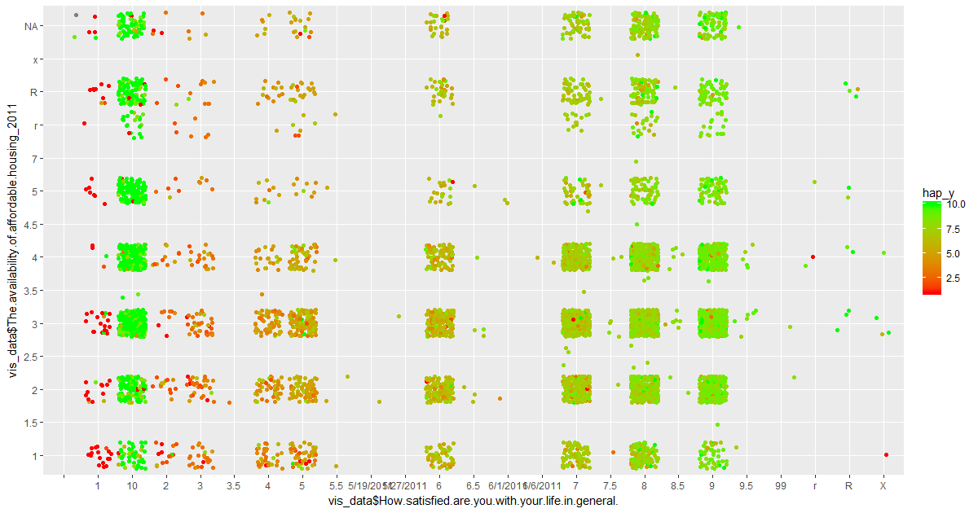

This is a relationship of person’s happiness with the public amenities and safety in that area. As the safety and amenities increases, it is observed that people are happier.

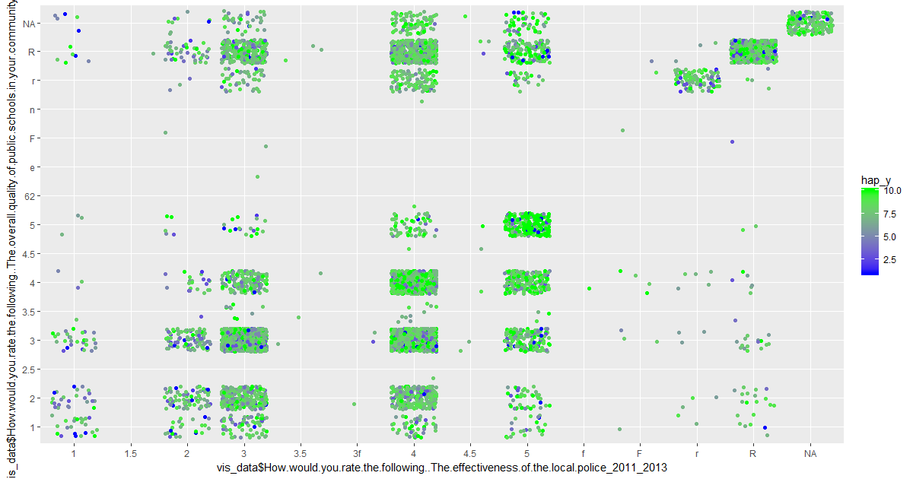

It is observed that single people are happy compared to married and people with younger age are happier than the old people. This could mean living standards with a family is difficult.

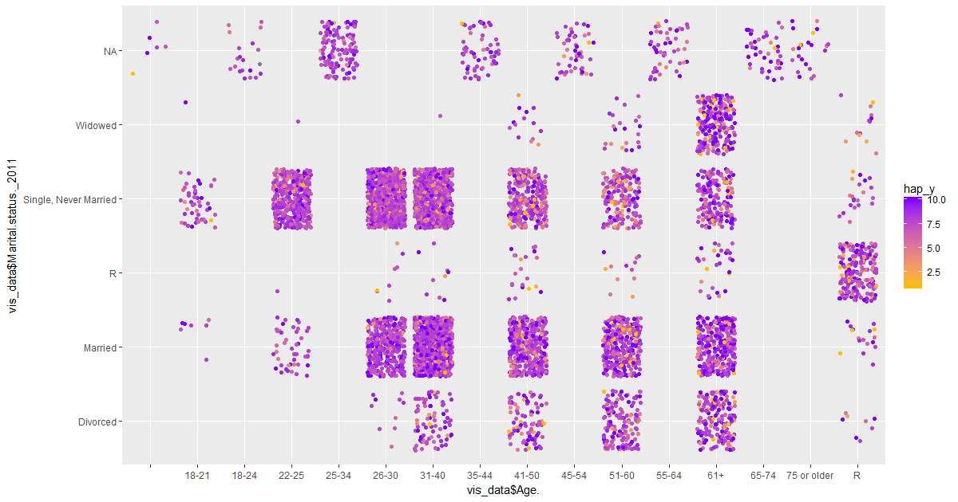

We feel that money plays an important part for the happiness of the people in Somerville. This could mean you should have a decent income to maintain a good living standard in Somerville.

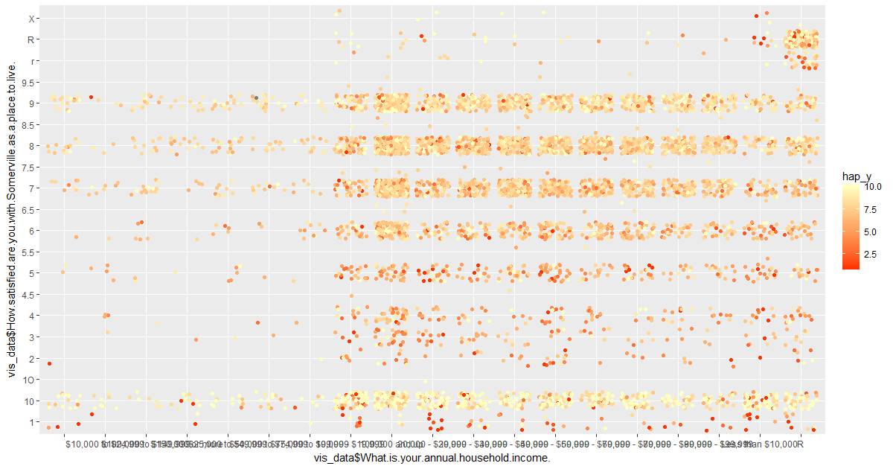

Below graph shows number of happy and unhappy people. It is seen that there are more happy people than unhappy.

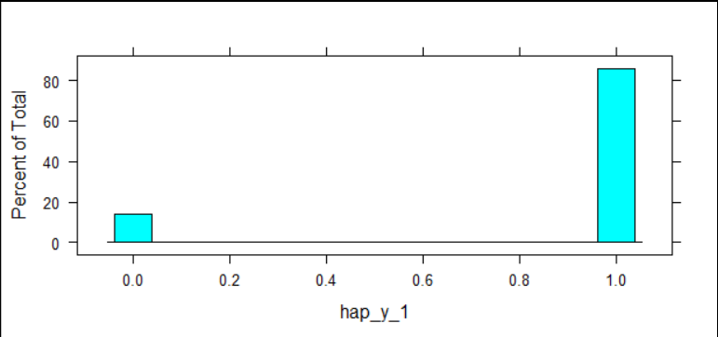

The graph shows that there are so many people with happiness standard more than seven in Somerville. So, overall people in the town are happy.

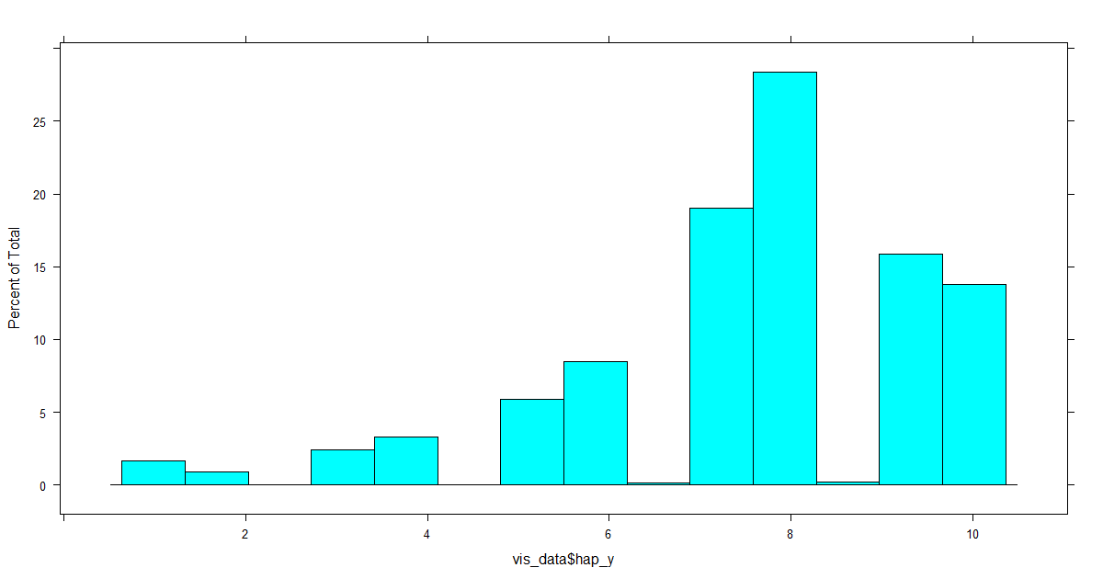

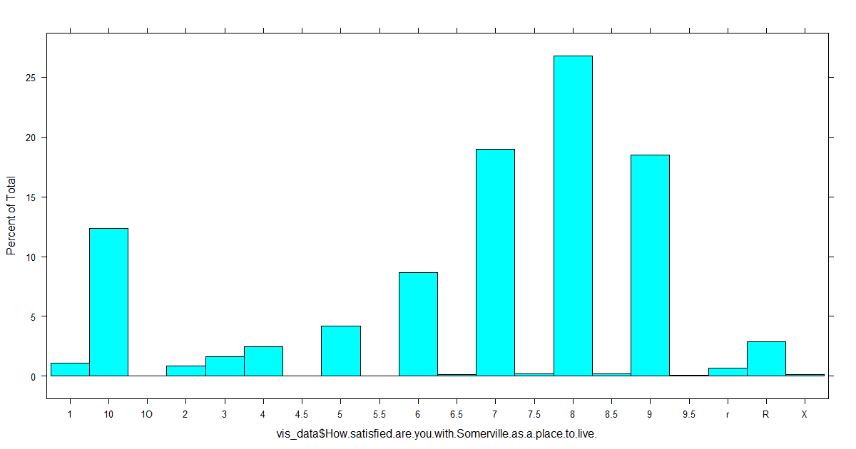

It is seen from the below graph that people who are more satisfied with their life in general are happier compared to less satisfied people in their lives.

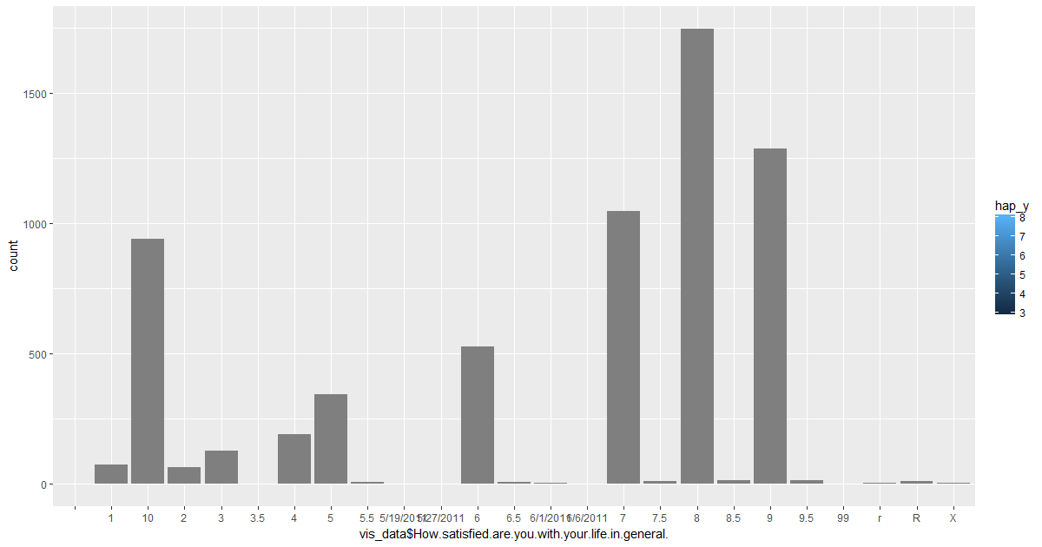

It could be said from the below graph that people with three public schools in their area are most happy compared to others.

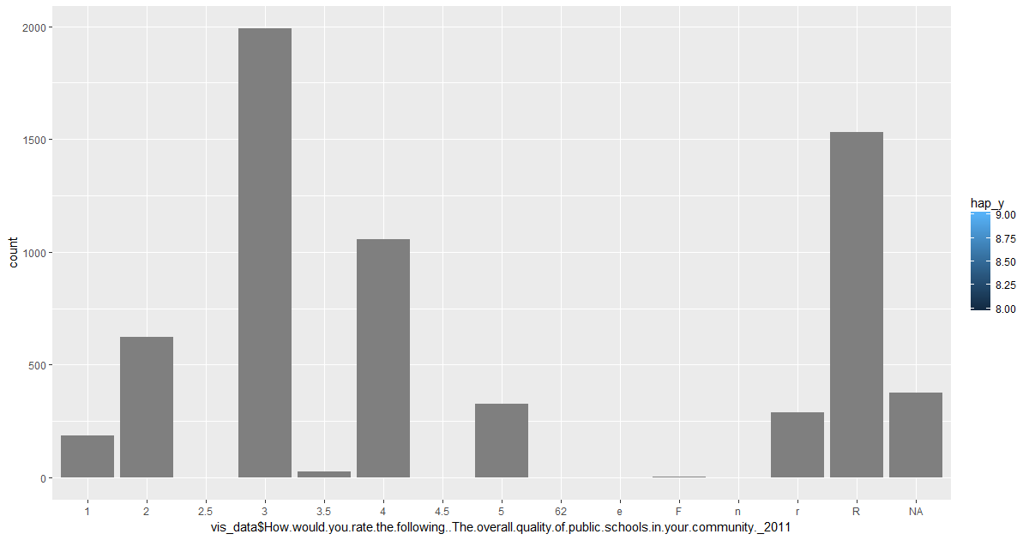

We can say from the below graph that people are happy if the effectiveness of the police in the area is more.

