Naan mudhalvan project

Customer churn prediction

Akshaya K 2021115011

Akshaya S M 2021115012

Preetham V 2021115077

Praveen M-2021115075

Akash M 2021115324

Data preprocessing and visualization:-

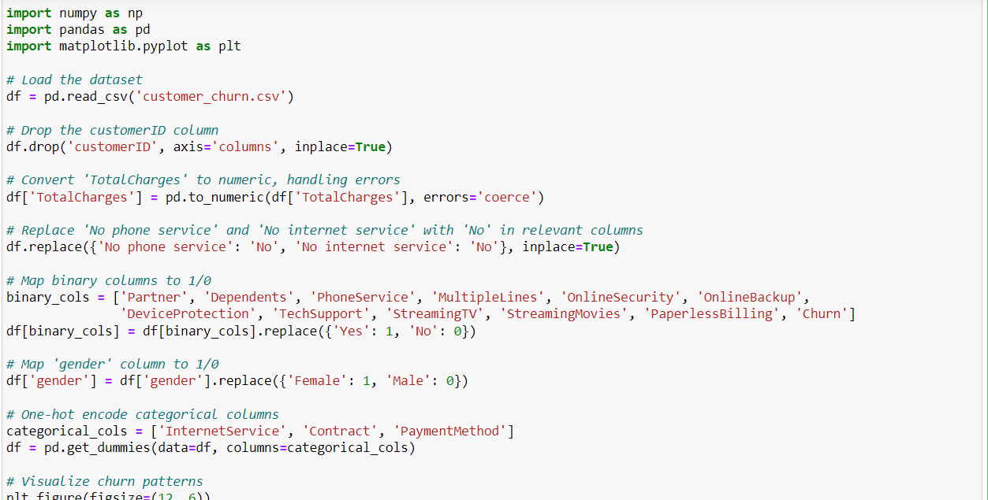

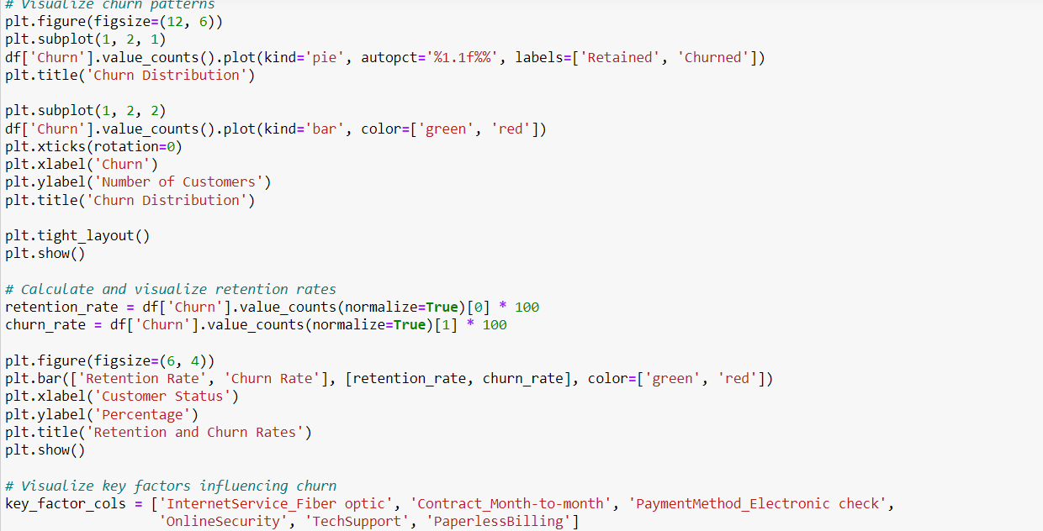

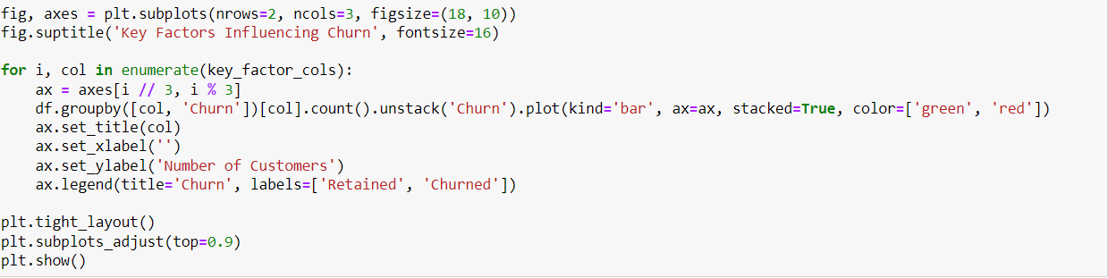

Results:-

