Automation Documentation

1. Purpose
Automate the Login and General Details flow of the KYC system using Playwright.

2. Tools
- Playwright
- TypeScript
- VS Code
- POM (Page Object Model)

3. Test Scenarios
A. Login Automation:
- Verify successful login.
- Verify playstore and Appstore re-direct link image
- Verify if user can login with invalid credential.
- Verify if user can login with empty fields.
B. General Details Automation:
- Verify if user can Navigate to General Details
- Verify if user can
- Verify if user can save their data.
- Verify if user can leave Required field empty
- Verify if user as a minor can apply for both trading and demat account.

4. Folder Structure
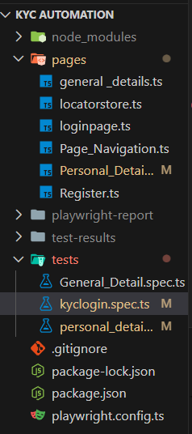

5. POM Summary
Login Page:
• LoginURL() – opens login page
• Login(username, password) – performs login
General Details Page:
• Methods to fill fields, select dropdowns, and upload documents

