BUG ANALYSER APP

23CS503 - APPLICATION DEVELOPMENT
A PROJECT REPORT

Submitted by

AKASH V (Register No: 727823TUIT005)

in partial fulfillment for the award of the degree of
BACHELOR OF TECHNOLOGY
IN
INFORMATION TECHNOLOGY



SRI KRISHNA COLLEGE OF TECHNOLOGY
An Autonomous Institution | Accredited by NAAC with 'A' Grade Affiliated to Anna University | Approved by AICTE
KOVAIPUDUR, COIMBATORE 641042

SEPTEMBER 2025

SRI KRISHNA COLLEGE OF TECHNOLOGY
An Autonomous Institution | Accredited by NAAC with 'A' Grade Affiliated to Anna University | Approved by AICTE
KOVAIPUDUR, COIMBATORE 641042

BONAFIDE CERTIFICATE

Certified that this project report “BUG ANALYSER APP” is the bonafide work of “AKASH V” who carried out the project work under my supervision.

SIGNATURE  Ms. P. MANOHARI,  SUPERVISOR,  Department of Information Technology,  Sri Krishna College of Technology,  Coimbatore -641042. | SIGNATURE  Dr. T. RAJESH KUMAR,  HEAD OF THE DEPARTMENT,  Department of Information Technology,  Sri Krishna College of Technology,  Coimbatore -641042.

Certified that the candidates were examined by us in the Project Viva Voce examination held on at Sri Krishna College of Technology, Kovaipudur, Coimbatore -641042.

INTERNAL EXAMINER

ACKNOWLEDGEMENT

First and foremost, I thank the Almighty for being our light and for
showering his gracious blessings throughout the course of this project.

I express my gratitude to our beloved Principal, Dr. M.G. Sumithra, for providing all facilities.

With the grateful heart, my sincere thanks to our Head of the Department Dr.T.RAJESH KUMAR, Department of Information Technology for the motivation and all support to complete the project work.

I am greatly indebted to our Industry Mentor Mr. E. Jeevanandham for his valuable guidance and suggestions in all aspects that aided us to ameliorate our skills.

I thank Ms.P.Manohari, Department of Information Technology for her motivation and support.

I am thankful to all the Teaching and Non-Teaching Staff of
Department of Information Technology and to all those who have
directly and indirectly extended their help to us in completing this project
work successfully.

I extend our sincere thanks to our family members and our beloved friends, who had been strongly supporting us in all our endeavor.

ABSTRACT

The Bug Analyzer Application leverages modern web technologies such as React.js, Spring Boot, and secured RESTful APIs to provide a comprehensive platform that streamlines bug tracking, analysis, and resolution for software development teams. The system offers an intuitive, user-friendly interface where developers, testers, and project managers can efficiently manage the complete bug lifecycle, while stakeholders gain powerful tools to analyze defect trends, monitor project health, and maintain software quality. By digitizing and automating traditional bug management processes, the platform ensures accuracy, accessibility, transparency, and reduced operational overhead.
Core functionalities include bug creation, tracking, assignment, and analysis, as well as advanced features such as real-time notifications, role-based dashboards, defect pattern recognition, and structured reporting through a responsive frontend integrated with secure backend services. Administrators benefit from a centralized dashboard to seamlessly manage users, projects, and system policies, while developers and testers enjoy a smooth and secure workflow with automated assignments, version control integration, and collaboration tools. The use of REST APIs ensures secure and efficient communication between the client and server, enhancing both performance and reliability.
By combining React.js’s dynamic frontend with Spring Boot’s robust backend and Spring Security, the application delivers a scalable and extensible solution that can be expanded with advanced capabilities such as predictive analytics, automated regression testing, or integration with CI/CD pipelines. This integration improves transparency, decision-making, and communication between stakeholders, ultimately enhancing software quality and delivery efficiency.
In conclusion, the Bug Analyzer Application provides a reliable and efficient digital platform that addresses the evolving needs of software development teams, ensuring streamlined bug management, enhanced quality assurance, and greater team collaboration.

TABLE OF CONTENT

CHAPTER.NO | TITLE | PAGE NO
1 | INTRODUCTION | 7
2 | SYSTEM SPECIFICATIONS | 8
3 | PROPOSED SYSTEMS | 9
4 | METHODOLOGIES | 11
5 | IMPLEMENTATION AND RESULT | 17
6 | CONCLUSION AND FUTURE SCOPE | 48
 | 6.1 CONCLUSION | 48
 | 6.2 FUTURE SCOPE | 48
7 | REFERENCES | 49

LIST OF FIGURES
FIGURE NO | TITLE | PAGE NO
1. | FLOWCHART DIAGRAM | 11
2. | USECASE DIAGRAM | 13
3. | CLASS DIAGRAM | 14
4. | SEQUENCE DIAGRAM | 15
5. | ER DIAGRAM | 16

CHAPTER 1

INTRODUCTION

In this chapter, we will present the problem statement, provide an overview, and outline the main objectives of the Bug Analyzer App.

PROBLEM STATEMENT

The Bug Analyzer Application eliminates the inefficiencies of manual and fragmented bug tracking by providing a centralized digital platform. It allows testers to submit structured bug reports with detailed metadata, while enabling developers, project managers, and administrators to handle, store, and retrieve defect records with accuracy. The system ensures a smooth, transparent, and user-friendly experience for all stakeholders involved in the software development lifecycle.
OVERVIEW
The Bug Analyzer Application is developed to streamline the process of collecting, tracking, and managing software defects within development projects. Traditional manual bug tracking methods are often time-consuming, error-prone, and difficult to maintain or analyze effectively. This system leverages React.js for a responsive and dynamic user interface and Spring Boot with secured REST APIs for efficient backend operations and secure data handling. Testers can easily submit bug reports online, while developers, project managers, and administrators benefit from a centralized dashboard to review, analyze, assign, and generate reports from the collected defect data.

OBJECTIVE

The main objective of the Bug Analyzer Application is to provide a centralized and efficient platform for tracking, analyzing, and managing software defects. The system focuses on simplifying the bug reporting process, enabling developers, testers, and project managers to easily retrieve, analyze, and manage bug records, while ensuring smooth interaction between the frontend and backend through secured REST APIs.

CHAPTER 2

SYSTEM SPECIFICATIONS

In the chapter, we are going to see the software that we have used to build the website. This chapter gives you a small description about the software used in the project.

2.1 SPRING BOOT

Spring Boot is an open-source Java-based framework developed by Pivotal (now part of VMware) that is used to create stand-alone, production-ready Spring applications with minimal configuration. It simplifies the development process by providing pre-configured templates and reducing the amount of boilerplate code required to set up a Spring application.

Spring Boot is built on top of the Spring Framework and provides features such as embedded servers (like Tomcat, Jetty, or Undertow), which eliminate the need to deploy applications to an external server. This makes it easy for developers to run and test applications directly.

It also supports auto-configuration, which automatically sets up the application based on the dependencies added, saving developers time and effort. Spring Boot includes a wide range of built-in tools for monitoring, security, logging, and performance optimization, making it highly suitable for enterprise-level applications.

Spring Boot follows a microservices architecture, allowing developers to build scalable and modular applications. It integrates well with databases, RESTful APIs, and cloud services, which makes it a powerful choice for back-end development.

Spring Boot is widely used because it is efficient, easy to configure, and highly flexible. It allows developers to focus more on writing business logic rather than worrying about infrastructure setup, making it an ideal framework for modern web application backends.

2.2 REACT JS

React JS is an open-source JavaScript library developed by Facebook for building user interfaces, particularly single-page applications where data changes dynamically without reloading the page. React focuses on building reusable UI components, making the development process faster and more efficient.

React uses a component-based architecture, where each part of the UI is divided into independent, reusable components. These components can manage their own state and can be combined to create complex UIs. React also uses a virtual DOM (Document Object Model) that improves performance by updating only the changed parts of the page instead of re-rendering the entire page.

React has strong community support and provides a wide range of libraries and tools that can be integrated to extend its functionality. It supports JSX, which allows developers to write HTML-like syntax directly within JavaScript, making code more readable and easier to maintain. Additionally, React can be easily integrated with other libraries and frameworks, and it supports server-side rendering for improved performance.

React JS is widely used for developing modern web applications because it is fast, scalable, and flexible. Its ability to manage dynamic data and provide a smooth user experience makes it an excellent choice for front-end development.

CHAPTER 3
PROPOSED SYSTEM
This chapter provides a brief description of the proposed concept and functionality behind the development of the Bug Analyzer App.

3.1 PROPOSED SYSTEM
The Bug Analyzer Application offers numerous benefits from both the administrative and development team perspectives. This platform enables project managers, developers, testers, and stakeholders to efficiently manage bug reports, analyze defect patterns, and track overall project health — all from a centralized interface. The system takes into account detailed bug reports, including severity, priority, environment, and reproduction steps, to streamline defect resolution processes and enhance the overall quality of software development and project management.
The system simplifies key processes, allowing testers to submit and update bug reports in real time, while developers can easily view assignments, track progress, and resolve issues efficiently. Project managers benefit from comprehensive dashboards that provide insights into project health, sprint progress, and team productivity, while administrators can oversee role-based access, user management, and security compliance through a centralized platform.
Once a bug report is submitted, it is automatically stored in the database and can be retrieved instantly by authorized users. Team members can review the details, analyze trends, collaborate through comments and attachments, and maintain a well-structured repository of all defect data for future reference. The system ensures that information is accurate, secure, and easily accessible, enabling smooth workflow management and traceability.
By automating routine tasks such as bug assignment, escalation, and notification management, the Bug Analyzer Application reduces manual effort, prevents inconsistencies, and improves overall efficiency in handling defect data. Testers and developers benefit from a streamlined reporting and resolution process, while project managers and stakeholders gain better control over defect analysis, quality metrics, and decision-making.

3.2 ADVANTAGES

• Efficiency: The system automates bug reporting, assignment, and tracking, reducing the time and effort required for manual defect management.
• Centralized Management: All bug reports, comments, attachments, and status updates are stored and maintained in a single platform, ensuring quick and accurate retrieval and analysis.
• Accessibility: Developers, testers, project managers, and stakeholders can access the system securely from any location through a responsive web interface with mobile compatibility.
• Transparency: The platform ensures clear bug submission, real-time status tracking, and accurate records, improving visibility, trust, and accountability across teams.
• Conflict Prevention: Automated workflows minimize errors, duplication, and inconsistencies in bug records, ensuring smooth defect resolution.
• Scalability: The system is designed to support future enhancements such as predictive analytics, CI/CD integration, AI-based bug classification, and advanced reporting without disrupting existing workflows.
• Data-Driven Decisions: Structured defect data, quality metrics, and advanced analytics help teams identify root causes, track performance, and make informed improvements in software quality.

CHAPTER 4
METHODOLOGIES
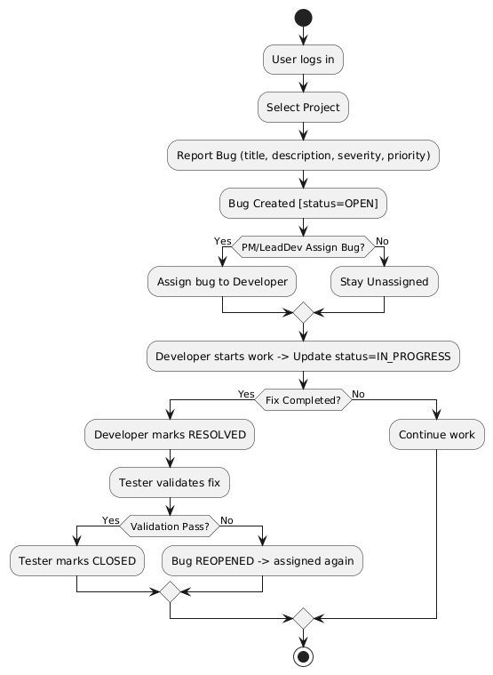
User Registration & Login:
Developers, testers, project managers, stakeholders, and administrators register on the platform by providing essential details such as name, ID, department, and role. Optional details like email, skill set, and contact number can also be included for better record management.
Role-Based Access:
Upon login, users are assigned roles such as Tester, Developer, Project Manager, Stakeholder, or Admin, which determine their permissions and accessible features within the system.
Bug Reporting (Tester Role):
Testers can log in, view assigned projects, and submit detailed bug reports with severity, priority, and attachments. The submitted bugs are securely stored in the database for further tracking.
Bug Assignment & Resolution (Developer Role):
Developers can log in and access their assigned bugs. They can update statuses, add comments, attach files, and resolve issues while tracking workload and progress.
Project Oversight & Reports (Manager Role):
Project managers can monitor bug trends, team performance, and project health. They can assign resources, track sprint progress, and generate structured reports for stakeholders.
System Oversight & Policy Management (Admin Role):
Administrators have full control over the system. They can manage users, projects, permissions, and monitor bug workflows to ensure compliance and data integrity.
Status & Transparency:
The system ensures transparency by providing real-time bug status updates, notifications, and accurate reports for all roles, improving accountability and visibility.
Data Storage & Retrieval:
A secure database integrated with Spring Boot stores all bug records, attachments, and activity logs, ensuring fast and efficient storage, retrieval, and analysis.
Admin Dashboard:
Administrators can oversee all projects, manage records, monitor activities, and generate consolidated reports that support decision-making and continuous software quality improvement.

Use Case Diagram:

The Bug Analyzer Application use case diagram illustrates the interactions between four main actors—testers, developers, project managers, and administrators—with various system functionalities. Testers can register or log in to the system to report bugs with severity, priority, and attachments, as well as track their submissions. Developers can log in to view and update assigned bugs, add comments, resolve issues, and manage their workload. Project managers monitor bug trends, assign tasks, review project health, and generate structured reports for stakeholders. Administrators oversee the entire system by managing users, projects, and workflows, while ensuring data integrity and compliance. The diagram highlights how the system streamlines defect reporting, resolution, and monitoring by enabling testers to log issues, developers to resolve them, managers to track progress, and administrators to maintain accurate records and reports for continuous quality improvement.
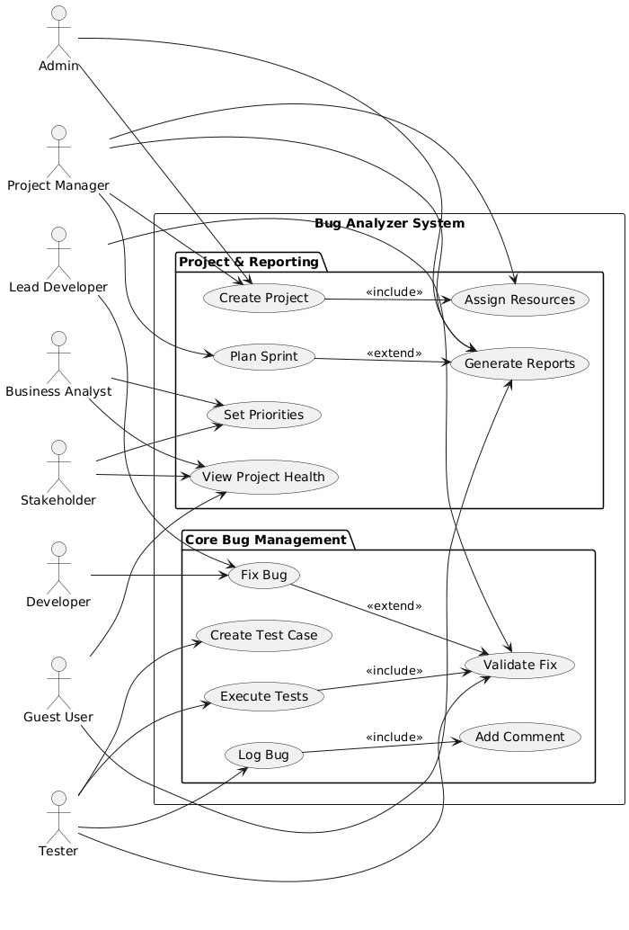

Class Diagram:

The Bug Analyzer Application is designed to manage interactions between testers, developers, project managers, and administrators through bug reporting, resolution, and monitoring. Testers can register, log in, select projects, and submit bug reports with severity, priority, and comments. Developers can log in to access assigned bugs, update statuses, add notes, and resolve issues while maintaining accurate records. Project managers oversee progress by tracking bug trends, monitoring team performance, and generating structured reports for stakeholders. Administrators manage the overall system by handling users, projects, and workflows, as well as ensuring data integrity and compliance. Each bug report links a tester to a project or module and is securely stored for future reference. Notifications and status updates provide transparency in reporting and resolution processes. Overall, the system streamlines defect management by integrating user roles, structured reporting, and real-time tracking into a unified platform.
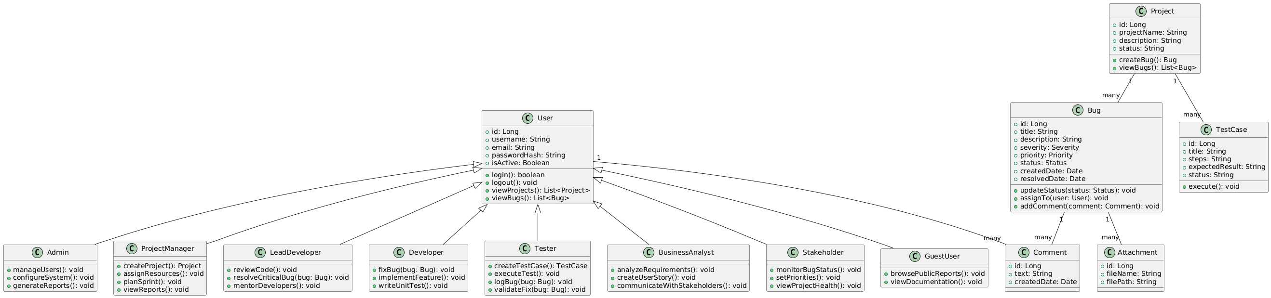

Sequence Diagram:

This sequence diagram represents the workflow of the Bug Analyzer Application, showing how different services interact during the process of reporting and resolving a bug. A tester begins by logging in with a username and password, which is validated by the login service to check if the user exists. Once the credentials are confirmed as valid, the tester proceeds to select a project and submit a bug report with details such as severity, priority, and description. The bug service processes the report and stores it securely in the database. Once stored successfully, a confirmation response is returned to the tester, ensuring that the bug has been recorded. Developers can later log in to access the stored bug reports through the bug tracking service, update the status, and resolve issues. Project managers log in to monitor bug trends and generate structured reports, while administrators manage users, projects, and overall workflows. This ensures a smooth flow from login to bug reporting, storage, resolution, and report generation.

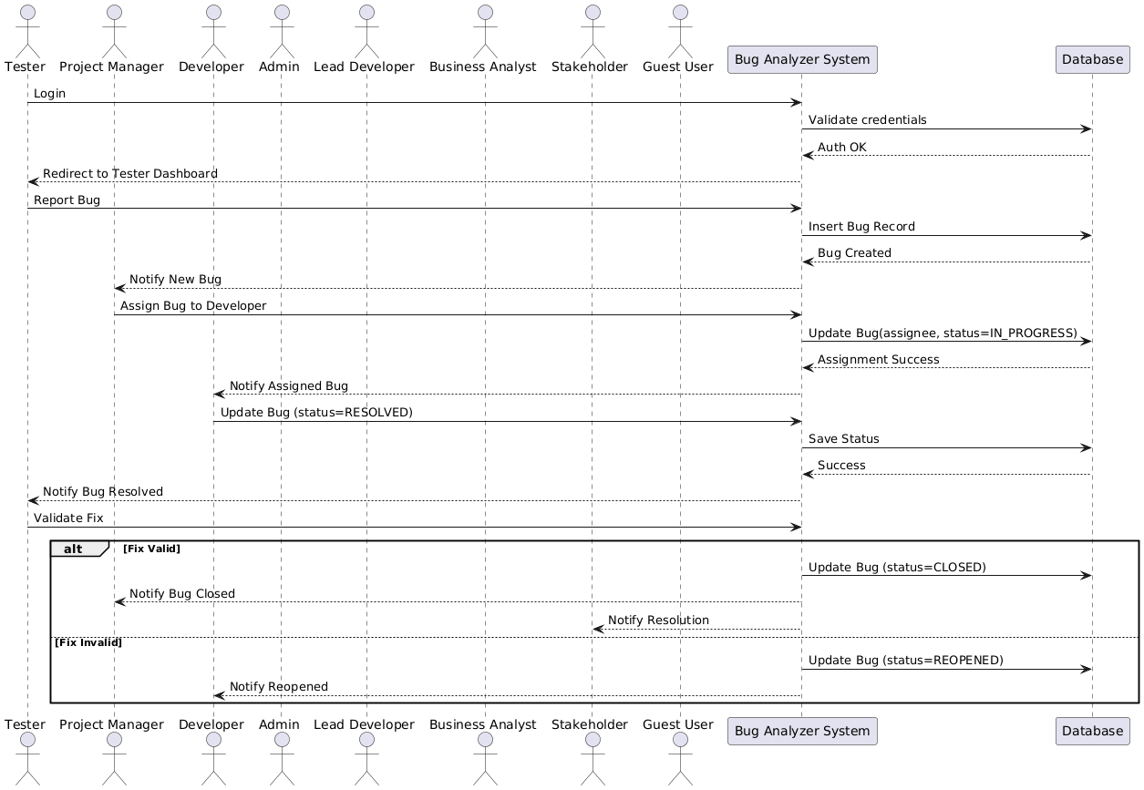
ER Diagram:

This sequence diagram illustrates the process flow of the Bug Analyzer Application, where a tester first logs in by entering a username and password, which the login service validates to confirm if the user exists. Upon successful validation, the tester proceeds to select a project and submit a bug report containing details such as severity, priority, and description. The bug service receives the submission and stores it securely in the database. Once stored successfully, the system sends a confirmation message to the tester, ensuring that the bug has been recorded. Later, developers can log in to access and update bug reports, changing their status and resolving issues. Project managers can log in to monitor bug progress, track trends, and generate structured reports, while administrators oversee records, manage users, and handle workflows. This ensures a smooth end-to-end interaction from login to bug reporting, storage, resolution, and reporting.

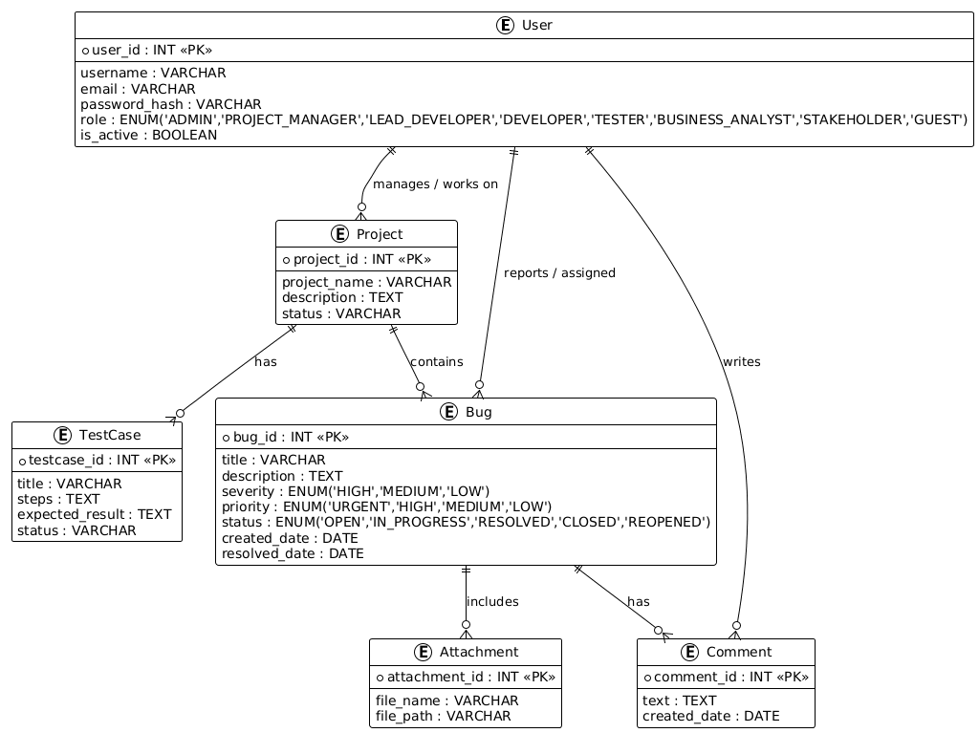

4.5 Entity Relationship Diagram

5.1 Login Page:

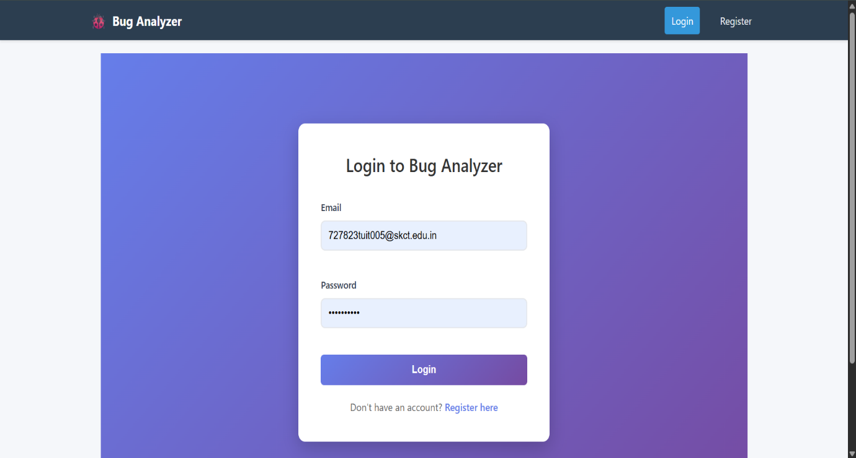

5.1 Login Page

5.2 Register Page:

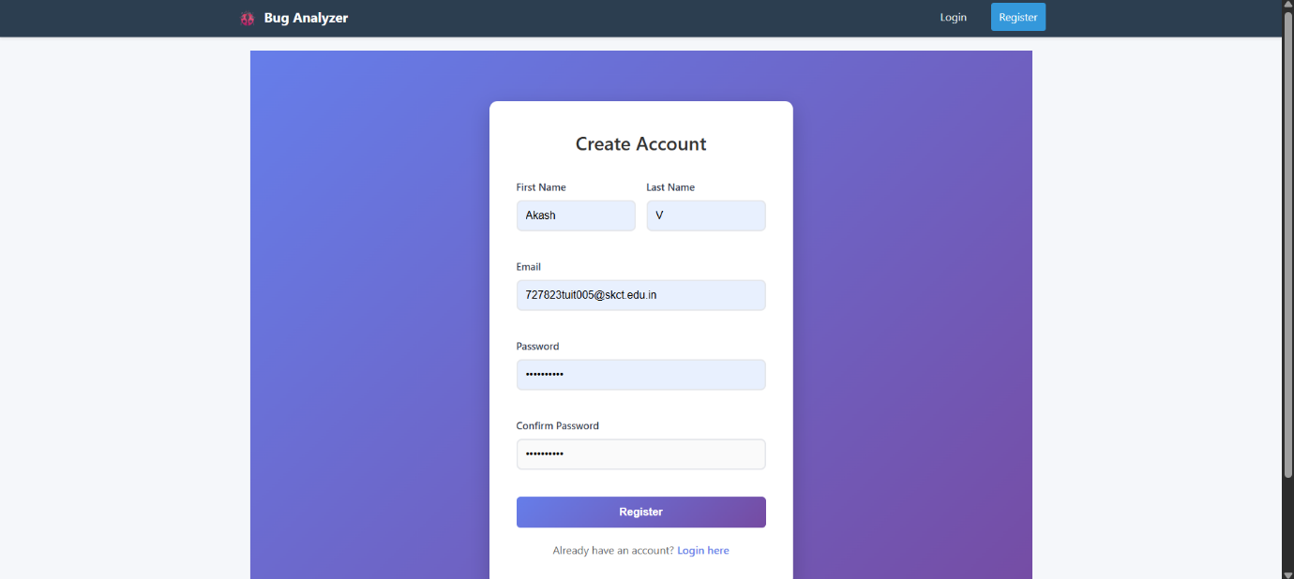

5.2 Register Page
5.3 Dashboard Page:

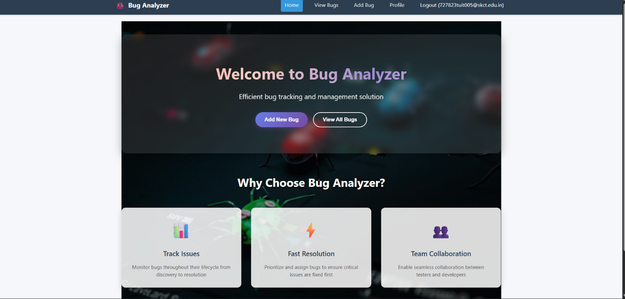

5.3 Dashboard Page

5.4 AddBug Page:

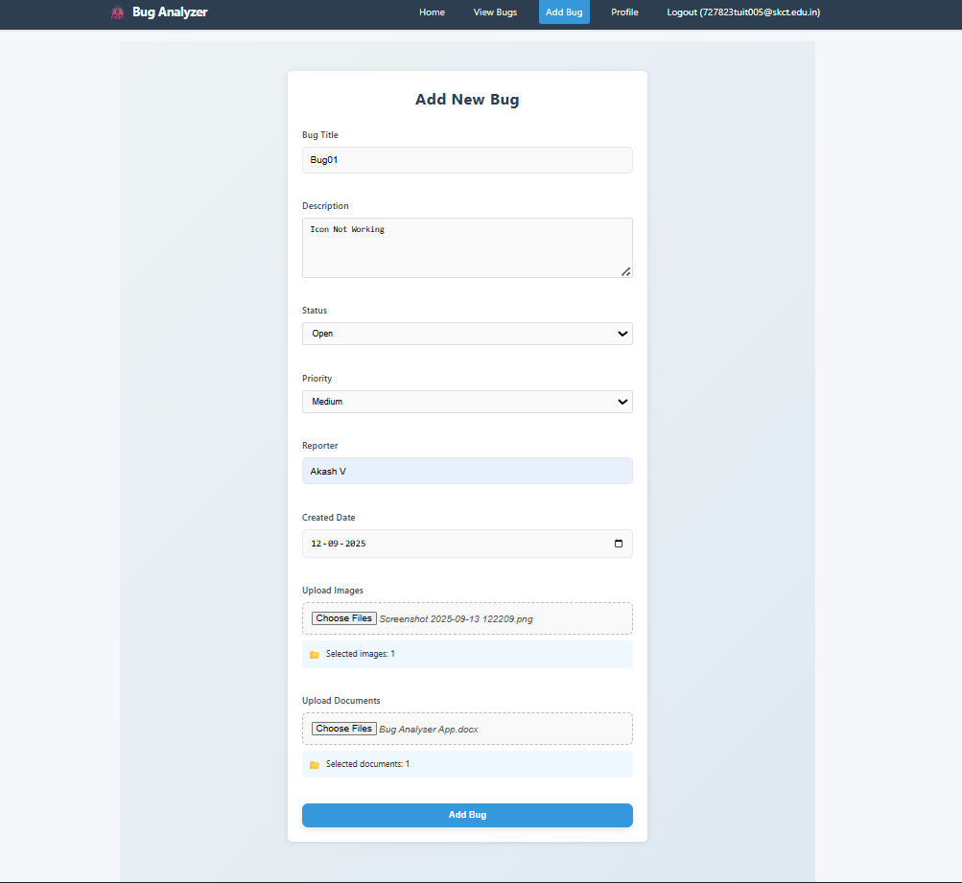

5.4 AddBug Page

5.5 ViewBug Page:

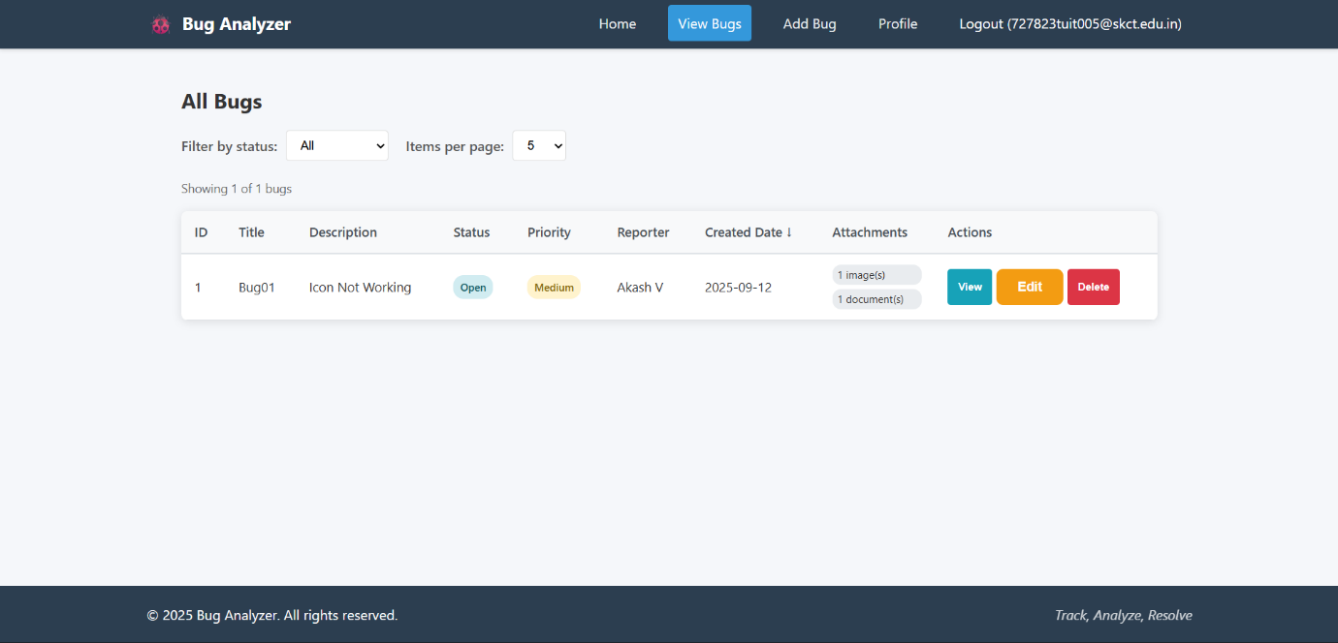

5.5 ViewBug Page

5.5 Coding:

Frontend:

AddBug.jsx
import React, { useState } from "react";
import { useNavigate } from "react-router-dom";
import API_BASE_URL from "../api";

function AddBug() {
const navigate = useNavigate();
const [bug, setBug] = useState({
title: "",
description: "",
status: "",
priority: "",
reporter: "",
createdDate: "",
});

const handleChange = (e) => {
setBug({ ...bug, [e.target.name]: e.target.value });
};

const handleSubmit = async (e) => {
e.preventDefault();

const bugToSubmit = {
...bug,
createdDate: bug.createdDate || new Date().toISOString().split("T")[0],
};

try {
const res = await fetch(`${API_BASE_URL}/bugs`, {
method: "POST",
headers: { "Content-Type": "application/json" },
body: JSON.stringify(bugToSubmit),
});

if (res.ok) {
window.alert("Bug added successfully!");
setBug({
title: "",
description: "",
status: "",
priority: "",
reporter: "",
createdDate: "",
});
navigate("/view", { replace: true });
window.location.reload(); // ✅ refresh list after add
} else {
window.alert("Failed to add bug.");
}
} catch (error) {
console.error("Error adding bug:", error);
window.alert("Error adding bug.");
}
};

return (
<div style={{ maxWidth: "450px", margin: "30px auto", padding: "25px", background: "#ffffff", borderRadius: "12px", boxShadow: "0 4px 12px rgba(0,0,0,0.1)", textAlign: "center" }}>
<h2 style={{ marginBottom: "20px", color: "#333" }}>Add New Bug</h2>
<form style={{ display: "flex", flexDirection: "column", gap: "12px" }} onSubmit={handleSubmit}>
<input name="title" placeholder="Bug Title" value={bug.title} onChange={handleChange} required />
<input name="description" placeholder="Description" value={bug.description} onChange={handleChange} required />
<input name="status" placeholder="Status" value={bug.status} onChange={handleChange} required />
<input name="priority" placeholder="Priority" value={bug.priority} onChange={handleChange} required />
<input name="reporter" placeholder="Reporter" value={bug.reporter} onChange={handleChange} required />
<input type="date" name="createdDate" value={bug.createdDate} onChange={handleChange} />
<button type="submit" style={{ padding: "12px", background: "#007bff", color: "white", border: "none", borderRadius: "6px", fontSize: "16px" }}>
Add Bug
</button>
</form>
</div>
);
}

export default AddBug;
Footer.jsx
import React from "react";

function Footer() {
return (
<footer style={{ textAlign: "center", padding: "10px", background: "#f4f4f4" }}>
<p>&copy; {new Date().getFullYear()} Bug Analyzer</p>
</footer>
);
}

export default Footer;
Home.jsx

import React from "react";
import { useNavigate } from "react-router-dom";

function Home() {
const navigate = useNavigate();

const styles = {
container: {
textAlign: "center",
marginTop: "60px",
},
heading: {
fontSize: "24px",
marginBottom: "20px",
color: "#333",
},
button: {
margin: "10px",
padding: "12px 24px",
fontSize: "16px",
border: "none",
borderRadius: "8px",
cursor: "pointer",
transition: "all 0.3s ease",
background: "#007bff",
color: "white",
},
buttonHover: {
background: "#0056b3",
},
};

return (
<div style={styles.container}>
<h1 style={styles.heading}>Welcome to Bug Analyzer</h1>
<button
style={styles.button}
onMouseOver={(e) =>
(e.target.style.background = styles.buttonHover.background)
}
onMouseOut={(e) => (e.target.style.background = styles.button.background)}
onClick={() => navigate("/add")}
>
Add New Bug
</button>
<button
style={styles.button}
onMouseOver={(e) =>
(e.target.style.background = styles.buttonHover.background)
}
onMouseOut={(e) => (e.target.style.background = styles.button.background)}
onClick={() => navigate("/view")}
>
View All Bugs
</button>
</div>
);
}

export default Home;
Navbar.jsx
import React from "react";
import { Link } from "react-router-dom";
import "../styles/Navbar.css";

function Navbar() {
return (
<nav className="navbar">
<h2 className="navbar-logo">Bug Analyzer</h2>
<ul className="navbar-links">
<li>
<Link to="/">Home</Link>
</li>
<li>
<Link to="/view">View Bugs</Link>
</li>
<li>
<Link to="/add">Add Bug</Link>
</li>
</ul>
</nav>
);
}

export default Navbar;
UpdateBug.jsx
import React, { useEffect, useState } from "react";
import { useParams, useNavigate } from "react-router-dom";
import API_BASE_URL from "../api";

function UpdateBug() {
const { id } = useParams();
const navigate = useNavigate();
const [bug, setBug] = useState({
title: "",
description: "",
status: "",
priority: "",
reporter: "",
createdDate: "",
});

useEffect(() => {
fetch(`${API_BASE_URL}/bugs/${id}`)
.then((res) => res.json())
.then((data) => setBug(data))
.catch((err) => console.error("Error fetching bug:", err));
}, [id]);

const handleChange = (e) => {
setBug({ ...bug, [e.target.name]: e.target.value });
};

const handleSubmit = async (e) => {
e.preventDefault();
try {
const res = await fetch(`${API_BASE_URL}/bugs/${id}`, {
method: "PUT",
headers: { "Content-Type": "application/json" },
body: JSON.stringify(bug),
});

if (res.ok) {
window.alert("Bug updated successfully!");
navigate("/view");
} else {
window.alert("Failed to update bug.");
}
} catch (error) {
console.error("Error updating bug:", error);
window.alert("Error updating bug.");
}
};

// Reuse styles
const styles = {
container: {
maxWidth: "450px",
margin: "30px auto",
padding: "25px",
background: "#ffffff",
borderRadius: "12px",
boxShadow: "0 4px 12px rgba(0,0,0,0.1)",
textAlign: "center",
},
heading: {
marginBottom: "20px",
color: "#333",
},
form: {
display: "flex",
flexDirection: "column",
gap: "12px",
},
input: {
padding: "12px",
border: "1px solid #ccc",
borderRadius: "6px",
fontSize: "14px",
transition: "all 0.3s ease",
},
button: {
padding: "12px",
background: "#28a745",
color: "white",
border: "none",
borderRadius: "6px",
fontSize: "16px",
cursor: "pointer",
transition: "background 0.3s ease",
},
buttonHover: {
background: "#1e7e34",
},
};

return (
<div style={styles.container}>
<h2 style={styles.heading}>Update Bug</h2>
<form style={styles.form} onSubmit={handleSubmit}>
<input
style={styles.input}
name="title"
value={bug.title}
onChange={handleChange}
placeholder="Bug Title"
required
/>
<input
style={styles.input}
name="description"
value={bug.description}
onChange={handleChange}
placeholder="Description"
required
/>
<input
style={styles.input}
name="status"
value={bug.status}
onChange={handleChange}
placeholder="Status"
required
/>
<input
style={styles.input}
name="priority"
value={bug.priority}
onChange={handleChange}
placeholder="Priority"
required
/>
<input
style={styles.input}
name="reporter"
value={bug.reporter}
onChange={handleChange}
placeholder="Reporter"
required
/>
<input
style={styles.input}
type="date"
name="createdDate"
value={bug.createdDate}
onChange={handleChange}
/>
<button
type="submit"
style={styles.button}
onMouseOver={(e) =>
(e.target.style.background = styles.buttonHover.background)
}
onMouseOut={(e) =>
(e.target.style.background = styles.button.background)
}
>
Update Bug
</button>
</form>
</div>
);
}

export default UpdateBug;
ViewBugDetails.jsx
import React, { useEffect, useState } from "react";
import { useParams, Link } from "react-router-dom";
import API_BASE_URL from "../api";

function ViewBugDetails() {
const { id } = useParams();
const [bug, setBug] = useState(null);

useEffect(() => {
fetch(`${API_BASE_URL}/bugs/${id}`)
.then((res) => res.json())
.then((data) => setBug(data))
.catch((err) => console.error("Error fetching bug details:", err));
}, [id]);

if (!bug) {
return <p>Loading bug details...</p>;
}

return (
<div style={{ padding: "20px" }}>
<h2>Bug Details</h2>
<p><strong>Title:</strong> {bug.title}</p>
<p><strong>Description:</strong> {bug.description}</p>
<p><strong>Status:</strong> {bug.status}</p>
<p><strong>Priority:</strong> {bug.priority}</p>
<p><strong>Reporter:</strong> {bug.reporter}</p>
<p><strong>Created Date:</strong> {bug.createdDate}</p>

<Link to="/view">⬅ Back to Bugs</Link>
</div>
);
}

export default ViewBugDetails;
ViewBugs.jsx
import React, { useEffect, useState } from "react";
import { useNavigate } from "react-router-dom";
import API_BASE_URL from "../api";

function ViewBugs() {
const [bugs, setBugs] = useState([]);
const navigate = useNavigate();

const fetchBugs = () => {
fetch(`${API_BASE_URL}/bugs`)
.then((res) => res.json())
.then((data) => setBugs(data))
.catch((err) => console.error("Error fetching bugs:", err));
};

useEffect(() => {
fetchBugs();
}, []);

const handleDelete = async (id) => {
if (window.confirm("Are you sure you want to delete this bug?")) {
try {
const res = await fetch(`${API_BASE_URL}/bugs/${id}`, {
method: "DELETE",
});
if (res.ok) {
window.alert("Bug deleted successfully!");
fetchBugs(); // ✅ refresh after delete
} else {
window.alert("Failed to delete bug.");
}
} catch (error) {
console.error("Error deleting bug:", error);
window.alert("Error deleting bug.");
}
}
};

return (
<div style={{ maxWidth: "1000px", margin: "30px auto", padding: "20px", background: "#fff", borderRadius: "12px", boxShadow: "0 4px 12px rgba(0,0,0,0.1)" }}>
<h2 style={{ textAlign: "center", marginBottom: "20px", color: "#333" }}>All Bugs</h2>
<table style={{ width: "100%", borderCollapse: "collapse" }}>
<thead>
<tr>
<th style={{ background: "#007bff", color: "white", padding: "12px", border: "1px solid #ddd" }}>ID</th>
<th style={{ background: "#007bff", color: "white", padding: "12px", border: "1px solid #ddd" }}>Title</th>
<th style={{ background: "#007bff", color: "white", padding: "12px", border: "1px solid #ddd" }}>Description</th>
<th style={{ background: "#007bff", color: "white", padding: "12px", border: "1px solid #ddd" }}>Status</th>
<th style={{ background: "#007bff", color: "white", padding: "12px", border: "1px solid #ddd" }}>Priority</th>
<th style={{ background: "#007bff", color: "white", padding: "12px", border: "1px solid #ddd" }}>Reporter</th>
<th style={{ background: "#007bff", color: "white", padding: "12px", border: "1px solid #ddd" }}>Created Date</th>
<th style={{ background: "#007bff", color: "white", padding: "12px", border: "1px solid #ddd" }}>Actions</th>
</tr>
</thead>
<tbody>
{bugs.map((bug) => (
<tr key={bug.id}>
<td style={{ padding: "12px", border: "1px solid #ddd", textAlign: "center" }}>{bug.id}</td>
<td style={{ padding: "12px", border: "1px solid #ddd", textAlign: "center" }}>{bug.title}</td>
<td style={{ padding: "12px", border: "1px solid #ddd", textAlign: "center" }}>{bug.description}</td>
<td style={{ padding: "12px", border: "1px solid #ddd", textAlign: "center" }}>{bug.status}</td>
<td style={{ padding: "12px", border: "1px solid #ddd", textAlign: "center" }}>{bug.priority}</td>
<td style={{ padding: "12px", border: "1px solid #ddd", textAlign: "center" }}>{bug.reporter}</td>
<td style={{ padding: "12px", border: "1px solid #ddd", textAlign: "center" }}>{bug.createdDate}</td>
<td style={{ padding: "12px", border: "1px solid #ddd", textAlign: "center" }}>
<button
style={{ padding: "6px 12px", marginRight: "6px", background: "#ffc107", border: "none", borderRadius: "6px", cursor: "pointer" }}
onClick={() => navigate(`/update/${bug.id}`)}
>
Edit
</button>
<button
style={{ padding: "6px 12px", background: "#dc3545", border: "none", color: "#fff", borderRadius: "6px", cursor: "pointer" }}
onClick={() => handleDelete(bug.id)}
>
Delete
</button>
</td>
</tr>
))}
</tbody>
</table>
</div>
);
}

export default ViewBugs;
Footer.css
footer {
text-align: center;
padding: 12px;
background: #333;
color: white;
font-size: 14px;
position: relative;
bottom: 0;
width: 100%;
}

Form.css
.form-container {
max-width: 400px;
margin: auto;
padding: 20px;
background: #fafafa;
border-radius: 8px;
box-shadow: 0 2px 4px rgba(0,0,0,0.1);
}

.form-container input,
.form-container button {
display: block;
width: 100%;
margin: 8px 0;
padding: 10px;
}

.form-container button {
background: #007bff;
color: white;
border: none;
cursor: pointer;
}

Home.css
.home-container {
text-align: center;
padding: 40px;
}

.home-image {
max-width: 500px;
margin-bottom: 20px;
border-radius: 12px;
}

.home-buttons {
margin-top: 20px;
}

.home-buttons .btn {
background: #222;
color: white;
padding: 12px 24px;
margin: 0 10px;
text-decoration: none;
border-radius: 6px;
}

.home-buttons .btn:hover {
background: #444;
}

Navbar.css
.navbar {
display: flex;
justify-content: space-between;
align-items: center;
background: #222;
color: white;
padding: 10px 20px;
}

.navbar-logo {
font-size: 20px;
}

.navbar-links {
list-style: none;
display: flex;
gap: 15px;
}

.navbar-links li a {
color: white;
text-decoration: none;
}

Backend:

Bug.java (Model)
package com.examly.springapp.model;

import jakarta.persistence.*;
import java.time.LocalDate;

@Entity
public class Bug {

@Id
@GeneratedValue(strategy = GenerationType.IDENTITY)
private Long bugId;

private String title;
private String description;
private String status;
private String priority;
private String reporter;
private LocalDate createdDate;

public Bug() {}

public Long getBugId() {
return bugId;
}
public void setBugId(Long bugId) {
this.bugId = bugId;
}

public String getTitle() {
return title;
}
public void setTitle(String title) {
this.title = title;
}

public String getDescription() {
return description;
}
public void setDescription(String description) {
this.description = description;
}

public String getStatus() {
return status;
}
public void setStatus(String status) {
this.status = status;
}

public String getPriority() {
return priority;
}
public void setPriority(String priority) {
this.priority = priority;
}

public String getReporter() {
return reporter;
}
public void setReporter(String reporter) {
this.reporter = reporter;
}

public LocalDate getCreatedDate() {
return createdDate;
}
public void setCreatedDate(LocalDate createdDate) {
this.createdDate = createdDate;
}
}

BugRepository.java
package com.examly.springapp.repository;

import org.springframework.data.jpa.repository.JpaRepository;
import com.examly.springapp.model.Bug;

public interface BugRepository extends JpaRepository<Bug, Long> {
}

3. BugService.java
package com.examly.springapp.service;

import com.examly.springapp.model.Bug;
import com.examly.springapp.repository.BugRepository;
import org.springframework.stereotype.Service;
import org.springframework.data.domain.Page;
import org.springframework.data.domain.Pageable;

import java.util.List;
import java.util.Optional;

@Service
public class BugService {

private final BugRepository bugRepository;

public BugService(BugRepository bugRepository) {
this.bugRepository = bugRepository;
}
public Bug addBug(Bug bug) {
return bugRepository.save(bug);
}
public List<Bug> getAllBugs() {
return bugRepository.findAll();
}

public Optional<Bug> getBugById(Long id) {
return bugRepository.findById(id);
}

public Bug updateBug(Long id, Bug updatedBug) {
return bugRepository.findById(id).map(bug -> {
bug.setTitle(updatedBug.getTitle());
bug.setDescription(updatedBug.getDescription());
bug.setStatus(updatedBug.getStatus());
bug.setPriority(updatedBug.getPriority());
bug.setReporter(updatedBug.getReporter());
bug.setCreatedDate(updatedBug.getCreatedDate());
return bugRepository.save(bug);
}).orElseThrow(() -> new RuntimeException("Bug not found with id " + id));
}

public void deleteBug(Long id) {
bugRepository.deleteById(id);
}

public Page<Bug> getBugsPaginated(Pageable pageable) {
return bugRepository.findAll(pageable);
}
}

BugController.java

package com.examly.springapp.controller;

import com.examly.springapp.model.Bug;
import com.examly.springapp.service.BugService;
import org.springframework.http.ResponseEntity;
import org.springframework.web.bind.annotation.*;

import org.springframework.data.domain.Page;
import org.springframework.data.domain.Pageable;
import org.springframework.data.domain.PageRequest;
import org.springframework.data.domain.Sort;

import java.util.List;

@RestController
@RequestMapping("/bugs")

public class BugController {

private final BugService bugService;

public BugController(BugService bugService) {
this.bugService = bugService;
}
@PostMapping()
public ResponseEntity<Bug> createBug(@RequestBody Bug bug) {
return ResponseEntity.ok(bugService.addBug(bug));
}

@GetMapping()
public ResponseEntity<List<Bug>> getAllBugs() {
return ResponseEntity.ok(bugService.getAllBugs());
}

@GetMapping("/{id}")
public ResponseEntity<Bug> getBugById(@PathVariable Long id) {
return bugService.getBugById(id)
.map(ResponseEntity::ok)
.orElse(ResponseEntity.notFound().build());
}

@PutMapping("/{id}")
public ResponseEntity<Bug> updateBug(@PathVariable Long id, @RequestBody Bug bug) {
return ResponseEntity.ok(bugService.updateBug(id, bug));
}

@DeleteMapping("/{id}")
public ResponseEntity<Void> deleteBug(@PathVariable Long id) {
bugService.deleteBug(id);
return ResponseEntity.noContent().build();
}

@GetMapping("/paginated")
public ResponseEntity<Page<Bug>> getBugsPaginated(
@RequestParam(defaultValue = "0") int page,
@RequestParam(defaultValue = "5") int size,
@RequestParam(defaultValue = "createdDate") String sortBy,
@RequestParam(defaultValue = "desc") String direction) {

Sort sort = direction.equalsIgnoreCase(Sort.Direction.ASC.name())
? Sort.by(sortBy).ascending()
: Sort.by(sortBy).descending();

Pageable pageable = PageRequest.of(page, size, sort);
Page<Bug> bugs = bugService.getBugsPaginated(pageable);
return ResponseEntity.ok(bugs);
}
}

CHAPTER 6
CONCLUSION
This chapter presents the conclusion derived from the Bug Analyzer App project and the learning outcomes from developing this solution.

6.1 CONCLUSION

In conclusion, the proposed Bug Analyzer Application aims to streamline the management of users, projects, bug reports, and workflows in a structured and efficient way. By providing features such as bug reporting, tracking, resolution, and report generation, the system minimizes manual effort, reduces errors, and enhances communication between testers, developers, project managers, and administrators. It ensures transparency, reliability, and accessibility, creating a seamless digital experience for all users.
Furthermore, the platform is scalable and adaptable for both small teams and large software enterprises. By automating defect management processes and offering insightful data for decision-making, the system improves coordination, optimizes resource utilization, and builds trust across development teams. Overall, this solution not only simplifies the bug tracking process for testers and developers but also empowers organizations to improve software quality and operate more effectively.

6.2 FUTURE SCOPE

- AI-Powered Bug Insights:
Integration of AI algorithms to analyze bug data, detect recurring issues, predict potential defects, and suggest resolutions based on historical trends and project patterns.
- Enhanced Security & Authentication:
Implementing advanced login security with two-factor authentication, role-based access control, and encrypted data storage to ensure safe handling of user, project, and bug information.
- Mobile Application Development:
Expanding the platform into a mobile app with features such as bug reporting, notifications, reminders for pending tasks, and seamless communication between testers, developers, and managers.
- Analytics and Performance Tracking:
Building dashboards and analytics tools for project managers and administrators to monitor bug trends, resolution times, developer performance, and overall project health.
- Integration with Reporting Tools:
Seamless generation of bug reports and insights that can be exported or shared for project reviews, quality assurance, and decision-making.
- Remote Bug Reporting:
Incorporating web forms, APIs, and CI/CD integrations to allow testers and systems to report bugs remotely, ensuring timely and wider defect coverage.
- Bug Rating and Prioritization Mechanism:
Introducing a structured system where testers and project managers can rate bug severity, assign priority levels, and provide detailed descriptions to streamline resolution and enhance software quality.

CHAPTER 7
REFERENCES
- Bug Tracking System by harshitbansal05 – GitHub: https://github.com/harshitbansal05/Bug-Tracking-System
- Bug Tracker Project in Java – GitHub: https://github.com/topics/bug-tracker-java
- Open Source Bug Tracker Tools – GitHub: https://github.com/topics/bug-tracker
- Bug Tracking System in PHP and MySQL – SourceCodester: https://www.sourcecodester.com/php/16175/bug-tracking-system-php-and-mysql-free-source-code.html
- Bugzilla – Official Site: https://www.bugzilla.org
- Jira Software by Atlassian – Atlassian: https://www.atlassian.com/software/jira
- MantisBT (Mantis Bug Tracker) – MantisBT: https://www.mantisbt.org
- Redmine Issue & Bug Tracker – Redmine: https://www.redmine.org
- Trac – Bug Tracking Tool – Trac: https://trac.edgewall.org
- Zoho BugTracker – Zoho: https://www.zoho.com/bugtracker/

