BUG ANALYZER APPLICATION(727823TUIT005-AKASH V)

UML Diagrams :

UseCase Diagram : 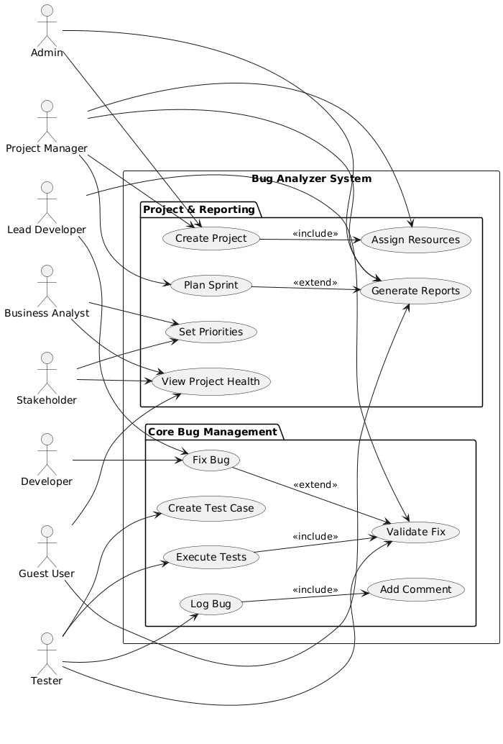

Class Diagram :
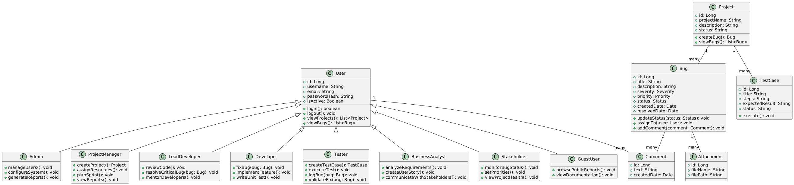

Flow Diagram :
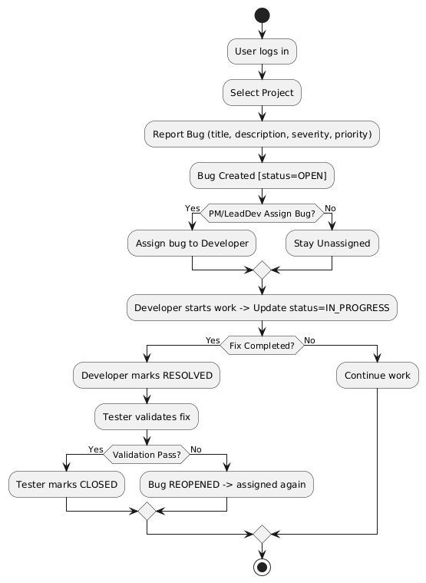

Sequence Diagram :
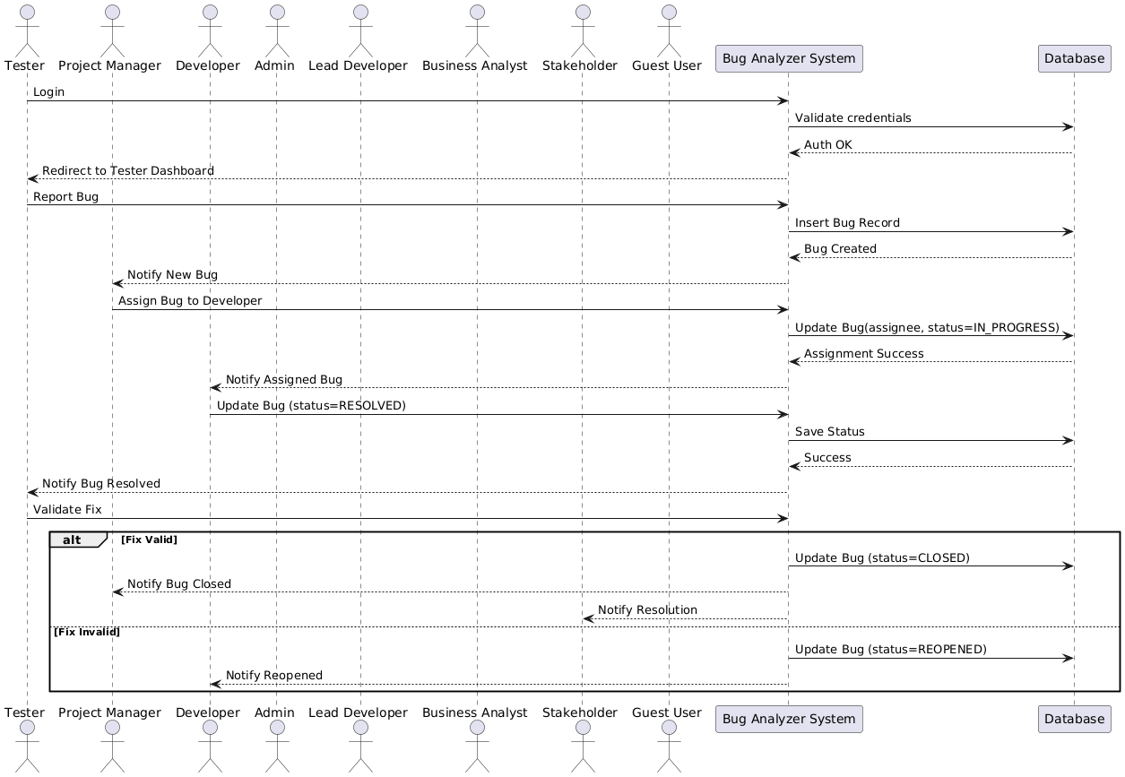

ER Diagram :
