**Establishing A Start-Up Restaurant in The City Of Melbourne**

Adedayo Olowu

August, 2019

**1.0 BACKGROUND**

Akatamba Limited is a Nigeria-based IT consulting firm focusing on providing specialized and customized services to assist investor who intends to set-up business out in major cities of the World. Due to market competition, Akatamba decided to adopt data science techniques to offer a brand-new recommendation system for its clients.

**1.1 INTRODUCTION**

Melbourne, the world's most livable city according to The Economist Intelligence Unit is the coastal capital and most populous city of the southeastern Australian state of Victoria and the second most populous city in Australia and Oceania. It has a population of about 5 million (19% of the population of Australia), and its inhabitants are referred to as "Melburnians". At the city's center is the modern Federation Square development, with plazas, bars, and restaurants by the Yarra River.

The city was founded on 30 August 1835, in the then-British colony of New South Wales by free settlers from the colony of Van Diemen’s Land (modern-day Tasmania).

Melbourne is an international cultural center and the city serves as Australia's cultural capital, with prominent offerings in the form of major events and festivals, drama, musicals, comedy, music, art, architecture, literature, film and television. The climate, waterfront location and nightlife make it one of the most vibrant destinations in Australia. For seven years in a row (from 2011 to 2017) it held the top position in a survey conducted by The Economist Intelligence Unit as the world most livable city.

Melbourne has long been regarded as Australia's sporting capital due to the role it has played in the development of Australian sport, the range and quality of its sporting events and venues, and its high rates of spectatorship and participation. Melbourne’s sporting reputation was recognized in 2016 when, after being ranked as the world's top sports city three times biennially, the Ultimate Sports City Awards in Switzerland named it 'Sports City of the Decade.

Melbourne has the 10th largest immigrant population among world metropolitan areas and with its diverse culture, comes diverse food items. There are many restaurants in Melbourne, each belonging to different categories like Chinese, Indian, French etc. Therefore, in this project we will list and visualize all major parts of Melbourne that has great restaurants.

**1.2 Problem Statement: Prospects of Start-Up Restaurant in Suburbs of Melbourne, Victoria, Australia.**

An investor is planning to build a **Start-Up Restaurant** in Melbourne that will always play an essential role in the business, social, intellectual and artistic life of a thriving and ever-bubbling **Melbourne** society.

The investor is particularly interested in locations of Melbourne and we will therefore focus on the areas with less or no Restaurants. We are focusing on areas with no Restaurants or having less than 2 Restaurants within 1 km and close to city center as possible-The less competitive suburbs.

We will use data analysis and clustering algorithm to generate the most optimal Suburb based on these criteria and suggest 5 neighborhoods to the investor and the Most appropriate among the 5.

**2.0** **Data Preparation**

The following are the sources of data necessary for our explorative analysis

1. Scrapping Melbourne suburbs Table from Wikipedia

https://en.wikipedia.org/wiki/List_of_Melbourne_suburbs

1. Scrapping population of Melbourne from urban.com

[https://www.urban.com.au/news/census-2016-the-20-most-densely-populated- areas-of-melbourne](https://www.urban.com.au/news/census-2016-the-20-most-densely-populated-%20%20areas-of-melbourne)

1. Melbourne Suburbs location data retrieved using Google maps API
2. Data coordinates of Suburb Venues will be retrieved using google API.
3. Requests and Beautifulsoup was used to scrap and wrangle the List of Melbourne suburbs
4. We also used Foursquare information on venue categories, top tips, location data, ratings

(Foursquare: website: [www.foursquare.com](http://www.foursquare.com)).

1. We will also be using the Foursquare API to explore Local Government Area in selected Suburbs in Melbourne. The Foursquare explore function will be used to get the most common venue categories in each Suburbs, and then use this feature to group the Suburbs into clusters. The following information are retrieved on the first query:

Venue ID

Venue Name

Coordinates: Latitude and Longitude

Category Name

Another venue query will be performed to retrieve venue ratings for each location. Note that rating information is a paid service from FourSquare and we are limited to only 50 queries per day. With this constraint, we limit the category analysis with only one type for this demo. I will try to retrieve as many ratings as possible for each retrieved venue I

**3.0 Methodology**

As a database, I used GitHub repository in my study. My master data which has the main components such as Suburb, PostCode, Local government Area, e.t.c. This is use to create a dataframe of df_melbourne_lga_suburb which contains 549 rows.

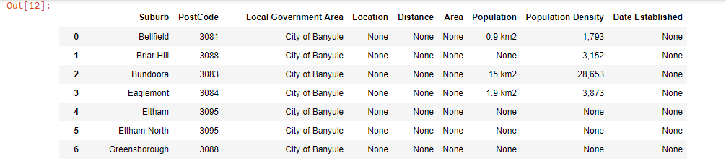

There were several unwanted columns with none value or unrelated entries. These columns were dropped using:

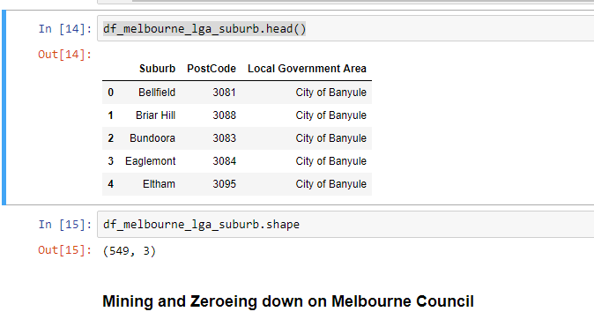

The last action produced a df that contains 549 rows and 3 columns. Our next task is to zeroeing on the City of Melbourne. We have the following:

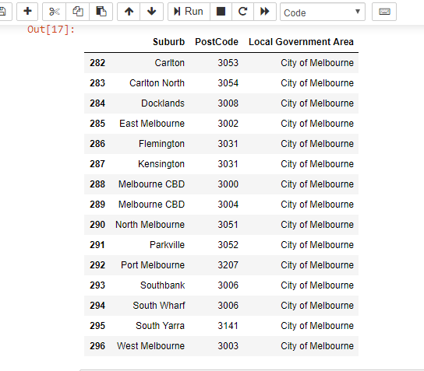

The geodate of the Suburbs were uploaded via a CSV file.

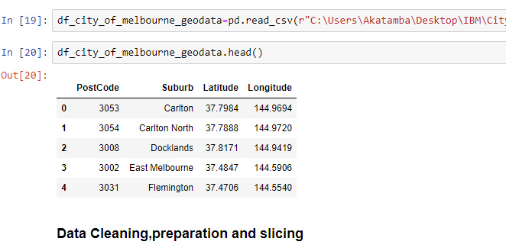

The 2 DFs were merged to produce a comprehensive melbourne neighborhood df.

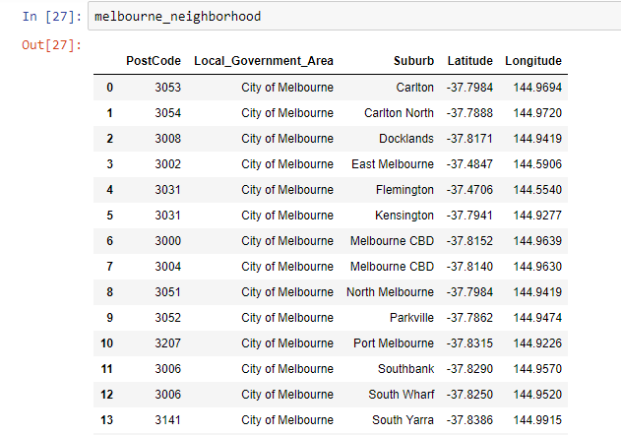

**4.0 SEGMENTING AND CLSUTERING SUBURBS IN THE CITY OF MELBOURNE**

**4.1 Retrieving FourSquare Places of interest.**

Using the Foursquare API, the explore API function was used to get the most common venue categories in each Suburb, and then used this feature to group the Suburbs into clusters. The k-means clustering algorithm was used for the analysis. Finally, the Folium library is used to visualize the recommended neighborhoods and their emerging clusters.

In the ipynb notebook, the function getNearbyVenues extracts the following information for the dataframe it generates:

Venue ID

Venue Name

Coordinates: Latitude and Longitude

Category Name

**4.2 The function getVenuesByCategory performs the following**:

It performs category based venue search to simulate user venue searches based on certain places of interest. This search extracts the following information:

Venue ID

Venue Name

Coordinates: Latitude and Longitude

Category Name

For each retrieved venueID, retrive the venues category rating.

The generated data frame in the second function contains the following column:

Search Venues with recommendations on: Food Venues (Restaurants, Fast foods, etc.)

To demonstrate user selection of places of interest, we will use this Food Venues category in our further analysis.

List of my FourSquare Data collection saved in Github can be found in the following location:

**https://github.com/akatamba/Coursera_Capstone/blob/master/The%20battle%20of%20Neighborhood-Start-up%20Restaurant%20in%20Melbourne%20Australia.ipynb**

I used the FourSquare API to retrieve venue scores of locations. Note that there is max query limit of 50 in FourSquare API for free subscription. So use or query carefully.

Data cleanup is needed to Eliminate possible venue duplicates and Improve the quality of our venue selection by removing venues with no ratings or 0.0.

With the coordinates of each postal code, a map of City of Melbourne with markers indicating the Postcode position is generated Map

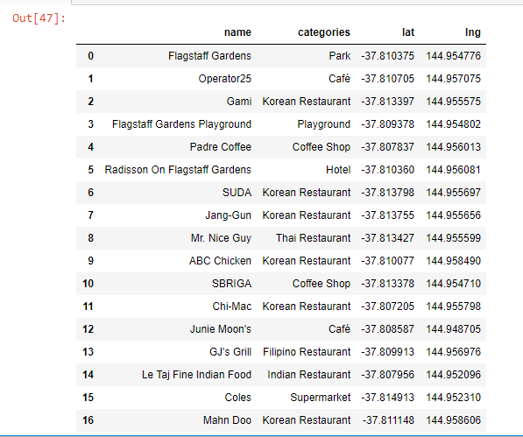

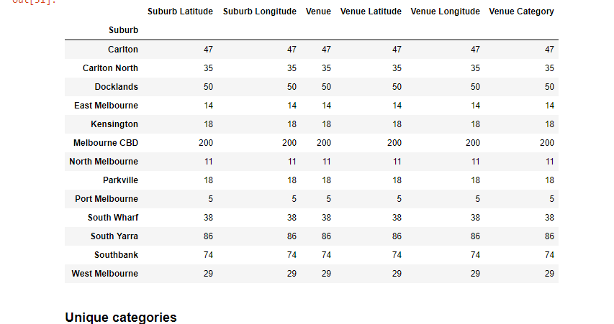

Create a map of Melbourne with Suburbs superimposed on top

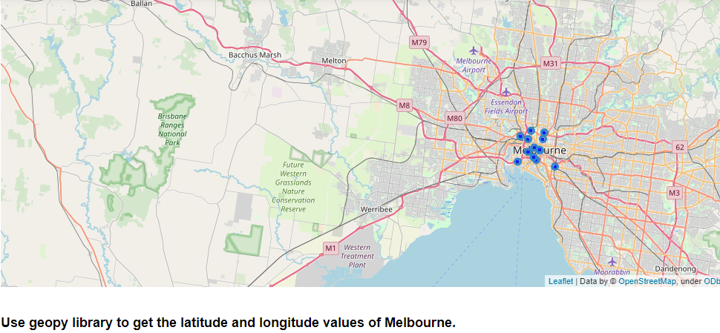

**5.0 Conclusion and Recommendation**

East Melbourne, Kensington, Port Melbourne and Parkville are the Suburbs that emerged as potential locations for our consideration. However, we hereby recommend Parkville as the most appropriate Suburb for the setting up of a start-up restaurant business in the City of Melbourne.

Our conclusion hinged squarely on the unavailability of any restaurant among the top venue visited by the inhabitants. Secondly, the harassment and price war of the market leaders would also be absent which allow the business to bud and grow.

Please refer to our cluster analysis earlier mentioned.

| 5.0- |  |  |  |  |  |  |  |  |  |
| --- | --- | --- | --- | --- | --- | --- | --- | --- | --- |
|  |  |  |  |  |  |  |  |  |  |
|  |  |  |  |  |  |  |  |  |  |
|  |  |  |  |  |  |  |  |  |  |
|  |  |  |  |  |  |  |  |  |  |
|  |  |  |  |  |  |  |  |  |  |
|  |  |  |  |  |  |  |  |  |  |
|  |  |  |  |  |  |  |  |  |  |
|  |  |  |  |  |  |  |  |  |  |
|  |  |  |  |  |  |  |  |  |  |
|  |  |  |  |  |  |  |  |  |  |
|  |  |  |  |  |  |  |  |  |  |
|  |  |  |  |  |  |  |  |  |  |
|  |  |  |  |  |  |  |  |  |  |
|  |  |  |  |  |  |  |  |  |  |
|  |  |  |  |  |  |  |  |  |  |
|  |  |  |  |  |  |  |  |  |  |
|  |  |  |  |  |  |  |  |  |  |
|  |  |  |  |  |  |  |  |  |  |
|  |  |  |  |  |  |  |  |  |  |
|  |  |  |  |  |  |  |  |  |  |
|  |  |  |  |  |  |  |  |  |  |
|  |  |  |  |  |  |  |  |  |  |
|  |  |  |  |  |  |  |  |  |  |
|  |  |  |  |  |  |  |  |  |  |
|  |  |  |  |  |  |  |  |  |  |
|  |  |  |  |  |  |  |  |  |  |
|  |  |  |  |  |  |  |  |  |  |
|  |  |  |  |  |  |  |  |  |  |
|  |  |  |  |  |  |  |  |  |  |
|  |  |  |  |  |  |  |  |  |  |
|  |  |  |  |  |  |  |  |  |  |
|  |  |  |  |  |  |  |  |  |  |
|  |  |  |  |  |  |  |  |  |  |
|  |  |  |  |  |  |  |  |  |  |
|  |  |  |  |  |  |  |  |  |  |
|  |  |  |  |  |  |  |  |  |  |
|  |  |  |  |  |  |  |  |  |  |
|  |  |  |  |  |  |  |  |  |  |
|  |  |  |  |  |  |  |  |  |  |
|  |  |  |  |  |  |  |  |  |  |
|  |  |  |  |  |  |  |  |  |  |
|  |  |  |  |  |  |  |  |  |  |
|  |  |  |  |  |  |  |  |  |  |
|  |  |  |  |  |  |  |  |  |  |
|  |  |  |  |  |  |  |  |  |  |
|  |  |  |  |  |  |  |  |  |  |
|  |  |  |  |  |  |  |  |  |  |
|  |  |  |  |  |  |  |  |  |  |
|  |  |  |  |  |  |  |  |  |  |
|  |  |  |  |  |  |  |  |  |  |
|  |  |  |  |  |  |  |  |  |  |
|  |  |  |  |  |  |  |  |  |  |
|  |  |  |  |  |  |  |  |  |  |
|  |  |  |  |  |  |  |  |  |  |
|  |  |  |  |  |  |  |  |  |  |
|  |  |  |  |  |  |  |  |  |  |
|  |  |  |  |  |  |  |  |  |  |
|  |  |  |  |  |  |  |  |  |  |
|  |  |  |  |  |  |  |  |  |  |
|  |  |  |  |  |  |  |  |  |  |
|  |  |  |  |  |  |  |  |  |  |
|  |  |  |  |  |  |  |  |  |  |
|  |  |  |  |  |  |  |  |  |  |
|  |  |  |  |  |  |  |  |  |  |
|  |  |  |  |  |  |  |  |  |  |
|  |  |  |  |  |  |  |  |  |  |
|  |  |  |  |  |  |  |  |  |  |
|  |  |  |  |  |  |  |  |  |  |
|  |  |  |  |  |  |  |  |  |  |
|  |  |  |  |  |  |  |  |  |  |
|  |  |  |  |  |  |  |  |  |  |
|  |  |  |  |  |  |  |  |  |  |
|  |  |  |  |  |  |  |  |  |  |
|  |  |  |  |  |  |  |  |  |  |
|  |  |  |  |  |  |  |  |  |  |
|  |  |  |  |  |  |  |  |  |  |
|  |  |  |  |  |  |  |  |  |  |
|  |  |  |  |  |  |  |  |  |  |
|  |  |  |  |  |  |  |  |  |  |
|  |  |  |  |  |  |  |  |  |  |
|  |  |  |  |  |  |  |  |  |  |
|  |  |  |  |  |  |  |  |  |  |
|  |  |  |  |  |  |  |  |  |  |
|  |  |  |  |  |  |  |  |  |  |
|  |  |  |  |  |  |  |  |  |  |
|  |  |  |  |  |  |  |  |  |  |
|  |  |  |  |  |  |  |  |  |  |
|  |  |  |  |  |  |  |  |  |  |
|  |  |  |  |  |  |  |  |  |  |
|  |  |  |  |  |  |  |  |  |  |
|  |  |  |  |  |  |  |  |  |  |
|  |  |  |  |  |  |  |  |  |  |
|  |  |  |  |  |  |  |  |  |  |
|  |  |  |  |  |  |  |  |  |  |
|  |  |  |  |  |  |  |  |  |  |
|  |  |  |  |  |  |  |  |  |  |
|  |  |  |  |  |  |  |  |  |  |
|  |  |  |  |  |  |  |  |  |  |
|  |  |  |  |  |  |  |  |  |  |
|  |  |  |  |  |  |  |  |  |  |
|  |  |  |  |  |  |  |  |  |  |
|  |  |  |  |  |  |  |  |  |  |
|  |  |  |  |  |  |  |  |  |  |
|  |  |  |  |  |  |  |  |  |  |
|  |  |  |  |  |  |  |  |  |  |
|  |  |  |  |  |  |  |  |  |  |
|  |  |  |  |  |  |  |  |  |  |
|  |  |  |  |  |  |  |  |  |  |
|  |  |  |  |  |  |  |  |  |  |
|  |  |  |  |  |  |  |  |  |  |
|  |  |  |  |  |  |  |  |  |  |
|  |  |  |  |  |  |  |  |  |  |
|  |  |  |  |  |  |  |  |  |  |
|  |  |  |  |  |  |  |  |  |  |
|  |  |  |  |  |  |  |  |  |  |
|  |  |  |  |  |  |  |  |  |  |
|  |  |  |  |  |  |  |  |  |  |
|  |  |  |  |  |  |  |  |  |  |
|  |  |  |  |  |  |  |  |  |  |
|  |  |  |  |  |  |  |  |  |  |
|  |  |  |  |  |  |  |  |  |  |
|  |  |  |  |  |  |  |  |  |  |
|  |  |  |  |  |  |  |  |  |  |
|  |  |  |  |  |  |  |  |  |  |
|  |  |  |  |  |  |  |  |  |  |
|  |  |  |  |  |  |  |  |  |  |
|  |  |  |  |  |  |  |  |  |  |
|  |  |  |  |  |  |  |  |  |  |
|  |  |  |  |  |  |  |  |  |  |
|  |  |  |  |  |  |  |  |  |  |
|  |  |  |  |  |  |  |  |  |  |
|  |  |  |  |  |  |  |  |  |  |
|  |  |  |  |  |  |  |  |  |  |
|  |  |  |  |  |  |  |  |  |  |
|  |  |  |  |  |  |  |  |  |  |
|  |  |  |  |  |  |  |  |  |  |
|  |  |  |  |  |  |  |  |  |  |
|  |  |  |  |  |  |  |  |  |  |
|  |  |  |  |  |  |  |  |  |  |
|  |  |  |  |  |  |  |  |  |  |
|  |  |  |  |  |  |  |  |  |  |
|  |  |  |  |  |  |  |  |  |  |
|  |  |  |  |  |  |  |  |  |  |
|  |  |  |  |  |  |  |  |  |  |
|  |  |  |  |  |  |  |  |  |  |
|  |  |  |  |  |  |  |  |  |  |
|  |  |  |  |  |  |  |  |  |  |
|  |  |  |  |  |  |  |  |  |  |
|  |  |  |  |  |  |  |  |  |  |
|  |  |  |  |  |  |  |  |  |  |
|  |  |  |  |  |  |  |  |  |  |
|  |  |  |  |  |  |  |  |  |  |
|  |  |  |  |  |  |  |  |  |  |
|  |  |  |  |  |  |  |  |  |  |
|  |  |  |  |  |  |  |  |  |  |
|  |  |  |  |  |  |  |  |  |  |
|  |  |  |  |  |  |  |  |  |  |
|  |  |  |  |  |  |  |  |  |  |
|  |  |  |  |  |  |  |  |  |  |
|  |  |  |  |  |  |  |  |  |  |
|  |  |  |  |  |  |  |  |  |  |
|  |  |  |  |  |  |  |  |  |  |
|  |  |  |  |  |  |  |  |  |  |
|  |  |  |  |  |  |  |  |  |  |
|  |  |  |  |  |  |  |  |  |  |
|  |  |  |  |  |  |  |  |  |  |
|  |  |  |  |  |  |  |  |  |  |
|  |  |  |  |  |  |  |  |  |  |
|  |  |  |  |  |  |  |  |  |  |
|  |  |  |  |  |  |  |  |  |  |
|  |  |  |  |  |  |  |  |  |  |
|  |  |  |  |  |  |  |  |  |  |
|  |  |  |  |  |  |  |  |  |  |
|  |  |  |  |  |  |  |  |  |  |
|  |  |  |  |  |  |  |  |  |  |
|  |  |  |  |  |  |  |  |  |  |
|  |  |  |  |  |  |  |  |  |  |
|  |  |  |  |  |  |  |  |  |  |
|  |  |  |  |  |  |  |  |  |  |
|  |  |  |  |  |  |  |  |  |  |
|  |  |  |  |  |  |  |  |  |  |
|  |  |  |  |  |  |  |  |  |  |
|  |  |  |  |  |  |  |  |  |  |
|  |  |  |  |  |  |  |  |  |  |
|  |  |  |  |  |  |  |  |  |  |
|  |  |  |  |  |  |  |  |  |  |
|  |  |  |  |  |  |  |  |  |  |
|  |  |  |  |  |  |  |  |  |  |
|  |  |  |  |  |  |  |  |  |  |
|  |  |  |  |  |  |  |  |  |  |
|  |  |  |  |  |  |  |  |  |  |
|  |  |  |  |  |  |  |  |  |  |
|  |  |  |  |  |  |  |  |  |  |
|  |  |  |  |  |  |  |  |  |  |
|  |  |  |  |  |  |  |  |  |  |
|  |  |  |  |  |  |  |  |  |  |
|  |  |  |  |  |  |  |  |  |  |
|  |  |  |  |  |  |  |  |  |  |
|  |  |  |  |  |  |  |  |  |  |
|  |  |  |  |  |  |  |  |  |  |
|  |  |  |  |  |  |  |  |  |  |
|  |  |  |  |  |  |  |  |  |  |
|  |  |  |  |  |  |  |  |  |  |
|  |  |  |  |  |  |  |  |  |  |
|  |  |  |  |  |  |  |  |  |  |
|  |  |  |  |  |  |  |  |  |  |
|  |  |  |  |  |  |  |  |  |  |
|  |  |  |  |  |  |  |  |  |  |
|  |  |  |  |  |  |  |  |  |  |
|  |  |  |  |  |  |  |  |  |  |
|  |  |  |  |  |  |  |  |  |  |
|  |  |  |  |  |  |  |  |  |  |
|  |  |  |  |  |  |  |  |  |  |
|  |  |  |  |  |  |  |  |  |  |
|  |  |  |  |  |  |  |  |  |  |
|  |  |  |  |  |  |  |  |  |  |
|  |  |  |  |  |  |  |  |  |  |
|  |  |  |  |  |  |  |  |  |  |
|  |  |  |  |  |  |  |  |  |  |
|  |  |  |  |  |  |  |  |  |  |
|  |  |  |  |  |  |  |  |  |  |
|  |  |  |  |  |  |  |  |  |  |
|  |  |  |  |  |  |  |  |  |  |
|  |  |  |  |  |  |  |  |  |  |
|  |  |  |  |  |  |  |  |  |  |
|  |  |  |  |  |  |  |  |  |  |
|  |  |  |  |  |  |  |  |  |  |
|  |  |  |  |  |  |  |  |  |  |
|  |  |  |  |  |  |  |  |  |  |
|  |  |  |  |  |  |  |  |  |  |
|  |  |  |  |  |  |  |  |  |  |
|  |  |  |  |  |  |  |  |  |  |
|  |  |  |  |  |  |  |  |  |  |
|  |  |  |  |  |  |  |  |  |  |
|  |  |  |  |  |  |  |  |  |  |
|  |  |  |  |  |  |  |  |  |  |
|  |  |  |  |  |  |  |  |  |  |
|  |  |  |  |  |  |  |  |  |  |
|  |  |  |  |  |  |  |  |  |  |
|  |  |  |  |  |  |  |  |  |  |
|  |  |  |  |  |  |  |  |  |  |
|  |  |  |  |  |  |  |  |  |  |
|  |  |  |  |  |  |  |  |  |  |
|  |  |  |  |  |  |  |  |  |  |
|  |  |  |  |  |  |  |  |  |  |
|  |  |  |  |  |  |  |  |  |  |
|  |  |  |  |  |  |  |  |  |  |
|  |  |  |  |  |  |  |  |  |  |
|  |  |  |  |  |  |  |  |  |  |
|  |  |  |  |  |  |  |  |  |  |
|  |  |  |  |  |  |  |  |  |  |
|  |  |  |  |  |  |  |  |  |  |
|  |  |  |  |  |  |  |  |  |  |
|  |  |  |  |  |  |  |  |  |  |
|  |  |  |  |  |  |  |  |  |  |
|  |  |  |  |  |  |  |  |  |  |
|  |  |  |  |  |  |  |  |  |  |
|  |  |  |  |  |  |  |  |  |  |
|  |  |  |  |  |  |  |  |  |  |
|  |  |  |  |  |  |  |  |  |  |
|  |  |  |  |  |  |  |  |  |  |
|  |  |  |  |  |  |  |  |  |  |
|  |  |  |  |  |  |  |  |  |  |
|  |  |  |  |  |  |  |  |  |  |
|  |  |  |  |  |  |  |  |  |  |
|  |  |  |  |  |  |  |  |  |  |
|  |  |  |  |  |  |  |  |  |  |
|  |  |  |  |  |  |  |  |  |  |
|  |  |  |  |  |  |  |  |  |  |
|  |  |  |  |  |  |  |  |  |  |
|  |  |  |  |  |  |  |  |  |  |
|  |  |  |  |  |  |  |  |  |  |
|  |  |  |  |  |  |  |  |  |  |
|  |  |  |  |  |  |  |  |  |  |
|  |  |  |  |  |  |  |  |  |  |
|  |  |  |  |  |  |  |  |  |  |
|  |  |  |  |  |  |  |  |  |  |
|  |  |  |  |  |  |  |  |  |  |
|  |  |  |  |  |  |  |  |  |  |
|  |  |  |  |  |  |  |  |  |  |
|  |  |  |  |  |  |  |  |  |  |
|  |  |  |  |  |  |  |  |  |  |
|  |  |  |  |  |  |  |  |  |  |
|  |  |  |  |  |  |  |  |  |  |
|  |  |  |  |  |  |  |  |  |  |
|  |  |  |  |  |  |  |  |  |  |
|  |  |  |  |  |  |  |  |  |  |
|  |  |  |  |  |  |  |  |  |  |
|  |  |  |  |  |  |  |  |  |  |
|  |  |  |  |  |  |  |  |  |  |
|  |  |  |  |  |  |  |  |  |  |
|  |  |  |  |  |  |  |  |  |  |
|  |  |  |  |  |  |  |  |  |  |
|  |  |  |  |  |  |  |  |  |  |
|  |  |  |  |  |  |  |  |  |  |
|  |  |  |  |  |  |  |  |  |  |
|  |  |  |  |  |  |  |  |  |  |
|  |  |  |  |  |  |  |  |  |  |
|  |  |  |  |  |  |  |  |  |  |
|  |  |  |  |  |  |  |  |  |  |
|  |  |  |  |  |  |  |  |  |  |
|  |  |  |  |  |  |  |  |  |  |
|  |  |  |  |  |  |  |  |  |  |
|  |  |  |  |  |  |  |  |  |  |
|  |  |  |  |  |  |  |  |  |  |
|  |  |  |  |  |  |  |  |  |  |
|  |  |  |  |  |  |  |  |  |  |
|  |  |  |  |  |  |  |  |  |  |
|  |  |  |  |  |  |  |  |  |  |
|  |  |  |  |  |  |  |  |  |  |
|  |  |  |  |  |  |  |  |  |  |
|  |  |  |  |  |  |  |  |  |  |
|  |  |  |  |  |  |  |  |  |  |
|  |  |  |  |  |  |  |  |  |  |
|  |  |  |  |  |  |  |  |  |  |
|  |  |  |  |  |  |  |  |  |  |
|  |  |  |  |  |  |  |  |  |  |
|  |  |  |  |  |  |  |  |  |  |
|  |  |  |  |  |  |  |  |  |  |
|  |  |  |  |  |  |  |  |  |  |
|  |  |  |  |  |  |  |  |  |  |
|  |  |  |  |  |  |  |  |  |  |
|  |  |  |  |  |  |  |  |  |  |
|  |  |  |  |  |  |  |  |  |  |
|  |  |  |  |  |  |  |  |  |  |
|  |  |  |  |  |  |  |  |  |  |
|  |  |  |  |  |  |  |  |  |  |
|  |  |  |  |  |  |  |  |  |  |
|  |  |  |  |  |  |  |  |  |  |
|  |  |  |  |  |  |  |  |  |  |
|  |  |  |  |  |  |  |  |  |  |
|  |  |  |  |  |  |  |  |  |  |
|  |  |  |  |  |  |  |  |  |  |
|  |  |  |  |  |  |  |  |  |  |
|  |  |  |  |  |  |  |  |  |  |
|  |  |  |  |  |  |  |  |  |  |
|  |  |  |  |  |  |  |  |  |  |
|  |  |  |  |  |  |  |  |  |  |
|  |  |  |  |  |  |  |  |  |  |
|  |  |  |  |  |  |  |  |  |  |
|  |  |  |  |  |  |  |  |  |  |
|  |  |  |  |  |  |  |  |  |  |
|  |  |  |  |  |  |  |  |  |  |
|  |  |  |  |  |  |  |  |  |  |
|  |  |  |  |  |  |  |  |  |  |
|  |  |  |  |  |  |  |  |  |  |
|  |  |  |  |  |  |  |  |  |  |
|  |  |  |  |  |  |  |  |  |  |
|  |  |  |  |  |  |  |  |  |  |
|  |  |  |  |  |  |  |  |  |  |
|  |  |  |  |  |  |  |  |  |  |
|  |  |  |  |  |  |  |  |  |  |
|  |  |  |  |  |  |  |  |  |  |
|  |  |  |  |  |  |  |  |  |  |
|  |  |  |  |  |  |  |  |  |  |
|  |  |  |  |  |  |  |  |  |  |
|  |  |  |  |  |  |  |  |  |  |
|  |  |  |  |  |  |  |  |  |  |
|  |  |  |  |  |  |  |  |  |  |
|  |  |  |  |  |  |  |  |  |  |
|  |  |  |  |  |  |  |  |  |  |
|  |  |  |  |  |  |  |  |  |  |
|  |  |  |  |  |  |  |  |  |  |
|  |  |  |  |  |  |  |  |  |  |
|  |  |  |  |  |  |  |  |  |  |
|  |  |  |  |  |  |  |  |  |  |
|  |  |  |  |  |  |  |  |  |  |
|  |  |  |  |  |  |  |  |  |  |
|  |  |  |  |  |  |  |  |  |  |
|  |  |  |  |  |  |  |  |  |  |
|  |  |  |  |  |  |  |  |  |  |
|  |  |  |  |  |  |  |  |  |  |
|  |  |  |  |  |  |  |  |  |  |
|  |  |  |  |  |  |  |  |  |  |
|  |  |  |  |  |  |  |  |  |  |
|  |  |  |  |  |  |  |  |  |  |
|  |  |  |  |  |  |  |  |  |  |
|  |  |  |  |  |  |  |  |  |  |
|  |  |  |  |  |  |  |  |  |  |
|  |  |  |  |  |  |  |  |  |  |
|  |  |  |  |  |  |  |  |  |  |
|  |  |  |  |  |  |  |  |  |  |
|  |  |  |  |  |  |  |  |  |  |
|  |  |  |  |  |  |  |  |  |  |
|  |  |  |  |  |  |  |  |  |  |
|  |  |  |  |  |  |  |  |  |  |
|  |  |  |  |  |  |  |  |  |  |
|  |  |  |  |  |  |  |  |  |  |
|  |  |  |  |  |  |  |  |  |  |
|  |  |  |  |  |  |  |  |  |  |
|  |  |  |  |  |  |  |  |  |  |
|  |  |  |  |  |  |  |  |  |  |
|  |  |  |  |  |  |  |  |  |  |
|  |  |  |  |  |  |  |  |  |  |
|  |  |  |  |  |  |  |  |  |  |
|  |  |  |  |  |  |  |  |  |  |
|  |  |  |  |  |  |  |  |  |  |
|  |  |  |  |  |  |  |  |  |  |
|  |  |  |  |  |  |  |  |  |  |
|  |  |  |  |  |  |  |  |  |  |
|  |  |  |  |  |  |  |  |  |  |
|  |  |  |  |  |  |  |  |  |  |
|  |  |  |  |  |  |  |  |  |  |
|  |  |  |  |  |  |  |  |  |  |
|  |  |  |  |  |  |  |  |  |  |
|  |  |  |  |  |  |  |  |  |  |
|  |  |  |  |  |  |  |  |  |  |
|  |  |  |  |  |  |  |  |  |  |
|  |  |  |  |  |  |  |  |  |  |
|  |  |  |  |  |  |  |  |  |  |
|  |  |  |  |  |  |  |  |  |  |
|  |  |  |  |  |  |  |  |  |  |
|  |  |  |  |  |  |  |  |  |  |
|  |  |  |  |  |  |  |  |  |  |
|  |  |  |  |  |  |  |  |  |  |
|  |  |  |  |  |  |  |  |  |  |
|  |  |  |  |  |  |  |  |  |  |
|  |  |  |  |  |  |  |  |  |  |
|  |  |  |  |  |  |  |  |  |  |
|  |  |  |  |  |  |  |  |  |  |
|  |  |  |  |  |  |  |  |  |  |
|  |  |  |  |  |  |  |  |  |  |
|  |  |  |  |  |  |  |  |  |  |
|  |  |  |  |  |  |  |  |  |  |
|  |  |  |  |  |  |  |  |  |  |
|  |  |  |  |  |  |  |  |  |  |
|  |  |  |  |  |  |  |  |  |  |
|  |  |  |  |  |  |  |  |  |  |
|  |  |  |  |  |  |  |  |  |  |
|  |  |  |  |  |  |  |  |  |  |
|  |  |  |  |  |  |  |  |  |  |
|  |  |  |  |  |  |  |  |  |  |
|  |  |  |  |  |  |  |  |  |  |
|  |  |  |  |  |  |  |  |  |  |
|  |  |  |  |  |  |  |  |  |  |
|  |  |  |  |  |  |  |  |  |  |
|  |  |  |  |  |  |  |  |  |  |
|  |  |  |  |  |  |  |  |  |  |
|  |  |  |  |  |  |  |  |  |  |
|  |  |  |  |  |  |  |  |  |  |
|  |  |  |  |  |  |  |  |  |  |
|  |  |  |  |  |  |  |  |  |  |
|  |  |  |  |  |  |  |  |  |  |
|  |  |  |  |  |  |  |  |  |  |
|  |  |  |  |  |  |  |  |  |  |
|  |  |  |  |  |  |  |  |  |  |
|  |  |  |  |  |  |  |  |  |  |
|  |  |  |  |  |  |  |  |  |  |
|  |  |  |  |  |  |  |  |  |  |
|  |  |  |  |  |  |  |  |  |  |
|  |  |  |  |  |  |  |  |  |  |
|  |  |  |  |  |  |  |  |  |  |
|  |  |  |  |  |  |  |  |  |  |
|  |  |  |  |  |  |  |  |  |  |
|  |  |  |  |  |  |  |  |  |  |
|  |  |  |  |  |  |  |  |  |  |
|  |  |  |  |  |  |  |  |  |  |
|  |  |  |  |  |  |  |  |  |  |
|  |  |  |  |  |  |  |  |  |  |
|  |  |  |  |  |  |  |  |  |  |
|  |  |  |  |  |  |  |  |  |  |
|  |  |  |  |  |  |  |  |  |  |
|  |  |  |  |  |  |  |  |  |  |
|  |  |  |  |  |  |  |  |  |  |
|  |  |  |  |  |  |  |  |  |  |
|  |  |  |  |  |  |  |  |  |  |
|  |  |  |  |  |  |  |  |  |  |
|  |  |  |  |  |  |  |  |  |  |
|  |  |  |  |  |  |  |  |  |  |
|  |  |  |  |  |  |  |  |  |  |
|  |  |  |  |  |  |  |  |  |  |
|  |  |  |  |  |  |  |  |  |  |
|  |  |  |  |  |  |  |  |  |  |
|  |  |  |  |  |  |  |  |  |  |
|  |  |  |  |  |  |  |  |  |  |
|  |  |  |  |  |  |  |  |  |  |
|  |  |  |  |  |  |  |  |  |  |
|  |  |  |  |  |  |  |  |  |  |
|  |  |  |  |  |  |  |  |  |  |
|  |  |  |  |  |  |  |  |  |  |
|  |  |  |  |  |  |  |  |  |  |
|  |  |  |  |  |  |  |  |  |  |
|  |  |  |  |  |  |  |  |  |  |
|  |  |  |  |  |  |  |  |  |  |
|  |  |  |  |  |  |  |  |  |  |
|  |  |  |  |  |  |  |  |  |  |
|  |  |  |  |  |  |  |  |  |  |
|  |  |  |  |  |  |  |  |  |  |
|  |  |  |  |  |  |  |  |  |  |
|  |  |  |  |  |  |  |  |  |  |
|  |  |  |  |  |  |  |  |  |  |
|  |  |  |  |  |  |  |  |  |  |
|  |  |  |  |  |  |  |  |  |  |
|  |  |  |  |  |  |  |  |  |  |
|  |  |  |  |  |  |  |  |  |  |
|  |  |  |  |  |  |  |  |  |  |
|  |  |  |  |  |  |  |  |  |  |
|  |  |  |  |  |  |  |  |  |  |
|  |  |  |  |  |  |  |  |  |  |
|  |  |  |  |  |  |  |  |  |  |
|  |  |  |  |  |  |  |  |  |  |
|  |  |  |  |  |  |  |  |  |  |
|  |  |  |  |  |  |  |  |  |  |
|  |  |  |  |  |  |  |  |  |  |
|  |  |  |  |  |  |  |  |  |  |
|  |  |  |  |  |  |  |  |  |  |
|  |  |  |  |  |  |  |  |  |  |
|  |  |  |  |  |  |  |  |  |  |
|  |  |  |  |  |  |  |  |  |  |
|  |  |  |  |  |  |  |  |  |  |
|  |  |  |  |  |  |  |  |  |  |
|  |  |  |  |  |  |  |  |  |  |
|  |  |  |  |  |  |  |  |  |  |
|  |  |  |  |  |  |  |  |  |  |
|  |  |  |  |  |  |  |  |  |  |
|  |  |  |  |  |  |  |  |  |  |
|  |  |  |  |  |  |  |  |  |  |
|  |  |  |  |  |  |  |  |  |  |
|  |  |  |  |  |  |  |  |  |  |
|  |  |  |  |  |  |  |  |  |  |
|  |  |  |  |  |  |  |  |  |  |
|  |  |  |  |  |  |  |  |  |  |
|  |  |  |  |  |  |  |  |  |  |
|  |  |  |  |  |  |  |  |  |  |
|  |  |  |  |  |  |  |  |  |  |
|  |  |  |  |  |  |  |  |  |  |
|  |  |  |  |  |  |  |  |  |  |
|  |  |  |  |  |  |  |  |  |  |
|  |  |  |  |  |  |  |  |  |  |
|  |  |  |  |  |  |  |  |  |  |
|  |  |  |  |  |  |  |  |  |  |
|  |  |  |  |  |  |  |  |  |  |
|  |  |  |  |  |  |  |  |  |  |
|  |  |  |  |  |  |  |  |  |  |
|  |  |  |  |  |  |  |  |  |  |
|  |  |  |  |  |  |  |  |  |  |
|  |  |  |  |  |  |  |  |  |  |
|  |  |  |  |  |  |  |  |  |  |
|  |  |  |  |  |  |  |  |  |  |
|  |  |  |  |  |  |  |  |  |  |
|  |  |  |  |  |  |  |  |  |  |
|  |  |  |  |  |  |  |  |  |  |
|  |  |  |  |  |  |  |  |  |  |
|  |  |  |  |  |  |  |  |  |  |
|  |  |  |  |  |  |  |  |  |  |
|  |  |  |  |  |  |  |  |  |  |
|  |  |  |  |  |  |  |  |  |  |
|  |  |  |  |  |  |  |  |  |  |
|  |  |  |  |  |  |  |  |  |  |
|  |  |  |  |  |  |  |  |  |  |

.

**3.0 METHODOLOGY**

As a database, I used GitHub repository in my study. My master data which has the main components Suburb, Postcode, Local Government Area, population density e.t.c

Singapore Towns List with median residential rental prices.

The source data contains median rental prices of Singapore HDB units from 2005 up to 2nd quarter of 2018.

I will retrive the most recent recorded rental prices from this data source (Q2 2018) being the most

relevant price available at this time. For this demonstration, I will simplify the analysis by using the

average rental prices of all available flat type.

Data Cleanup and re-grouping. The retrieved table contains some un-wanted entries and needs some cleanup.

he following tasks will be performed:

Drop/ignore cells with missing data.

Use most current data record.

Fix data types.

Post Processed Singapore towns list with and median residential rental prices