David Kopp

9-8-15

Comp322

Programing Project #01

1) Logging into the K200 Server.

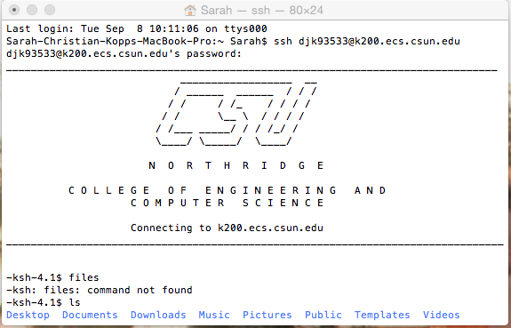

2) The compile and execution of myprog.c.

