David Kopp

9-15-15

Comp322

Programming Project #2

1) All the files after compilation.

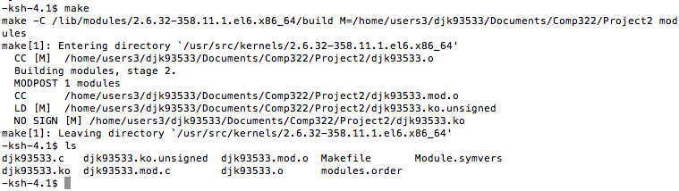

2) Screen shot of the denial message from k200 server while trying to insert new module into the kernel.

Macintosh HD:Users:Sarah:Desktop:Screen Shot 2015-09-15 at 2.39.07 PM.png