David Kopp

9-24-15

Comp322

Programming Project #3

1) Run of the pwd command after comp322> prompt:

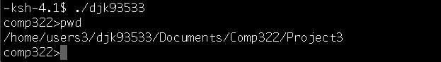

2) The display of history after the 13th command was entered:

