|  |  |  |  |  |  |
| --- | --- | --- | --- | --- | --- |
|  | | **ASSIGNMENT COVER PAGE** | | | C:\Users\hoching.tay\Desktop\Lincoln_UK_06092017-01.png |
| **Programme** | | | **Course Code and Title** | | |
| Bachelor of Computer Science (Hons)/  Bachelor of Computer Science (Hons) In Computer & Network Technology/  Bachelor of Software Engineering (Hons) | | | CPR3113/N Principles of Programming | | |
| **Student’s name / student’s id** | | | **Lecturer’s name** | | |
| CHAN SEOW FEN / 0207368 | | | Tan Phit Huan | | |
| **Date issued** | **Submission Deadline** | | | **Indicative Weighting** | |
| Week 3 - 26/09/2022 | Week 7 – 28/10/2022 | | | 30% | |
| **Assignment 1 title** | Selection and Iteration | | | | |
| This assessment assesses the following course learning outcomes | | | | | |
| **# as in Course Guide** | **UOWM KDU Penang University College Learning Outcome** | | | | |
| **LO1** | **Analyze algorithms to solve basic computing problems using flow charts and pseudocodes.** | | | | |
| **LO2** | **Demonstrate a computational solution using principle of selection and iteration.** | | | | |
| **# as in Course Guide** | **University of Lincoln Learning Outcome** | | | | |
| **LO3** | **Demonstrate the ability to select from a range of possible options, to provide justification for that selection, and to implement algorithms in a particular context** | | | | |
| **LO1** | **Characterise a problem in the context of possible solution mechanisms** | | | | |
| **LO2** | **Model a problem solution using appropriate vocabulary** | | | | |
| **LO1** | **Implement control flow with decisions and loops using good programming practices** | | | | |
| **LO2** | **Determine an appropriate algorithmic approach to a problem** | | | | |
| **LO2** | **Implement control flow with decisions and loops using good programming practices** | | | | |
| **LO3** | **Apply object-oriented principles to the implementation of software programs** | | | | |
| **Student’s declaration** | | | | | |
| I certify that the work submitted for this assignment is my own and research sources are fully acknowledged.  Student’s signature: Submission Date: | | | | | |

**Table of Content**

|  |  |  |
| --- | --- | --- |
| **1.** | **Question 1**   * 1. Defining diagram   2. Pseudocode   3. Desk checking table | 3 - 4  4 - 7  7 - 10 |
| **2.** | **Question 2**  2.1 Java program code  2.2 Description | 10 - 14  15 - 21 |

1. **Question 1**

**1.1 Defining diagram**

|  |  |  |
| --- | --- | --- |
| Input | Processing | Output |
| name  identityCardNo  s\_height  s\_weight  bloodType  decision | Get patient’s details (name, identityCardNo, height, weight, bloodType)  Validate name input and repeat prompting process for any invalid input by checking it should only contains space and alphabet but not blank  Validate identityCardNo input and repeat prompting process for any invalid input by checking it should contains 12 digits and it is numeric  Get dob from the first six digits of identityCardNo and store them in DD/MM/YY date format  Check if the last digit of identityCardNo is an odd number or an even number, then store gender as male or female  Validate s\_height input and repeat prompting process for any invalid input by checking it should be numeric and should not be zero or lesser than zero and higher than 3m  Validate s\_weight input and repeat prompting process for any invalid input by checking it should be numeric and should not be zero or lesser than zero and heavier than 640kg  Validate bloodType input and repeat prompting process for any invalid input by checking if it is either A+, A-, B+, B-, O+, O-, AB+, or AB-  Calculate bmi by using weight (kg) / [height(m)]2  Check if bmi is 30.0 and above or between 29.9 and 25.0 or between 24.9 and 18.5 or below 18.5, then store weightStatus as Obese or Overweight or Healthy Weight or Underweight  Display the patient’s information (name, identityCardNo, height, weight, bloodType , dob, gender, bmi, weightStatus)  Get the administrator’s decision to decide whether have a loop and continue to ask for the patient’s details or end the program  Validate decision input and repeat prompting process for any invalid input by checking if it is either yes or no | name  identityCardNo  height  weight  bloodType  dob  gender  bmi  weightStatus |

**1.2 Pseudocode**

START PatientInfo

1 INITIALISE validName to false

2 INITIALISE validIC to false

3 INITIALISE gender=””

4 INITIALISE height to 0

5 INITIALISE weight to 0

6 INITIALISE heightNumeric to true

7 INITIALISE weightNumeric to true

8 DOWHILE decision is ‘Y’ or ‘y’

9 DOWHILE validName is false

10 GET name

11 IF name is blank THEN

DISPLAY “Invalid name, it should not be blank. Please input again.”

validName=false

ELSE   
 FOR all the characters in the name

IF character is NOT letter AND is NOT whitespace THEN

DISPLAY "Invalid name, it should not contain special characters or numbers. Please input again."

validName=false

BREAK

ELSE

validName=true

ENDIF

ENDFOR  
 ENDIF

ENDDO

12 DOWHILE validIC is false

13 GET identityCardNo

14 IF length of identityCardNo is NOT equal to 12 THEN

DISPLAY “Invalid IC, it should contain 12 digits. Please input again.”

validIC=false

ELSE   
 FOR all the characters in identityCardNo

IF character is NOT numeric THEN

DISPLAY “Invalid IC, it should contain only numbers. Please input again.”

validIC=false

BREAK

ELSE

validIC=true

ENDIF

ENDFOR  
 ENDIF

ENDDO

15 dob = fifth and sixth character from identityCardNo + “/” + third and fourth character from identityCardNo + “/” + first and second character from identityCardNo

16 IF last character of identityCardNo % 2 is NOT 0 THEN

gender = Male  
ELSE

gender = Female

ENDIF

17 DOWHILE validHeight is false

18 GET s\_height

19 TRY

height = convert s\_height from string datatype to double datatype

CATCH execption THEN  
 heightNumeric=false

ENDTRY

20 IF heightNumeric is true THEN

IF height>0 AND height<=3 THEN

validHeight=true

ELSE

DISPLAY “Invalid height, it should not be negative value or higher than 3m. Please input again.”  
validHeight=false

ENDIF

ELSE

DISPLAY “Invalid height, please enter a valid height which is a number.”

validHeight=false

heightNumeric=true  
ENDIF

ENDDO

21 DOWHILE validWeight is false

22 GET s\_weight

23 TRY

weight = convert s\_weight from string datatype to double datatype

CATCH execption THEN  
 weightNumeric=false

ENDTRY

24 IF weightNumeric is true THEN

IF weight>0 AND weight<=640 THEN

validWeight=true

ELSE

DISPLAY “Invalid weight, it should not be 0 or lower than 0 or heavier than 640kg. Please input again.”  
validWeight=false

ENDIF

ELSE

DISPLAY “Invalid weight, please enter a valid weight which is a number.”

validWeight=false

weightNumeric=true

ENDIF

ENDDO

25 DOWHILE validBloodType is false

26 GET bloodType

27 IF bloodType equals to “A+” OR bloodType equals to “A-” OR bloodType equals to “B+” OR bloodType equals to B-” OR bloodType equals to “O+” OR bloodType equals to “O-” OR bloodType equals to “AB+” OR bloodType equals to “AB-” THEN

validBloodType=true

ELSE

DISPLAY “Invalid blood type. Please input again.”

validBloodType=false

ENDIF

ENDDO

28 bmi=weight/(height)2

29 IF bmi>=30 THEN

weightStatus = “Obese”

ELSE IF bmi<30 AND bmi>=25 THEN

weightStatus = “Overweight”

ELSE IF bmi<25 AND bmi>=18.5 THEN

weightStatus = “Healthy Weight”

ELSE

weightStatus = “Underweight”

ENDIF

30 DISPLAY “Name: ”+name

31 DISPLAY “Identity card number: ”+identityCardNo

32 DISPLAY “Height: ”+height with two decimal place + ‘ m’  
33 DISPLAY “Weight: ”+weight with one decimal place + ‘ kg’

34 DISPLAY “Blood type: ”+bloodType  
35 DISPLAY “Date of birth[DD/MM/YY]: ”+dob  
36 DISPLAY “Gender: ”+gender

37 DISPLAY “BMI: ”+bmi with one decimal place

38 DISPLAY “Weight status: ”+weightStatus

39 DOWHILE validDecision is false

40 GET decision

41 IF decision is NOT ‘Y’ AND decision is NOT ‘y’ AND decision is NOT ‘N’ AND decision is NOT ‘n’ THEN

DISPLAY "Invalid input, please key in either Y or N."

validDecision=false

ELSE

validDecision=true

ENDIF

ENDDO

ENDDO

END PatientInfo

**1.3 Desk checking table**

Input data

|  |  |  |  |
| --- | --- | --- | --- |
|  | First data set | Second data set | |
| name | Tan Yu Sheng | Noor Arzila | ,45489,Ali |
| identityCardNo | 010528020721 | 750326070614 | bdbc,020708070433 |
| s\_height | 1.76 | 1.55 | 1.28.9,1.8 |
| s\_weight | 80 | 48 | 1000,ad,100 |
| bloodType | O+ | AB- | dads,A+ |
| decision | n | y | f,N |

Expected output

|  |  |  |  |
| --- | --- | --- | --- |
|  | First data set | Second data set | |
| name | Tan Yu Sheng | Noor Arzila | Ali |
| identityCardNo | 010528020721 | 750326070614 | 020708070433 |
| height + ‘ m’ | 1.76 m | 1.55 m | 1.80 m |
| weight + ‘ kg’ | 80.0 kg | 48.0 kg | 100.0 kg |
| bloodType | O+ | AB- | A+ |
| dob | 28/05/01 | 26/03/75 | 08/07/02 |
| gender | Male | Female | Male |
| bmi | 25.8 | 20.0 | 30.9 |
| weightStatus | Overweight | Healthy Weight | Obese |

Desk check table – First data set

|  |  |  |  |  |  |  |  |  |  |  |  |  |  |  |  |  |  |  |  |  |  |
| --- | --- | --- | --- | --- | --- | --- | --- | --- | --- | --- | --- | --- | --- | --- | --- | --- | --- | --- | --- | --- | --- |
|  | valid Name | valid IC | gender | s\_  height | height | s\_  weight | weight | height Numeric | weight Numeric | DO WHILE  condition | name | identity  CardNo | dob | blood  Type | decision | bmi | weight  Status | valid  Height | valid  Weight | valid  Blood  Type | valid  Decision |
| 1,2,3,4,5,6,7 | false | false |  |  | 0 |  | 0 | true | true |  |  |  |  |  |  |  |  |  |  |  |  |
| 8 |  |  |  |  |  |  |  |  |  | false |  |  |  |  |  |  |  |  |  |  |  |
| 9 |  |  |  |  |  |  |  |  |  | true |  |  |  |  |  |  |  |  |  |  |  |
| 10 |  |  |  |  |  |  |  |  |  |  | Tan Yu Sheng |  |  |  |  |  |  |  |  |  |  |
| 11 | true |  |  |  |  |  |  |  |  |  |  |  |  |  |  |  |  |  |  |  |  |
| 9 |  |  |  |  |  |  |  |  |  | false |  |  |  |  |  |  |  |  |  |  |  |
| 12 |  |  |  |  |  |  |  |  |  | true |  |  |  |  |  |  |  |  |  |  |  |
| 13 |  |  |  |  |  |  |  |  |  |  |  | 010528020721 |  |  |  |  |  |  |  |  |  |
| 14 |  | true |  |  |  |  |  |  |  |  |  |  |  |  |  |  |  |  |  |  |  |
| 12 |  |  |  |  |  |  |  |  |  | false |  |  |  |  |  |  |  |  |  |  |  |
| 15 |  |  |  |  |  |  |  |  |  |  |  |  | 28/05/01 |  |  |  |  |  |  |  |  |
| 16 |  |  | Male |  |  |  |  |  |  |  |  |  |  |  |  |  |  |  |  |  |  |
| 17 |  |  |  |  |  |  |  |  |  | false |  |  |  |  |  |  |  |  |  |  |  |
| 18 |  |  |  | 1.76 |  |  |  |  |  |  |  |  |  |  |  |  |  |  |  |  |  |
| 19 |  |  |  |  | 1.76 |  |  |  |  |  |  |  |  |  |  |  |  |  |  |  |  |
| 20 |  |  |  |  |  |  |  |  |  |  |  |  |  |  |  |  |  | true |  |  |  |
| 17 |  |  |  |  |  |  |  |  |  | false |  |  |  |  |  |  |  |  |  |  |  |
| 21 |  |  |  |  |  |  |  |  |  | false |  |  |  |  |  |  |  |  |  |  |  |
| 22 |  |  |  |  |  | 80 |  |  |  |  |  |  |  |  |  |  |  |  |  |  |  |
| 23 |  |  |  |  |  |  | 80.0 |  |  |  |  |  |  |  |  |  |  |  |  |  |  |
| 24 |  |  |  |  |  |  |  |  |  |  |  |  |  |  |  |  |  |  | true |  |  |
| 21 |  |  |  |  |  |  |  |  |  | false |  |  |  |  |  |  |  |  |  |  |  |
| 25 |  |  |  |  |  |  |  |  |  | false |  |  |  |  |  |  |  |  |  |  |  |
| 26 |  |  |  |  |  |  |  |  |  |  |  |  |  | O+ |  |  |  |  |  |  |  |
| 27 |  |  |  |  |  |  |  |  |  |  |  |  |  |  |  |  |  |  |  | true |  |
| 25 |  |  |  |  |  |  |  |  |  | false |  |  |  |  |  |  |  |  |  |  |  |
| 28 |  |  |  |  |  |  |  |  |  |  |  |  |  |  |  | 25.8 |  |  |  |  |  |
| 29 |  |  |  |  |  |  |  |  |  |  |  |  |  |  |  |  | Overweight |  |  |  |  |
| 30,31,32,33,34,35,36,37,38 |  |  | print |  | print + ‘ m’ |  | print + ‘ kg’ |  |  |  | print | print | print | print |  | print | print |  |  |  |  |
| 39 |  |  |  |  |  |  |  |  |  | false |  |  |  |  |  |  |  |  |  |  |  |
| 40 |  |  |  |  |  |  |  |  |  |  |  |  |  |  | n |  |  |  |  |  |  |
| 41 |  |  |  |  |  |  |  |  |  |  |  |  |  |  |  |  |  |  |  |  | true |
| 39 |  |  |  |  |  |  |  |  |  | false |  |  |  |  |  |  |  |  |  |  |  |
| 8 |  |  |  |  |  |  |  |  |  | false |  |  |  |  |  |  |  |  |  |  |  |

Desk check table – Second data set

|  |  |  |  |  |  |  |  |  |  |  |  |  |  |  |  |  |  |  |  |  |  |
| --- | --- | --- | --- | --- | --- | --- | --- | --- | --- | --- | --- | --- | --- | --- | --- | --- | --- | --- | --- | --- | --- |
|  | valid Name | valid IC | gender | s\_  height | height | s\_  weight | weight | height Numeric | weight Numeric | DO WHILE  condition | name | identity  CardNo | dob | blood  Type | decision | bmi | weight  Status | valid  Height | valid  Weight | valid  Blood  Type | valid  Decision |
| 1,2,3,4,5,6,7 | false | false |  |  | 0 |  | 0 | true | true |  |  |  |  |  |  |  |  |  |  |  |  |
| 8 |  |  |  |  |  |  |  |  |  | false |  |  |  |  |  |  |  |  |  |  |  |
| 9 |  |  |  |  |  |  |  |  |  | true |  |  |  |  |  |  |  |  |  |  |  |
| 10 |  |  |  |  |  |  |  |  |  |  | Noor Arzila |  |  |  |  |  |  |  |  |  |  |
| 11 | true |  |  |  |  |  |  |  |  |  |  |  |  |  |  |  |  |  |  |  |  |
| 9 |  |  |  |  |  |  |  |  |  | false |  |  |  |  |  |  |  |  |  |  |  |
| 12 |  |  |  |  |  |  |  |  |  | true |  |  |  |  |  |  |  |  |  |  |  |
| 13 |  |  |  |  |  |  |  |  |  |  |  | 750326070614 |  |  |  |  |  |  |  |  |  |
| 14 |  | true |  |  |  |  |  |  |  |  |  |  |  |  |  |  |  |  |  |  |  |
| 12 |  |  |  |  |  |  |  |  |  | false |  |  |  |  |  |  |  |  |  |  |  |
| 15 |  |  |  |  |  |  |  |  |  |  |  |  | 26/03/75 |  |  |  |  |  |  |  |  |
| 16 |  |  | Female |  |  |  |  |  |  |  |  |  |  |  |  |  |  |  |  |  |  |
| 17 |  |  |  |  |  |  |  |  |  | false |  |  |  |  |  |  |  |  |  |  |  |
| 18 |  |  |  | 1.55 |  |  |  |  |  |  |  |  |  |  |  |  |  |  |  |  |  |
| 19 |  |  |  |  | 1.55 |  |  |  |  |  |  |  |  |  |  |  |  |  |  |  |  |
| 20 |  |  |  |  |  |  |  |  |  |  |  |  |  |  |  |  |  | true |  |  |  |
| 17 |  |  |  |  |  |  |  |  |  | false |  |  |  |  |  |  |  |  |  |  |  |
| 21 |  |  |  |  |  |  |  |  |  | false |  |  |  |  |  |  |  |  |  |  |  |
| 22 |  |  |  |  |  | 48 |  |  |  |  |  |  |  |  |  |  |  |  |  |  |  |
| 23 |  |  |  |  |  |  | 48.0 |  |  |  |  |  |  |  |  |  |  |  |  |  |  |
| 24 |  |  |  |  |  |  |  |  |  |  |  |  |  |  |  |  |  |  | true |  |  |
| 21 |  |  |  |  |  |  |  |  |  | false |  |  |  |  |  |  |  |  |  |  |  |
| 25 |  |  |  |  |  |  |  |  |  | false |  |  |  |  |  |  |  |  |  |  |  |
| 26 |  |  |  |  |  |  |  |  |  |  |  |  |  | AB- |  |  |  |  |  |  |  |
| 27 |  |  |  |  |  |  |  |  |  |  |  |  |  |  |  |  |  |  |  | true |  |
| 25 |  |  |  |  |  |  |  |  |  | false |  |  |  |  |  |  |  |  |  |  |  |
| 28 |  |  |  |  |  |  |  |  |  |  |  |  |  |  |  | 20.0 |  |  |  |  |  |
| 29 |  |  |  |  |  |  |  |  |  |  |  |  |  |  |  |  | Healthy Weight |  |  |  |  |
| 30,31,32,33,34,35,36,37,38 |  |  | print |  | print + ‘ m’ |  | print + ‘ kg’ |  |  |  | print | print | print | print |  | print | print |  |  |  |  |
| 39 |  |  |  |  |  |  |  |  |  | false |  |  |  |  |  |  |  |  |  |  |  |
| 40 |  |  |  |  |  |  |  |  |  |  |  |  |  |  | y |  |  |  |  |  |  |
| 41 |  |  |  |  |  |  |  |  |  |  |  |  |  |  |  |  |  |  |  |  | true |
| 39 |  |  |  |  |  |  |  |  |  | false |  |  |  |  |  |  |  |  |  |  |  |
| 8 |  |  |  |  |  |  |  |  |  | true |  |  |  |  |  |  |  |  |  |  |  |
| 9 |  |  |  |  |  |  |  |  |  | false |  |  |  |  |  |  |  |  |  |  |  |
| 10 |  |  |  |  |  |  |  |  |  |  |  |  |  |  |  |  |  |  |  |  |  |
| 11 | false |  |  |  |  |  |  |  |  |  |  |  |  |  |  |  |  |  |  |  |  |
| 9 |  |  |  |  |  |  |  |  |  | true |  |  |  |  |  |  |  |  |  |  |  |
| 10 |  |  |  |  |  |  |  |  |  |  | 45489 |  |  |  |  |  |  |  |  |  |  |
| 11 | false |  |  |  |  |  |  |  |  |  |  |  |  |  |  |  |  |  |  |  |  |
| 9 |  |  |  |  |  |  |  |  |  | true |  |  |  |  |  |  |  |  |  |  |  |
| 10 |  |  |  |  |  |  |  |  |  |  | Ali |  |  |  |  |  |  |  |  |  |  |
| 11 | true |  |  |  |  |  |  |  |  |  |  |  |  |  |  |  |  |  |  |  |  |
| 9 |  |  |  |  |  |  |  |  |  | false |  |  |  |  |  |  |  |  |  |  |  |
| 12 |  |  |  |  |  |  |  |  |  | false |  |  |  |  |  |  |  |  |  |  |  |
| 13 |  |  |  |  |  |  |  |  |  |  |  | bdbc |  |  |  |  |  |  |  |  |  |
| 14 |  | false |  |  |  |  |  |  |  |  |  |  |  |  |  |  |  |  |  |  |  |
| 12 |  |  |  |  |  |  |  |  |  | true |  |  |  |  |  |  |  |  |  |  |  |
| 13 |  |  |  |  |  |  |  |  |  |  |  | 020708070433 |  |  |  |  |  |  |  |  |  |
| 14 |  | true |  |  |  |  |  |  |  |  |  |  |  |  |  |  |  |  |  |  |  |
| 12 |  |  |  |  |  |  |  |  |  | false |  |  |  |  |  |  |  |  |  |  |  |
| 15 |  |  |  |  |  |  |  |  |  |  |  |  | 08/07/02 |  |  |  |  |  |  |  |  |
| 16 |  |  | Male |  |  |  |  |  |  |  |  |  |  |  |  |  |  |  |  |  |  |
| 17 |  |  |  |  |  |  |  |  |  | false |  |  |  |  |  |  |  |  |  |  |  |
| 18 |  |  |  | 1.28.9 |  |  |  |  |  |  |  |  |  |  |  |  |  |  |  |  |  |
| 19 |  |  |  |  |  |  |  | false |  |  |  |  |  |  |  |  |  |  |  |  |  |
| 20 |  |  |  |  |  |  |  | true |  |  |  |  |  |  |  |  |  | false |  |  |  |
| 17 |  |  |  |  |  |  |  |  |  | true |  |  |  |  |  |  |  |  |  |  |  |
| 18 |  |  |  | 1.8 |  |  |  |  |  |  |  |  |  |  |  |  |  |  |  |  |  |
| 19 |  |  |  |  | 1.8 |  |  |  |  |  |  |  |  |  |  |  |  |  |  |  |  |
| 20 |  |  |  |  |  |  |  |  |  |  |  |  |  |  |  |  |  | true |  |  |  |
| 17 |  |  |  |  |  |  |  |  |  | false |  |  |  |  |  |  |  |  |  |  |  |
|  | valid Name | valid IC | gender | s\_  height | height | s\_  weight | weight | height Numeric | weight Numeric | DO WHILE  condition | name | identity  CardNo | dob | blood  Type | decision | bmi | weight  Status | valid  Height | valid  Weight | valid  Blood  Type | valid  Decision |
| 21 |  |  |  |  |  |  |  |  |  | false |  |  |  |  |  |  |  |  |  |  |  |
| 22 |  |  |  |  |  | 1000 |  |  |  |  |  |  |  |  |  |  |  |  |  |  |  |
| 23 |  |  |  |  |  |  | 1000 |  |  |  |  |  |  |  |  |  |  |  |  |  |  |
| 24 |  |  |  |  |  |  |  |  |  |  |  |  |  |  |  |  |  |  | false |  |  |
| 21 |  |  |  |  |  |  |  |  |  | true |  |  |  |  |  |  |  |  |  |  |  |
| 22 |  |  |  |  |  | ad |  |  |  |  |  |  |  |  |  |  |  |  |  |  |  |
| 23 |  |  |  |  |  |  |  |  | false |  |  |  |  |  |  |  |  |  |  |  |  |
| 24 |  |  |  |  |  |  |  |  | true |  |  |  |  |  |  |  |  |  | false |  |  |
| 21 |  |  |  |  |  |  |  |  |  | true |  |  |  |  |  |  |  |  |  |  |  |
| 22 |  |  |  |  |  | 100 |  |  |  |  |  |  |  |  |  |  |  |  |  |  |  |
| 23 |  |  |  |  |  |  | 100.0 |  |  |  |  |  |  |  |  |  |  |  |  |  |  |
| 24 |  |  |  |  |  |  |  |  |  |  |  |  |  |  |  |  |  |  | true |  |  |
| 21 |  |  |  |  |  |  |  |  |  | false |  |  |  |  |  |  |  |  |  |  |  |
| 25 |  |  |  |  |  |  |  |  |  | false |  |  |  |  |  |  |  |  |  |  |  |
| 26 |  |  |  |  |  |  |  |  |  |  |  |  |  | dads |  |  |  |  |  |  |  |
| 27 |  |  |  |  |  |  |  |  |  |  |  |  |  |  |  |  |  |  |  | false |  |
| 25 |  |  |  |  |  |  |  |  |  | true |  |  |  |  |  |  |  |  |  |  |  |
| 26 |  |  |  |  |  |  |  |  |  |  |  |  |  | A+ |  |  |  |  |  |  |  |
| 27 |  |  |  |  |  |  |  |  |  |  |  |  |  |  |  |  |  |  |  | true |  |
| 25 |  |  |  |  |  |  |  |  |  | false |  |  |  |  |  |  |  |  |  |  |  |
| 28 |  |  |  |  |  |  |  |  |  |  |  |  |  |  |  | 30.9 |  |  |  |  |  |
| 29 |  |  |  |  |  |  |  |  |  |  |  |  |  |  |  |  | Obese |  |  |  |  |
| 30,31,32,33,34,35,36,37,38 |  |  | print |  | print + ‘ m’ |  | print + ‘ kg’ |  |  |  | print | print | print | print |  | print | print |  |  |  |  |
| 39 |  |  |  |  |  |  |  |  |  | false |  |  |  |  |  |  |  |  |  |  |  |
| 40 |  |  |  |  |  |  |  |  |  |  |  |  |  |  | f |  |  |  |  |  |  |
| 41 |  |  |  |  |  |  |  |  |  |  |  |  |  |  |  |  |  |  |  |  | false |
| 39 |  |  |  |  |  |  |  |  |  | true |  |  |  |  |  |  |  |  |  |  |  |
| 40 |  |  |  |  |  |  |  |  |  |  |  |  |  |  | N |  |  |  |  |  |  |
| 41 |  |  |  |  |  |  |  |  |  |  |  |  |  |  |  |  |  |  |  |  | true |
| 39 |  |  |  |  |  |  |  |  |  | false |  |  |  |  |  |  |  |  |  |  |  |
| 8 |  |  |  |  |  |  |  |  |  | false |  |  |  |  |  |  |  |  |  |  |  |

1. **Question 2**

**2.1 Java program code**

package assignment;

import java.util.Scanner; //scanner class use to scan administrator's input

public class assignment1 {

public static void main(String[]arg)

{

String name, identityCardNo, bloodType, weightStatus, dob, gender="";

String s\_height,s\_weight; //store height and weight in string datatype in order to validate that administrator input is a valid number

double height=0, weight=0;

char decision; //administrator's decision to continue key in next patient's details or not

boolean validName=false, validIC=false, validHeight, validWeight, validBloodType, validDecision; //for input validation

boolean heightNumeric=true,weightNumeric=true; //for weight and height input validation (try catch)

Scanner sc = new Scanner(System.in);

do

{

System.out.println("Please enter the patient's details.");

do

{

System.out.print("Name: ");

name = sc.nextLine();

if (name.isBlank()==true) //check if the name input is blank

{

System.out.print("Invalid name, it should not be blank.\nPlease input again.\n");

validName=false;

}

else

{

for (int i=0;i<name.length();i++) //checking if the name only contain space and alphabet

{

char character = name.charAt(i);

if (!Character.isLetter(character) && !Character.isWhitespace(character))

{

System.out.print("Invalid name, it should not contain special characters or numbers.\nPlease input again.\n");

validName=false;

break;

}

else

{validName=true;}

}

}

}while(validName==false);

do

{

System.out.print("Identity card number(no dash needed): ");

identityCardNo = sc.nextLine();

if(identityCardNo.length()!=12) //ic validation, ic must contain 12 digits

{

System.out.print("Invalid IC, it should contain 12 digits.\nPlease input again.\n");

validIC=false;

}

else

{

for (int i=0;i<12;i++) //checking if the identityCardNo only contain numbers

{

char chara = identityCardNo.charAt(i);

if (!Character.isDigit(chara))

{

System.out.print("Invalid IC, it should contain only numbers.\nPlease input again.\n");

validIC=false;

break;

}

else

{validIC=true;}

}

}

}while(validIC==false);

dob =identityCardNo.substring(4,6)+"/"

+identityCardNo.substring(2,4)+"/"

+identityCardNo.substring(0,2); //store dob in format of DD/MM/YY

if(identityCardNo.charAt(11)%2!=0) //last digit even number is female, odd number is male

{

gender = "Male";

}

else

{

gender = "Female";

}

do

{

System.out.print("Height(in meter): ");

s\_height = sc.nextLine();

try //check if the height input by administrator is number

{

height = Double.parseDouble(s\_height); //convert string to numeric type

}

catch (NumberFormatException e) //indicate the string is not in numeric format

{

heightNumeric=false;

}

if(heightNumeric==true) //validate true height value which should not be negative or zero or higher than 3m.

{

if (height>0 && height<=3)

{

validHeight=true;

}

else

{

System.out.print("Invalid height, it should not be negative value or higher than 3m.\nPlease input again.\n");

validHeight=false;

}

}

else

{

System.out.print("Invalid height, please enter a valid height which is a number.\n");

validHeight=false;

heightNumeric=true; //reset heightNumeric to true for try catch

}

}while(validHeight==false);

do

{

System.out.print("Weight(in kilogram): ");

s\_weight = sc.nextLine();

try //check if the weight input by administrator is number

{

weight = Double.parseDouble(s\_weight); //convert string to numeric type

}

catch (NumberFormatException e) //indicate the string is not in numeric format

{

weightNumeric=false;

}

if(weightNumeric==true)

{

if (weight>0 && weight<=640 ) //validate true weight value which should not be negative or zero or heavier than 640kg.

{

validWeight=true;

}

else

{

System.out.print("Invalid weight, it should not be 0 or lower than 0 or heavier than 640kg.\nPlease input again.\n");

validWeight=false;

}

}

else

{

System.out.print("Invalid weight, please enter a valid height which is a number.\n");

validWeight=false;

weightNumeric=true; //reset weightNumeric to true for try catch

}

}while(validWeight==false);

do

{

System.out.print("Blood type(A+,A-,B+,B-,O+,O-,AB+,AB-): ");

bloodType = sc.nextLine();

if(bloodType.equals("A+") || bloodType.equals("A-")||

bloodType.equals("B+")|| bloodType.equals("B-")||

bloodType.equals("O+")|| bloodType.equals("O-")||

bloodType.equals("AB+")|| bloodType.equals("AB-")) //validate blood type input

{

validBloodType=true;

}

else

{

System.out.print("Invalid blood type.\nPlease input again.\n");

validBloodType=false;

}

}while (validBloodType==false);

double bmi=weight/(Math.pow(height,2)); //calculate bmi value

if(bmi>=30) //assigning weight status

{

weightStatus="Obese";

}

else if(bmi<30 && bmi>=25)

{

weightStatus="Overweight";

}

else if(bmi<25 && bmi>=18.5)

{

weightStatus="Healthy Weight";

}

else

{

weightStatus="Underweight";

}

System.out.println("============================================="); //print out patient's information

System.out.println("Name: \t\t\t "+name);

System.out.println("Identity card number: "+identityCardNo);

System.out.printf("Height: \t\t %.2f m",height);

System.out.printf("\nWeight: \t\t %.1f kg",weight);

System.out.println("\nBlood type: \t\t "+bloodType);

System.out.println("Date of birth[DD/MM/YY]: "+dob);

System.out.println("Gender: \t\t "+gender);

System.out.printf("BMI: \t\t\t %.1f",bmi);

System.out.println("\nWeight status: \t\t "+weightStatus);

System.out.println("=============================================");

do

{

System.out.print("Continue for the next patient's details?[Y/N]: "); //asking if administrator want to continue for the next patient's details

decision = sc.next().charAt(0);

sc.nextLine(); // Consume newline left-over

if(decision!='Y'&& decision!='y'&&decision!='N'&&decision!='n')

{

System.out.println("Invalid input, please key in either Y or N.");

validDecision=false;

}

else

{

validDecision=true;

}

}while(validDecision==false);

}while(decision=='Y'||decision=='y');

}

}

**2.2 Description**

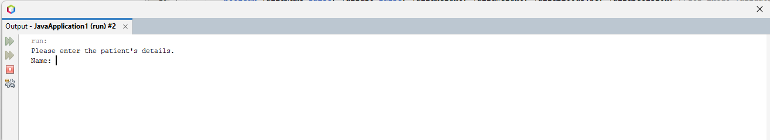

*Figure 1.1* Prompt for name

This program is built to enable administrator to key in the patient’s details (name, identity card number, height, weight and blood type), after that, the program will print out the patient’s information (name, identity card number, height, weight, blood type, date of birth, gender, BMI, and weight status), thus helping the administrator to handle patients’ records.

After running the program, the program will prompt for the patient’s name as shown in *Figure 1.1*.

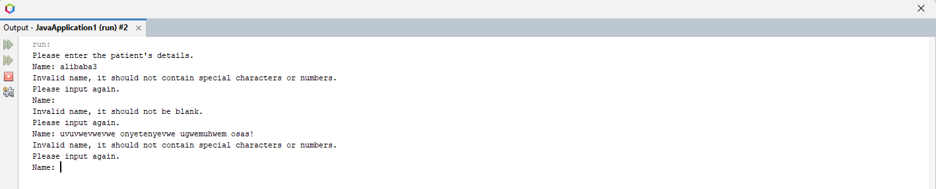

*Figure 1.4* Invalid name – contain special characters

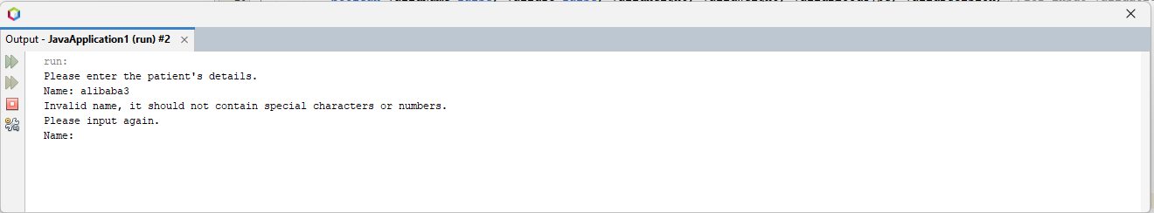

*Figure 1.2* Invalid name – contain numbers

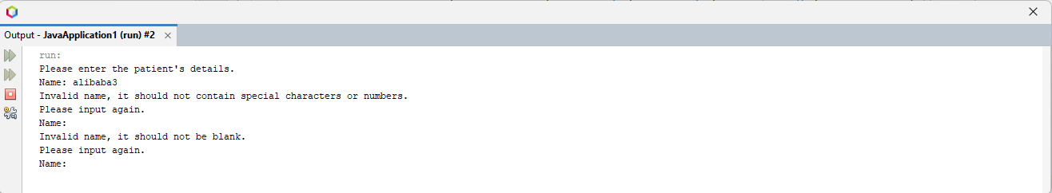

*Figure 1.3* Invalid name – blank

The program will validate name input by the administrator, if the name input is blank or contain numbers and special characters, the program will prompt error message and allow the administrator to repeat the input for patient’s name until the input is a valid name. (*Figure 1.2, Figure 1.3, Figure 1.4*)

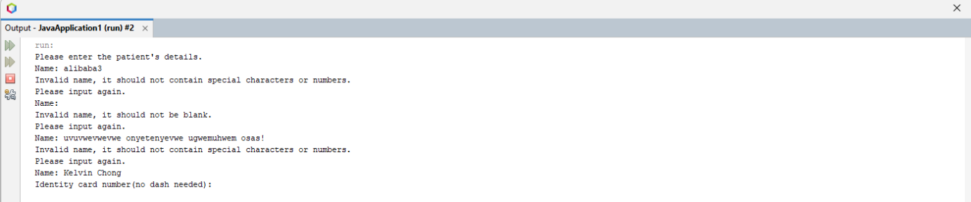

*Figure 2.1* Prompt for identity card number

After input a valid name, the program will continue prompt for identity card number as shown in *Figure 2.1*.

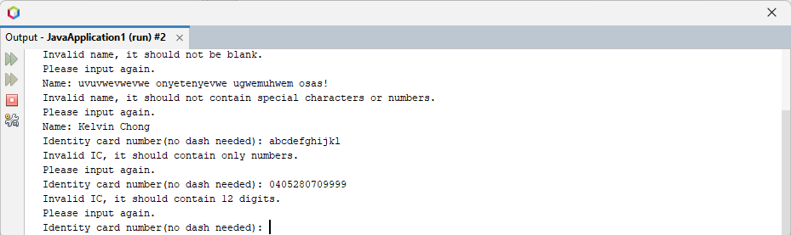

*Figure 2.2* Invalid identity card number – not made up of 12 digits

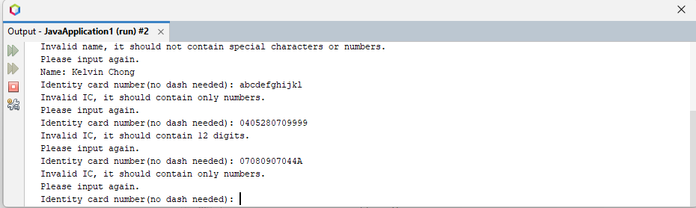

*Figure 2.3* Invalid identity card number – contain non-numeric character

The program will validate identity card number input by the administrator which should be exactly 12 numbers and does not include non-numeric character. The program will prompt error message and allow the administrator to repeat the input for patient’s identity card number for every invalid input. (*Figure 2.2, Figure 2.3*)

After administrator input a valid identity card number, the program will ask for patient’s height in meter as shown in *Figure 3.1*.

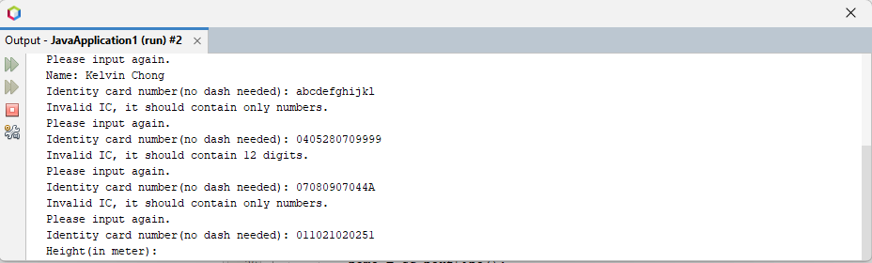

*Figure 3.1* Prompt for patient’s height

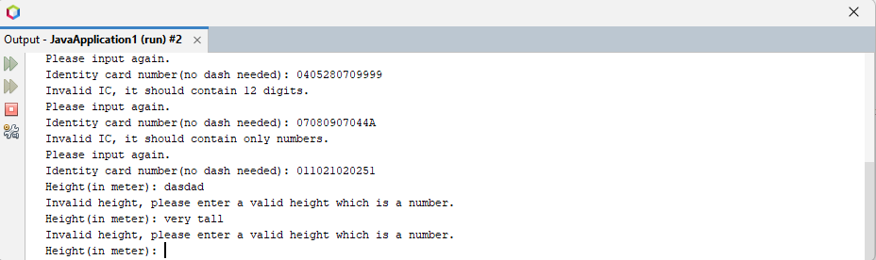

*Figure 3.2* Invalid height – contain non-numeric character

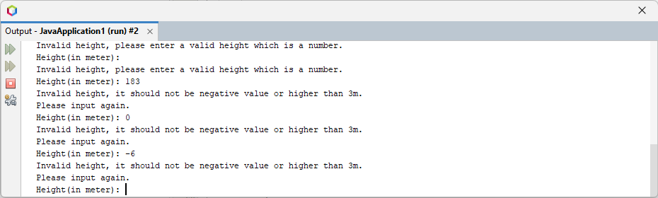

*Figure 3.3* Invalid height – not within normal range (0m<x<= 3m)

The program will validate the patient’s height input by the administrator which should be numeric and within normal height range (0m<x<= 3m). The program will prompt error message and allow the administrator to repeat the input for patient’s height for every invalid input. (*Figure 3.2, Figure 3.3*)

After administrator input a valid height, the program will ask for patient’s weight in kilogram as shown in *Figure 4.1*.

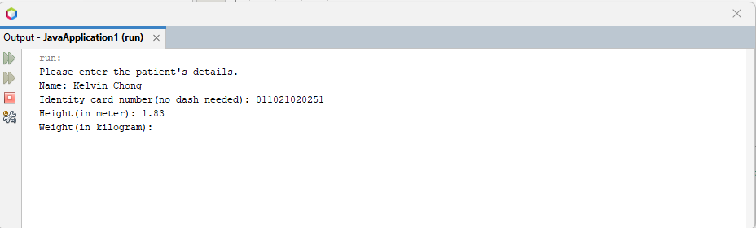

*Figure 4.1* Prompt for patient’s weight

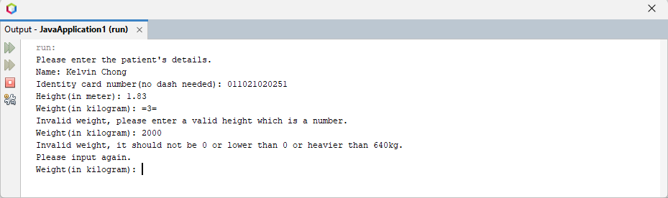

*Figure 4.3* Invalid weight - not within normal range (0kg<x<= 640kg)

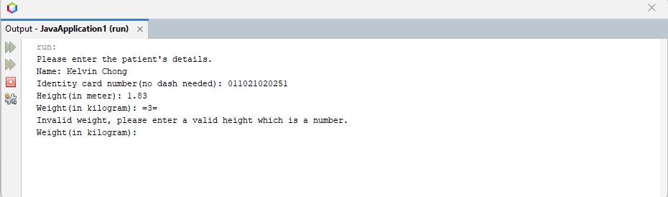

*Figure 4.2* Invalid weight - contain non-numeric character

The program will validate the patient’s weight input by the administrator which should be numeric and within normal weight range (0kg<x<=640kg). The program will prompt error message and allow the administrator to repeat the input for patient’s weight for every invalid input. (*Figure 4.2, Figure 4.3*)

After administrator input a valid weight, the program will ask for patient’s blood type with the given list (A+,A-,B+,B-,O+,O-,AB+,AB-) as shown in *Figure 5.1*.

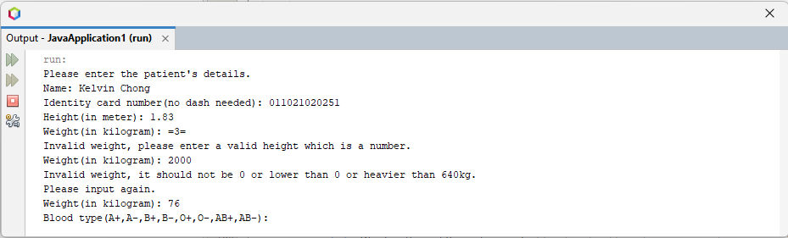

*Figure 5.1* Prompt for patient’s weight

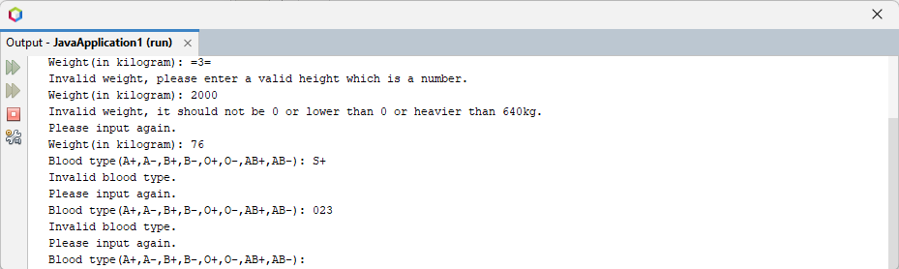

*Figure 5.2* Invalid blood type – not in given list

The program will validate the patient’s blood type input by the administrator which should be in the given list (A+,A-,B+,B-,O+,O-,AB+,AB-). The program will prompt error message and allow the administrator to repeat the input for patient’s blood type for every invalid input. (*Figure 5.2*)

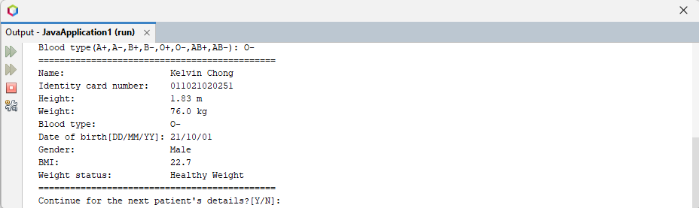

*Figure 6.1 Display patient’s information and ask for decision*

After administrator input a valid blood type, the program will display patient’s information (name, identity card number, height, weight, blood type, date of birth, gender, BMI, and weight status) as shown in *Figure 6.1*. After that, the program will ask for administrator’s decision to either continue handling the next patient’s details or close the program. If the administrator key in either ‘Y’ or ‘y’ or ‘yes’, the program will loop again for the administrator to key in patient’s details as shown in *Figure 6.2.*

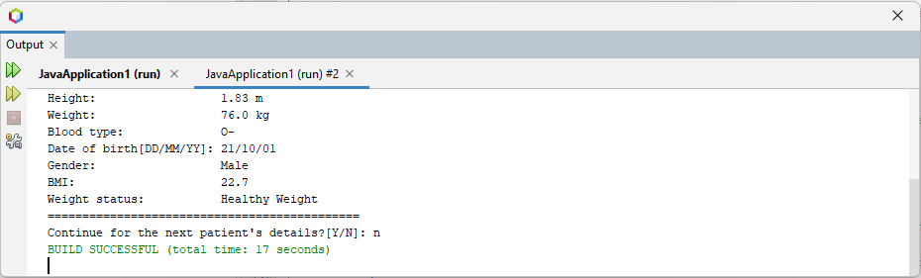

*Figure 6.3* End the program

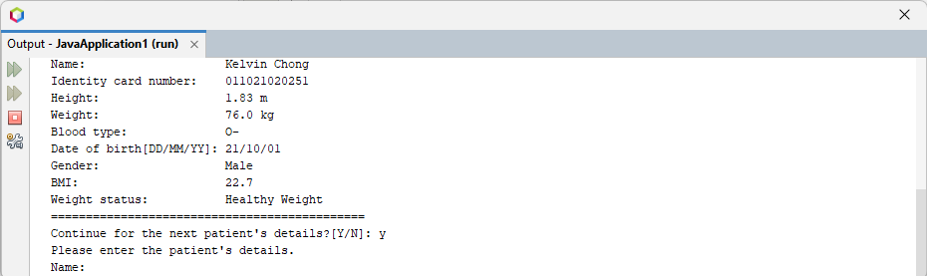

*Figure 6.2* Continue for next patient’s details

If the administrator choose to shut down the program and key in ‘n’ or ‘N’ or ‘no’, the program will eventually end as shown in *Figure 6.3*.

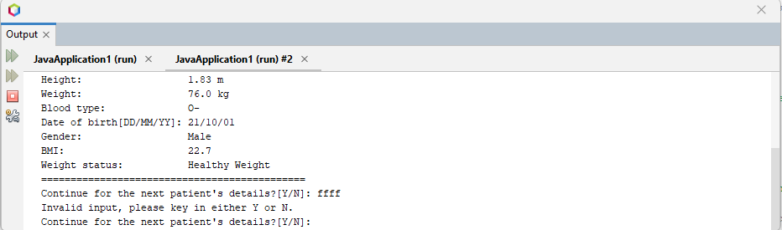

*Figure 6.4* Invalid decision

The program will also validate the decision input by the administrator which should be either ‘y’ or ‘Y’ or ‘n’ or ‘N’ or ‘yes’ or ‘no’. The program will prompt error message and allow the administrator to repeat the input for the decision for every invalid input. (*Figure 6.4*)