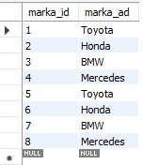 | 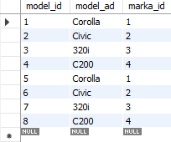
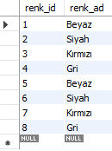 | 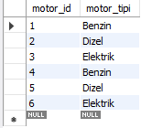
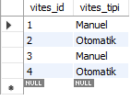 | 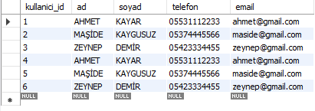
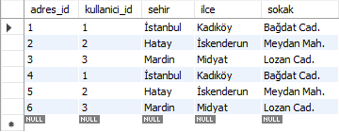 | 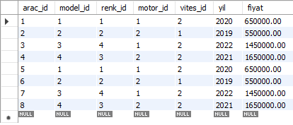
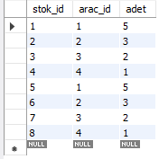 | 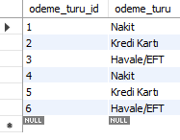
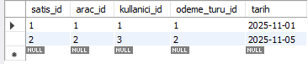 | 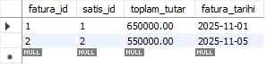
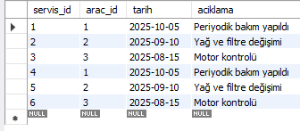

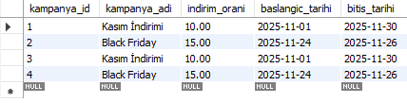
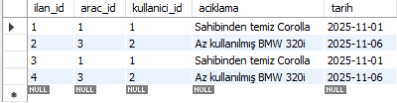

CREATE DATABASE AracSatisSistemi;
USE AracSatisSistemi;

CREATE TABLE Markalar (
marka_id INT AUTO_INCREMENT PRIMARY KEY,
marka_ad VARCHAR(50)
);

CREATE TABLE Modeller (
model_id INT AUTO_INCREMENT PRIMARY KEY,
model_ad VARCHAR(50),
marka_id INT,
FOREIGN KEY (marka_id) REFERENCES Markalar(marka_id)
);

CREATE TABLE Renkler (
renk_id INT AUTO_INCREMENT PRIMARY KEY,
renk_ad VARCHAR(30)
);

CREATE TABLE MotorTipleri (
motor_id INT AUTO_INCREMENT PRIMARY KEY,
motor_tipi VARCHAR(30)
);

CREATE TABLE VitesTipleri (
vites_id INT AUTO_INCREMENT PRIMARY KEY,
vites_tipi VARCHAR(30)
);

CREATE TABLE Kullanicilar (
kullanici_id INT AUTO_INCREMENT PRIMARY KEY,
ad VARCHAR(50),
soyad VARCHAR(50),
telefon VARCHAR(20),
email VARCHAR(50)
);

CREATE TABLE Adresler (
adres_id INT AUTO_INCREMENT PRIMARY KEY,
kullanici_id INT,
sehir VARCHAR(50),
ilce VARCHAR(50),
sokak VARCHAR(100),
FOREIGN KEY (kullanici_id) REFERENCES Kullanicilar(kullanici_id)
);

CREATE TABLE Araclar (
arac_id INT AUTO_INCREMENT PRIMARY KEY,
model_id INT,
renk_id INT,
motor_id INT,
vites_id INT,
yil INT,
fiyat BIGINT,
FOREIGN KEY (model_id) REFERENCES Modeller(model_id),
FOREIGN KEY (renk_id) REFERENCES Renkler(renk_id),
FOREIGN KEY (motor_id) REFERENCES MotorTipleri(motor_id),
FOREIGN KEY (vites_id) REFERENCES VitesTipleri(vites_id)
);

CREATE TABLE Stok (
stok_id INT AUTO_INCREMENT PRIMARY KEY,
arac_id INT,
adet INT,
FOREIGN KEY (arac_id) REFERENCES Araclar(arac_id)
);

CREATE TABLE Satislar (
satis_id INT AUTO_INCREMENT PRIMARY KEY,
arac_id INT,
kullanici_id INT,
odeme_turu_id INT,
tarih DATE,
FOREIGN KEY (arac_id) REFERENCES Araclar(arac_id),
FOREIGN KEY (kullanici_id) REFERENCES Kullanicilar(kullanici_id),
FOREIGN KEY (odeme_turu_id) REFERENCES OdemeTurleri(odeme_turu_id)
);

CREATE TABLE OdemeTurleri (
odeme_turu_id INT AUTO_INCREMENT PRIMARY KEY,
odeme_turu VARCHAR(30)
);

CREATE TABLE Faturalar (
fatura_id INT AUTO_INCREMENT PRIMARY KEY,
satis_id INT,
toplam_tutar INT,
fatura_tarihi DATE,
FOREIGN KEY (satis_id) REFERENCES Satislar(satis_id)
);

CREATE TABLE Fotograflar (
foto_id INT AUTO_INCREMENT PRIMARY KEY,
arac_id INT,
foto_url VARCHAR(250),
FOREIGN KEY (arac_id) REFERENCES Araclar(arac_id)
);

CREATE TABLE ServisKayitlari (
servis_id INT AUTO_INCREMENT PRIMARY KEY,
arac_id INT,
tarih DATE,
aciklama VARCHAR(350),
FOREIGN KEY (arac_id) REFERENCES Araclar(arac_id)
);

CREATE TABLE Kampanyalar (
kampanya_id INT AUTO_INCREMENT PRIMARY KEY,
kampanya_adi VARCHAR(50),
indirim_orani INT,
baslangic_tarihi DATE,
bitis_tarihi DATE
);

CREATE TABLE Ilanlar (
ilan_id INT AUTO_INCREMENT PRIMARY KEY,
arac_id INT,
kullanici_id INT,
aciklama VARCHAR(350),
tarih DATE,
FOREIGN KEY (arac_id) REFERENCES Araclar(arac_id),
FOREIGN KEY (kullanici_id) REFERENCES Kullanicilar(kullanici_id)
);

-- -------------------------------------------------------------------------------------------------------------------------------

INSERT INTO Markalar (marka_ad) VALUES
('Toyota'),
('Honda'),
('BMW'),
('Mercedes');

INSERT INTO Modeller (model_ad, marka_id) VALUES
('Corolla', 1),
('Civic', 2),
('320i', 3),
('C200', 4);

INSERT INTO Renkler (renk_ad) VALUES
('Beyaz'),
('Siyah'),
('Kırmızı'),
('Gri');

INSERT INTO MotorTipleri (motor_tipi) VALUES
('Benzin'),
('Dizel'),
('Elektrik');

INSERT INTO VitesTipleri (vites_tipi) VALUES
('Manuel'),
('Otomatik');

INSERT INTO Kullanicilar (ad, soyad, telefon, email) VALUES
('AHMET', 'KAYAR', '05531112233', 'ahmet@gmail.com'),
('MAŞİDE', 'KAYGUSUZ', '05374445566', 'maside@gmail.com'),
('ZEYNEP', 'DEMİR', '05423334455', 'zeynep@gmail.com');

INSERT INTO Adresler (kullanici_id, sehir, ilce, sokak) VALUES
(1, 'İstanbul', 'Kadıköy', 'Bağdat Cad.'),
(2, 'Hatay', 'İskenderun', 'Meydan Mah.'),
(3, 'Mardin', 'Midyat', 'Lozan Cad.');

INSERT INTO Araclar (model_id, renk_id, motor_id, vites_id, yil, fiyat) VALUES
(1, 1, 1, 2, 2020, 650000),
(2, 2, 2, 1, 2019, 550000),
(3, 4, 1, 2, 2022, 1450000),
(4, 3, 2, 2, 2021, 1650000);

INSERT INTO Stok (arac_id, adet) VALUES
(1, 5),
(2, 3),
(3, 2),
(4, 1);

INSERT INTO OdemeTurleri (odeme_turu) VALUES
('Nakit'),
('Kredi Kartı'),
('Havale/EFT');

INSERT INTO Satislar (arac_id, kullanici_id, odeme_turu_id, tarih) VALUES
(1, 1, 1, '2025-11-01'),
(2, 3, 2, '2025-11-05');

INSERT INTO Faturalar (satis_id, toplam_tutar, fatura_tarihi) VALUES
(1, 650000, '2025-11-01'),
(2, 550000, '2025-11-05');

INSERT INTO Fotograflar (arac_id, foto_url) VALUES
(1, 'https://www.corolla1.jpg'),
(2, 'https://www.civic1.jpg'),
(3, 'https://www.320i.jpg'),
(4, 'https://www.c200.jpg');

INSERT INTO ServisKayitlari (arac_id, tarih, aciklama) VALUES
(1, '2025-10-05', 'Periyodik bakım yapıldı'),
(2, '2025-09-10', 'Yağ ve filtre değişimi'),
(3, '2025-08-15', 'Motor kontrolü');

INSERT INTO Kampanyalar (kampanya_adi, indirim_orani, baslangic_tarihi, bitis_tarihi) VALUES
('Kasım İndirimi', 10.00, '2025-11-01', '2025-11-30'),
('Black Friday', 15.00, '2025-11-24', '2025-11-26');

INSERT INTO Ilanlar (arac_id, kullanici_id, aciklama, tarih) VALUES
(1, 1, 'Sahibinden temiz Corolla', '2025-11-01'),
(3, 2, 'Az kullanılmış BMW 320i', '2025-11-06');

-- ---------------------------------------------------------------------------------------------------------------------------------

SELECT * FROM Markalar;
SELECT * FROM Modeller;
SELECT * FROM Renkler;
SELECT * FROM MotorTipleri;
SELECT * FROM VitesTipleri;
SELECT * FROM Kullanicilar;
SELECT * FROM Adresler;
SELECT * FROM Araclar;
SELECT * FROM Stok;
SELECT * FROM OdemeTurleri;
SELECT * FROM Satislar;
SELECT * FROM Faturalar;
SELECT * FROM AracDosyalari;
SELECT * FROM ServisKayitlari;
SELECT * FROM Kampanyalar;
SELECT * FROM Ilanlar;

