

BEng (Hons) Electrical & Electronic Engineering (Advanced Standing)
________________________________________________________
Level HE6
_________________________________________________________
Module Title: Electrical Machines and Power Electronic drives
Module Number: EEE6011
_________________________________________________________
Assignment: 1 of 1
Assignment Title: Performance analysis of DC and AC machines
_________________________________________________________
Module Tutor: Anu M L A.Lonappan@bolton.ac.uk
Dr Prasanthi Achikulath: pa13ext@greatermanchester.ac.uk

‘
Assessment Number | 002
Assessment Type (and weighting) | Coursework (40%)
Submission Date | 25th April 2026

Aim:
The aim of this course work is to critically analyze the performance of D.C. and A.C. machines using simulation and experimental work.
Learning outcome
LO1: Critically evaluate the environmental and societal impact of solutions to complex problems and minimize adverse impacts. (C7)
LO2: Apply knowledge of engineering management principles, commercial context, project and change management, and relevant legal matters including intellectual property rights. (C15)
LO3: Communicate effectively on complex engineering matters with technical and non-technical audiences. (C17)
Assessment weighting
This assignment represents 40 % of the total assessment for the module.
Use of Generative Artificial Intelligence (GAI) Applications in this Assessment
AI Status | Application | Notes
Category A | No GAI tool is permitted. | While grammar and/or spell checkers may be used to correct individual words and sentences, the use of GAI is not allowed. This is because the learning outcomes require you to produce original assessment work without any GAI assistance  Any GAI generated content which is presented as your own original work and is not acknowledged will be assessed for academic misconduct.
Declaration: At the end of the assessment, you should also include a declaration of any software tools including Generative AI (GAI) applications that you used in developing and completing the assessment.

PART 1: DC Motor and Chopper Drive System Evaluation for Industrial Applications
An automated manufacturing facility is upgrading its material handling system to improve operational efficiency, reduce energy consumption, and enhance workplace safety. The facility operates heavy-duty lifting equipment for vertical material transport and conveyor belt systems for continuous horizontal movement
The engineering department is evaluating DC series and shunt motor technologies and their associated DC chopper drive systems:
The evaluation must consider technical performance, system control, lifecycle cost, project implementation planning, and compliance with safety and legal requirements.
You have been appointed as a Graduate Electrical Engineer to conduct a simulation based technical and management evaluation using MATLAB/Simulink and recommend the most suitable motor drive solution for the facility.

Task 1.1: Performance Analysis and Engineering Evaluation of DC Motors
Design and simulate DC Series Motor and DC Shunt Motor models using MATLAB/Simulink to analyze their operational characteristics.
1.1.1 Generate the following characteristic curves for both motors:
  - Speed vs Torque (N–Ta)
  - Speed vs Armature Current (N–Ia)
  - Torque vs Armature Current (Ta–Ia)
- Analyze how changes in load torque influence motor speed and current.
- Evaluate the operational suitability of each motor for lifting systems and conveyor systems.
1.1.2 Discuss the following engineering management considerations:
- maintenance requirements of each motor type
- expected reliability and operational downtime
- implications for system maintenance planning and operational continuity

Task 1.2: Simulation Validation and Project Risk Considerations
Compare the simulation results with laboratory experimental data to validate the motor models.
1.2.1 Performance Comparison
- Compare the Speed–Torque, Speed–Current, and Torque–Current characteristics obtained from simulation and experimental results, and discuss the motor performance under different operating conditions.
- Explain any differences between simulation and hardware results by considering factors such as mechanical losses, temperature rise, magnetic saturation, brush voltage drop, and other non-ideal conditions.
1.2.2 Risk, Quality, and Change Management
Evaluate the project risks associated with implementing the motor-drive upgrade, including:
- technical risks (model inaccuracies, control instability)
- operational risks (system downtime during installation)
- integration risks when connecting the new drive system to existing equipment.
Propose strategies for:
- reliable simulation validation and system testing
- quality assurance during system commissioning
- transition planning from the existing motor system to the upgraded motor-drive system
- training of maintenance staff and operators during system implementation.

Task 1.3: DC Chopper Drive Simulation and Commercial Evaluation
1.3.1 Design and simulate Class A DC chopper drives to improve motor speed control and operational efficiency.
You are required to:
- Develop MATLAB/Simulink models of Class A and Class B chopper drives.
- Implement PWM control to regulate armature voltage and current.
- Investigate how duty cycle variation affects motor speed, armature current, voltage, and electromagnetic torque.
- Analyze performance using voltage, current, speed, and torque waveforms.
1.3.2 Based on the simulation results, conduct a commercial and legal evaluation including:
- lifecycle cost comparison between the motor drive systems
- energy consumption and long term operating costs
- impact of maintenance and downtime on production efficiency
- compliance with industrial electrical safety standards
- consideration of intellectual property and software licensing issues related to MATLAB/Simulink modelling.

Part 2: Sustainable Motor Drive Selection for Industrial Automation
A modern automated manufacturing facility is upgrading its production system to improve energy efficiency, reduce operational costs, and minimize environmental impact. The facility currently uses three-phase induction motors in conveyor systems and material handling equipment. However, management is considering replacing some of these motors with Permanent Magnet Synchronous Motors (PMSM) to achieve higher efficiency and better speed control.
The engineering department must evaluate both motor technologies and their associated power electronic drive systems to determine the most suitable solution for sustainable and efficient industrial operation.
You have been appointed as a Graduate Electrical Engineer to investigate the performance of Induction Motor drives and PMSM drives using MATLAB/Simulink, compare their characteristics, and recommend the most appropriate motor drive system.

Task 2.1: Performance Analysis of Three-Phase Induction Motor
Investigate the operational characteristics of a three-phase induction motor using simulation.
You are required to:
- Plot the speed–torque characteristics of the induction motor.
- Analyze how changes in load torque affect motor speed.
- Evaluate motor performance under different loading conditions.
- Record key parameters including rotor speed, electromagnetic torque, power factor, mechanical output power, and efficiency.
- Identify stable and unstable operating regions from the speed–torque curve.
- Analyze how varying loads affect speed, torque, and power factor.
Discuss the suitability of induction motors for industrial applications such as conveyor systems and material handling.

Task 2.2: Simulation and Critical Evaluation of Speed Control of an Induction Motor Using a Variable Frequency Drive (VFD)
Simulate a Variable Frequency Drive (VFD) for an induction motor to improve efficiency and speed control, and critically evaluate its performance, environmental benefits, and suitability for industrial applications.
You are required to:
- Develop a MATLAB/Simulink model of a VFD-controlled induction motor.
- Implement V/f control strategy to regulate motor speed.
- Simulate the system under different load and frequency conditions.
- Analyze motor performance including speed response, torque, stator current, power factor, output power, and efficiency.
- Critically evaluate how Variable Frequency Drive (VFD) technology improves energy efficiency in industrial motor systems and discuss its environmental benefits and societal impacts, including reduced energy consumption, lower emissions, improved process control, and cost savings.

Task 2.3: Design, Simulation, and Critical Evaluation of a PMSM Drive Using a PWM-Based Inverter
Investigate the performance of a Permanent Magnet Synchronous Motor (PMSM) driven by a PWM-based inverter and critically evaluate its efficiency, environmental benefits, and suitability for modern industrial applications.
You are required to:
- Develop a MATLAB/Simulink model of a three-phase voltage source inverter (VSI) driving a PMSM.
- Implement Sinusoidal PWM (SPWM) to generate inverter switching signals.
- Integrate the PMSM model with the inverter output.
- Simulate the system and observe motor speed, electromagnetic torque, stator currents, and rotor position.
- Critically evaluate how PMSM Drive Using a PWM-Based Inverter technology improves energy efficiency in industrial motor systems and discuss its environmental benefits and societal impacts, including reduced energy consumption, lower emissions, improved process control, and cost savings.
Deliverables:
- Consolidated Report: Containing distinct sections for each task, each with an introduction, methodology, findings, and conclusion.
- Graphical Representations and Tabulated Data: Appropriately labeled and included within the respective sections of the report.
- MATLAB Code: Included within the report, well-commented, and properly formatted.
- Testing Results and Comparisons: Included within the report with detailed observations and discussions.
- Design Specifications: Detailed design elements, layouts, and specifications incorporated within the design report.

Submission Guidelines:
Report Structure
You must demonstrate competent analytical skills which should be evidenced by the appropriate use of calculations and reasoned arguments. The reports should be presented carefully, with accurate spelling, punctuation and word processed and referenced using the Harvard System.
You are required to write a technical report for this experiment, which will include
- A titled front sheet
- A list of contents with page numbers
- Experimental approach, procedure, devices, setup and actual tasks
- Experiment results, including data, graphs, and calculations
- Analysis and explanations of experiment results, comparisons, observations, and comments
- Some photos of the experimental setup, the original technical diary and the plagiarism coversheet should be attached to a report.
- Comments and conclusions with proper reference.

Minimum Secondary Research Source Requirements:
Level HE6 - It is expected that the Reference List will contain between fifteen to twenty sources. As a MINIMUM the Reference List should include three refereed academic journals and five academic books.

 | 21/03 | 04/04 | 18/04 | 22/03 | 12/04 | 19/04
Task 1.1
Task 1.2
Task 1.3
Task 2.1
Task 2.2
Task 2.3
The submission deadline is given below

Marking Scheme
Section | Marks
Task 1.1: Performance Analysis and Engineering Evaluation of DC Motors | 13 marks
Task 1.2: Simulation Validation and Project Risk Considerations | 13 marks
Task 1.3: DC Chopper Drive Simulation and Commercial Evaluation | 14 marks
Task 2.1: Performance Analysis of Three-Phase Induction Motor | 13 marks
Task 2.2: Simulation and Critical Evaluation of Speed Control of an Induction Motor Using a Variable Frequency Drive (VFD) | 13 marks
Task 2.3: Design, Simulation, and Critical Evaluation of a PMSM Drive Using a PWM-Based Inverter | 14 marks
Overall presentation | 20 marks
Total | 100 Marks

Reference
- Abu-Rub, H. (2012) High Performance Control of AC Drives with MATLAB. Hoboken: Wiley.
- Anderson, L. R. (1988) Electric machines and transformers. 2nd ed. Englewood Cliffs. N.J.: Prentice-Hall.
- Chapman, S. J. (2012) Electric Machinery Fundamentals. 5th ed. McGraw-Hill.
- Hindmarsh, J. (1984) Electrical Machines and Their Applications. 4th ed.Oxford: Pergamon Press.
- Lander, C. W. (1993) Power Electronics. 3rd ed. London: McGraw-Hill.
- Rezzoug, A. (2013) Non-Conventional Electrical Machines. John Wiley & Sons.
- Shaffer, R. (2007) Fundamentals of Power Electronics with MATLAB. Boston: Course Technology.
- Wildi, T. (2013) Electrical Machines, Drives and Power Systems. 6th ed. Pearson.

Guidelines for the Preparation and Submission of Written Assessments

- Written assessments should be word-processed in Arial or Calibri Light font size 12. There should be double-spacing, and each page should be numbered.
- 2000 words or equivalent report
- There should be a title page identifying the programme name, module title, assessment title, your student number, your marking tutor and the date of submission.
- You should include a word-count at the end of the assessment (excluding references, figures, tables and appendices).
Where a word limit is specified, the following penalty system applies:
- Up to 10% over the specified word length = no penalty
- 10 – 20% over the specified indicative word length = 5 marks subtracted (but if the assessment would normally gain a pass mark, then the final mark to be no lower than the pass mark for the assessment).
- More than 20% over the indicative word length = if the assessment would normally gain a pass mark or more, then the final mark will be capped at the pass mark for the assessment.

- All written work should be referenced using the standard University of Bolton referencing style– see: https://www.bolton.ac.uk/library/Study-Skills/Referencing/Home.aspx
- Unless otherwise notified by your Module Tutor, electronic copies of assignments should be saved as word documents and uploaded into Turnitin via the Moodle class area. If you experience problems in uploading your work, then you must send an electronic copy of your assessment to your Module Tutor via email BEFORE the due date/time.
- Please note that when you submit your work to Moodle, it will automatically be checked for matches against other electronic information. The individual percentage text matches may be used as evidence in an academic misconduct investigation (see Section 13).
- Late work will be subject to the penalties:
  - Up to 7 calendar days late = 10 marks subtracted but if the assignment would normally gain a pass mark, then the final mark to be no lower than the pass mark for the assignment.
  - More than 7 calendar days late = This will be counted as non-submission and no marks will be recorded.
Where assessments are graded Pass/Fail only, they will not be accepted beyond the deadline date for submission and will be recorded as a Fail. Students may request an extension to the original published deadline date as described below.
- In the case of exceptional and unforeseen circumstances, an extension of up to 14 days after the assessment deadline may be granted. This must be agreed by your Programme Leader, following a discussion with the Module Tutor. You should complete an Extension Request Form available from your Tutor and attach documentary evidence of your circumstances, prior to the published submission deadline.
Extensions over 14 calendar days should be requested using the Mitigating Circumstances procedure, with the exception of extensions for individual projects and artefacts which, at the discretion of the Programme Leader, may be longer than 14 days.
Requests for extensions which take a submission date past the end of the module (normally in week 15) must be made using the Mitigating Circumstances procedures.
Some students with registered disabilities will be eligible for revised submission deadlines. Revised submission deadlines do not require the completion extension request paperwork.
Please note that the failure of data storage systems is not considered to be a valid reason for an extension. It is therefore important that you keep multiple copies of your work on different storage devices before submitting it.
Specific Assessment Criteria:
First class (70% and above):
Students will apply advanced problem-solving skills, technical knowledge and understanding, to establish rigorous and creative solutions that are fit for purpose for all aspects of the problem including production, operation, maintenance, and disposal. Their work will comprehensively address all aspects of DC and AC machine performance, including simulation accuracy, motor operation, efficiency, and system optimization. They will critically evaluate the commercial, economic, and social implications of electrical machine applications and effectively apply engineering knowledge to real-world scenarios involving electrical drives and power systems. Research demonstrating the use of an extensive range of current secondary research sources will be evident. Academic style and references will be excellent.
Second class (50-69%):
Students will apply advanced problem-solving skills, technical knowledge and understanding, to establish rigorous and creative solutions that are fit for purpose for all aspects of the problem including production, operation, maintenance, and disposal. Their analysis will cover key aspects of motor simulation, performance evaluation, and the practical applications of DC and AC machines. They will assess the commercial and economic impacts of electrical machines and demonstrate a broad understanding of relevant engineering principles. Research demonstrating the use of a wide range of current secondary research sources will be evident. Academic style and references will be good.
Third class (40-49%):
Students will apply advanced problem-solving skills, technical knowledge and understanding, to establish rigorous and creative solutions that are fit for purpose for all aspects of the problem including production, operation, maintenance, and disposal. Their analysis will focus on essential aspects of motor performance and evaluation, demonstrating a general understanding of engineering applications in power systems. They will provide an overview of the commercial and economic implications of electrical machines. Research demonstrating the use of a range of current secondary research sources will be evident. Academic style and reference will be fair.
Fail (39% and below): Students who do not meet the requirements of a third-class grade will not successfully complete the assessment activity.

APPENDIX
LAB EXPERIMENTS WORKSHEET
1. LOAD TEST ON DC SERIES MOTOR
To obtain the performance characteristics of DC series motor by using load test and compare the hardware experimental results with MATLAB Simulink simulation results.
Formulae:
Circumference of the brake drum, R = ____________ m.
Torque, T = (S₁ + S₂) x R x 9.81 Nm.
Input Power, P_{i} = VI Watts
Output Power, P_{o} = 2ℼNT/60 Watts
Efficiency, η% = (P₀ / P_{i})x 100 %
Precautions:

The motor should be started and stopped with 25% of rated load.

Circuit diagram:
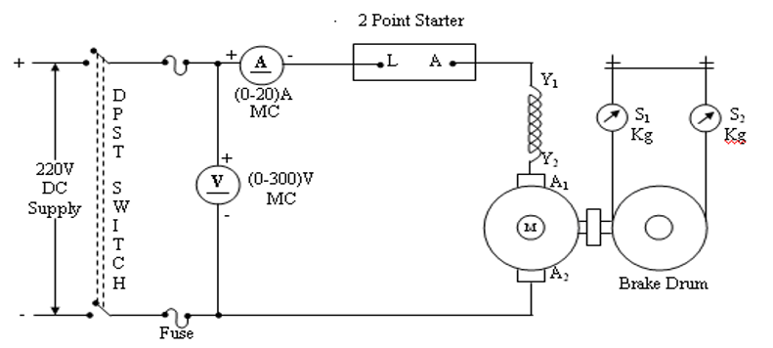
Figure 1: Circuit Diagram for load test of DC series motor
Procedure:
1. Connections are given as per the circuit diagram
2. Observing the precautions the DPST switch is closed.
3. The motor is started with the help of two-point dc starter slowly.
4. Load on the motor is varied with the help of pony brake arrangement.
5. Spring balance, ammeter, voltmeter and speed readings are noted down for various line currents as the load is applied. Care must be taken to avoid the speed reaching dangerously high values while reducing the load.
6. At a minimum safe load the DPST switch is opened.
7. Disconnect and return the apparatus.

Name Plate Details:

Table : Load test on DC Series motor

Voltage (V) | Armature  Current, I_{a}  (A) | S₁  (kg) | S₂  (Kg) | S₁-S₂  (kg) | Speed  (N rpm) | Torque  (T Nm) | Output Power P₀ (Watts) | Input Power P_{i}  (Watts) | Efficiency  η

Analysis of Speed Vs Armature current graph
Scale:
X axis: 1 div = _________
Y axis: 1 div = _________
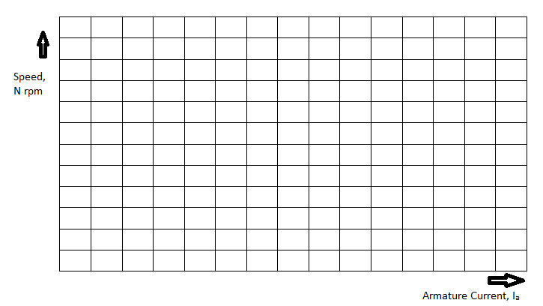
Speed Vs Armature Current
Analysis:

Analysis of Torque Vs Armature current graph
Scale:
X axis: 1 div = _____
Y axis: 1 div = _____
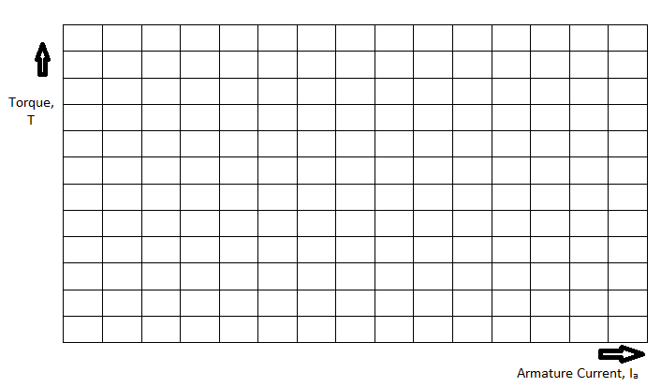 Torque Vs Armature Current
Analysis:

Analysis of Speed Vs Torque graph
Scale:
X axis: 1 div = _____
Y axis: 1 div = _____ 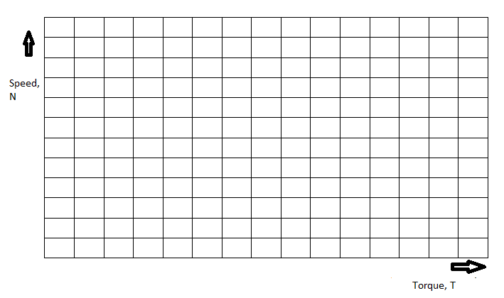
Speed Vs Torque

2. LOAD TEST ON DC SHUNT MOTOR
To obtain the performance characteristics of DC shunt motor by using load test and compare the hardware experimental results with MATLAB Simulink simulation results.
FORMULAE:
Circumference of the brake drum, R = ____________ m.
Torque, T = (S₁ – S₂) x R x 9.81 Nm.
Input Power, P_{i} = VI Watts
Output Power, P_{o} = 2ℼNT/60 Watts
Efficiency, η% = (P₀ / P_{i})x 100 %

PRECAUTIONS:
DC shunt motor should be started and stopped under no load condition.
CIRCUIT DIAGRAM:
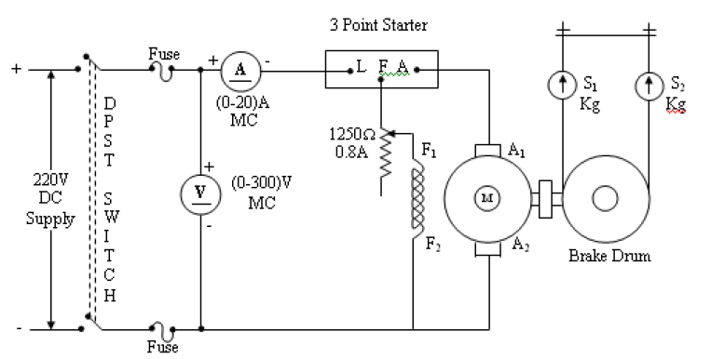

Figure 2: Circuit Diagram for load test of DC Shunt motor

PROCEDURE:
1. Connections are made as per the circuit diagram.
2. After checking the no load condition, and minimum field rheostat position, DPST switch is closed and starter resistance is gradually removed.
3. The motor is brought to its rated speed by adjusting the field rheostat.
4. Ammeter, Voltmeter readings, speed and spring balance readings are noted under no load condition.
5. The load is then added to the motor gradually and for each load, voltmeter, ammeter, spring balance readings and speed of the motor are noted.
6. The motor is then brought to no load condition and field rheostat to minimum position, then DPST switch is opened.
Name Plate Details: ____________________________________________________________________________________________________________________

Table : Load test on DC Shunt motor

Voltage (V) | Current  (A) | S₁  (kg) | S₂  (Kg) | S₁-S₂  (kg) | Speed  (N rpm) | Torque  (T Nm) | Output Power P₀ (Watts) | Input Power P_{i}  (Watts) | Efficiency  η

Analysis of Speed Vs Torque graph
Scale:
X axis: 1 div = _________
Y axis: 1 div = _________ 
Speed Vs Armature Current
Analysis:

Analysis of Torque Vs Armature current graph
Scale:
X axis: 1 div = _____
Y axis: 1 div = _____
Torque Vs Armature Current
Analysis:

Analysis of Speed Vs Torque graph
Scale:
X axis: 1 div = _____
Y axis: 1 div = _____ 
Speed Vs Torque

LAB SAFETY GUIDELINES
To develop a healthy respect for electricity, it is important to understand how it acts, how it can be directed, what hazards it presents, and how these hazards can be minimized through safe laboratory procedures.
How Shock Occurs
Electricity can travel only in a closed or looped circuit. Normally, travel is through a conductor. Shocks occur when the body becomes a part of the electric circuit. The current must enter the body at one point and leave at another. Shocks may occur in one of three ways; the person must come in contact
- With both wires of the electric circuit.
- With one wire of an energized circuit and the ground or
- With a metallic part that has become “hot” by itself being in contact with an energized wire, while the person is in contact with the circuit ground. It is possible to receive a shock by touching only the energized wire, or an energized metallic part, and the ground because of the nature of an electric circuit. An electric circuit constitutes a completely continuous path. It starts at the generator, flows through wires (conductors) to the transformer, and back to the generator.

In the transformer, the voltage is reduced (or increased) and flows into the building, where it is used to do useful work, and then back to the transformer. The generator and the transformer both have direct connections to the ground, and the current will use these paths if its normal path of return is broken and if it can get to the ground.
To receive a shock, a person must become part of an actual circuit; that is, the current must flow through his body as it would through a conductor. Under certain conditions, a person may be exposed to electricity but, unless his body becomes part of a circuit, no harm results. If, for instance, a person is standing on an insulating mat and touches only one wire of a 120-volt circuit, no complete circuit is established, and he will feel no shock. If, however, a person should touch both conductors of a circuit, even with the same finger, the finger becomes part of the circuit, current flowing through the finger from one side of the circuit to the other. For this reason, shock occurs when a finger is placed in a lamp socket (It is difficult to touch the base of the socket without also touching the side.)
Severity of Shock
The severity of the shock received when a person becomes a part of an electrical circuit is affected by three primary factors. These factors are: (1) the rate of flow of current through the body, measured in amperes; (2) the path of the current through the body, and (3) the length of time the body is in the circuit. Other factors which may affect the degree of shock are the frequency of the current phase of the heart cycle when shock occurs, and the physical and psychological condition of the person.
Remember that electric shock is no joke - for three reasons:
- A shock, even a small one, is more harmful if it passes through the heart. Electrical leads should be handled with one hand only, while the other is safely out of the way.
- Under certain conditions, electricity can produce a painful burn.
- A sudden, unexpected shock causes a fast reaction, and the reaction can result in injury, either to the person getting shocked, or a bystander. Be especially cautious when the circuit contains coils and capacitors. These can cause shocks after the power has been turned off.
It is a good idea in any lab where electricity is used to learn where the master disconnects is in case of emergency. All students should be aware of elementary first aid and what to do if an accident occurs, either to themselves or another student.
Few suggestions are
- DON’T ever turn the power on until the circuit is checked.
- DO be ready to turn the power off fast.
- DON’T ever clown around.
- DO make connections with one hand.
- DO turn the power off after every use.
- DO be prepared ahead.
- DO put everything carefully away after use.
- DO keep leads neat and area clean.
- DO follow instructions.
- Open and free wires shall be avoided before energizing the circuit.
- Do not energize any circuits until the instructor checks it.
- The supply voltage of the table is 220 VAC only. Please check the voltage rating of any equipment before plugging into the table sockets. Use proper supply voltage for all the equipments in the lab. If a 110 VAC supply is needed, then ask the technician to provide it
- The range of different power equipments should be correctly selected at the right time. Do not overload any equipment / instrument
- Seek help from your instructor for any doubt about the circuit connection.
- Modification to the circuit may only be performed when the system is switched off (zero voltage/zero current)
- Always use the coupling and shaft end guards to protect against contact with rotating parts.
- After finishing the experiment, turn off all the supply and bring them back to zero reading before dismantling the circuit. The first connections to be removed during dismantling the circuit are connections from all the voltage supplies.
- Normally it is not required to open the device’s housing. However, if it is necessary to open the housing then it must be performed by lab technician and under the condition only when the mains plug and all connecting leads have been disconnected.
- Attention should be given to the proper routing of the cables related to experiments when connecting the rotating machines. Cables should never have a chance to meet rotating components
- Machines are to be positioned immediately adjacent to one another with their base please securely bolted together
- Connect the thermal switch of the motor to the “TEMP CONTROL” on the control unit.
- Connect all the “PE” or ground connections present on the motor, generator and the tacho generator panels to the “PE “connection of the supply.
- Ground all the ground connections of isolation amplifier, CASSY and profi-CASSY units.
- When a DC motor is removed from its power source then subsequently driven by at the cradle dynamometer it can go into generator operation, thus producing voltage which will continue to be present at its terminals.
- Safety of working shall be strictly observed and maintained by one of the group members throughout the experiment time.
- Push the emergency button “RED BUTTON” present on the experiment table in case of any emergency or safety related events.
EE-Power Lab Regulations:
- Please adhere to the lab timings.
- Safety shoes and clothing is strictly enforced for any activities in the lab
- Keep good housekeeping while working in the lab and place the wires and other accessories at their specified locations after finishing the work.

