FoodieMeter Backend API
Preliminary User Manual (PUM)
Version 0.1 — Draft
This is a preliminary manual: it covers install → setup → understand the interface → use the core features. It is not a complete final manual — endpoints and screens not yet built (subscriptions, AI recommendations, gamification, image recognition — see the project CLAUDE.md) are out of scope for this document.
Scope note: this repository is the backend API only — there is no mobile app in this codebase (a teammate builds that separately). "The application" documented here is therefore the API service itself, and its GUI is Swagger UI at /api/docs — the interactive page a developer/tester uses to explore and call every endpoint. Every screenshot in this manual is a real capture of the API actually running, not a mockup.

1. System / Device Requirements
Node.js | v20 or later (built and tested on v22.13.0)
npm | v10 or later (bundled with Node.js)
PostgreSQL | v14+ — either a local install, or a hosted instance (this project uses Supabase)
git | to clone the repository
Disk space | ~350 MB (mostly node_modules)
Network | required for npm install and to reach the database
OS | developed on macOS; Node/Express run the same on Linux and Windows

2. Where / How to Download
The source code is hosted on GitHub:
https://github.com/akbariff/foodie-meter-backend
Clone it with git (no installer or app-store download — this is a source-code repository, run locally):
git clone https://github.com/akbariff/foodie-meter-backend.git
cd foodie-meter-backend

3. Step-by-Step Installation
- Install dependencies:
npm install
- Copy the environment template:
cp .env.example .env
- Open .env and fill in the required values (see Section 4).
- Create the database tables:
npx prisma migrate dev
- Seed sample curated recipes (optional but recommended):
node prisma/seed.js
- Start the server:
npm run dev
A successful start prints:
Foodie Meter API listening on http://localhost:4477
API docs: http://localhost:4477/api/docs

4. Permissions Required During Installation
There is no OS-level installer, so there are no app-store-style permission prompts. What "permission" means here is credentials and network access:
- Network access for npm install (downloading packages) and for the app to reach its database.
- Database credentials — either a local PostgreSQL role, or a connection string to a hosted database (Supabase in this project).
- A free local port (4477 by default) for the server to bind to.
- Optional: a Gmail App Password if you want the app to send real verification/reset emails. Without it, the app automatically falls back to a disposable test inbox — nothing blocks installation.

5. Initial Configuration (no setup wizard — a .env file)
There is no interactive setup wizard; configuration is a plain-text .env file. The fields that matter for a first run:
DATABASE_URL | PostgreSQL connection string
PORT | defaults to 4477
JWT_SECRET | any long random string, used to sign login tokens
VERIFICATION_CODE_TTL_MINUTES | how long a signup/reset code stays valid (default 15)
SMTP_USER / SMTP_PASS / MAIL_FROM | optional — leave as placeholders to use the automatic test-inbox fallback
If PostgreSQL is unreachable (for example, a paused free-tier Supabase project), migrate/start commands fail with a clear connection error — this is expected behavior, not a bug, and is documented in the project's CLAUDE.md.

6. What Happens When the App Is "Opened" for the First Time
"Opening" the app means visiting its interactive documentation in a browser once the server is running:
http://localhost:4477/api/docs
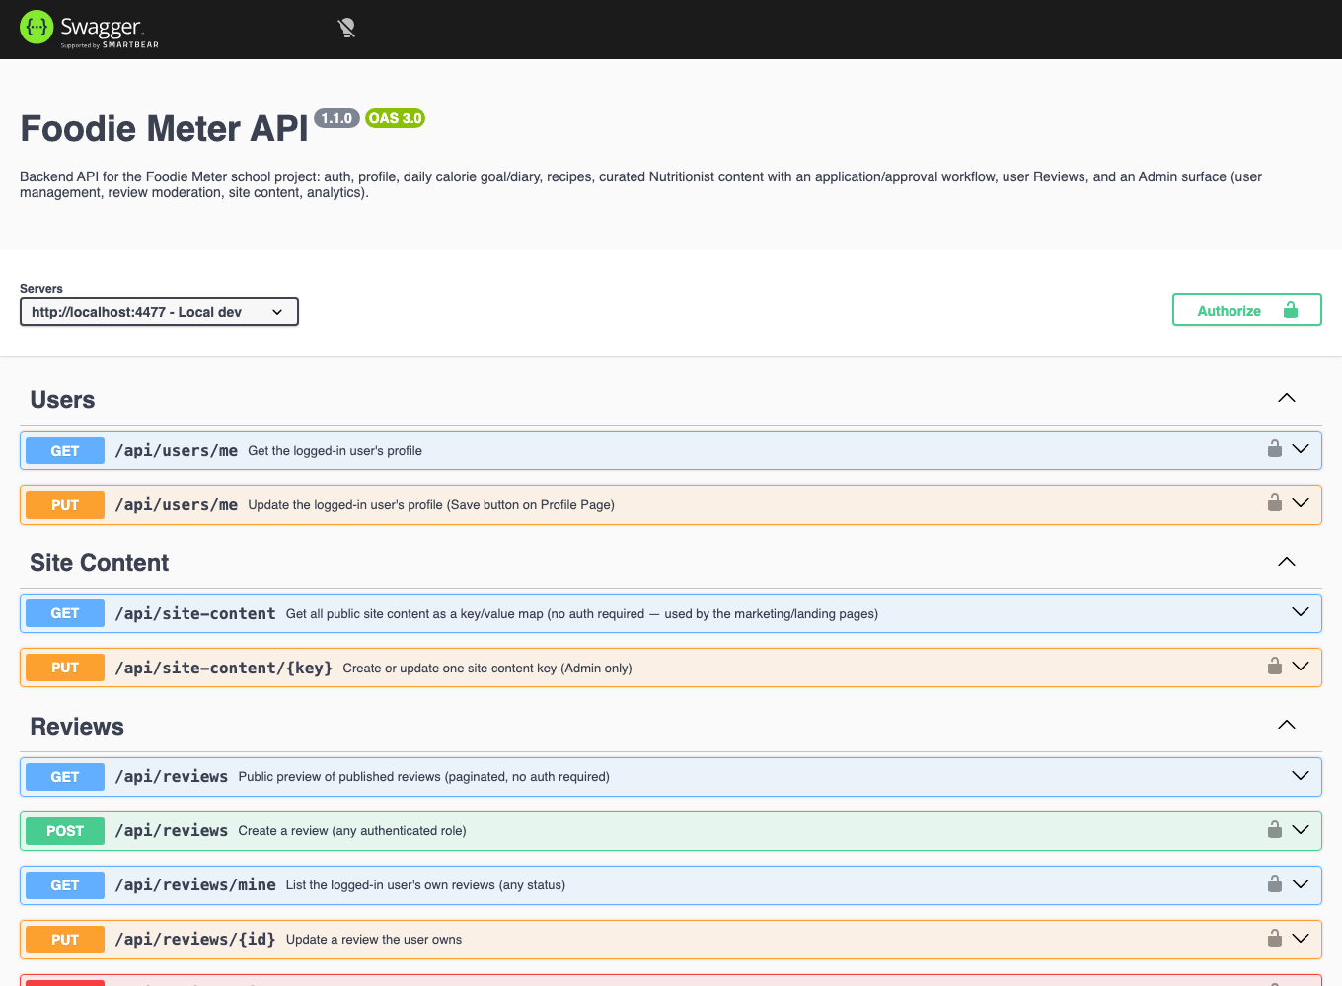
Figure 1 — Swagger UI, the first screen you see. This is the API's home / dashboard.
A quick health check is also available, useful for confirming the server is alive without opening the full UI:
curl http://localhost:4477/health
→ {"status":"ok"}

7. Initial GUI Tour — Labeled
Swagger UI is organized the same way throughout the API: a top bar, a server selector and an Authorize button, then endpoints grouped into collapsible sections by feature area.
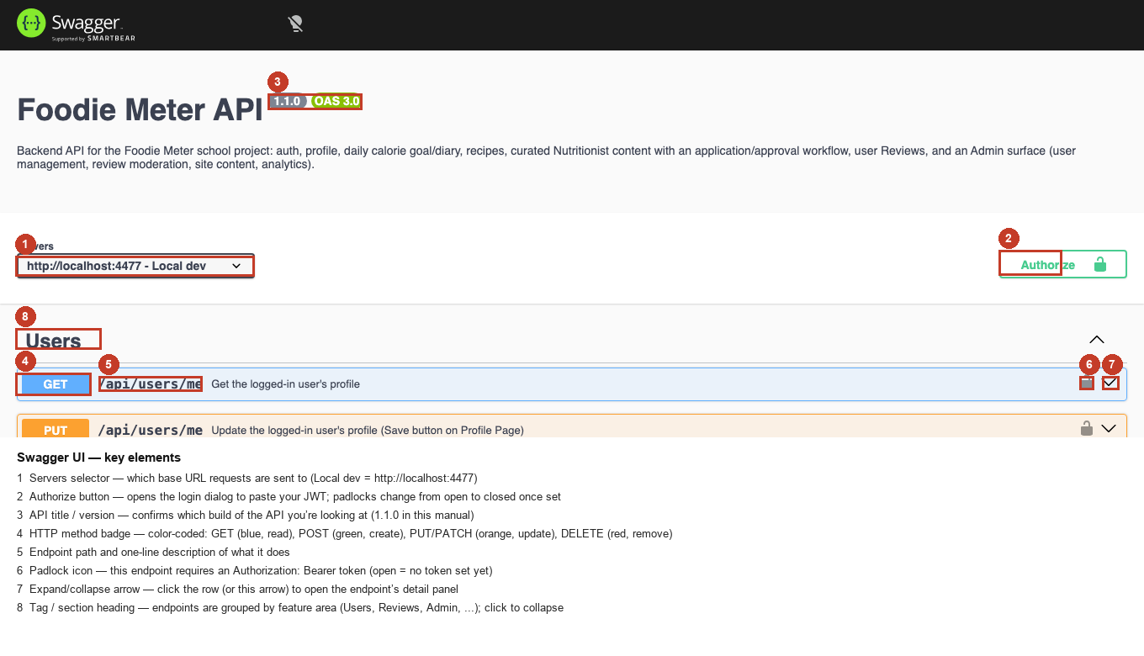
Figure 2 — key elements of the Swagger UI screen, numbered and explained below.
1. Servers selector — which base URL requests are sent to.
2. Authorize button — opens the login dialog to paste a JWT; every protected endpoint's padlock updates once a token is set.
3. API title / version — confirms which build of the API is running.
4. HTTP method badge — color-coded: GET (blue, read), POST (green, create), PUT/PATCH (orange, update), DELETE (red, remove).
5. Endpoint path and a one-line description of what it does.
6. Padlock icon — this endpoint requires Authorization: Bearer <token>.
7. Expand/collapse arrow — opens the endpoint's detail panel (parameters, request body, "Try it out").
8. Tag / section heading — endpoints are grouped by feature area (Users, Reviews, Admin, ...).

8. Sign Up / Login (Account Setup)
Every account starts the same way: sign up, verify the emailed code, then log in to receive a token. All three steps are done from the same Swagger UI screen by expanding an endpoint, clicking "Try it out," editing the example request body, and clicking "Execute."

8.1 Sign up
Expand POST /api/auth/signup and click "Try it out."
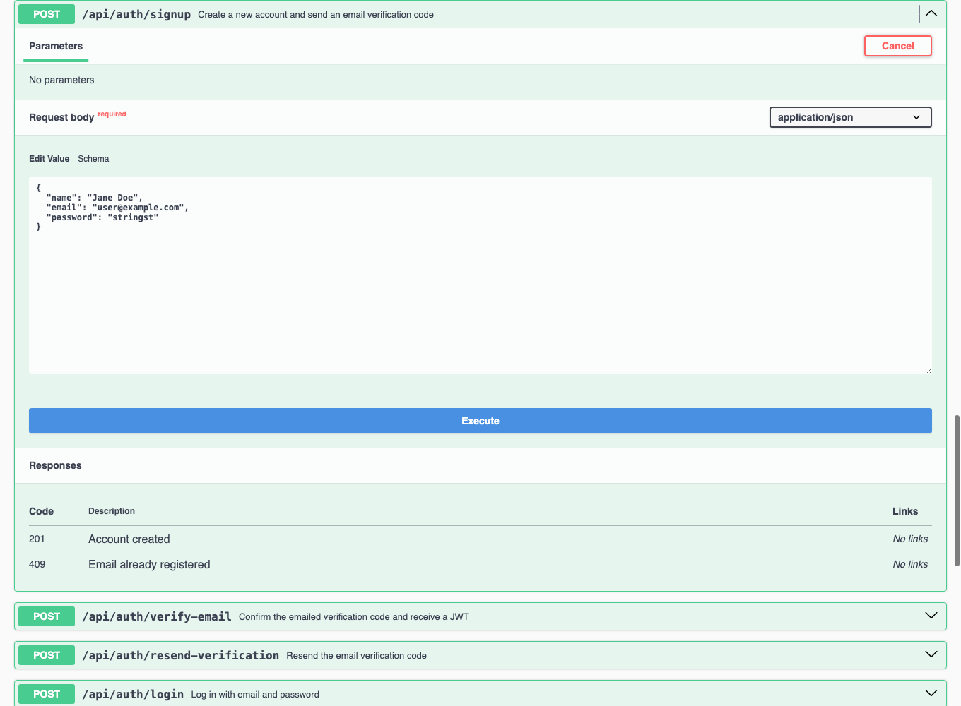
Figure 3 — the signup endpoint expanded, showing the editable example request body.
Replace the example values with a real name, email, and password (minimum 8 characters), then click "Execute":
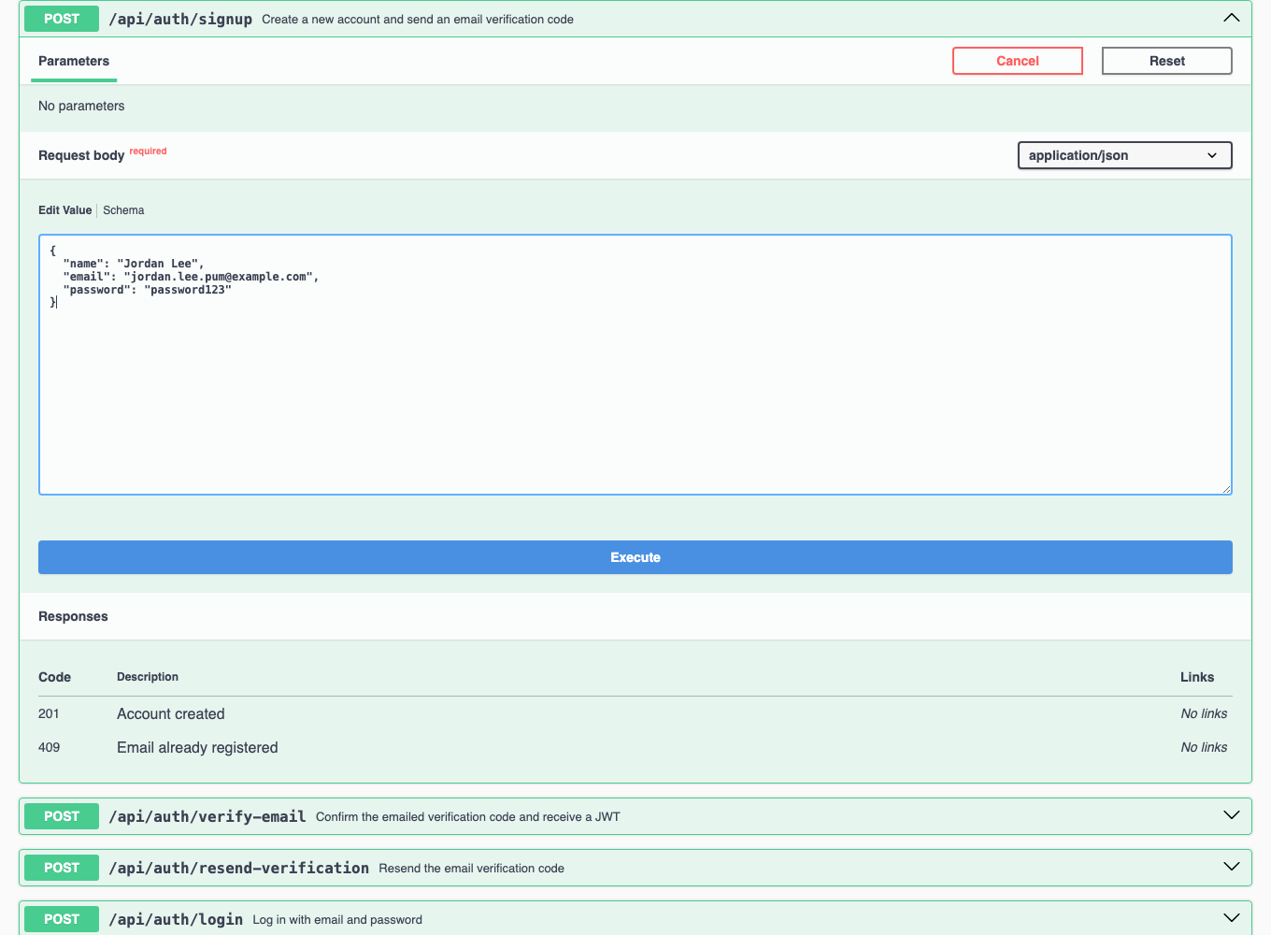
Figure 4 — signup request filled in and ready to send.
A successful signup returns 201 Created. The account exists but is unverified, and a 6-digit code has been emailed to it:
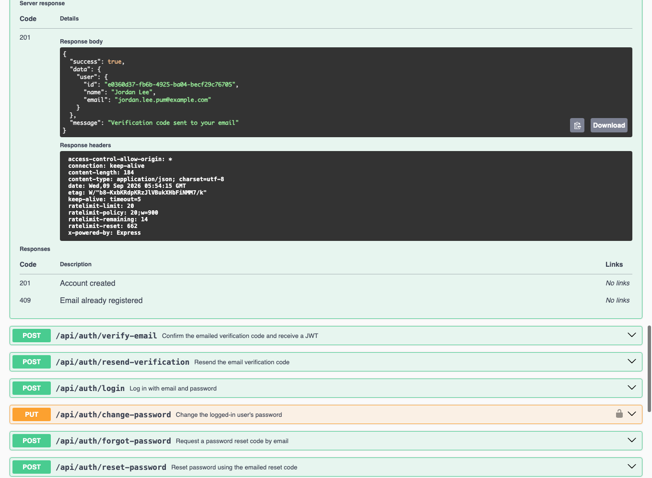
Figure 5 — the live server response: 201, with the new user's id, name, and email.
In local development, if no real email is configured, the verification code is also printed to the server console — this is what makes the flow testable without a mailbox.

8.2 Verify email
Expand POST /api/auth/verify-email, fill in the same email and the 6-digit code, and execute:
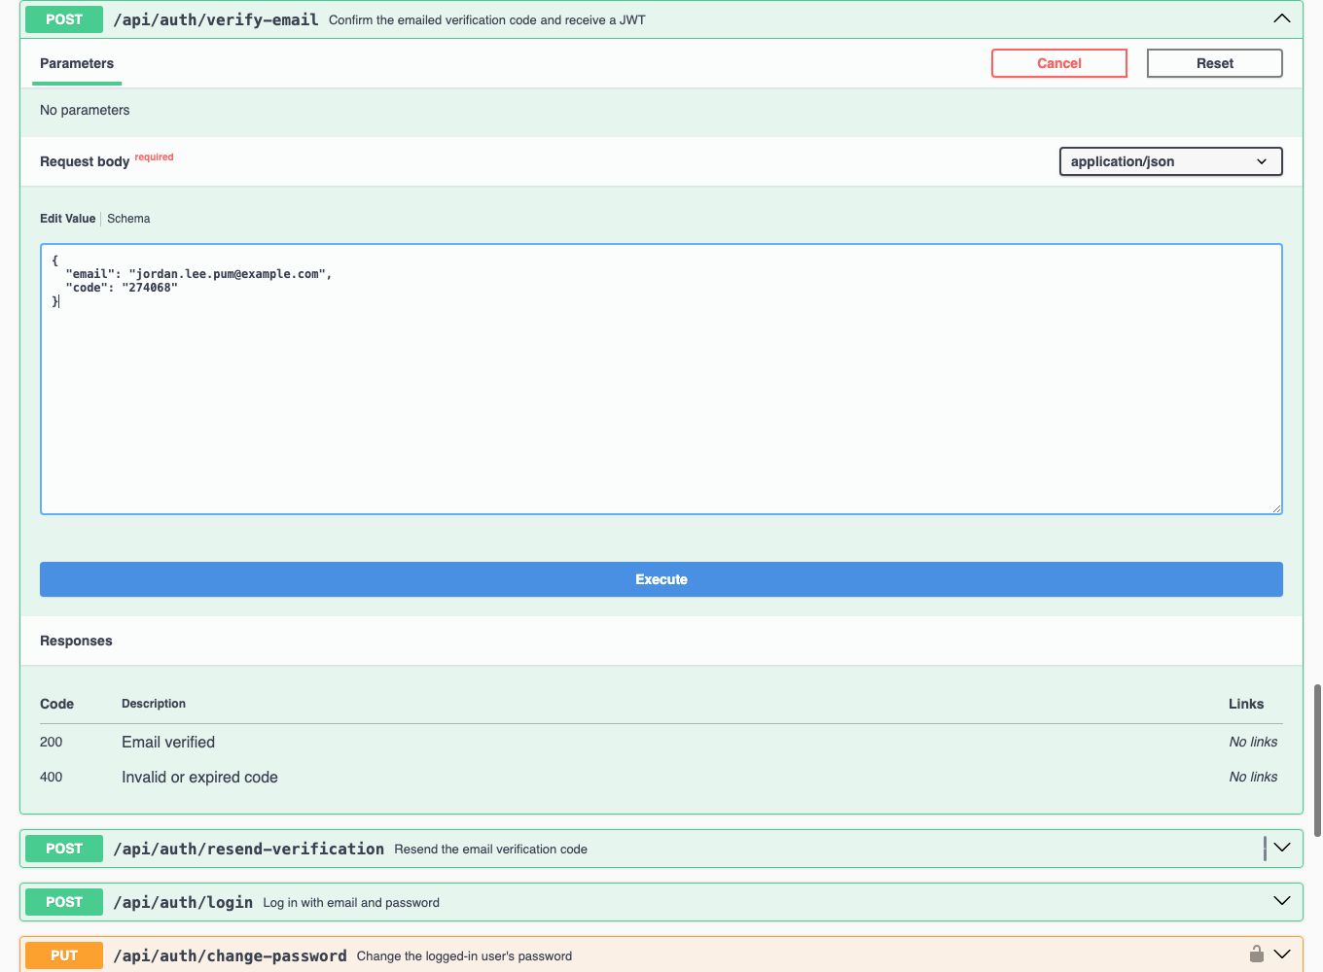
Figure 6 — verify-email request, code taken from the server console.
A successful verification returns 200 OK with a JWT — this token is what proves who you are on every subsequent request:
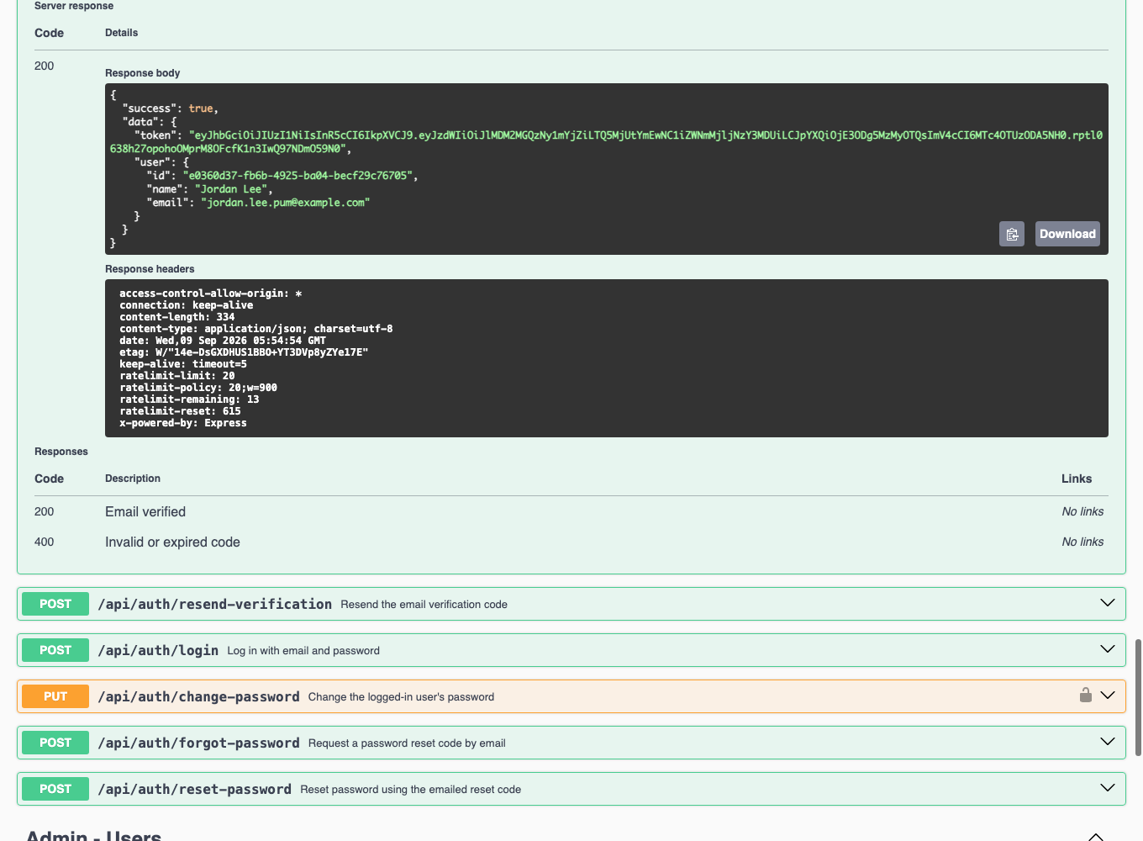
Figure 7 — verified: the response includes a signed JWT.

8.3 Log in
Once verified, the same credentials work through POST /api/auth/login on any later visit (a fresh token is issued each time):
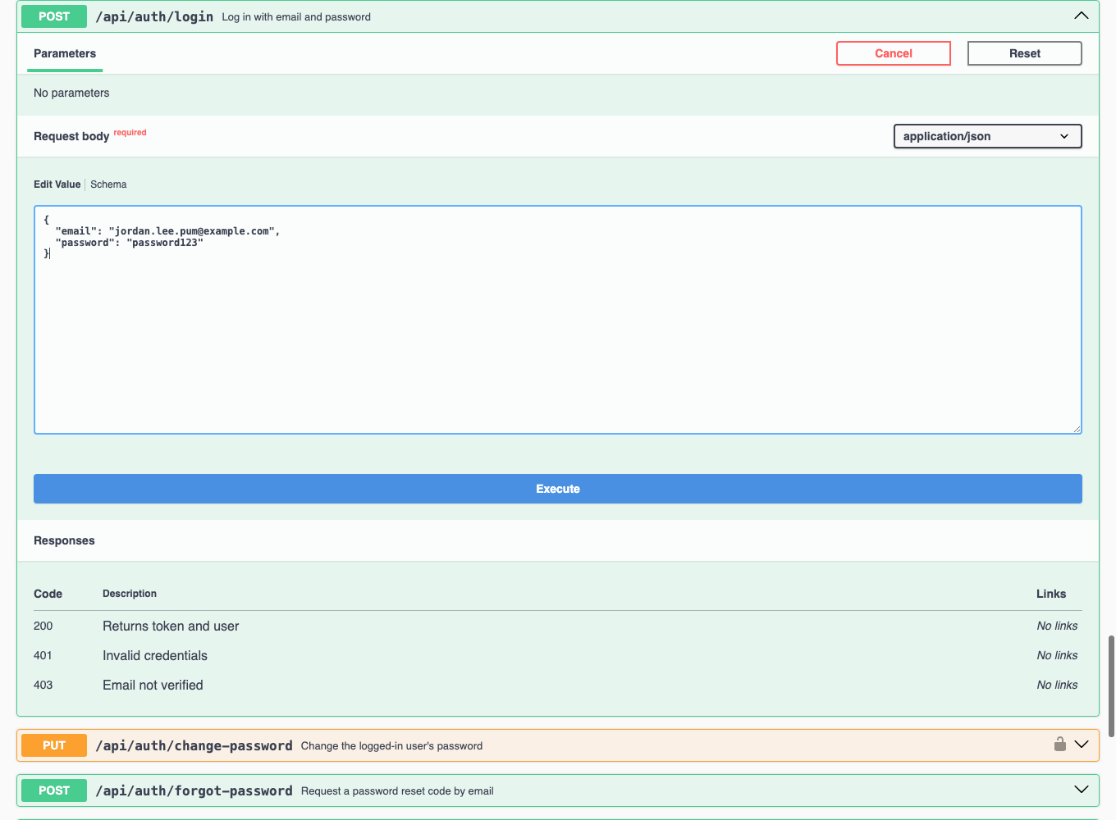
Figure 8 — login request with email and password.
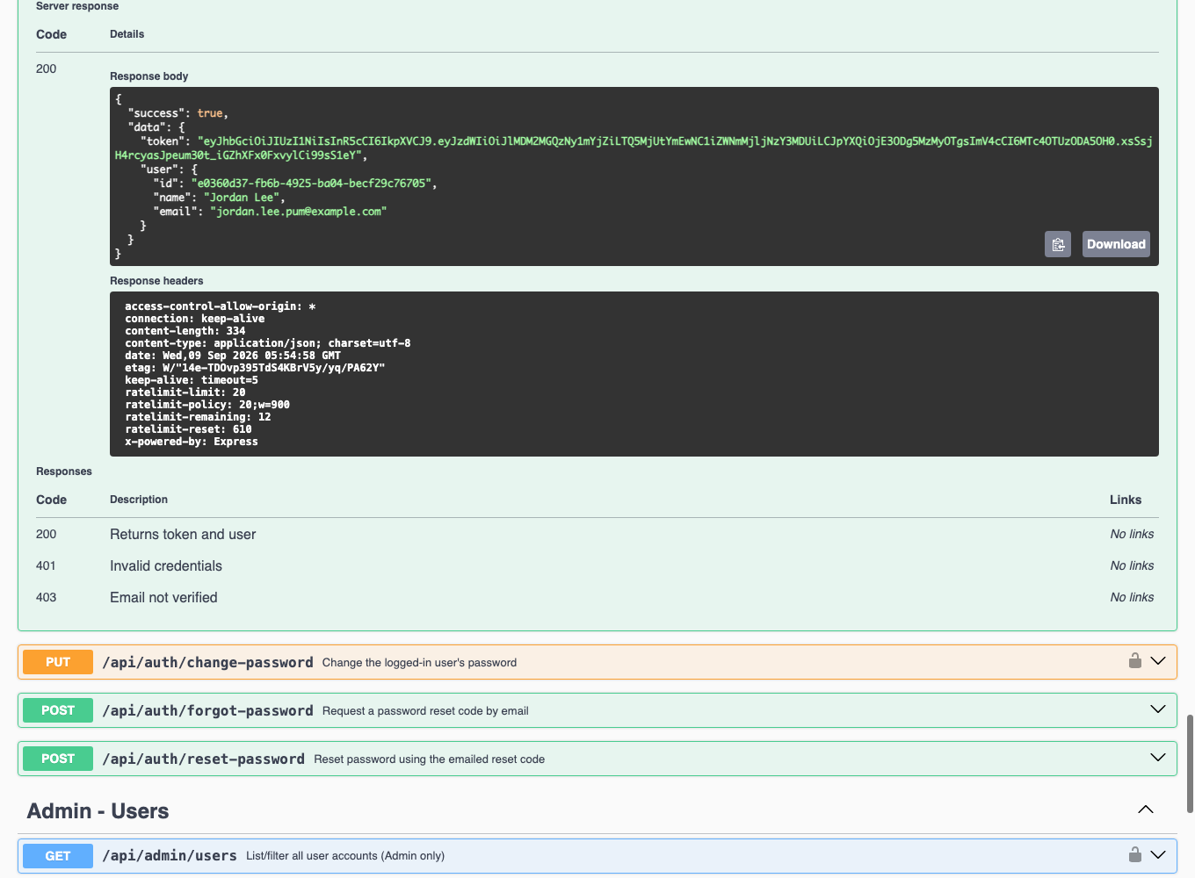
Figure 9 — 200 OK with a fresh JWT.

8.4 Authorize (unlock the protected endpoints)
Click the green "Authorize" button at the top of the page, paste the token from step 8.2 or 8.3, and confirm:
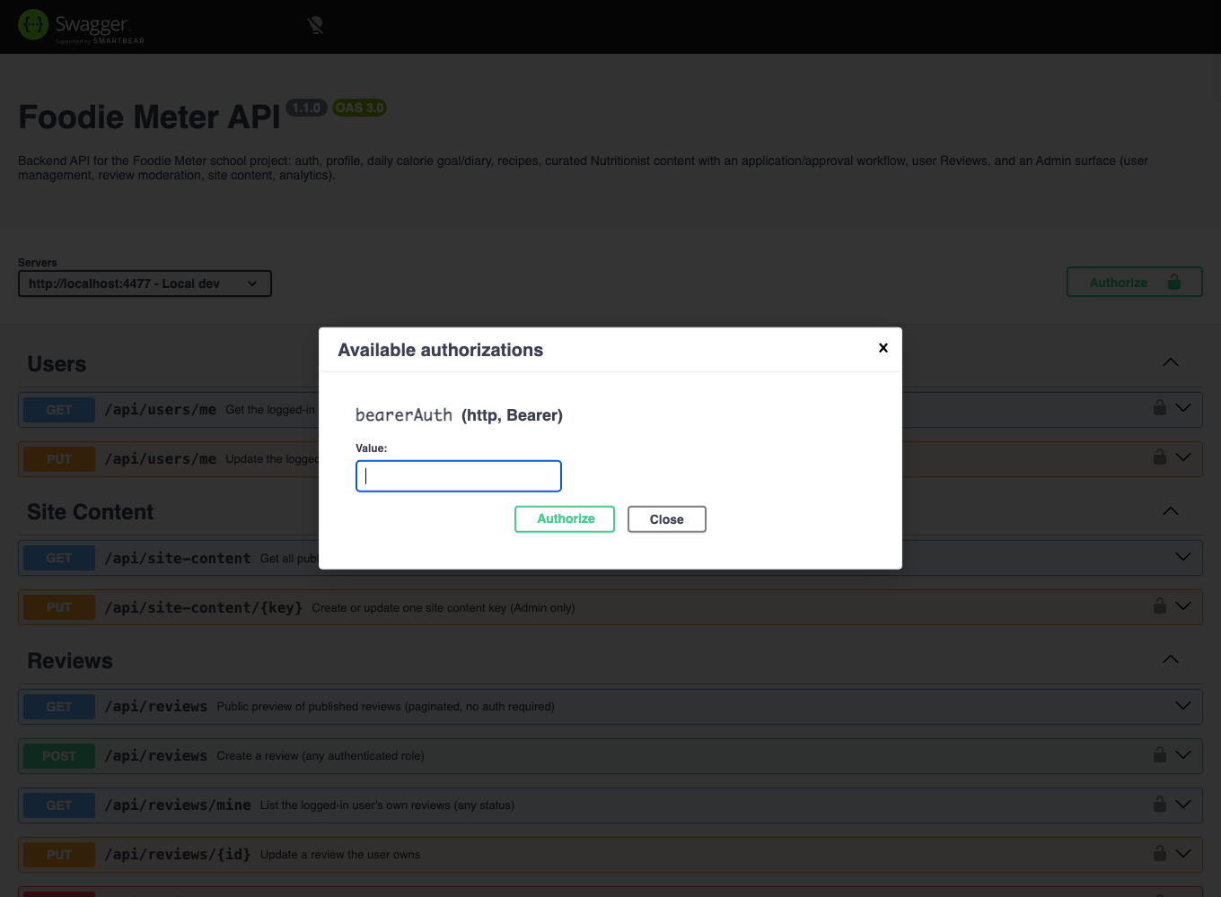
Figure 10 — the Authorize dialog, empty.
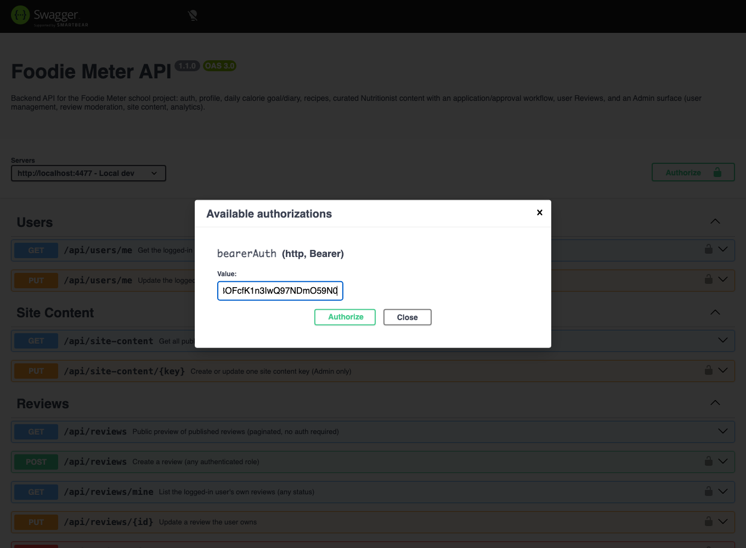
Figure 11 — the token pasted in.
Every padlock icon on the page switches from open to closed — every protected endpoint can now be called directly from this page:
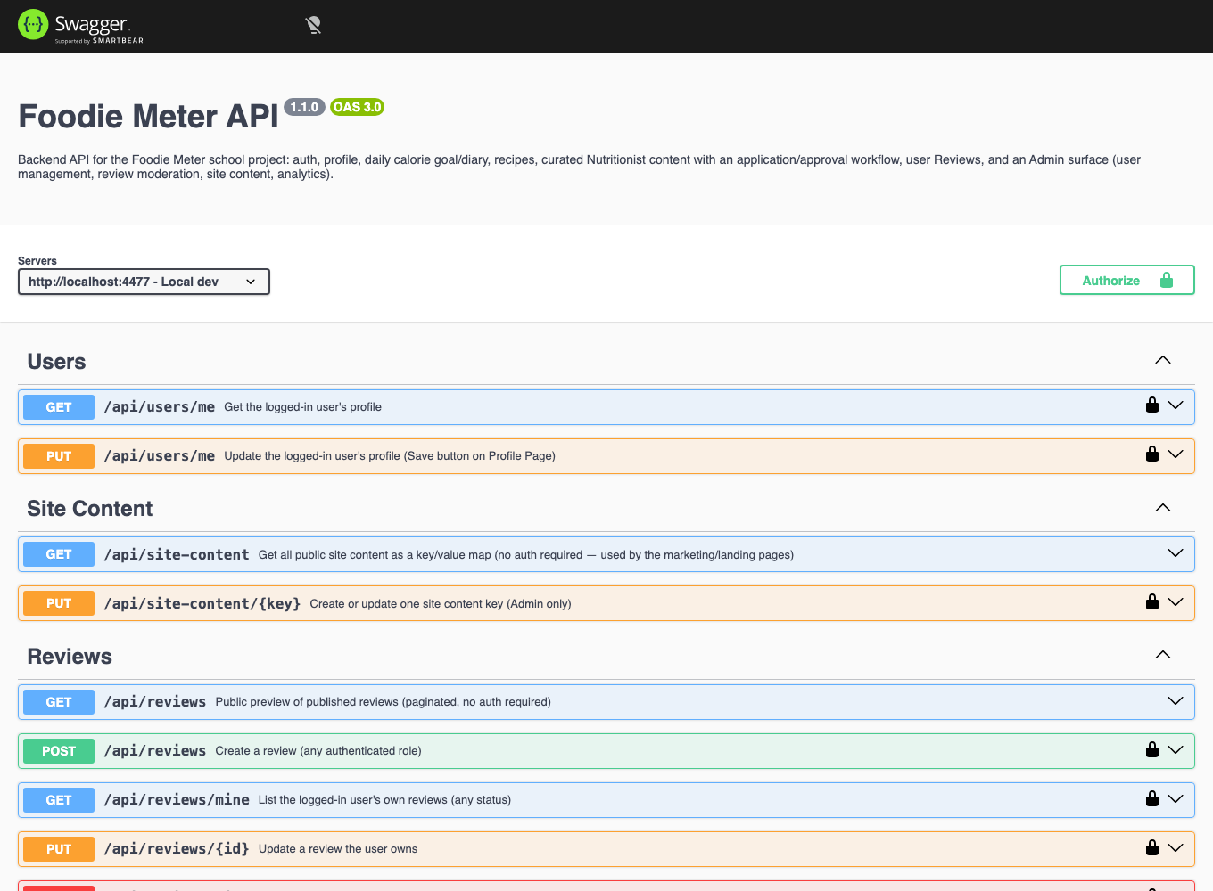
Figure 12 — authorized: padlocks are now closed across the whole page.

9. Required Permissions (Roles)
Every account has a role and a subscription tier. A brand-new account is always USER / FREE — there is no self-service way to become NUTRITIONIST or ADMIN. See docs/DATABASE_SCHEMA.docx for the full model.
USER | default role — full access to their own profile, calorie goal, food diary, and recipes
NUTRITIONIST | granted only after applying (POST /api/nutritionist-applications) and being approved by an Admin — can publish curated recipes in their assigned category and flag user recipes for moderation
ADMIN | created directly in the database (deliberately no bootstrap endpoint) — manages accounts, applications, reviews, and site content

10. Basic Feature Walkthrough
With an Authorized session, the core user journey is: set a calorie goal → log a meal → check the daily summary → create a recipe. This is the same "pick a starting point → act on it → save/view the result" shape as any core app feature, expressed as API calls.

10.1 Set a daily calorie goal
Expand PUT /api/calorie-goal, "Try it out," set a target, execute:
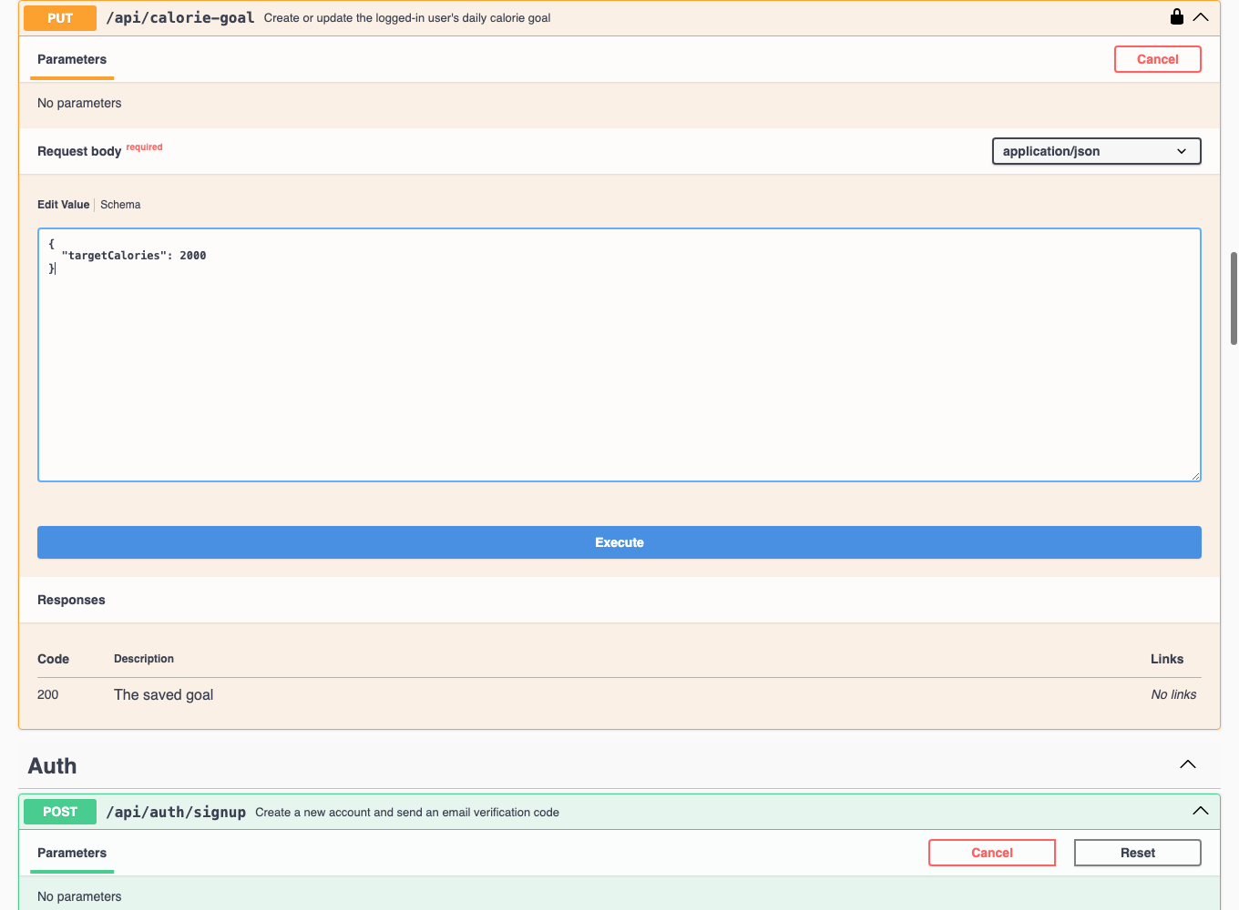
Figure 13 — setting a 2000-calorie daily goal.
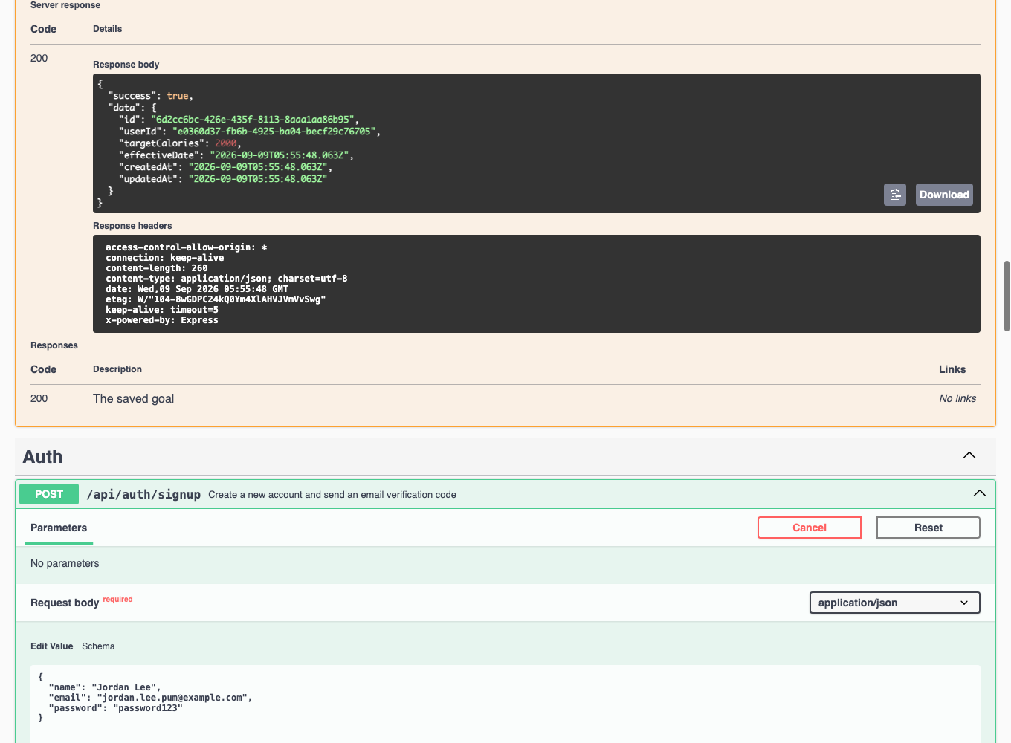
Figure 14 — 200 OK, the saved goal.

10.2 Log a meal (food diary)
Expand POST /api/calorie-intake and record what was eaten:
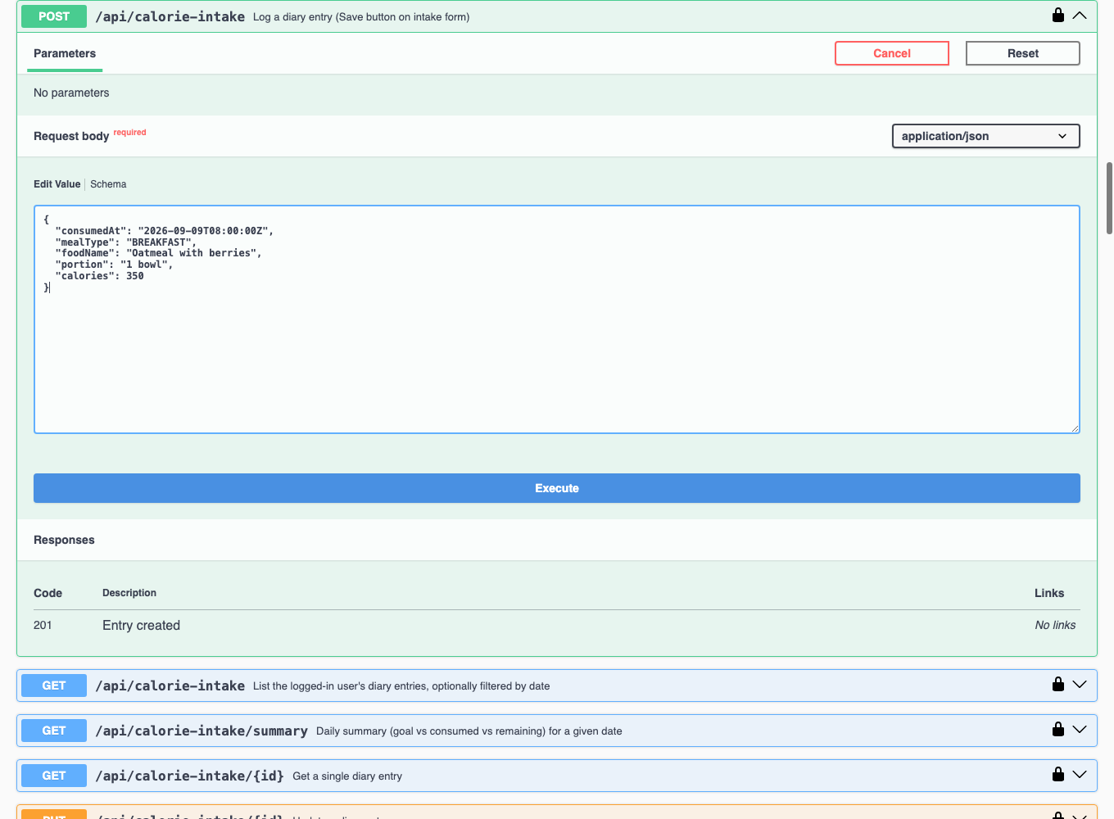
Figure 15 — logging breakfast: oatmeal with berries, 350 calories.
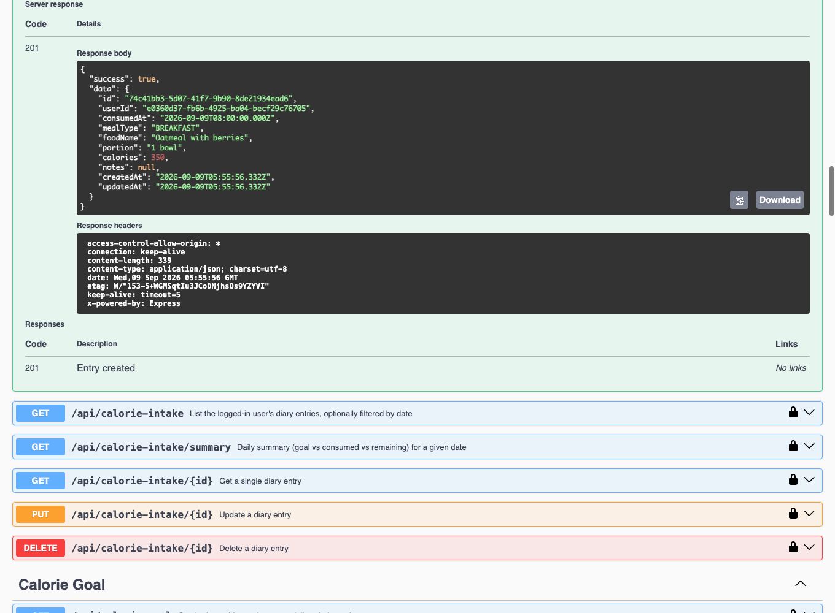
Figure 16 — 201 Created, the saved diary entry.

10.3 View the daily summary
Expand GET /api/calorie-intake/summary, set the date query parameter, execute:
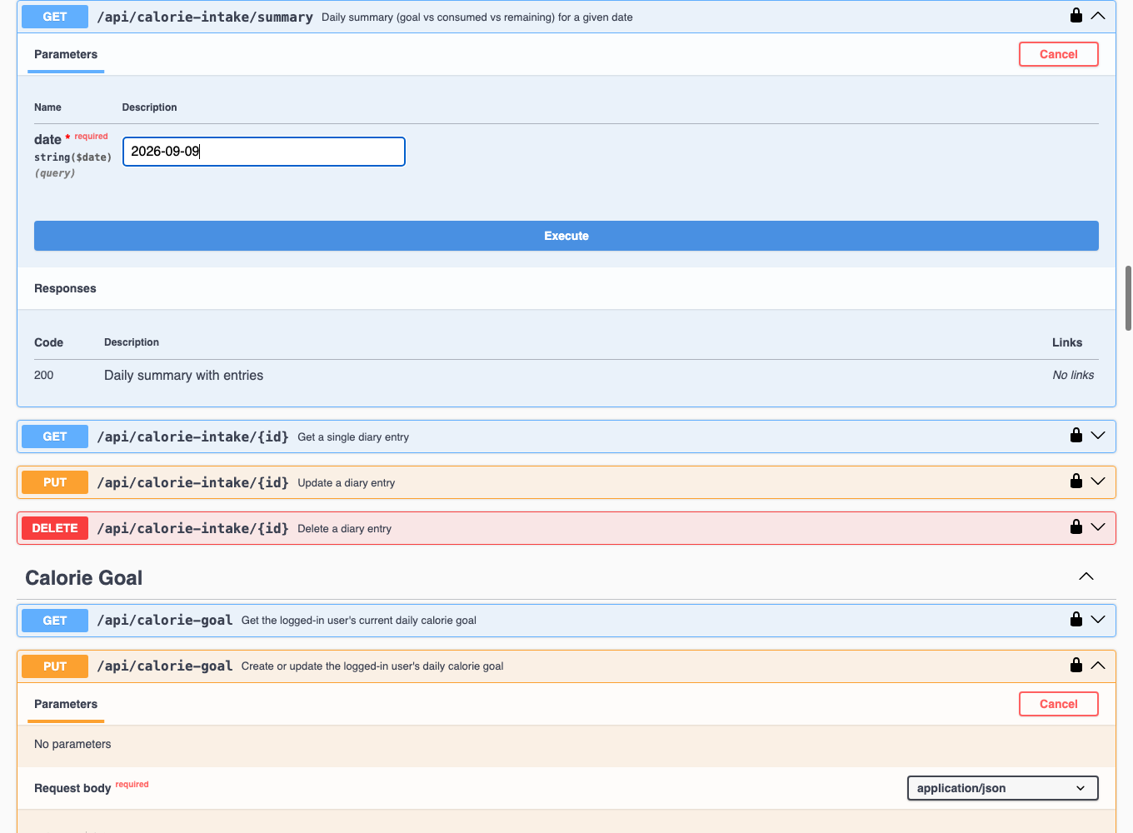
Figure 17 — requesting the summary for 2026-09-09.
This is the core value of the diary feature: goal vs. consumed vs. remaining, computed server-side.
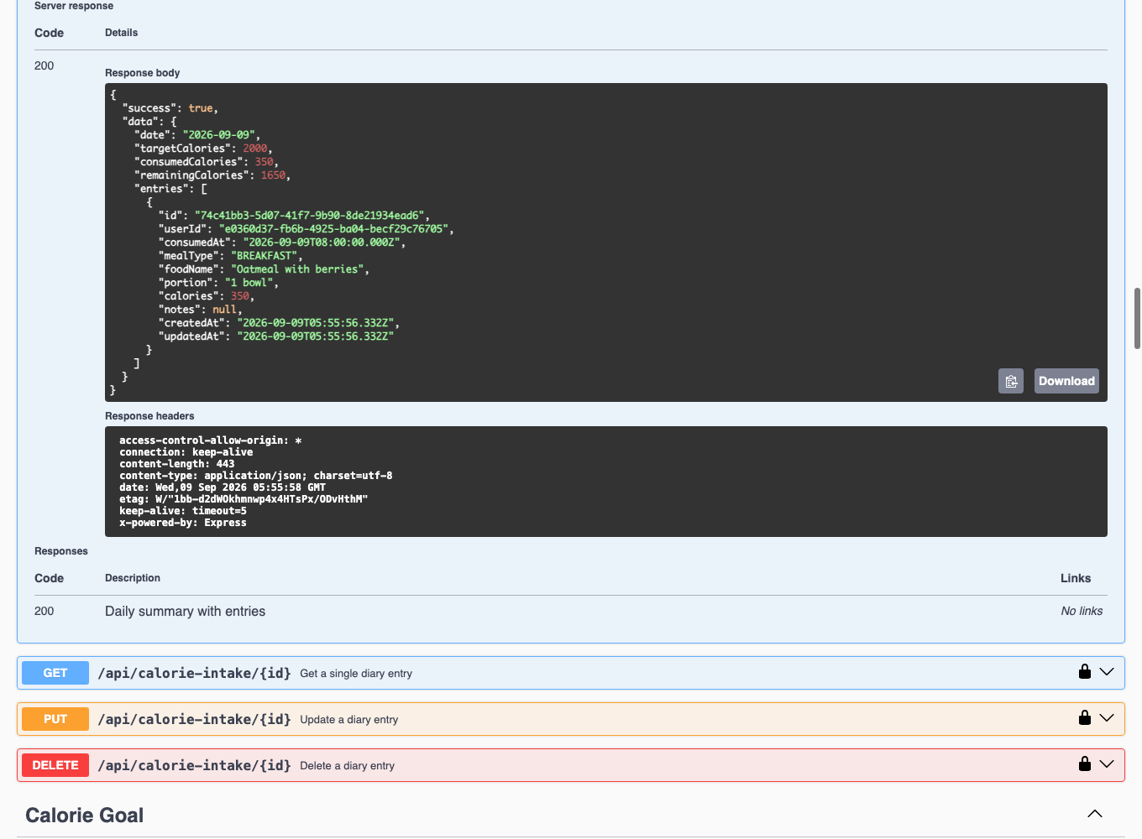
Figure 18 — target 2000, consumed 350, remaining 1650.

10.4 Create a recipe
Expand POST /api/recipes and save one:
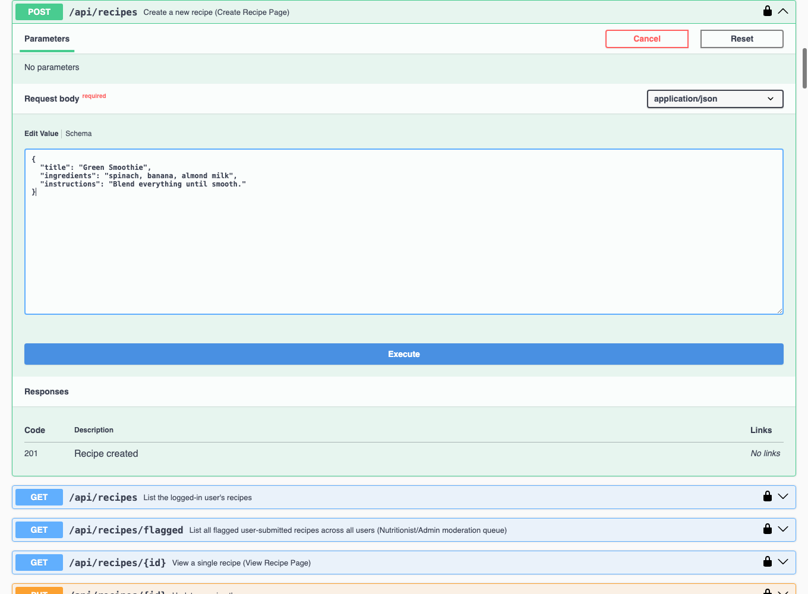
Figure 19 — a Green Smoothie recipe, ready to save.
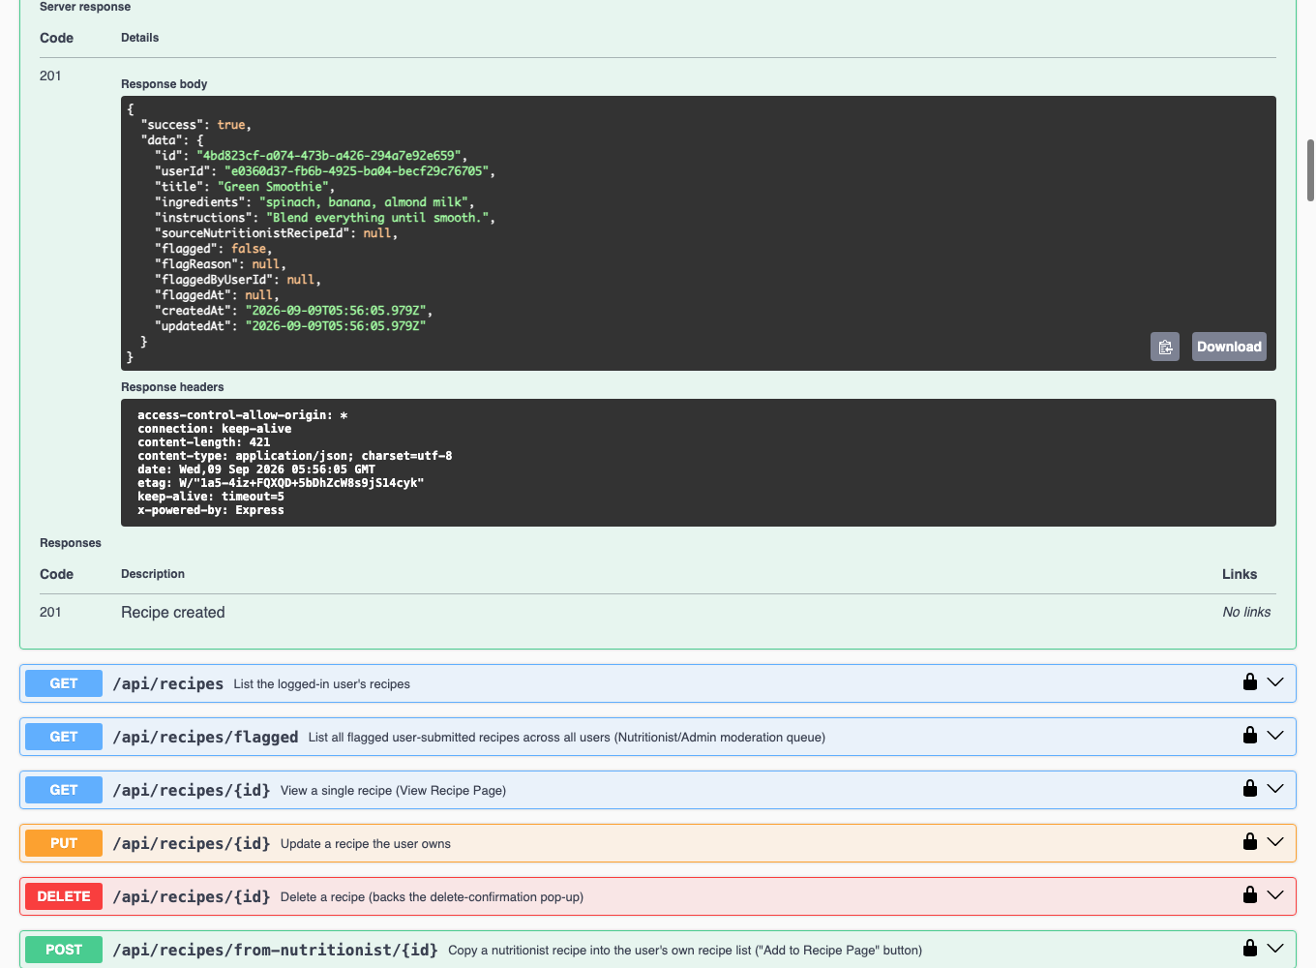
Figure 20 — 201 Created, the saved recipe.

11. Known Preliminary Limitations
- This manual documents the API via Swagger UI, not the end-user mobile app (built separately by a teammate).
- If the database is a paused free-tier Supabase project, migrate/start commands will fail with a connection error until it is resumed from the Supabase dashboard.
- Subscriptions/payments, AI recommendations, gamification, and image-recognition logging are not implemented yet — see the project CLAUDE.md for current scope.
- This is a preliminary manual: it proves install → setup → core-feature use works, not a complete reference for every endpoint (that's Swagger UI itself, kept always up to date at /api/docs).

