Foodie Meter — Database Schema Reference
Generated directly from prisma/schema.prisma (Phase 1 + Phase 2). Regenerate this document after any schema change — it is a rendered reference, not a second source of truth.

Entity-Relationship Diagram
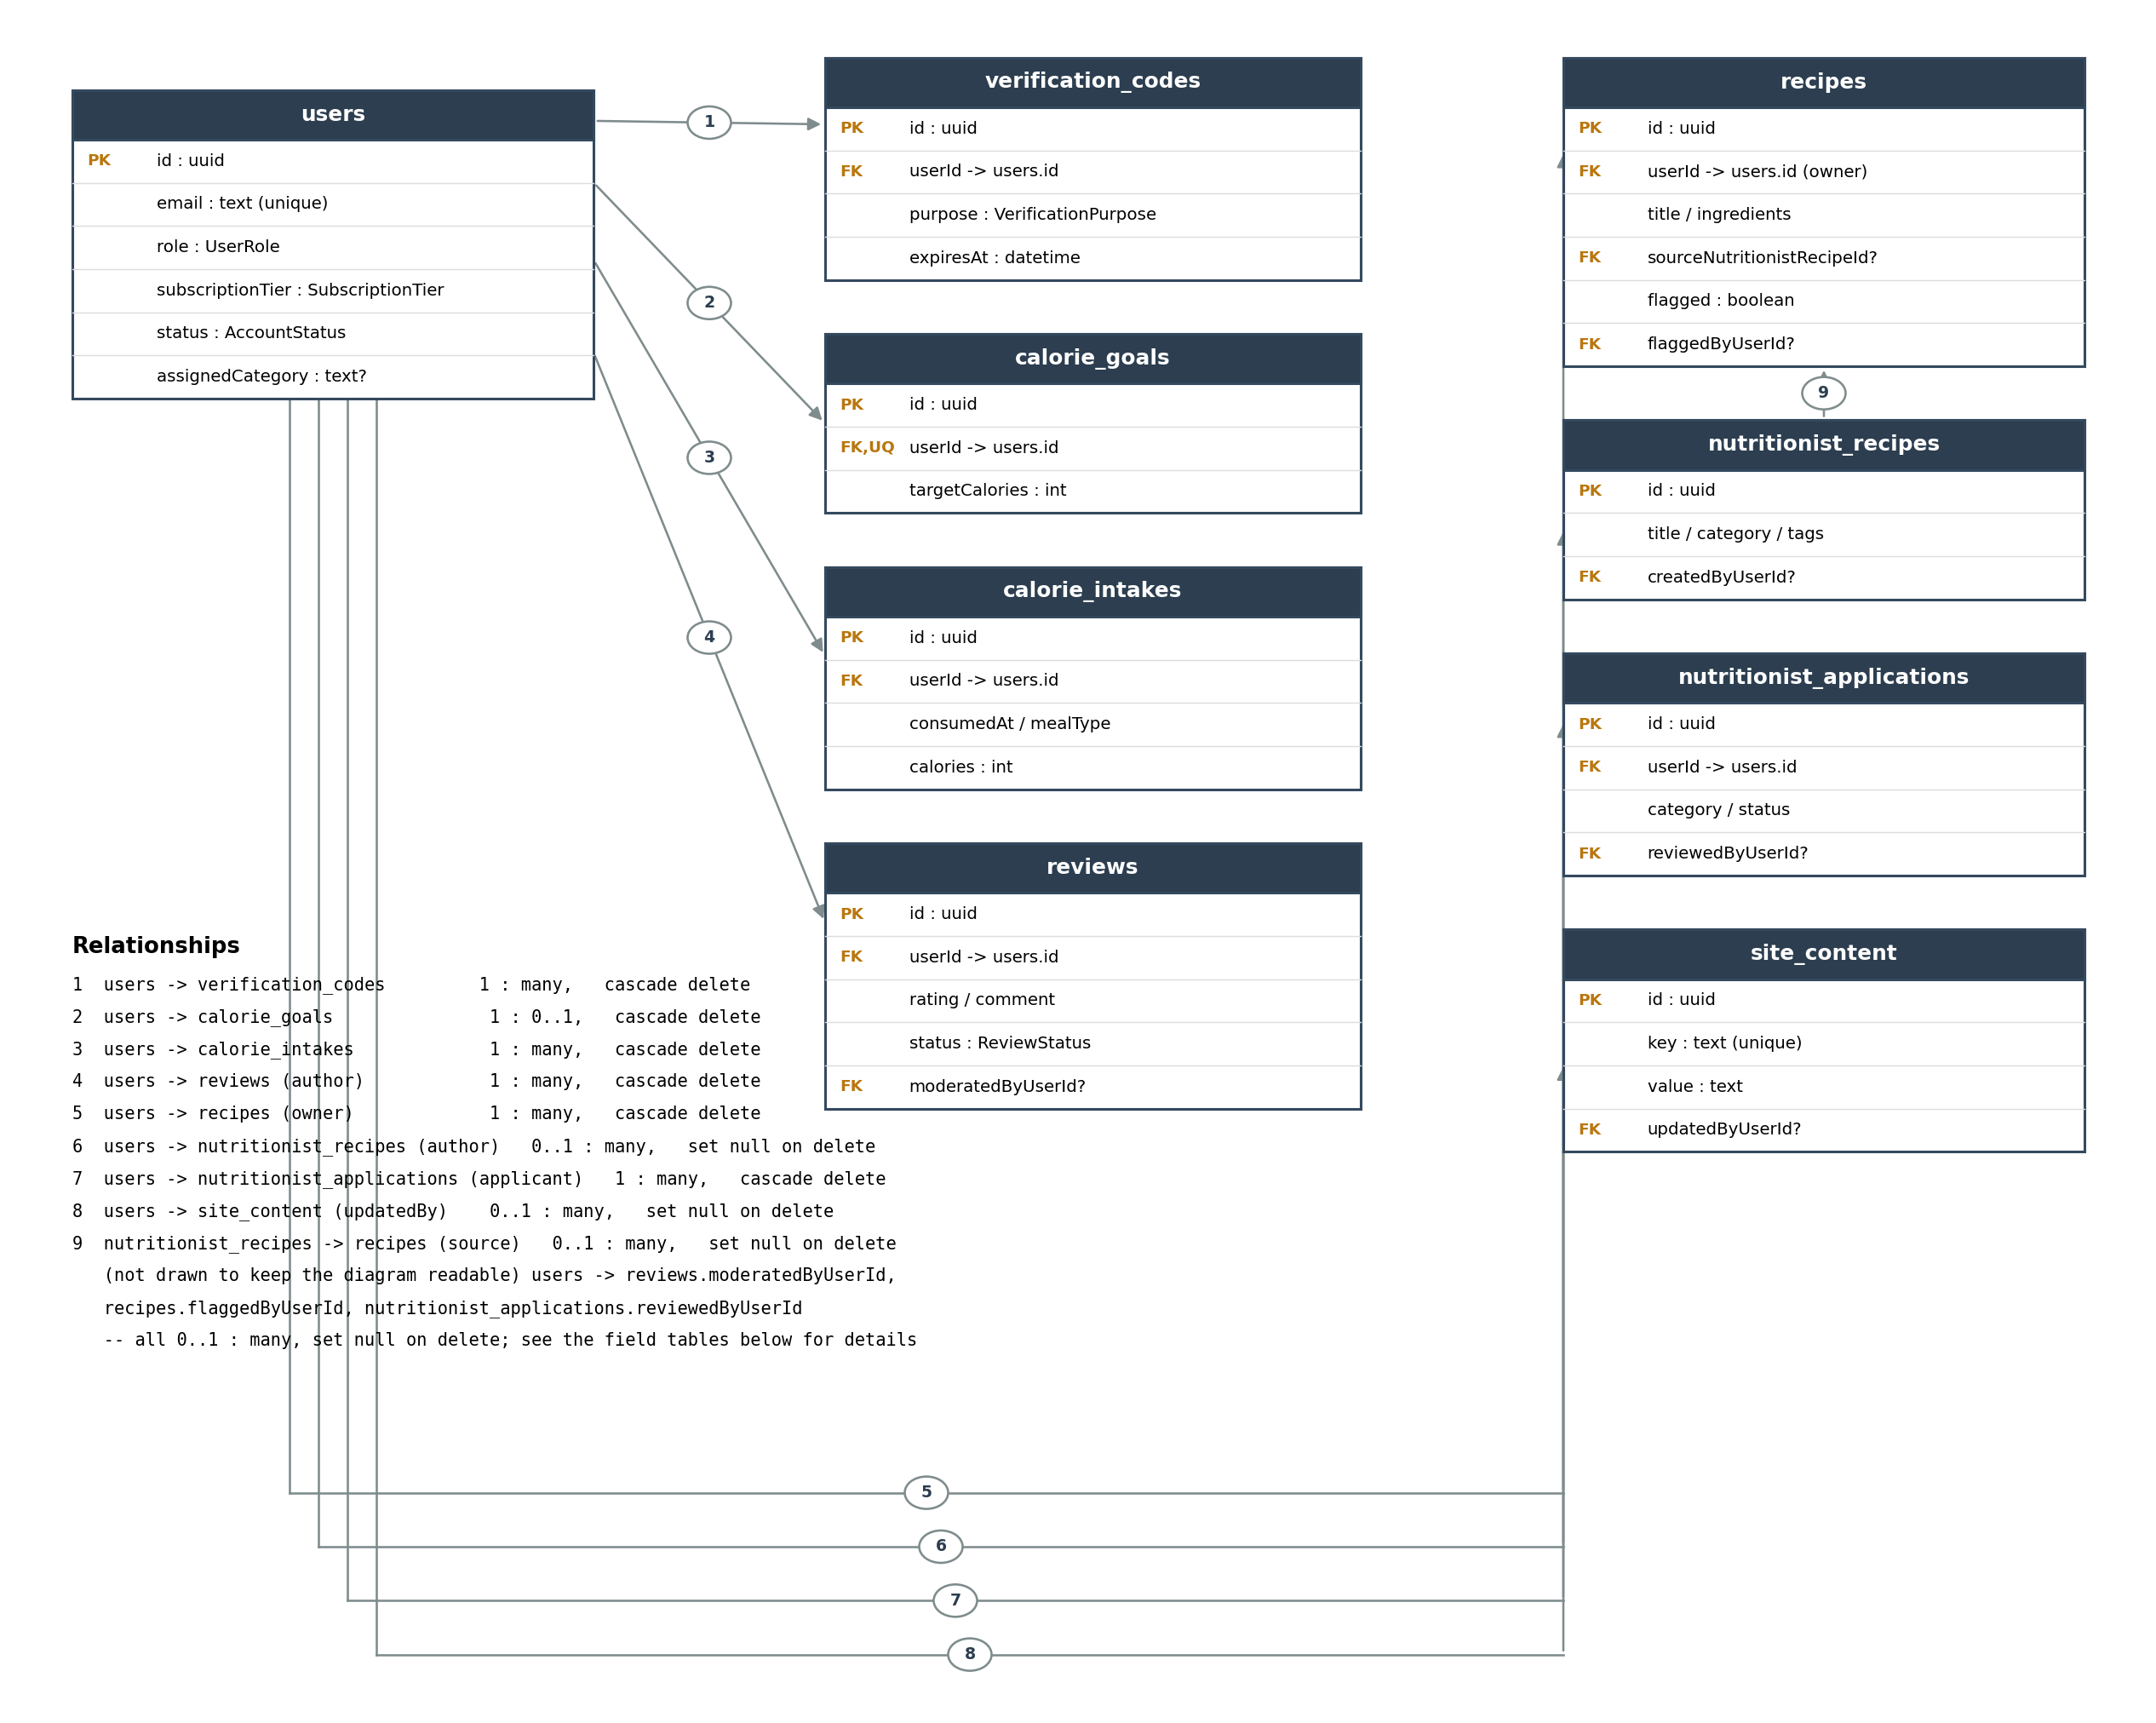

Tables

1. users
One row per registered account. Holds authentication data plus the role/tier/status fields that drive authorization — status and role are re-checked from the database on every authenticated request (not trusted from the JWT), so a suspension or a role promotion takes effect immediately on an already-issued token.
Field | Type | Constraints | Description
id | uuid | PK, default uuid() | Unique user identifier
name | text | required | Display name
email | text | unique, required | Login identifier; used for verification/reset emails
passwordHash | text | required | bcrypt hash — plaintext password is never stored
isVerified | boolean | default false | Set true once email verification succeeds
role | enum UserRole | default USER | USER / NUTRITIONIST / ADMIN
subscriptionTier | enum SubscriptionTier | default FREE | FREE / PREMIUM
status | enum AccountStatus | default ACTIVE | ACTIVE / SUSPENDED
assignedCategory | text? | nullable | Only meaningful when role = NUTRITIONIST; the content category they were approved for
createdAt | datetime | default now()
updatedAt | datetime | auto | Updated on every write

2. verification_codes
Short-lived codes used for both email verification and password reset. The code itself is bcrypt-hashed before storage, the same way passwords are.
Field | Type | Constraints | Description
id | uuid | PK
userId | uuid | FK -> users.id, cascade delete
codeHash | text | required | bcrypt hash of the 6-digit code
purpose | enum VerificationPurpose | default EMAIL_VERIFY | EMAIL_VERIFY / PASSWORD_RESET
expiresAt | datetime | required | Code is rejected after this time
consumedAt | datetime? | nullable | Set once the code has been used; codes are single-use
createdAt | datetime | default now()

3. calorie_goals
One current daily calorie target per user (upsert semantics, not a history table).
Field | Type | Constraints | Description
id | uuid | PK
userId | uuid | FK -> users.id, unique, cascade delete | Unique — one goal per user
targetCalories | int | required, 800-10000 | Daily calorie target
effectiveDate | datetime | default now() | Updated whenever the goal changes
createdAt / updatedAt | datetime

4. calorie_intakes (food diary)
Meal-level diary entries. Indexed on (userId, consumedAt) since the primary access pattern is "this user's entries for a given day," used by both the diary list and the daily summary endpoint.
Field | Type | Constraints | Description
id | uuid | PK
userId | uuid | FK -> users.id, cascade delete
consumedAt | datetime | required | When the meal was eaten
mealType | enum MealType | required | BREAKFAST / LUNCH / DINNER / SNACK
foodName | text | required
portion | text? | nullable | Free-text portion size, e.g. "1 bowl"
calories | int | required, >= 0
notes | text? | nullable
createdAt / updatedAt | datetime

5. recipes
User-owned recipes, either created from scratch or copied from the curated nutritionist_recipes list. Also carries the moderation flag a Nutritionist/Admin can set on any user's recipe (cross-user, deliberately — moderation has to be able to see and act on other users' content).
Field | Type | Constraints | Description
id | uuid | PK
userId | uuid | FK -> users.id, cascade delete | Owner of the recipe
title | text | required
ingredients | text | required
instructions | text | required
sourceNutritionistRecipeId | uuid? | FK -> nutritionist_recipes.id, nullable, set null on delete | Set when copied from a curated recipe
flagged | boolean | default false | Set by a Nutritionist/Admin moderating user-submitted recipes
flagReason | text? | nullable
flaggedByUserId | uuid? | FK -> users.id, nullable, set null on delete | Who flagged it
flaggedAt | datetime? | nullable
createdAt / updatedAt | datetime

6. nutritionist_recipes
The curated recipe library. Rows with createdByUserId = null are the original seed-managed catalog; rows with it set were published by an authenticated Nutritionist, scoped to their assigned category (enforced in the API layer, not just this schema).
Field | Type | Constraints | Description
id | uuid | PK
title | text | required
ingredients | text | required
instructions | text | required
category | text? | nullable, indexed | Matches a Nutritionist's assignedCategory
tags | text? | nullable | Comma-separated, e.g. "low-cal,high-iron,allergen-safe"
createdByUserId | uuid? | FK -> users.id, nullable, set null on delete | Null for the original seed catalog
createdAt / updatedAt | datetime

7. reviews
General product/service reviews (not tied to a specific recipe). Published immediately on creation; Admin can moderate a review to REJECTED, which removes it from the public listing without deleting it.
Field | Type | Constraints | Description
id | uuid | PK
userId | uuid | FK -> users.id, cascade delete | Author
rating | int | required, 1-5
comment | text | required
status | enum ReviewStatus | default PUBLISHED | PUBLISHED / REJECTED
moderatedByUserId | uuid? | FK -> users.id, nullable, set null on delete | Admin who last changed the status
moderatedAt | datetime? | nullable
createdAt / updatedAt | datetime

8. nutritionist_applications
A USER applies to become a Nutritionist; an Admin decision either promotes them (role -> NUTRITIONIST, assignedCategory set from the application) or rejects the application. There is no self-service path to the NUTRITIONIST or ADMIN role other than this workflow.
Field | Type | Constraints | Description
id | uuid | PK
userId | uuid | FK -> users.id, cascade delete | Applicant
category | text | required | Requested content category
message | text? | nullable | Free-text pitch/credentials
status | enum NutritionistApplicationStatus | default PENDING | PENDING / APPROVED / REJECTED
reviewedByUserId | uuid? | FK -> users.id, nullable, set null on delete | Admin who decided it
reviewedAt | datetime? | nullable
createdAt | datetime | default now()

9. site_content
A simple admin-managed key/value store for marketing/landing-page copy (e.g. hero heading, pricing blurb). Publicly readable as a flat map; only an Admin can write to it.
Field | Type | Constraints | Description
id | uuid | PK
key | text | unique, required | e.g. "hero_heading"
value | text | required
updatedByUserId | uuid? | FK -> users.id, nullable, set null on delete
updatedAt | datetime | auto

Enum reference
Enum | Values
UserRole | USER, NUTRITIONIST, ADMIN
SubscriptionTier | FREE, PREMIUM
AccountStatus | ACTIVE, SUSPENDED
VerificationPurpose | EMAIL_VERIFY, PASSWORD_RESET
MealType | BREAKFAST, LUNCH, DINNER, SNACK
ReviewStatus | PUBLISHED, REJECTED
NutritionistApplicationStatus | PENDING, APPROVED, REJECTED

