https://www.tenouk.com/ModuleZ.html

Z.5 STACK AND HEAP
- The stack is where memory is allocated for automatic variables within functions. A stack is a Last In First Out (LIFO) storage where new storage is allocated and de-allocated at only one end, called the top of the stack. Every function call will create a stack (normally called stack frame) and when the function exit, the stack frame will be destroyed.
- By referring the following program example and Figure z.3, when a program begins execution in the function main(), stack frame is created, space is allocated on the stack for all variables declared withinmain().
- Then, when main() calls a function,a(), new stack frame is created for the variables in a() at the top of themain() stack. Any parameters passed bymain() to a() are stored on this stack.
- Ifa() were to call any additional functions such as b() and c(), new stack frames would be allocated at the new top of the stack. Notice that the order of the execution happened in the sequence.
- Whenc(), b() anda() return, storage for their local variables are de-allocated, the stack frames are destroyed and the top of the stack returns to the previous condition. The order of the execution is in the reverse.
- As can be seen, the memory allocated in the stack area is used and reused during program execution. It should be clear that memory allocated in this area will contain garbage values left over from previous usage.
#include <stdio.h>

int a();
int b();
int c();

int a()
{
b();
c();
return 0;
}

int b()
{ return 0; }

int c()
{ return 0; }

int main()
{
a();
return 0;
}
- By taking just the stack area, the following Figure illustrates what had happened to the stack when the above program is run. At the end there should be equilibrium.
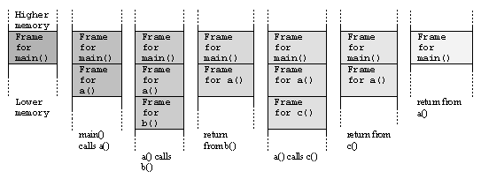
Figure z.3: Stack frame and function call

