ISO 11898 Based Software for CAN BUS Protocol

Business Engagement Model for Licensing the CAN Protocol Stack: What are the Value Adds?
Our Controller Area Network (CAN) Protocol Stack (ISO 11898) is a Ready-to-integrate and Production Grade in-vehicle networking solution.
This software solution is ideal to support in-vehicle networking functions, within passenger vehicles
We offer this CAN Bus Protocol stack under a one-time licensing fee model. This engagement model has proved to be a great value-add for our customers across US, India, China, Taiwan, South Korea and Europe
The following are some of the benefits of our One-Time Licensing Fee Model:
- You get access to the source code of the CAN Bus Software Stack.
- You become the owner of the IP rights of the CAN Software.
- By owning the IP rights, your organization can deploy this CAN Bus Software in multiple production programs.

A Software Stack for CAN BUS Protocol (ISO 11898): Details of the Software Architecture
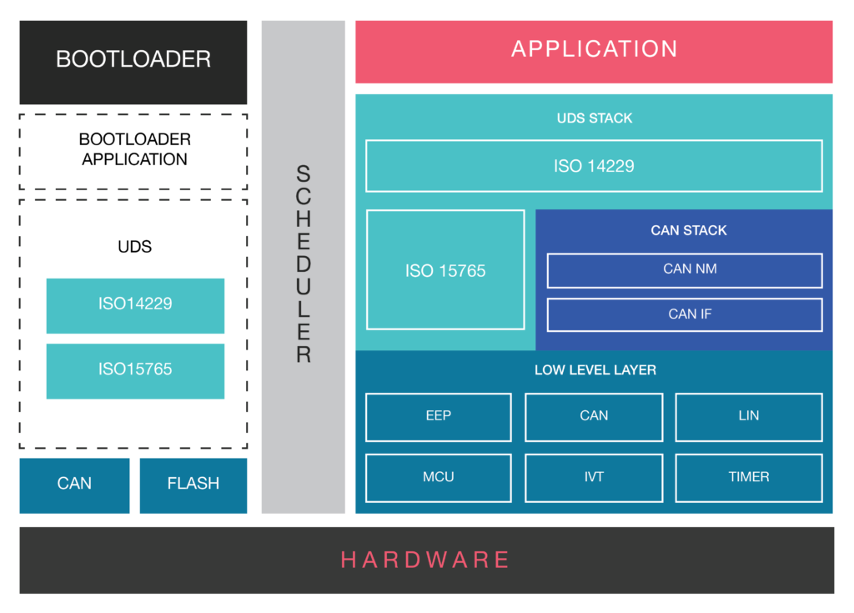

CAN Bus Software Stack comprises of the following layers and software components:
- A Software Stack/Package compliant with ISO 11898: Our CAN BUS Stack consists of CAN Network Management (NM) Layer and CAN Interface (IF) Layer.
  - NM layer manages sleep/wake up functionality.
  - CAN Bus Interface Layer carries out all hardware independent tasks, related to the flow of data to the upper layer modules of the CAN software stack.
- UDS Software Stack compliant with ISO 14229: UDS is the off-board diagnostics application. It is based on ISO 14229 Standard. This layer manages the diagnostics aspect of CAN bus software.
- Flash Bootloader Application: Flash Bootloader is tasked with ECU Reprogramming. In our CAN software stack, we provide a UDS based flash bootloader for ECU Flashing purposes.
- ISO Transport Layer (ISO 15765): Responsible for segmenting the data, if the size of the data frame is more than 8 Bytes.
- Low-Level Driver: The CAN BUS Device Driver enables the access to hardware resources, for the upper software layers. It also offers access to the hardware independent API, to the application layer.

CAN Bus Software Integration, Configuration and Testing Services
Extensive experience in successful integration of CAN Bus software and CAN Interface Layer (CAN IF). Configuration can be facilitated by both manual and tool based approach.
We have designed a Proprietary tool for CAN Bus Software Stack Configuration. This is a PC based tool named as Auto-code Generator Tool. This tool has helped our customers to reduce 3-4 weeks of turn-around time.
Our team has also successfully integrated CAN Bus Protocol for in-vehicle networking functions in order to power Automotive Applications such as:
- Seating ECU
- Body Control Module
- Telematics ECU
- Engine Control Unit

Development and Integration of CAN Bus Device Drivers:
- Support for all Microcontroller Families (Renesas, TI, Fujitsu etc.)
- Supports 29 and 11 bit identifiers .
- Hardware Filtering (Acceptance Filtering) of messages and signals
- Support for standard baud rates of 125kbps, 250 kbps and 500 kbps
- Leverage Reusable components of CAN BUS device drivers to reduce time-to-market
- Support for CAN BUS device driver integration, across production programs.

CAN Bus Protocol Stack Support and Maintenance Services:
- Creation of High Level Design documents (HLDD) and Low-Level Documents (LLD)
- CAN Conformance Testing of Data Link Layer with Vector tools like CAN Stress
- Design of Integration and Functional Test Plans
- Support for MISRA compliance report creation
- End-to-end Testing Services ( Unit, Integration and Functional Testing)

Design and Development of PC Based Auto Code Generator Tool:
- CAN DBC File to configuration file generation tool
- Auto Generated and MISRA C compliant code
- Code generated in fraction of seconds
- PC based (Windows) tool
- Easy to remove Tx and Rx messages from the CAN Matrix

Development and Configuration of CAN Bus Interface Layer (CAN IF):
- Ready-to-deploy CAN Bus Interface layer (CAN IF); only configuration is needed
- Tx and Rx message configuration from the CAN DBC file (CAN Matrix)
- Support for Tool based/ manual configuration of CAN Interface layer (CAN IF)
- Configurable Skeleton code (.C, .F, cgf.c and cgf.h) of CAN Bus Interface layer (CAN IF) is also available
- Low level and high level documents are provided
- Support for software level message filtering
- Signal and message extraction provided as a default feature

Integration and Configuration of CAN TP (ISO 15765) and Network Management Layer:
- Message and mode monitoring
- Checksum strategies to ensure message validation
- Integration of UDS (ISO 14229) stack over CAN TP (ISO 15765)
- Customizations as per your business requirements
- Built-in error handling feature of CAN BUS off
- Ready-to-deploy CAN TP layer for reduced turnaround time

Controller Area Network (CAN)
CAN or Controller Area Network is a two wired half duplex high speed serial network technology. It is basically used in communication among different devices in a low radius region, such as in an automobile. A CAN protocol is a CSMA-CD/ASM protocol or carrier sense multiple access collision detection arbitration on message priority protocol. CSMA ensures each node must wait for a given period before sending any message. Collision detection ensures that the collision is avoided by selecting the messages based on their prescribed priority.
It provides signaling rate from 125kbps to 1 Mbps. It provides for 2048 different message identifiers.
It is ISO-11898 standard and makes use of the 7 layer Open Systems Interconnection model.

History:
It was developed by Robert Bosch in 1982 and officially released by the Detroit’s society of Automotive Engineers in 1986. The first car integrating CAN bus was manufactured by Mercedes Benz in 1992.

ISO 11898 Architecture:
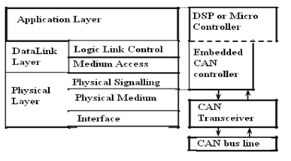
Image source – theremino
The layered architecture consists of three layers.
- Application Layer: It interacts with operating system or the application of CAN device.
- Data Link Layer: It connects the actual data to the protocol in terms of sending, receiving and validating data.
- Physical Layer: It represents the actual hardware.
The standard CAN frame consists of the following bits:
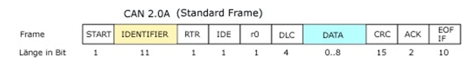

The standard CAN frame consists of the following bits:
- SOF- Start of Frame. The message starts from this point.
- Identifier: It decides the priority of the message. Lower the binary value, higher is the priority. It is 11 bit.
- RTR– Remote Transmission Request. It is dominant when information is required from another node. Each node receives the request, but only that node whose identifier matches that of the message is the required node. Each node receives the response as well.z
- IDE– Single Identification Extension. If it is dominant, it means a standard CAN identifier with no extension is being transmitted.
- R0– reserved bit.
- DLC– Data Length Code. It defines the length of the data being sent. It is 4 bit
- Data– Up to 64 bit of data can be transmitted.
- CRC– Cyclic Redundancy Check. It contains the checksum (number of bits transmitted) of the preceding application data for error detection.
- ACK– Acknowledge. It is 2 bit. It is dominant if an accurate message is received.
- EOF– end of frame. It marks end of can frame and disables bit stuffing.
- IFS– Inter Frame Space. It contains the time required by the controller to move a correctly received frame to its proper position.

5 Different message types are:
- Data Frame: It consists of arbitrary field, data field, crc field and the acknowledge fields.
- Remote Frame: It requests for transmission of data from another node. Here the RTR bit is recessive.
- Error Frame: It is transmitted when a error is detected.
- Overload Frame: It is used to provide delay between messages. It is transmitted when the nodes become too busy.
- Valid Frame: A message is valid if the EOF field is recessive. Else the message is transmitted again.

CAN Physical Layer:

CAN Bus

digital.ni 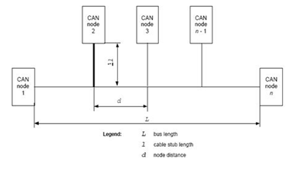
It consists of two wire serial link- CAN_H and CAN_L and their voltage levels relative to each other determine whether a 1 or 0 is transmitted. This is differential signaling. The current flowing in each signal line is equal but opposite in direction, resulting in a field-canceling effect that is a key to low noise emissions. This ensures a balanced differential signaling which reduces noise coupling and allows high rate of transmission over the wires. Usually the wires are twisted pair cables with bus length of 40 m and maximum of 30 nodes. It is a shielded or unshielded cable with a characteristic impedance of 120 Ohms.

Controller Area Network (CAN)
- Communication
2 Comments
CAN or Controller Area Network is a two wired half duplex high speed serial network technology. It is basically used in communication among different devices in a low radius region, such as in an automobile. A CAN protocol is a CSMA-CD/ASM protocol or carrier sense multiple access collision detection arbitration on message priority protocol. CSMA ensures each node must wait for a given period before sending any message. Collision detection ensures that the collision is avoided by selecting the messages based on their prescribed priority.
It provides signaling rate from 125kbps to 1 Mbps. It provides for 2048 different message identifiers.
It is ISO-11898 standard and makes use of the 7 layer Open Systems Interconnection model.

History:
It was developed by Robert Bosch in 1982 and officially released by the Detroit’s society of Automotive Engineers in 1986. The first car integrating CAN bus was manufactured by Mercedes Benz in 1992.

ISO 11898 Architecture:
theremino
The layered architecture consists of three layers
- Application Layer: It interacts with operating system or the application of CAN device.
- Data Link Layer: It connects the actual data to the protocol in terms of sending, receiving and validating data.
- Physical Layer: It represents the actual hardware.
The standard CAN frame consists of the following bits:
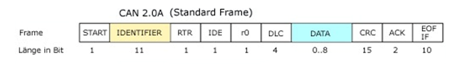The standard CAN frame consists of the following bits:
- SOF- Start of Frame. The message starts from this point.
- Identifier: It decides the priority of the message. Lower the binary value, higher is the priority. It is 11 bit.
- RTR– Remote Transmission Request. It is dominant when information is required from another node. Each node receives the request, but only that node whose identifier matches that of the message is the required node. Each node receives the response as well.z
- IDE– Single Identification Extension. If it is dominant, it means a standard CAN identifier with no extension is being transmitted.
- R0– reserved bit.
- DLC– Data Length Code. It defines the length of the data being sent. It is 4 bit
- Data– Up to 64 bit of data can be transmitted.
- CRC– Cyclic Redundancy Check. It contains the checksum (number of bits transmitted) of the preceding application data for error detection.
- ACK– Acknowledge. It is 2 bit. It is dominant if an accurate message is received.
- EOF– end of frame. It marks end of can frame and disables bit stuffing.
- IFS– Inter Frame Space. It contains the time required by the controller to move a correctly received frame to its proper position.

5 Different message types are:
- Data Frame: It consists of arbitrary field, data field, crc field and the acknowledge fields.
- Remote Frame: It requests for transmission of data from another node. Here the RTR bit is recessive.
- Error Frame: It is transmitted when a error is detected.
- Overload Frame: It is used to provide delay between messages. It is transmitted when the nodes become too busy.
- Valid Frame: A message is valid if the EOF field is recessive. Else the message is transmitted again.

CAN Physical Layer:

CAN Bus
digital.ni
It consists of two wire serial link- CAN_H and CAN_L and their voltage levels relative to each other determine whether a 1 or 0 is transmitted. This is differential signaling. The current flowing in each signal line is equal but opposite in direction, resulting in a field-canceling effect that is a key to low noise emissions. This ensures a balanced differential signaling which reduces noise coupling and allows high rate of transmission over the wires. Usually the wires are twisted pair cables with bus length of 40 m and maximum of 30 nodes. It is a shielded or unshielded cable with a characteristic impedance of 120 Ohms.

CAN TRANSCEIVER:
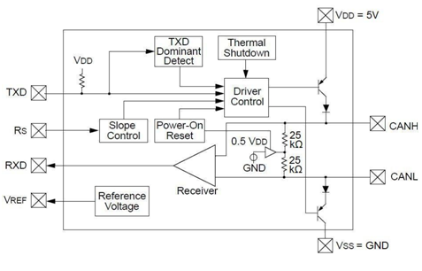
CAN for vehicles by Hugo Provencher. The two wires CANH and CANL are at normally 2.5V determined by the two transistors and the 2.5V voltage source. Basically the difference between the two wires should always be 0. The driver control determines the voltage applied to the CANH and CANL wires. When both the transistors are conducting, the voltage drop across the 1st transistor and the diode is 1.5V, making the CANH wire pull up to 3.5V. The voltage drop across the 2nd transistor and the diode is 1V, making the CANL wire pull down to 1.5V.The diodes are used for high voltage protection. The receiver is a discriminator circuit which gives an output of 1 when the two inputs CANH and CANL are same and a output of 0 if the two inputs are different. The TXD dominant block is used for ground fault protection and the Thermal shutdown block disables the driver control if the diodes and the transistors get overheated.

Advantages of CAN:
- It reduces wiring since it is a distributed control and this ensures enhancing of the system performance.
- Many CAN chip manufactures provided the data link layer and the physical layer interfaced to the chip and all the software developer needs to do only is to develop the application coding.
- It provides the ability to work in different electrical environment and ensures noise free transmission.
- Traffic congestion is eliminated as the messages are transmitted based on their priority and it allows the entire network to meet the timing constraints.
- It provides for error free transmission as each node can check for errors during the transmission of the message and send the error frame.

Society of Automotive Engineers standard SAE J1939 is the vehicle bus recommended practice used for communication and diagnostics among vehicle components. Originating in the car and heavy-duty truck industry in the United States, it is now widely used in other parts of the world.

