AGILENT E36102A DC Power Supply,

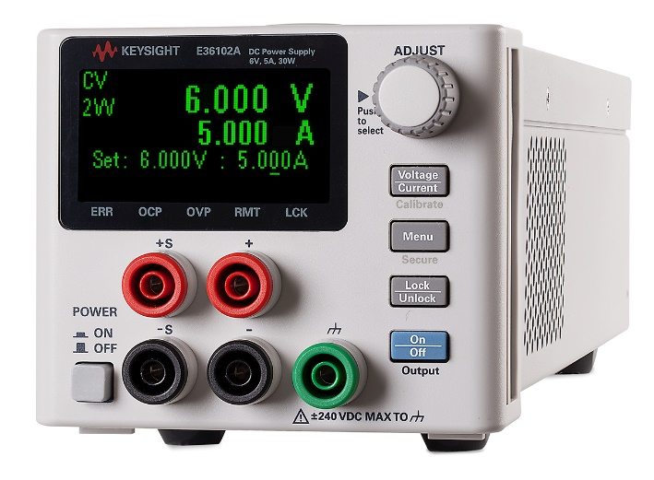

Key Features & Specifications

Output rating (0 to 40 °C)
- Voltage: 6 V
- Current: 5 A
- Power: 30 W

Programming accuracy
- Voltage: 0.05% + 3 mV
- Current: 0.05% + 5 mA

Ripple & noise (20 Hz to 20 MHz)
- Voltage rms: 350 µV
- Voltage peak-to-peak: 10 mV
- Current rms: 2 mA

Readback accuracy
- Voltage: 0.05% + 3 mV
- Current: 0.05% + 4 mA

Description

This product has been replaced by a “B” version. The last order date for the “A” version is March 1st
Keysight E36100 Series basic DC power supplies feature a compact size (2U, ¼-rack), a high-contrast OLED display that is viewable from any angle, and modern USB and LAN (LXI Core) connectivity. They also include low power current measurement capability and overvoltage, overcurrent, and overtemperature protection. You can control these power supplies via the intuitive front-panel interface, a Web interface running on a browser, a SCPI or IVI program, Keysight IO Libraries, or a BenchVue app running on your PC or mobile device.
Counterfeits of this or closely related products have been found in the market. To ensure you are purchasing an authentic Keysight product with the quality and performance you expect, purchase through Keysight authorized distribution partners. Click on the “How to Buy or Rent” button, above, to find authorized distribution partners.

OLED is an acronym for Organic Light Emitting Diode, and it represents a type of technology that is used for displays. OLED displays have a layer made of organic material (carbon plus other substances) sandwiched between two electrodes which, when given electrical power, emits light.
The pixels on OLED displays are lit independently as each of them can receive electrical current independently. That means that OLED displays do not require additional backlight the way traditional LCD displays do. One important consequence is that OLED displays are thinner and lighter than LCD screens.
Another benefit of OLED is its image quality. OLED displays can light each of their pixels independently, and they can also turn off each of them independently. When no electrical current goes through a pixel, it is effectively off, which means that it is as close to absolute black as possible. That gives the OLED displays an edge over traditional LCD screens which always have the backlight on, and thus are never able to obtain "true blacks" on the images they display. Another essential aspect of OLED displays is that they can offer an extremely high contrast ratio. We already know that OLED can display absolute blacks, but it can also color each pixel using the exact brightness levels needed, as all it takes is more electric current sent to that specific pixel.
OLED displays use independently lit pixels, while LCD screens use a backlight to display images. In an OLED display, each pixel has its own "backlight" if you want, which sends its own light into the world. In an LCD screen, there is a backlight source for the entire screen, that is usually offered by a lamp, and that light goes through the pixels found in the display. On an LCD screen, pixels do not throw their own light, but rather block the backlight (from the lamp) from getting out. Regardless of how well it is made, no LCD screen can completely block the backlight it receives, which means that no LCD screen can offer the same "true black" as an OLED screen can


