https://developer.android.com/studio/profile/battery-historian
https://developer.android.com/topic/performance/power/battery-historian

Profile battery usage with Batterystats and Battery Historian
This walkthrough shows the basic usage and workflow for the Batterystats tool and the Battery Historian script.
Batterystats is a tool included in the Android framework that collects battery data on your device. You can use adb to dump the collected battery data to your development machine and create a report you can analyze using Battery Historian. Battery Historian converts the report from Batterystats into an HTML visualization that you can view in your browser.
What it's good for:
- Showing you where and how processes are drawing current from the battery.
- Identifying tasks in your app that could be deferred or even removed to improve battery life.
Note: To use Batterystats and Battery Historian, you need a mobile device running Android 5.0 or higher with USB Debugging enabled.

Install Battery Historian

The easiest way to install Battery Historian is to use Docker. For alternate installation methods, including building from source, see the Read Me on the project's GitHub page. To install using Docker, do the following:
- Install Docker Community Edition following the instructions on the Docker website.
- To confirm that Docker is correctly installed, open the command line and enter the following command:
$ docker run hello-world
If Docker is correctly installed, you will see output like this:
Unable to find image 'hello-world:latest' locally
latest: Pulling from library/hello-world
78445dd45222: Pull complete
Digest:
sha256:c5515758d4c5e1e838e9cd307f6c6a0d620b5e07e6f927b07d05f6d12a1ac8d7
Status: Downloaded newer image for hello-world:latest

Hello from Docker!
This message shows that your installation appears to be working correctly.

To generate this message, Docker took the following steps:
1. The Docker client contacted the Docker daemon.
2. The Docker daemon pulled the "hello-world" image from the Docker Hub.
3. The Docker daemon created a new container from that image which runs the
executable that produces the output you are currently reading.
4. The Docker daemon streamed that output to the Docker client, which sent it to your terminal.
3.Run the Battery Historian image using the following command:
$ docker run -p port_number:9999 gcr.io/android-battery-historian/stable:3.0 --port 9999
Battery Historian will use the port of your choice, as specified using port_number.
Note: If you are using a Windows machine, you may need to enable virtualization in your BIOS. Check the documentation for your motherboard for more information about how to enable virtualization. If you are able to run the Android Emulator, then virtualization is already enabled.
- Battery Historian will use the port of your choice, as specified using port_number.
Note: If you are using a Windows machine, you may need to enable virtualization in your BIOS. Check the documentation for your motherboard for more information about how to enable virtualization. If you are able to run the Android Emulator, then virtualization is already enabled.
- Navigate to Battery Historian in your browser to confirm that it is running. The address varies depending on your operating system:
For Linux and Mac
Battery Historian is available at http://localhost:port_number.
For Windows
Once you start Docker, it tells you the IP address of the machine it is using. So, for example, if the IP address is 123.456.78.90, Battery Historian is available at http://123.456.78.90:port_number
You will see the Battery Historian start page, where you can upload and view battery statistics.
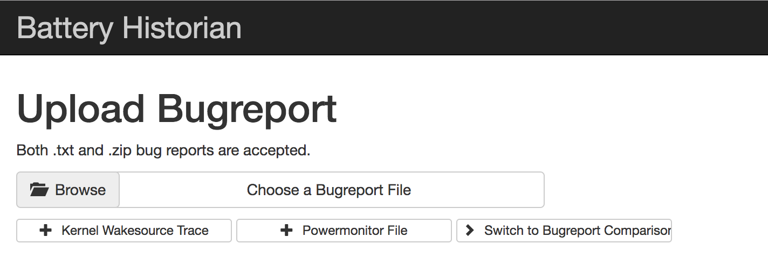
Figure 1. The start page for Battery Historian

Gather data with Batterystats
To collect data from your device using Batterystats and open it in Battery Historian, do the following:
- Connect your mobile device to your computer.
- From a Terminal window, shut down your running adb server.
adb kill-server
- Restart adb and check for connected devices.
adb devices
- You should see your device listed, similar to the example output below.
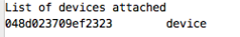
Figure 2. The output of adb devices, showing one connected device
If you don't see any devices, make sure your phone is connected, and USB Debugging is turned on, and then kill and restart adb.
- Reset battery data gathering.
adb shell dumpsys batterystats --reset
- The device is always collecting batterystats and other debugging information in the background. Resetting erases old battery collection data. If you do not reset, the output will be huge.
- Disconnect your device from your computer so that you are only drawing current from the device's battery.
- Play with your app and perform actions for which you would like data; for example, disconnect from WiFi and send data to the cloud.
- Reconnect your phone.
- Make sure your phone is recognized:
adb devices
- Dump all battery data. This can take a while:
adb shell dumpsys batterystats [path/]batterystats.txt
- The batterystats.txt file is created in the directory you specify using the optional path argument. If you do not specify a path, the file is created in your home directory.
- Create a report from raw data.
For devices running Android 7.0 and higher:
adb bugreport > [path/]bugreport.zip
For devices running Android 6.0 and lower:
adb bugreport > [path/]bugreport.txt
- Bugreport may take several minutes to complete. Do not disconnect your device or cancel the process until it is complete.
As with batterystats.txt above, these files are created in the directory you specify using the optional path argument. If you do not specify a path, they are created in your home directory.
- If it's not already running, run Battery Historian using the following command:
docker --run -p port_number:9999 gcr.io/android-battery-historian:2.1 --port 9999
- To view your data in Battery Historian, open the Battery Historian in your browser. (For Mac and Linux, Battery Historian runs at http://localhost/port_number. For Windows, Battery Historian runs at http://your_IP_address/port_number.)
- Click Browse and then choose the bugreport file you created above.
- Click Submit. Battery Historian will open a chart created from your batterystats data.

View data with Battery Historian charts
The Battery Historian chart graphs power-relevant events over time.
Each row shows a colored bar segment when a system component is active and thus drawing current from the battery. The chart does not show how much battery was used by the component, only that the app was active. Charts are organized by category, showing a bar for each category over time, as displayed on the X-axis of the chart.
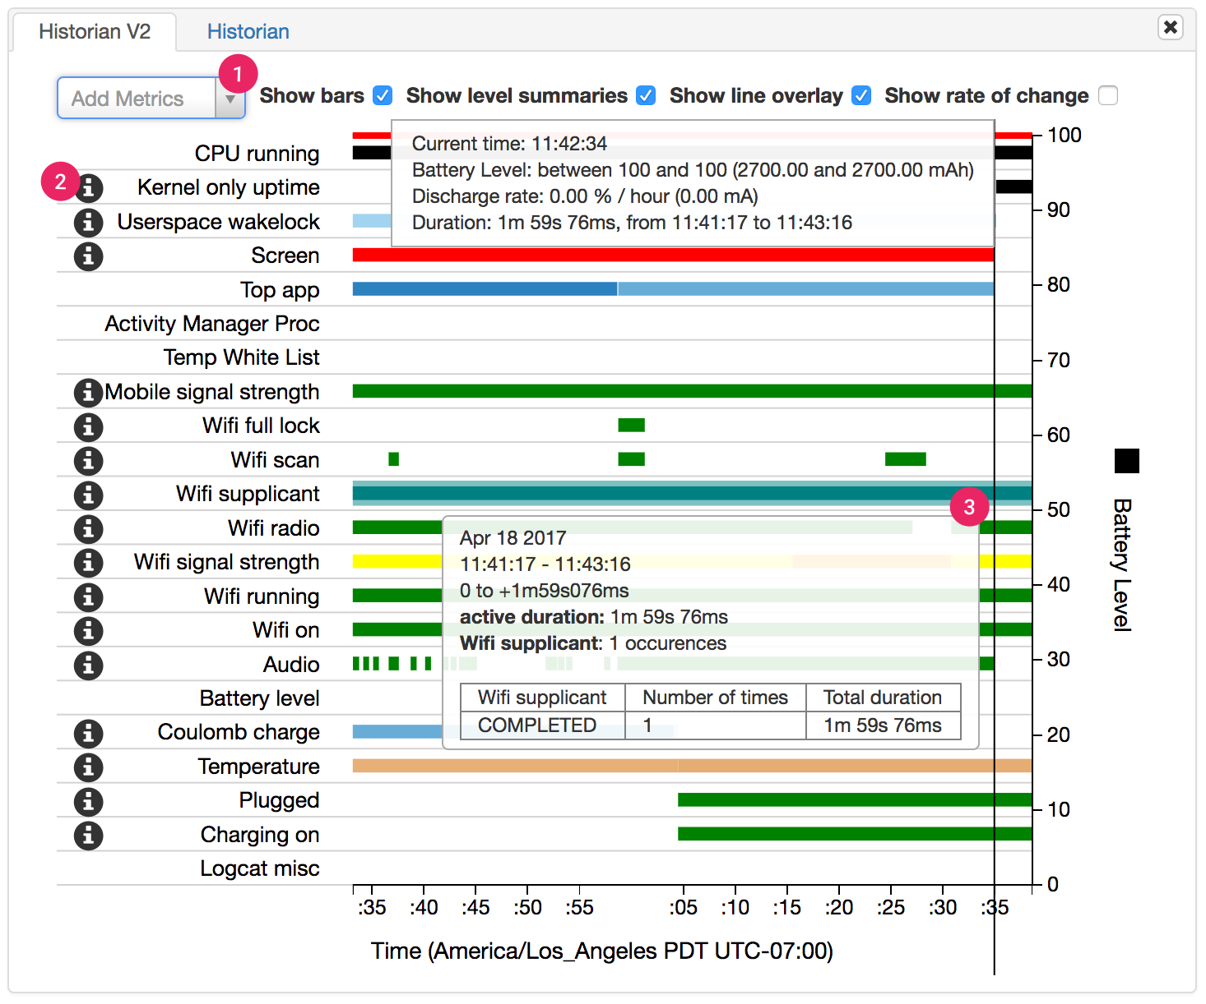
Figure 3. Example of a Battery Historian chart
- Add additional metrics from the dropdown list.
- Hover over the information icons to see more information about each metric, including a key for the colors used in the chart.
- Hover over a bar to see more detailed information about that metric and the battery stats at a specific point on the timeline.

Additional batterystats output
You can view additional information from the batterystats.txt file in the stats section below the Battery Historian chart.
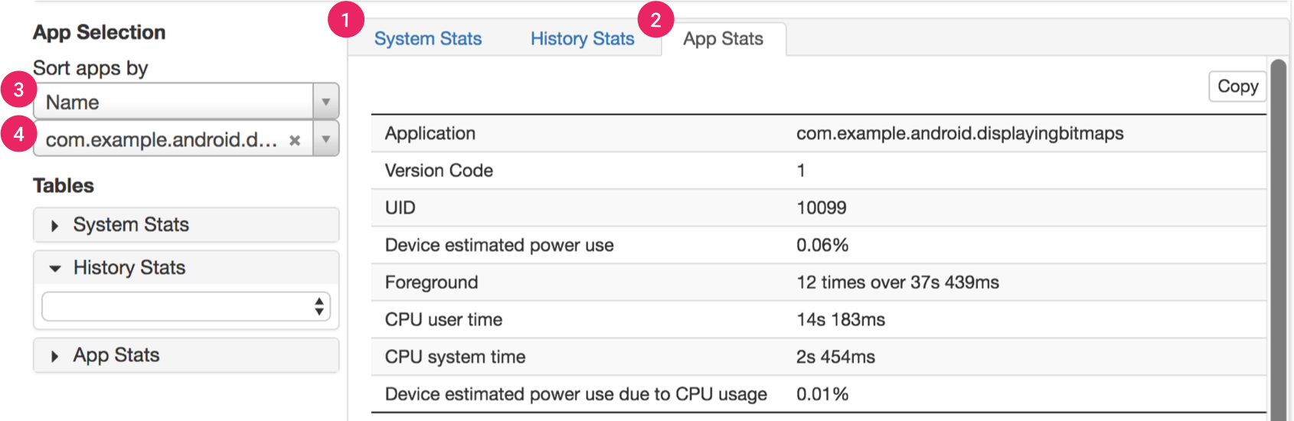
Figure 4. The stats section of Battery Historian
The 1 System Stats tab includes system-wide statistics, such as cell signal levels and screen brightness. This information provides an overall picture of what's happening with the device. This is especially useful to make sure no external events are affecting your test.
The 2 App Stats tab includes information about specific apps. Sort the list of apps using the 3 Sort apps by dropdown list in the App Selection pane on the left. You can select a specific app to view stats for using the 4 apps dropdown list below.
For more information about battery performance, see Optimizing Battery Life.

Analyze power use with Battery Historian
The Battery Historian tool provides insight into a device’s battery consumption over time. At a system-wide level, the tool visualizes power-related events from the system logs in an HTML representation. At an app-specific level, the tool provides a variety of data that can help you identify battery-draining app behavior.
This document describes some of the ways you can use Battery Historian to learn about battery-consumption patterns. The document begins by explaining how to read the system-wide data that Battery Historian reports. Then, it presents ways in which you can use Battery Historian to diagnose and troubleshoot your own app's behavior related to battery consumption. Last, it offers several tips on scenarios in which Battery Historian may be particularly useful.

Use the system-wide view
The Battery Historian tool provides a system-wide visualization of various app and system behaviors, along with their correlation against battery consumption over time. This view, shown in Figure 1, can help you diagnose and identify power use issues with your app.
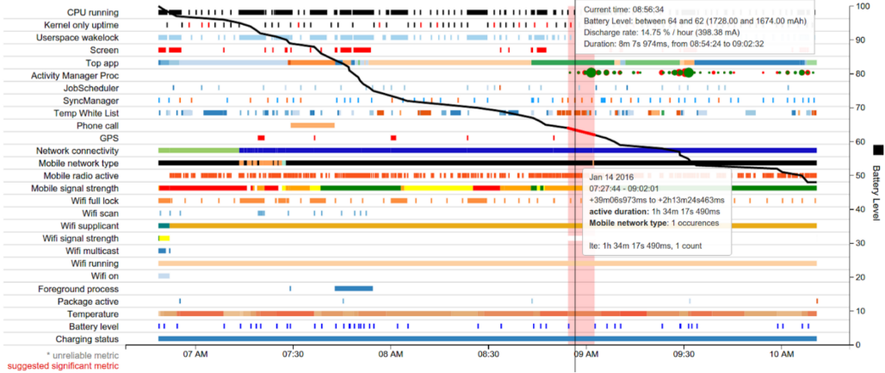
Figure 1. Battery Historian’s display of system-wide events affecting power consumption.
Of particular interest in this figure is the black, horizontal, downward trend line representing Battery Level, measured on the y-axis. For example, at the very beginning of the Battery Level line, at approximately 6:50 AM, the visualization shows a relatively steep drop in battery level.
Figure 2 provides a close-up of that part of the display.
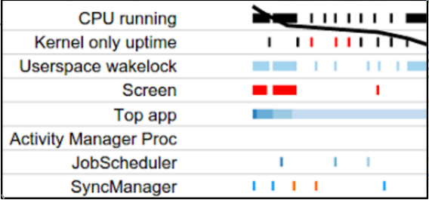
Figure 2. A close-up of the Battery Historian timeline from roughly 6:50 AM to 7:20 AM.
At the very beginning of the Battery Level line, as battery decline steeply, the display shows three things happening: The CPU is running, an app has acquired a wakelock, and the screen is on. In this way, Battery Historian helps you understand what events are happening when battery consumption is high. You can then target these behaviors in your app and investigate whether there are related optimizations you can make.
The system-wide visualization can provide other clues, as well. For instance, if it shows that the mobile radio is frequently being turned off and on, there may be an opportunity to optimize this behavior through intelligent scheduling APIs such as JobScheduler or Firebase Job Dispatcher.
The next section explains how to investigate behavior and events specific to your own app.

View app-specific data
In addition to the macro-level data provided by the system-wide view, Battery Historian also provides tables and some visualization of data specific to each app running on your device. The tabular data includes:
- The app’s estimated power use on the device.
- Network information.
- Wakelocks.
- Services.
- Process info.
The tables provide two dimensions of data about your app. First, you can look up where your app’s power usage ranks compared to other apps. To do so, click Device Power Estimates table under Tables. This example examines a fictional app called Pug Power.
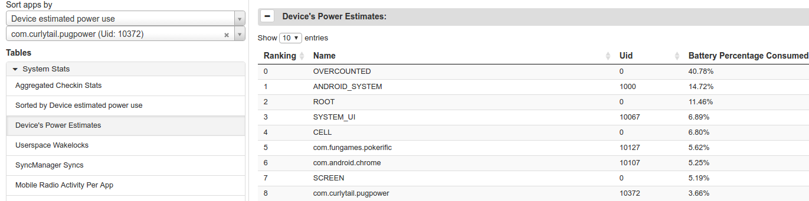
Figure 3. Investigating which apps consume the most power.
The table in Figure 3 reveals that Pug Power is the ninth biggest consumer of battery power on this device, and the third biggest app that is not part of the OS. This data suggests that this app bears deeper investigation.
To look up the data for a specific app, enter its package name into the lower of the two dropdown menus under App Selection, located under the left side of the visualization.
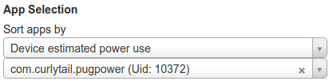
Figure 4. Entering a specific app whose data to view.
When you select a specific app, the following data visualization categories change to display app-specific data instead of system-wide data:
- SyncManager.
- Foreground process.
- Userspace Wakelock.
- Top app.
- JobScheduler.
- Activity Manager Proc.
The SyncManager and JobScheduler visualizations immediately make it obvious if your app performs syncs and executes jobs more frequently than necessary. In doing so, they can quickly reveal an opportunity to optimize your app’s behavior for improved battery performance.
You can also obtain one more piece of app-specific visualization data, Userspace Wakelock. To include this information in the bug report, enter the following command in your terminal window:
$ adb shell dumpsys batterystats --enable full-wake-history
Note: From Android 6.0 (API level 23), the platform includes Doze functionality, which imposes certain optimizations on apps. For example, Doze batches jobs to take place during brief maintenance windows, regardless of how JobScheduler has scheduled them.
Figures 5 and 6 show data for Pug Power: Figure 5 shows the visualization of the app-specific data, and Figure 6 shows the corresponding tabular data.
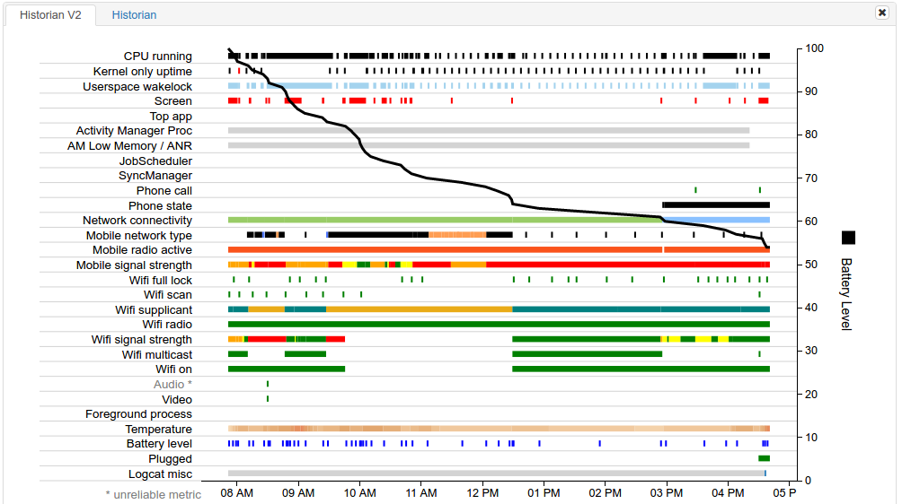
Figure 5. Visualization of data for fictional app Pug Power.
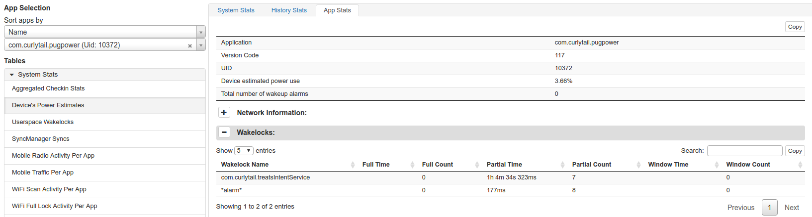
Figure 6. Tabular data for the fictional Pug Power app.
A look at the visualization does not show anything immediately obvious. The JobScheduler line shows that the app has no jobs scheduled. The SyncManager line shows that the app has not performed any syncs.
However, examination of the Wakelocks segment of the tabular data reveals that Pug Power acquires wakelocks totaling over an hour. This unusual and costly behavior can account for the app’s high level of power consumption. This piece of information helps the developer target an area where optimization is likely to greatly help. In this case, why does the app acquire so much wakelock time, and how can the developer ameliorate this behavior?

Other cases where Battery Historian can help
There are many other cases in which Battery Historian can help you diagnose opportunities for improving battery behavior. For example, Battery Historian can tell you if your app is:
- Firing wakeup alarms overly frequently (every 10 seconds or less).
- Continuously holding a GPS lock.
- Scheduling jobs every 30 seconds or less.
- Scheduling syncs every 30 seconds or less.
- Using the cellular radio more frequently than you expect.

