TrustZone technology for ARM
Architecture
Version 0.1a

Table of contents page num
Chapter 1 : Introduction 1
Chapter 2 : Architecture 2
Chapter 3 : Booting sequence 3
Chapter 4 : Build steps 4
Chapter 5 : Flashing steps 5-7
Chapter 6 : Errors 8

Chapter 1
Introduction
"ARM® TrustZone® technology is a system- wide approach to security for a wide array of client and server computing platforms, including handsets, tablets, wearable devices and enterprise systems. Applications enabled by the technology are extremely varied but include payment protection technology, digital rights management, BYOD, and a host of secured enterprise solutions."
Trust zone is a set of security extensions added to ARM processors. It can run 2 operating systems. 1.Secure operating system 2.Normal operating system. Both operating system have the same capabilities and Operate in a separate memory space
Enables a single physical processor core to execute from both the Normal world and the Secure world. Normal world components cannot access secure world resources and secure world can access normal world components.

Chapter 2
Architecture

Architecture of OP-TEE:

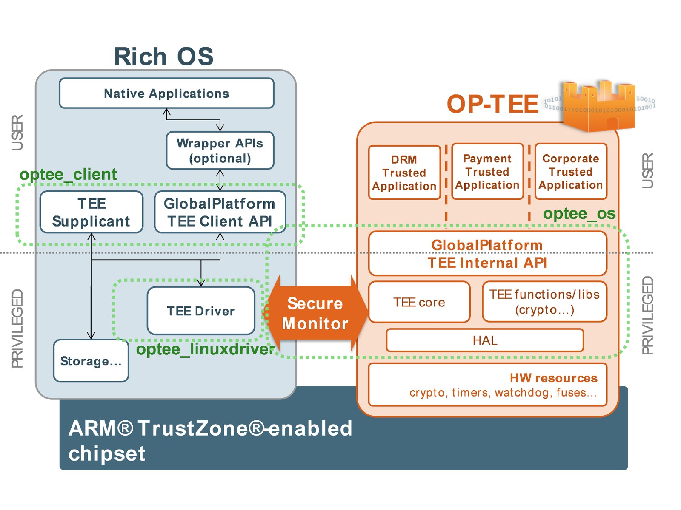

Chapter 3
Booting sequence

Bootflow of OPTEE:

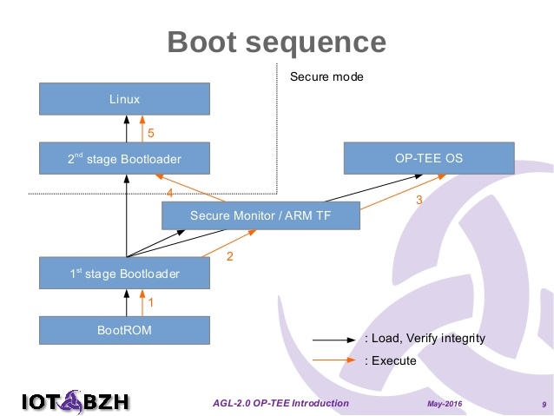

Chapter 4
Build steps
Step1: Install the following packages regardless of what target you will use in the end.
$ sudo apt-get install android-tools-adb android-tools-fastboot autoconf \
automake bc bison build-essential cscope curl device-tree-compiler \
expect flex ftp-upload gdisk iasl libattr1-dev libc6:i386 libcap-dev \
libfdt-dev libftdi-dev libglib2.0-dev libhidapi-dev libncurses5-dev \
libpixman-1-dev libssl-dev libstdc++6:i386 libtool libz1:i386 make \
mtools netcat python-crypto python-serial python-wand unzip uuid-dev \
xdg-utils xterm xz-utils zlib1g-dev
Step2: install repo
Step3: Choose the manifest corresponding to the platform you intend to use. For example, if you intend to use Raspberry Pi3, then ${TARGET}.xml should be rpi3.xml.
$ mkdir -p $HOME/devel/optee
$ cd $HOME/devel/optee
$ repo init -u https://github.com/OP-TEE/manifest.git -m ${TARGET}.xml
$ repo sync
Step4: Download the toolchains
$ cd build
$ make toolchains
Step5: $ make
Chapter 5
Flashing steps
Step1: Partitioning Sd-card
$ fdisk /dev/sdx # where sdx is the name of your sd-card
> p # prints partition table
> d # repeat until all partitions are deleted
> n # create a new partition
> p # create primary
> 1 # make it the first partition
> <enter> # use the default sector
> +32M # create a boot partition with 32MB of space
> n # create rootfs partition
> p
> 2
> <enter>
> <enter> # fill the remaining disk, adjust size to fit your needs
> t # change partition type
> 1 # select first partition
> e # use type 'e' (FAT16)
> a # make partition bootable
> 1 # select first partition
> p # double check everything looks right
> w # write partition table to disk.
Step2: loading images into boot
run the following as root
$ mkfs.vfat -F16 -n BOOT /dev/sdx1
$ mkdir -p /media/boot
$ mount /dev/sdx1 /media/boot
$ cd /media
$ gunzip -cd /home/lagadanu/trustzone/build/../out-br/images/rootfs.cpio.gz | sudo cpio -idmv "boot/*"
$ umount boot
Step3: Loading images into root
run the following as root
$ mkfs.ext4 -L rootfs /dev/sdx2
$ mkdir -p /media/rootfs
$ mount /dev/sdx2 /media/rootfs
$ cd rootfs
$ gunzip -cd /home/lagadanu/trustzone/build/../out-br/images/rootfs.cpio.gz | sudo cpio -idmv
$ rm -rf /media/rootfs/boot/*
$ cd .. && umount rootfs

Chapter 6
Errors
1. uboot.env file is missing
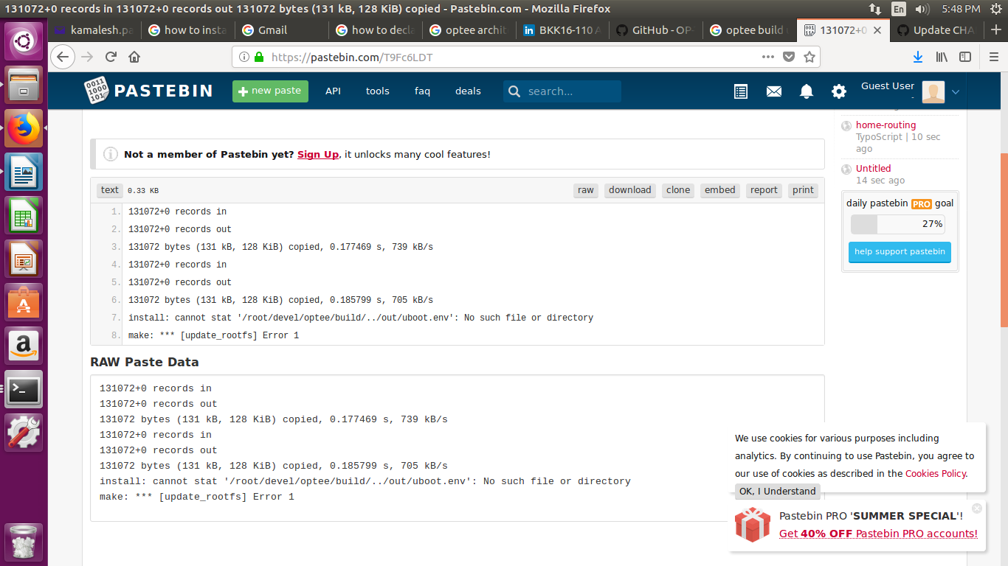

Solution: Copy uboot.env.txt from /home/lagadanu/trustzone/build/rpi3/firmware to /home/lagadanu/trustzone/out
2.lagadanu@vta049l:~/devel/optee/rpi$ repo init -u https://github.com/OP-TEE/manifest.git -m rpi3.xml
Traceback (most recent call last):
File "/home/lagadanu/devel/optee/.repo/repo/main.py", line 41, in <module>
from git_command import git, GitCommand
ImportError: No module named git_command

