Project Proposal for Recipe Finder

Presented to

Dr. Mike Wu

San José State University

Department of Computer Science

In Partial fulfillment of the

Requirements for the Class

Spring 2023: CS 157C

By

Team 3:

Akbar Savakov

Anushree Shah

Kevin Lam

February 2023

**Project Description**

***History:***

Home cooking has become very popular and necessary in recent years especially during the COVID phase when the pandemic hit and all the restaurants were shut down. People were forced to cook at home. Cooking enthusiasts and people new to the field of cooking are looking for ways to make the most of the ingredients they have on hand. Cooking and recipe apps have been around for a while now, but most of them only provide a list of recipes based on the user's search queries.

A new trend is emerging where users want to input the ingredients they have in their kitchen or fridge and then receive recipe suggestions based on those ingredients. This approach provides a more personalized and convenient experience for users who want to make a meal out of the ingredients they already have.

However, finding recipes that use only the ingredients you already have can be a challenge, especially if you're trying to cater to specific dietary needs or time constraints. Recipe Finder aims to make this process easier by providing personalized recipe suggestions based on the ingredients you have and your individual preferences.

The initial idea of this project came from the realization that many people struggle with meal planning and finding recipes that fit their dietary restrictions and preferences. For example, a vegetarian may find it challenging to come up with new and exciting meal ideas that don't involve meat. Similarly, a busy individual may not have the time to research and plan meals in advance. People moving to a new city or country might not have eaten or used a certain vegetable or item that is commonly available there. In such cases, our application comes to their rescue.

***Goal:***

The goal of Recipe Finder is to provide a user-friendly platform that allows users to easily input the ingredients they have on hand and receive customized recipe suggestions that meet their dietary needs and cooking preferences. The platform will allow users to filter recipe suggestions based on estimated cooking time, vegetarian/vegan/non-vegetarian options, and other criteria. Users will also be able to post their own recipes for others to try out.

***Motivation:***

There are several reasons why an application like this is needed.

Firstly, it helps to reduce food waste. Every year, billions of tons of food is wasted globally, with a significant amount of that waste coming from households. By using the ingredients that the users already have at home, this application can help reduce the amount of food that goes to waste.

Secondly, it can save users a lot of their time and money. Rather than having to go to the grocery store to buy ingredients for a specific recipe, users can input the ingredients they have and receive suggestions for recipes that they can make with those ingredients. This can save them time and money by reducing the number of trips they have to make to the grocery store.

Finally, the application can promote healthy and sustainable eating habits. By allowing users to filter recipes based on dietary requirements, such as vegetarian or vegan options, the application can encourage users to make healthier choices.

***Application Domain:***

Recipe Finder falls under the domain of food and cooking. The application will be designed to cater to a wide range of users, including home cooks, food bloggers, and anyone who wants to make the most of the ingredients they have on hand. The platform will include features that are useful to all types of users, including recipe suggestions, ingredient search, and a social aspect for sharing and discovering new recipes.

***Stakeholders:***

The stakeholders for Recipe Finder include:

* ***Users:*** The primary stakeholders are the users of the application. They will be able to input their ingredients, filter recipe suggestions, and post their own recipes to the platform.
* ***Food bloggers:*** Recipe Finder will provide a platform for food bloggers to share their recipes with a wider audience.
* ***Advertisers:*** Recipe Finder will have the potential to attract advertisers who want to promote their products to a targeted audience of home cooks and food enthusiasts.
* ***Investors:*** Investors may be interested in supporting Recipe Finder as a promising startup that has the potential for growth and profitability.

**Development Environment**

***NoSQL Database Used:***

Our team has been assigned with Redis (Remote Dictionary Server). It falls under the category of a key-value database.

***Structure of the System:***

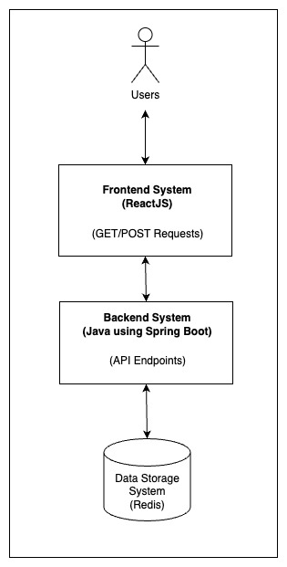

* ***React Frontend:*** This is the user interface that the user interacts with. It sends requests to the Java Spring Boot Backend via REST API.
* ***Java Spring Boot Backend:*** This is the backend application that handles incoming requests from the frontend, processes them, and returns the appropriate response. It communicates with Redis database to fetch and store recipe data.
* ***Redis Database:*** This is a NoSQL database used to store and retrieve recipe data. It is used to store all the recipes posted by the users, and also to store the ingredients and their corresponding recipes.
* ***Recipe API:*** This is the REST API provided by the Java Spring Boot Backend that handles all the recipe-related requests, including searching for recipes, filtering recipes based on cooking time or dietary preferences, and creating or updating recipes.

**Technologies required:**

* ***Frontend:*** ReactJS
* ***Backend:*** Java using Spring Boot
* ***Database:*** Redis
* ***Others:*** Git

**Functional Requirements**

***Use Case Diagram:***

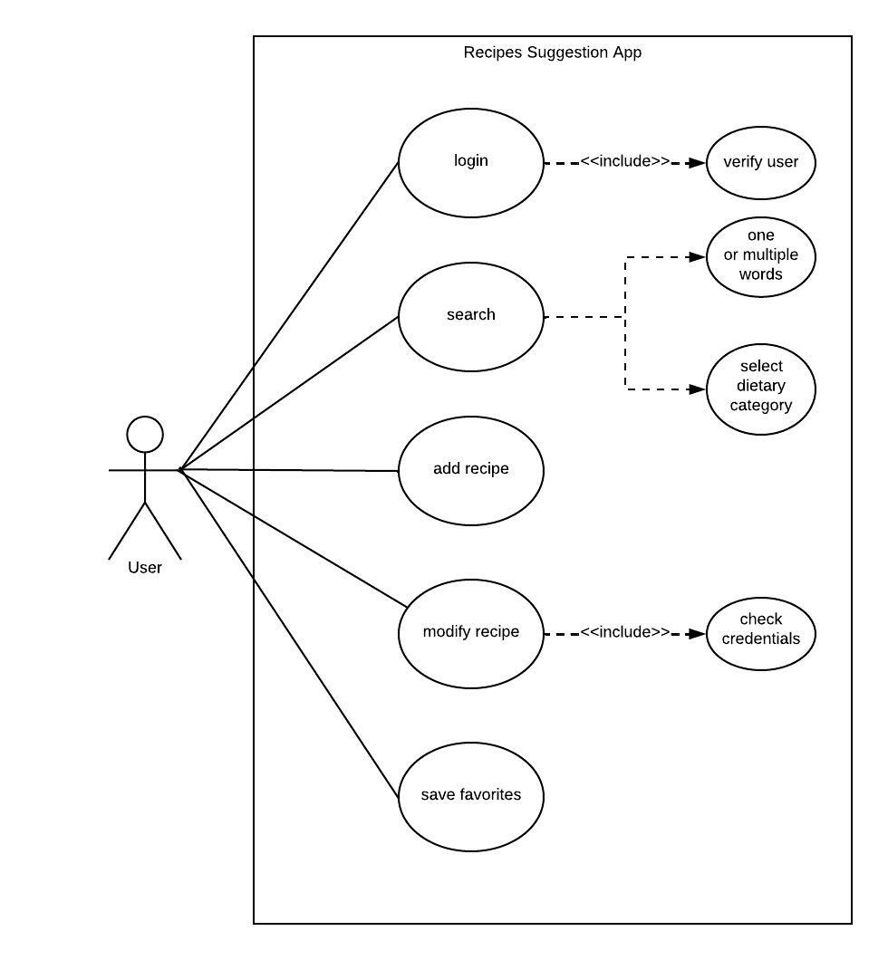

***Use Cases of the Application:***

* ***Login/Create Profile:***The feature’s purpose is to let users create a new profile or login if they are an existing user. Profile is needed to add new recipes, and modify existing recipes. Each user will be added to the database and each time the user logs in, the application will check the database.
* ***Search:***Users will be able to type ingredients or choose multiple items that they have to get a recipe. If one ingredient is entered, then the application will show recipes that contain the chosen ingredient. For multiple ingredients the system should give out recipes that match with selected ingredients.
* ***Post a recipe:***Users will be able to post their own recipes for others to try and experiment. The user will be asked to enter the name of the recipe, estimated preparation and cooking time, the ingredients required for preparing the dish, and the detailed steps of the recipe. The user can also upload pictures of the final outcome if they wish to.
* ***Modify a recipe:*** Users will be able to modify the recipe that they have posted earlier. The system has to update the database of the exact recipe post. Only user’s own recipes are allowed to be modified.
* ***Save to favorites:*** This feature allows the user to save favorite or frequently used recipes as a bookmark. The application will provide its designated section to access all saved recipes. The functionality gives great user experience and allows future easy access. The database will be binded and save the data only if the user has an account. If the user does not have an account and if the user presses the save button the application should give a message to create a new account in order to use that feature.

**Non-Functional Requirements**

***Graphical User Interface:***

The Adobe XD Artboard that shows the design for the user interface of our application can be accessed at the following link:

<https://xd.adobe.com/view/ba4f43f0-f553-4a06-9fa2-43dd751771d3-ef1c/>

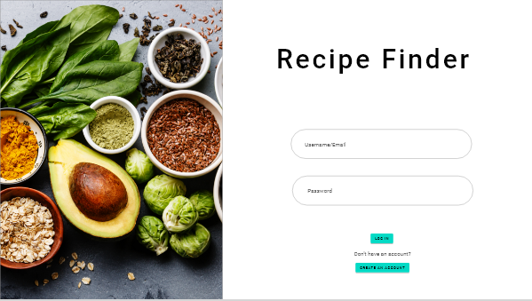 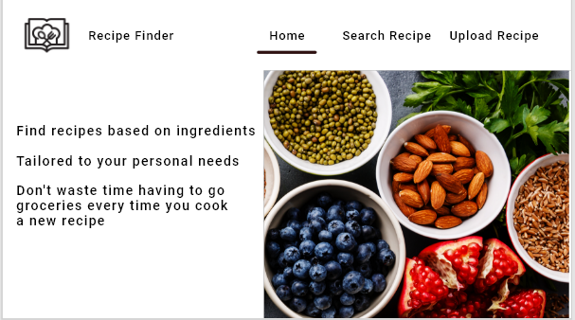

***Fig 1. Login Page Fig 2. Home Page***

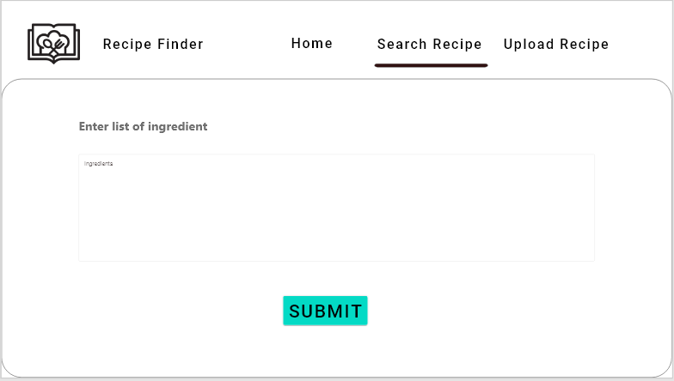 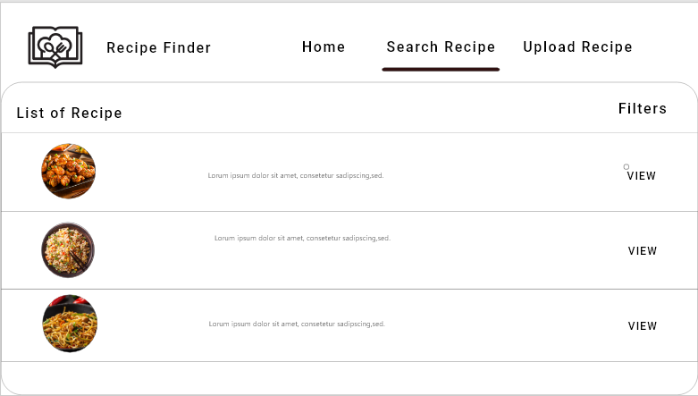

***Fig 3. Search Page (User enters ingredients) Fig 4. Search Page (Results of the recipes***

***based on users’ ingredients)***

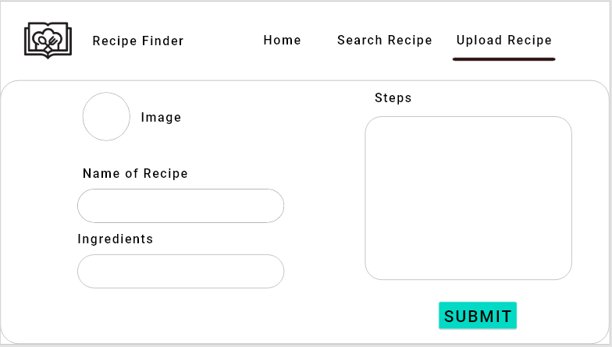

***Fig 5. Upload Recipe Page***

***Security:***

* ***Authentication and Authorization:***Users of this application would be required to create an account and log in to that account in order to access certain features of the application such as posting recipes or viewing recipes. Redis can store session data securely and invalidate the session when the user logs out or when the session expires, thereby preventing unauthorized access.
* ***Encryption:***The application would have sensitive data such as user login credentials and personal information. This data would be encrypted before storing in the database. Encryption can prevent unauthorized access to the data, even if the database is compromised. Redis supports data encryption using the industry-standard AES algorithm.
* ***Rate Limiting:*** Redis is capable of easily implementing rate limiting to prevent brute-force attacks, and other types of attacks that can cause damage or disrupt the normal operation of a system as well as to limit the number of requests per user. Redis can track the number of requests made by each user and block further requests once a certain threshold is reached.

***Access Control:***

Access control is needed to determine who is allowed to access certain data, apps, and resources. It also controls when to give the permission based on various circumstances. Since our application is open for guest users they have access to some of the features of the application. However, to be able to use all features every user has to create their own accounts. Users data will be securely stored in the database, protecting from unauthorized users or hackers to access their data.

* User’s access will be controlled through authentication.
* Redis Access Control List will be experimented to limit and control connection to the Redis server.
* Role-based access control will be tested to define roles and assign permissions to those roles.