**Akbar Zaputra – 4506210018**

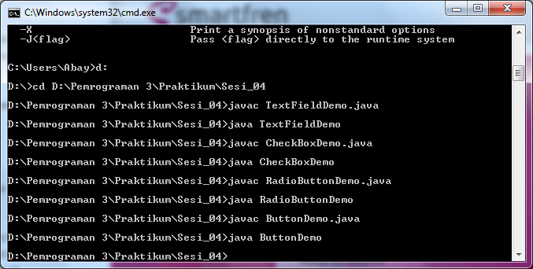

TextFieldDemo.java

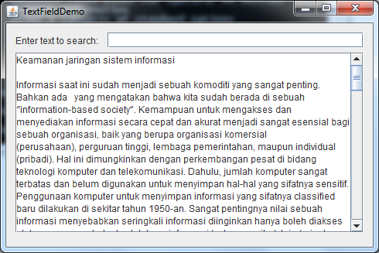

ButtonDemo.java

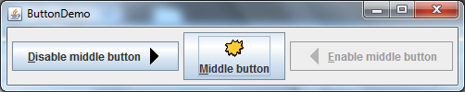

CheckBoxDemo.java

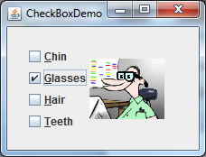

RadioButtonDemo.java

