Assignment 6 – Part 3
Submitted by Arun Suresh(ARUNSURE) and Baskar Adyar Krishnan(BASKARAD)

State Diagram:

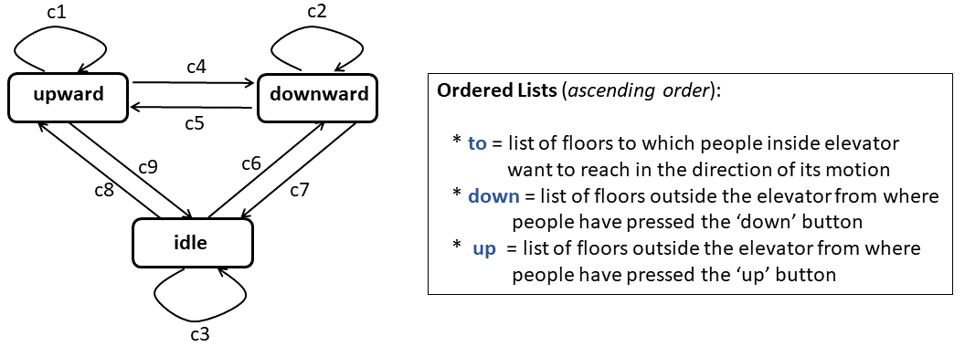

Conditions:

c1 = !to.isempty() || (!up.isempty() && up.max() ≥ f) ||
(!down.isempty() && down.max() > f)
c2 = !to.isempty() || (!up.isempty() && up.min() < f) ||
(!down.isempty() && down.min() ≤ f)
c3 = to.isempty() && up.isempty() && down.isempty()

c4 = to.isempty() && (!up.isempty() && !down.isempty()) && (!up.isempty() && up.max() < f) && (!down.isempty() && down.max()≤ f)

c5 = to.isempty() && (!up.isempty() && !down.isempty()) &&
(!up.isempty() && up.min() ≥ f) && (!down.isempty() && down.min()> f)

c6 = !to.isempty() || (!up.isempty() && up.min() < f) ||
(!down.isempty() && down.min() ≤ f)

c7 = to.isempty() && up.isempty() && down.isempty()

c8 = !to.isempty() || (!up.isempty() && up.max() ≥ f) ||
(!down.isempty() && down.max() > f)

c9 = to.isempty() && up.isempty() && down.isempty()

Prepare a file StateChart.pdf containing the state chart picture and the definitions for all nine guard conditions c1..c9.

What to Submit. Prepare a directory named A6_Part3_UBITId1_UBITId2 if this part is done by a team of two students; otherwise, name it as A6_Part3_UBITId if done solo. (Order the UBITIds in alphabetic order, in the former case.) In this directory, place the file StateChart.pdf. Compress the directory and submit it using submit_cse522. Only one submission per team is required.

End of Assignment 6 – Part 3

