**Smith School Rankings Scrutiny**

**Member Names:**Akshay Belnekar

Abhishek Shetty

Rutuja Samant

Vaibhavi Hedaoo

**Mission Statement:**

To model a database for ranking of various UMD Smith School programs, our mission is to provide a user-friendly platform that offers multi-year rankings for various graduate programs. Our goal is to enable the Smith School to draw valuable insights and facilitate data-driven decision-making regarding program rankings over the years.

**Mission Objectives:**

* To find the top 5 ranked programs over the last 3 years, so that Smith School can display these programs on their website to increase transparency.
* To find the top 5 improved/declined programs over the last 3 years to help the Smith School analyze this trend and what changes led to this trend.
* To find the top 5 programs with consistent ranking across all ranking sources, so that Smith School can assign singular ranks to these programs irrespective of ranking sources.
* To find the top 3 performing degrees in Smith School based on program rankings which can be displayed on the website to provide students/parents with useful information in their research.
* To find the proportion of programs that improved/declined over the last year rankings to help Smith School track results of their program improvement efforts.

**Business terms:**

Ranking system is used to assess and evaluate the quality, performance, and reputation of various academic programs offered by Robert H. Smith school of business.

Full-time programs are intended for students who can dedicate themselves to full-time study. They are more intense and last less time.

Part-time programs are intended for working professionals and people with other obligations. They are spread out over a longer length of time, allowing students to work and study at the same time.

**Facts:**

Ranking Source

Program Name

Ranking Year

**Attributes and identifiers in sentences:**

Smith School Ranking, Inc. is a company that publishes an annual report on program rankings. To keep track of all the program names, program rankings, school names, program types, and program categories, a database is required. Every program has a unique program ID, program name, type of program, and program category. The program categories are Masters program and Master of Business Administration. Each category has a unique category id and category name. The types of programs are full-time and part-time. Each program type has a unique program type id and type name. Every program has a ranking, unique ranking ID, ranking source, year, position, and previous year ranking. Each program has a school name and a unique school ID.

**Entities:**

Program (**programId**, programName)

ProgramCategory (**prgCtgryId**, prgCtgryName)

ProgramType (**prgTypeId**, prgTypeName)

RankingSource (**rnkngSrcId**, rnkngSrcName)

**Relationships:**

Belongs: binary relationship

1 Program Category to 1 or more Programs

1 Program to 1 Program Category - *Note: Inferred by best judgement*

Has: binary relationship

1 Program Type to 1 or more Programs

1 Program to 1 Program Types - *Note: Inferred by best judgement*

Rank (rankingYear, rankingPosition, rankingPositionPrevYear): binary relationship

1 Program to 1 or more Ranking Sources

1 Ranking Source to 1 or more Programs

**ER diagram:**

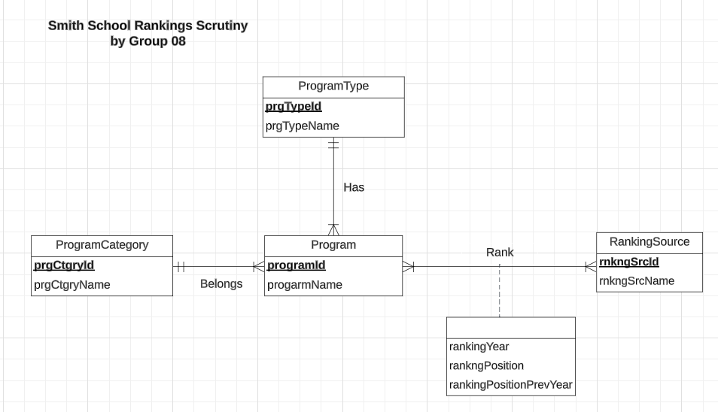

**Relations:**

Program (**programId**, programName, *prgCtgryId*, *prgTypeId*)

ProgramCategory (**prgCtgryId**, prgCtgryName)

ProgramType (**prgTypeId**, prgTypeName)

RankingSource (**rnkngSrcId**, rnkngSrcName)

Rank (***programId***, ***rnkngSrcId***, rankingYear, rankingPosition, rankingPositionPrevYear)

**Functional Dependencies:**

programId → programName, prgCtgryId*,* prgTypeId

prgCtgryId → prgCtgryName

prgTypeId → prgTypeName

rnkgnSrcId → rnkngSrcName

programId, rnkgnSrcId → rankingYear, rankingPosition, rankingPositionPrevYear

1. There are no multi-valued attributes in the relations, hence it is 1NF
2. There are no partial dependencies in the relations, hence it is 2NF
3. There are no transitive dependencies in the relations, hence it is 3NF

**Business Rules:**

**[R1]** When a program category is deleted from the database, the corresponding program should also be deleted from the database.

**[R2]** When a program category is updated in the database, the corresponding program category should also be updated in the Program table of the database.

**[R3]** When ranking source information is updated in the database, corresponding ranking information should be updated accordingly.

**[R4]** When ranking source information is deleted from the database, corresponding ranking information should be deleted accordingly.

**[R5]** When a program type is deleted from the database, the corresponding program information should be deleted from the database as well.

**[R6]**When a program type is updated from the database, the corresponding program information should be updated from the database as well.

**[R7]** When a program is updated in the database, the corresponding ranking source should be updated accordingly.

**[R8]** When a program is deleted in the database, the corresponding ranking source information should be deleted accordingly.

**Referential Integrities:**

|  |  |  |  |  |  |  |  |
| --- | --- | --- | --- | --- | --- | --- | --- |
| **Relation** | **Foreign Key** | **Base Relation** | **Primary Key** | **Business Rule** | **Constraint: ON DELETE** | **Business Rule** | **Constraint: ON UPDATE** |
| Program | prgCtgryId | ProgramCategory | prgCtgryId | R1 | CASCADE | R2 | CASCADE |
| Program | prgTypeId | ProgramType | prgTypeId | R5 | CASCADE | R6 | CASCADE |
| Rank | programId | Program | programId | R7 | CASCADE | R8 | CASCADE |
| Rank | rnkngSrcId | RankingSource | rnkngSrcId | R4 | CASCADE | R3 | CASCADE |

**Sample Data:**

1. Program**:**

| **programId** | **programName** |
| --- | --- |
| 1 | Information Systems |
| 2 | Business Analytics |
| 3 | Marketing Analytics |
| 4 | Accounting |

1. ProgramCategory

|  |  |
| --- | --- |
| **prgCtgryId** | **prgCtgryName** |
| 1 | Information Technology |
| 2 | Analytics |
| 3 | Finance |

1. ProgramType

|  |  |
| --- | --- |
| **prgTypeId** | **prgTypeName** |
| 1 | Masters of Science |
| 2 | Bachelors |
| 3 | Masters of Business Administration |

1. RankingSource

|  |  |
| --- | --- |
| **rnkgnSrcId** | **rnkngSrcName** |
| 1 | US World News |
| 2 | Q.S Rankings |
| 3 | Times Higher Education |

1. Ranking

|  |  |  |  |  |
| --- | --- | --- | --- | --- |
| **programId** | **rnkgnSrcId** | **rankingPosition** | **rankingPositionPrevYear** | **rankingYear** |
| 1 | 1 | 1 | 2 | 2020 |
| 2 | 1 | 3 | 1 | 2020 |
| 3 | 1 | 10 | 15 | 2020 |