**BUDT702 DATABASE MANAGEMENT SYSTEMS**

**Submitted by: Project_0501_08**

**Smith School Rankings Scrutiny**

**Team Members:**

Akshay Belnekar

Abhishek Shetty

Rutuja Samant

Vaibhavi Hedaoo

**Data sources/ References:**

1. QS World University Ranking: <https://www.topuniversities.com/qs-world-university-rankings/>

2. U.S. News: <https://www.usnews.com/>

3. Financial Times: <https://rankings.ft.com/>

4. UMD Smith School Programs: <https://www.rhsmith.umd.edu/programs>

**Testing the Project:**

**Below are the steps to run corresponding business transactions.**

**1. What are the top 5 ranked programs over the last 3 years?**

**GO**

**DROP VIEW IF EXISTS Top5RankedPrograms**

**GO**

**CREATE VIEW Top5RankedPrograms AS**

**SELECT TOP 5 p.programName 'Program Name', rs.rnkngSrcName 'Ranking Source', r.rankingYear 'Year', r.rankingPosition 'Rank'**

**FROM [RankingScrutiny.Program] p**

**JOIN [RankingScrutiny.Rank] r ON p.programId = r.programId**

**JOIN [RankingScrutiny.RankingSource] rs ON r.rnkngSrcId = rs.rnkngSrcId**

**WHERE r.rankingPosition IS NOT NULL AND r.rankingYear >= YEAR(GETDATE()) - 5**

**ORDER BY r.rankingPosition;**

**GO**

**SELECT \***

**FROM Top5RankedPrograms;**

**Select the query as shown in below screenshot and click on Execute.**

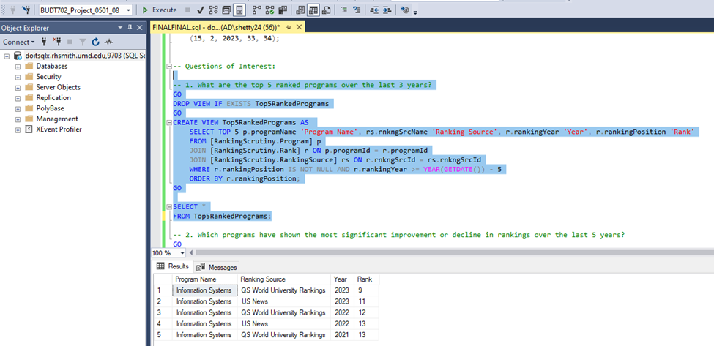

**2. Which programs have shown the most significant improvement or decline in rankings over the last 5 years?**

**GO**

**DROP VIEW IF EXISTS Top5ImprovedDeclinedPrograms**

**GO**

**CREATE VIEW Top5ImprovedDeclinedPrograms AS**

**SELECT TOP 5 p.programName 'Program Name', pt.prgTypeName 'Type',rs.rnkngSrcName 'Ranking Source', r.rankingPosition 'Current Year Rank', r.rankingPositionPrevYear 'Previous Year Rank', r.rankingYear 'Current Year'**

**FROM [RankingScrutiny.Program] p**

**JOIN [RankingScrutiny.Rank] r ON p.programId = r.programId**

**JOIN [RankingScrutiny.ProgramType] pt ON p.prgCtgryId = pt.prgTypeId**

**JOIN [RankingScrutiny.RankingSource] rs ON r.rnkngSrcId = rs.rnkngSrcId**

**WHERE r.rankingYear >= YEAR(GETDATE()) - 3**

**ORDER BY ABS(r.rankingPosition - r.rankingPositionPrevYear) DESC;**

**GO**

**SELECT \***

**FROM Top5ImprovedDeclinedPrograms;**

**Select the query as shown in below screenshot and click on Execute.**

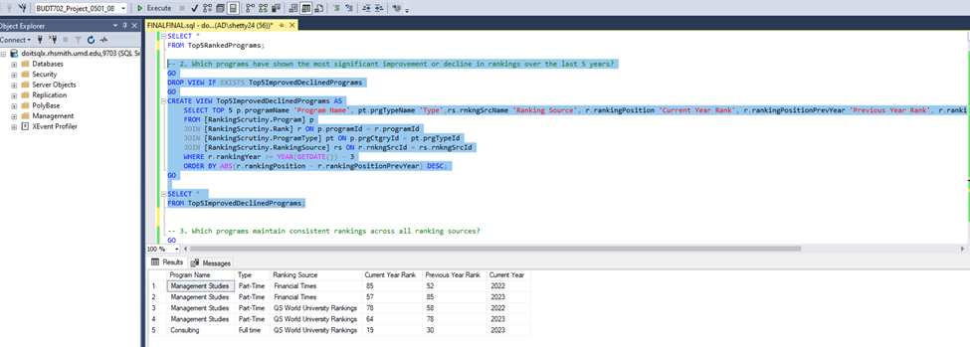

**3. Which programs maintain consistent rankings across all ranking sources?**

**GO**

**DROP VIEW IF EXISTS ConsistentRankingsPrograms**

**GO**

**CREATE VIEW ConsistentRankingsPrograms AS**

**SELECT p.programName 'Program Name', AVG(r.rankingPosition) AS 'AverageRanking'**

**FROM [RankingScrutiny.Program] p**

**JOIN [RankingScrutiny.Rank] r ON p.programId = r.programId**

**GROUP BY p.programId, p.programName**

**HAVING COUNT(DISTINCT r.rnkngSrcId) = (SELECT COUNT(*) FROM [RankingScrutiny.RankingSource]);**

**GO**

**SELECT TOP 5 \***

**FROM ConsistentRankingsPrograms**

**ORDER BY AverageRanking**

**Select the query as shown in below screenshot and click on Execute.** 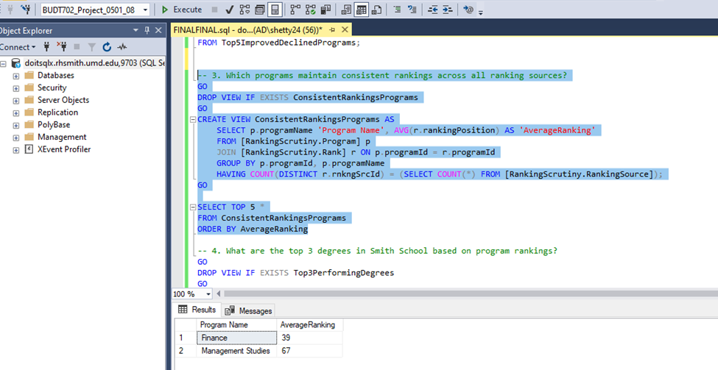

**4. What are the top 3 degrees in Smith School based on program rankings?**

**GO**

**DROP VIEW IF EXISTS Top3PerformingDegrees**

**GO**

**CREATE VIEW Top3PerformingDegrees AS**

**SELECT TOP 3 p.programName 'Program Name', r.rankingPosition 'Rank', r.rankingYear 'Year'**

**FROM [RankingScrutiny.Program] p**

**JOIN [RankingScrutiny.Rank] r ON p.programId = r.programId**

**WHERE r.rankingPosition IS NOT NULL**

**ORDER BY r.rankingPosition ASC;**

**GO**

**SELECT \***

**FROM Top3PerformingDegrees;**

**Select the query as shown in below screenshot and click on Execute.**

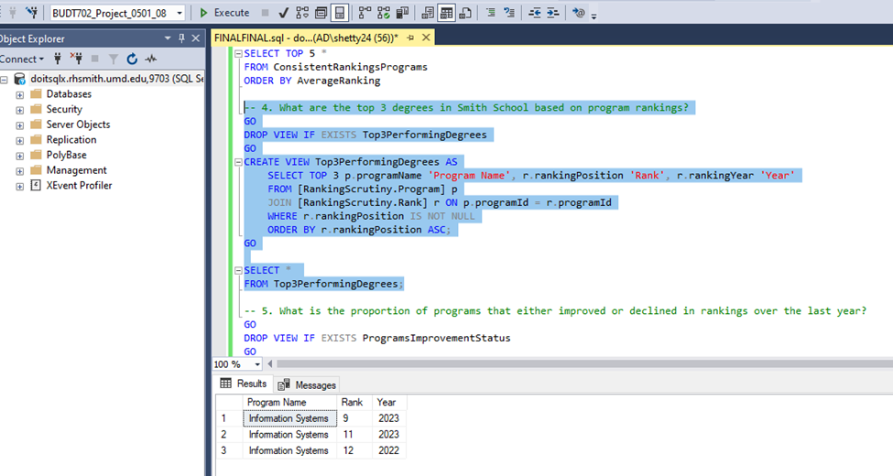

**5. What is the proportion of programs that either improved or declined in rankings over the last year?**

**GO**

**DROP VIEW IF EXISTS ProgramsImprovementStatus**

**GO**

**CREATE VIEW ProgramsImprovementStatus AS**

**SELECT p.programId, p.programName, r.rankingYear, r.rankingPosition, r.rankingPositionPrevYear,**

**CASE**

**WHEN r.rankingPosition > r.rankingPositionPrevYear THEN 'Declined'**

**WHEN r.rankingPosition < r.rankingPositionPrevYear THEN 'Improved'**

**ELSE 'No Change'**

**END AS ImprovementStatus**

**FROM [RankingScrutiny.Program] p**

**JOIN [RankingScrutiny.Rank] r ON p.programId = r.programId**

**WHERE r.rankingYear = YEAR(GETDATE()) AND r.rankingPositionPrevYear IS NOT NULL;**

**GO**

**SELECT ImprovementStatus, COUNT(programId) AS ProgramCount, CAST(ROUND((COUNT(programId)) * 100.0 / (SELECT COUNT(*) FROM ProgramsImprovementStatus), 2) AS decimal(18, 2)) AS Proportion**

**FROM ProgramsImprovementStatus**

**GROUP BY ImprovementStatus;**

**Select the query as shown in below screenshot and click on Execute.**

