|  |
| --- |
| **[Undisciplining the Victorian Classroom logo](https://undiscipliningvc.org/)Peer-Reviewed Syllabus**  **Peer Reviewer:** Elaine Freedgood  **Date:** 2021  **License:** [CC BY-NC 4.0](https://creativecommons.org/licenses/by-nc/4.0/) |

**Unsettling Victorian Literature**

Margaret Linley, Simon Fraser University, email: [mlinley@sfu.ca](mailto:mlinley@sfu.ca)

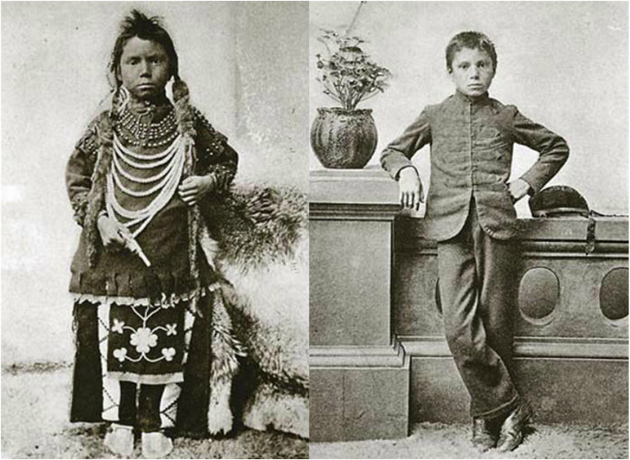

Fig. 1 (Left): Department of Indian Affairs. Thomas Moore before Tuition at Regina Indian Industrial School. 1897. Saskatchewan Archives Board. InJohn S. Milloy, *A National Crime*.

Fig. 2 (Right): Department of Indian Affairs. Thomas Moore after Tuition at Regina Indian Industrial School. 1897. Saskatchewan Archives Board. InJohn S. Milloy, *A National Crime*.

The Victorian period (1837–1901) is the offspring of the symbolic power of Queen Victoria, who transformed from “mother of the nation” to “mother of empire” in 1876, and the economic and cultural force of what is often referred to as the British “imperial century.” Against the prevailing triumphalism of imperial expansion that underwrites standard histories of the Victorian period, this course attends closely to the ways Victorian forms of colonialism continue to trouble the very identity of scholars and students alike studying in settler society today, potentially exposing the unsettling nature of understanding and reconciling our identities. To this end, we will engage intersections of racialized, settler colonial, and environmental awareness in Victorian literature, recovering the historical experiences of Indigenous peoples in predominantly white settler nations that emerged during the nineteenth century, attending to processes and effects of dispossession and violence entailed in colonialism, and questioning ongoing tendencies toward disavowal or conceptual displacement of this history. Our focus will shift from metropolitan, imperial culture to Indigenous and settler perspectives. Our approach will be comparative, looking at historical relationships between nature and society across global geopolitical spaces. And our method will be disruptive, upending the standard, linear cultural history by reading contemporary literature that writes back to the colonial consolidation of the Victorian period, such as Tomson Highway’s (Cree) play *The Rez Sisters* (1988)*.* The first weeks of the course will engage Victorian literature and culture through a settler colonial, Indigenous, and ecocritical lens by studying a canon linked to the remote region of northern England (the English Lake District, now a national park and a UNESCO World Heritage site) made famous in the nineteenth century by the nature poet William Wordsworth. This canon of literature functions within a centre/periphery, local/global geocultural framework that will help us identify and disrupt racialized colonial paradigms. The remainder of the course will study literature from colonial societies by and about settlers and Indigenous peoples, including Olive Schreiner’s *Story of an African Farm;* selections from Anna Jameson’s *Winter Studies and Summer Rambles in Canada*; Bemwewegiizhigokwe/Jane Johnston Schoolcraft’s (Ojibwe) poetry and transcriptions of traditional oral stories; Black emigrant Mary Ann Shadd’s pamphlet, *A Plea for Emigration*; and Tekahionwake/E. Pauline Johnson’s (Kanien'kehá:ka) poetry and *Legends of Vancouver*.

**Reading Schedule**

**(to be adjusted as necessary)**

**Week 1, Intro: Placing Ourselves, Placing Victorian**

Janet Marie Rogers (Mohawk/Tuscorora), “Forever” (video and audio performance); William Wordsworth, from “Home at Grasmere" (video: Hannah Britton reading)

* Leanne Simpson (Michi Saagiig Nishnaabeg), “Land as Pedagogy”
* Lorenzo Veracini, “‘Settler Colonialism’: Career of a Concept”
* Key Moments in Indigenous History
* https://native-land.ca/
* 19th century timeline

*Note:* I use the first week of the course to introduce to my students the two main questions that will guide their study of Victorian literature: What does Victorian mean to you? And how do you understand the relation between Victorian (however you understand the term), settler colonialism, the environment, and the land you’re on? Recognizing the unceded, ancestral, traditional Coast Salish territories, the framework (which could be adapted to any educational level) for this course aspires to foster and honour Indigenous resurgence as well as a plurality of decolonizing and antiracist practices. Such a framework also opens a space for my students and I to acknowledge and address our own relationship to the people on whose land we are living. But what’s at stake for settlers, recent immigrants, and Indigenous peoples in the practice of land acknowledgments? What’s the best way to proceed with such practices? We discuss these questions as we compare Indigenous and imperial maps, timelines, and poetry, and think about relationships between such categories as English and Indigenous, Canada and Victorian Britain, colonialism and imperialism. We approach the Victorian period as a global category that is temporally and spatially diverse and contested and reflect on ourselves as agents within an ongoing history. Rogers’s (Mohawk/Tuscorora) video performance of “Forever” juxtaposed with a performance hosted by the Wordsworth Museum of an excerpt from Wordsworth’s “Home at Grasmere” (written in the early nineteenth century but first published on its own in 1888) helps to bring these issues into focus.

**Module One: Exploring English Victorian Settler Stories**

**Week 2, Settler Natures**

William Wordsworth, “There was a boy,” “Lines Written in Early Spring,” “Michael: A Pastoral Poem,” “I wandered lonely as a cloud,” selections from *Guide to the Lakes*

* Alan Bewell, from “‘I see around me things which you cannot see’: William Wordsworth and the Historical Ecology of Human Passion,” in *Natures in Translation*
* Lisa Ottum, “Discriminating Vision: Rereading Place in Wordsworth’s Guide to the Lakes”

**Week 3, Settler Sovereignties**

Mary Shelley, *Frankenstein*

* Alan Bewell, “*Frankenstein* and the Origin and Extinction of Species”
* Carolyn Betensky, “Casual Racism in Victorian Literature”

**Week 4, Old World Problems**

Elizabeth Gaskell, *Mary Barton*

* Margaret S. Kennedy, “A Breath of Fresh Air: Eco-Consciousness in Mary Barton and *Jane Eyre*”

**Week 5, New World Fixes - Blog Post #1 Due**

Elizabeth Gaskell, *Mary Barton* (cont.)

* Fariha Shaikh, “Temporally out of Sync: Migration as Fiction and Philanthropy in Gaskell’s Life and Work”
* Elaine Freedgood, “Coziness and Its Vicissitudes: Checked Curtains and Global Cotton Markets in *Mary Barton,*” in *The Ideas in Things*

*Note:* In Module One, my students explore how Wordsworth, Shelley, and Gaskell each represent an implicitly racialized settler mythology premised on distinct iterations of universal whiteness as the norm. Our readings help us locate Wordsworth’s nativist writing, Shelley’s cosmopolitan narrative, and Gaskell’s industrial problem novel within a global context of imperial expansion, colonial exploitation, and ecological destruction. We consider how Wordsworth’s analogy between the presumed inevitable displacement and extinction of North American aboriginal cultures (gleaned in stories told by European settlers) and the disappearing rural culture of the Lake District tells a nostalgic story about the inescapable and tragic passing of Indigenous cultures and their native environments in the modern world. Next we lean into articles by Betensky and Bewell to consider various ways of reading race in *Frankenstein*. Is the creature a racialized analogue for stateless peoples, or does he embody yet another banal iteration of settler society and its presumption of “terra nullius” when he proposes an immigration scheme to settle apart from humans in the “vast wilds” of South America where he will dwell “in the most savage of places”? We debate whether Shelley reveals and critiques or merely perpetuates the exclusionary logic of an English liberty endlessly haunted by its occluded other. With *Mary Barton*, our focus is especially on the novel’s complex representation of industrial class conflict and environmental degradation in northern England and its solution in emigration to “them Indian countries” outside Toronto and a new life with a cottage, garden and orchard made possible by the clearing of “primeval trees” for miles around. In the recent iteration of the course, students were particularly struck by how the novel’s settler colonial fantasy neither acknowledges Indigenous inhabitants and their lands nor the collatoral environmental violence it requires, while also perpetuating racialized and gendered labor systems. Noting the irony of this Victorian “own your own” story, as one student put it, “it would only be a matter of time before industrialization would become a problem in Canada.”

**Module Two: Settler Stories of Displacement and Diaspora**

**Week 6, Indigeneity and Unsettling Stories in South Africa**

Olive Schreiner, *Story of an African Farm*

* Ryan Fong, “The Stories Outside the African Farm: Indigeneity, Orality, and Unsettling the Victorian”
* Elizabeth DeLoughrey and George B. Handley, selections from “Introduction: Toward an Aesthetics of the Earth,” *Postcolonial Ecologies*

**Week 7, Black Settlers and Diaspora - Blog Post #2 Due**

Mary Ann Shad, *A Plea for Emigration*

* Rinaldo Walcott, “‘Who Is She and What Is She to You?’ Mary Ann Shadd Cary and the (Im)possibility of Black/Canadian Studies”
* Lauren F. Klein, “Dimensions of Scale: Invisible Labor, Editorial Work, and the Future of Quantitative Literary Studies”
* *On Property: Rinaldo Walcott*, CBC Podcast
* Ronjaunee Chatterjee, Alicia Mireles Christoff, Amy R. Wong, “Undisciplining Victorian Studies:

*Note:* Module Two deliberately disrupts the temporal linearity of Victorian chronology by placing Schreiner before Shadd, who further pressures field boundaries as a non-British writer of the Black diaspora. In reading Schreiner, we consider how the Wordsworthian pastoralism fails in the South African context, we contrast Gaskell’s utopian settler fantasy with Schreiner’s dystopian vision, we think about the complex ways that land can function as witness and memory, and we pay attention to the ethnic complexity of the conflicted white settler society and its tortured representation of gender, labor, and language. We attend to Indigenous presences as well and notice how the novel marginalizes Indigenous voices even as it reveals how the farm depends on Indigenous labor. After reading Fong’s article, one student argued for the continuing necessity of studying Victorian literature and commented that “colonial literature does not define Indigenous people, so we cannot allow it to get away with its portrayal of them without criticism … We as modern scholars in our criticism must include the perspective that the texts suppress.” In moving from South Africa to an emigration guide for Black settlers by a free Black woman who sought refuge in colonial Canada from the American Fugitive Slave Act (1850), we open Victorian settler paradigms to the history of transatlantic slavery and Black diaspora. Shadd promotes British North America as a safe haven at the end of the Underground Railroad. Some students were aware of this aspect of Canadian history, but none knew that slavery existed earlier in colonial Canada or that Canadian settler colonialism was embedded in transatlantic trade networks dependent on slavery. Shadd helped us consider how certain ways of telling Victorian history privilege Canadian exceptionalism, and her guide prompted us to explore how Black emigrant and Indigenous experience may be linked, yet distinct, through intersecting histories of slavery and settler colonialism.

**Module Three: Victorian Settler Colonialism, Indigenous Perspectives**

**Week 8, The Anti-Settler as Eco-Tourist**

Anna Jameson from *Winter Studies and Summer Rambles in Canada*; Bemwewegiizhigokwe/Jane Johnston Schoolcraft (Ojibwe), selected poetry and legends

* Wendy Roy, selections from *Maps of Difference*, “Woman Question” and “Jameson's Sketches and the Language of Landscape Aesthetics”
* John Kucich, “Ecocultural Contact and the Panarchy of Place: Jane Johnston Schoolcraft and Margaret Fuller in the Great Lakes”

**Week 9, Indigenous Stories**

Anna Jameson and Bemwewegiizhigokwe/Jane Johnston Schoolcraft (cont.)

* Kevin Hutchings, “Cultural Genocide and the First Nations of Upper Canada: Some Romantic-era Roots of Canada’s Residential School System”
* Thomas King (Cherokee), “What Is It About Us That You Don’t Like” from *The Truth About Stories: A Native Narrative* (and CBC live recording)
* Kevin Hutchings, “Romantic Ecology, Aboriginal Culture, and the Ideology of Improvement in British Atlantic Literature”

**Week 10, Writing Back - Blog Post #3 Due**

Tomson Highway (Cree), *The Rez Sisters*

* Deena Rymhs, “Idling No More: The Road in Tomson Highway's *The Rez Sisters*”
* Sherene H. Razack, “Gendered Racial Violence and Spatialized Justice: The Murder of Pamela George”

*Note:* In Module Three, we spend two weeks on Jameson’s travels around the Great Lakes and especially her relationship with Bemwewegiizhigokwe/Schoolcraft and her family, whose traditional Anishinaabeg territories had been recently remapped by the American/British border. We focus in particular on the parts of Jameson’s *Winter Studies and Summer Rambles* that feature Bemwewegiizhigokwe/Schoolcraft’s poetry and translations of Ojibwe oral legends. Though Bemwewegiizhigokwe/Schoolcraft’s writings circulated in manuscript and were posthumously edited and published by her husband, Jameson’s travelogue is where some of Bemwewegiizhigokwe/Schoolcraft’s writings first appeared in print. We compare various versions of Bemwewegiizhigokwe/Schoolcraft’s poetry—in Ojibwemowin, her mother tongue, and in her own translations of the texts into English, as well as her husband’s transcriptions and Jameson’s publication. We then place these Victorian and Indigenous writings in dialogue with Highway’s *The* *Rez Sisters* (1986), a play set on Manitoulin Island near the site where Jameson witnessed the controversial Bond Head colonial treaty negotiations of 1836. Highway writes back to the colonial era and its consequences from an Indigenous perspective and helps us recognize historical continuities and our place within them. Throughout this module we consider how processes of mediation and translation complicate colonial representations of Indigenous perspectives. We compare Victorian, settler colonial, and Indigenous relationships to the natural environment and the land. We consider the particular effects of gender oppression and racial injustice expressed in the literature (and also Fig. 1 and 2) as they map on to the history of colonial policy and laws aimed at dispossession, oppression, and assimilation. We reflect on how Canada is dealing with this legacy today in, for example, the National Inquiry into Missing and Murdered Indigenous Women and Girls, the National Inquiry into the Residential School System, and ongoing confrontations with the pipeline industry.

**Module 4: Settler Nation, Indigenous Resistance and Resilience**

**Week 11, First Generation and First Peoples**

Isabella Valancy Crawford “The Camp of Souls,” “The Canoe,” “The Lily Bed”; William Wilfred Campbell, from *Lake Lyrics* and *The Dread Voyage Poems*; Charles G.D. Roberts “Canada,” “The Frosted Pane,” “The Potato Harvest,” “The Solitary Woodsman”; additional readings to be selected from the following:

* Duncan Campbell Scott, “The Onondaga Madonna”; Armand Garnett Ruffo, (Ojibwe), “Poem for Duncan Campbell Scott”
* Emma Lee Warrior (Peigan), “Compatriots”
* Willie Dunn (Mi’kmaq), “The Ballad of Crowfoot” (NFB music video)
* DMR Bentley, “Charles GD Roberts and William Wilfred Campbell as Canadian Tour Guides”
* Melissa Valiska Gregory, “Race and the Dramatic Monologue”
* Bob Joseph, “21 Things You May Not Know About the Indian Act”

**Week 12, From Protest Poetry to Victorian Vancouver**

Victorian Vancouver and Tekahionwake/E. Pauline Johnson (Kanienʼkehá꞉ka), including “Lost Lagoon,” “The Cattle Thief,” “The Corn Husker,” “The Indian Corn Planter,” and selections from *Legends of Vancouver*: “The Recluse” and “The Lure of Stanley Park”

* Lee Maracle (Sto:Loh), “Goodbye Snauq”
* Lee Maracle, “Goodbye Snauq: How We Work with Story” (video interview)
* Nicole Shukin, “Ecological Citizenship, Ecological Melancholia: The Ruins of Stanley Park”
* Carole Gerson “Rereading Pauline Johnson”
* Alix Shield, “Rethinking the Paratext: Digital Story-Mapping E. Pauline Johnson’s and Chief Joe and Mary Capilano’s *Legends of Vancouver* (1911)”
* Postcard images: “The Lions and Brockton Point, Stanley Park” and “Deadman's Island, Stanley Park, and Snow Capped Mountains”

**Week 13, Tekahionwake/E. Pauline Johnson (Kanienʼkehá:ka) cont. and** **Conclusion - Blog Post #4 Due**

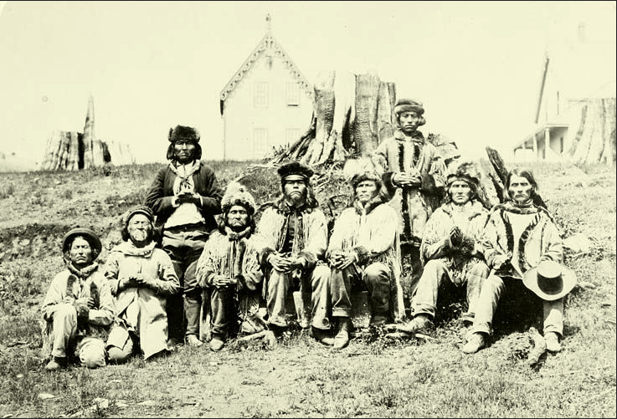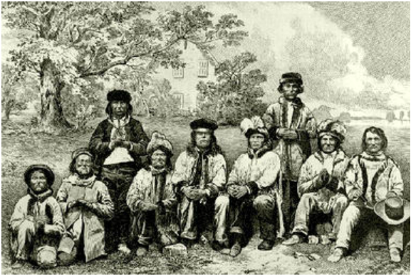

Fig. 3 First Nations Chiefs, 1967 Fig. 4 First Nations Chiefs, 1867.

Photo. Archives Canada (F. Dally) Engraving. Archives Canada

*Note:* In Module Four, we explore ways to engage Victorian settler literature critically, without embarrassment or disavowal. We also continue our efforts to learn how to recognize, without affirming, the continuing logics of Victorian colonialism within settler society today. At the center of the approach in this module is an ongoing dialogue between Indigenous and settler voices through time and across various political geographies within what we now call Canada. We address cultural appropriation through Crawford’s and Campbell’s late Victorian dramatic monologues featuring Indigenous characters; Warrior’s “Compatriots,” a story published in 1987 about troubling authenticity; and the above paired photo and engraving (Fig. 3 and 4) for the British illustrated press, intended to show BC First Nations celebrating the birthday of Queen Victoria in the year of Canada’s birth as a nation—ironically, the Secwepemc and St'át'imc chiefs have never recognized British sovereignty, and they have not ceded their Aboriginal Title and Rights to their land and resources. We go on to analyze the gothic disposition of the haunted colonial imagination, as well as the various expressions of ecological melancholia, alongside strident statements of Anglo patriotism and Tekahionwake/Johnson’s Indigenous protest poetry. We consider the importance of story expressed by Indigenous writers throughout the course, from Bemwewegiizhigokwe/Schoolcraft’s Ojibwe legends and Tekahionwake/Johnson’s retelling of Chief Joe Capilano’s Squamish legends to Simpson’s story of Binoojiinh and making maple syrup, King’s various retellings of the origin of Turtle Island, Dunn’s “Ballad of Crowfoot,” and Maracle’s story about the dispossession of Snauq (now known as False Creek, a scenic residential area and tourist destination in Vancouver). We analyze the image featured on this website, “The Lions and Brockton Point, Stanley Park,” a late-nineteenth century picturesque postcard of one of Canada’s most iconic Victorian landmarks. The twin peaks still distinguish the Vancouver skyline today, but the homes belonging to the Indigenous and immigrant community shown in the postcard are long gone, having been expropriated and finally forcibly removed in 1931. Students are surprised when they learn the image is not of a stereotypical settler village. The final word on this module goes to one of my students: “‘Should we read Victorian authors?’ I think the answer to that is, yes, absolutely … Both to understand Canada's history and our current world, we must read these works. When we examine these works alongside those of Native voices, we are able to gain a fuller historical picture. We access the colonial perspective and understand how we may see it continuing in similar ways today.”

**Sample Assignments**

**Blog Posts 20%:** Each of you will submit **at least** **four** blog posts, one for each module, over the course of the term (via the “Discussions” section on Canvas). Consider the secondary readings as a framework for discussing the primary works. Each post should be around 250–300 words in length, and they can address any aspect of one of the texts we have studied up to the due date that you find interesting, compelling, disturbing, puzzling, etc. Comments should be written in complete sentences, but they will not be marked for grammatical correctness; they are low-stakes writing, in other words. Be sure to include page numbers when quoting the text.

Blog Post #1 due Week 5

Blog Post #2 due Week 7

Blog Post #3 due Week 10

Blog Post #4 due Week 13

Some ideas to get you started with your posts:

* Select a passage from one of the secondary readings that you wish to discuss (include page numbers) —perhaps because you find it inspiring or difficult or problematic—and discuss it in the form of a critical analysis, summary in your own words/explication, or series of questions.
* Briefly summarize the main points of one of the essays. What did you find interesting about the essay? What ideas, problems, or questions would you like us to discuss?
* Are there points of difference between certain critical readings that you find interesting, difficult, or troubling?
* Are there any particularly striking unifying themes and ideas between the critical articles and primary texts?
* What aspects of a particular critical reading do you think might be most useful in helping you understand the literary case studies?
* What are the advantages or disadvantages of the theoretical or critical approaches or methods outlined in one of the articles?

**Oral Presentation (15%) and Short Paper, max. 800 words (15%):** You will be asked to do one oral presentation (max. two presenters per week; you are encouraged to work together). The presentation will be on an aspect of the assigned primary text(s) and criticism for that week and should consist of a PowerPoint presentation of 20–25 minutes followed by a class discussion, which you will lead. The primary text will function as a case study for the critical readings—to demonstrate how the theory or main ideas in a critical argument work. The purpose of the assignment is to give you an opportunity to apply the theoretical/critical readings to an analysis of a text and present it orally and in writing. You should aim for a close analysis of the sample text framed by your assigned theoretical readings contextualized within the larger themes of the course. The objective of your presentation is to use the case study to illuminate or illustrate important issues, problems, and debates raised by the theoretical text. You may need to work out your specific topic in consultation with me well in advance of, and at least one week prior to, the presentation. Though collaborative, the presentation should be spread evenly among the presenters. Presentations will be posted to the Canvas site.

You will each submit your own short paper of 800 words in hard copy the week after the presentation. This assignment requires close and careful attention to the primary text framed by the critical readings. The aim is to use the critical framework to develop a brief but engaging analysis of the primary text. To that end, the assignment is designed to help focus your thinking and develop your skills as a careful critical reader. The grade for the assignment will also depend on the structure, clarity, and accuracy of your writing.

**Final Paper (40%):** Includes a 250-word proposal and annotated bibliography (10%) due Apr. 13; final essay, 8–10 pages (30%)

The topic for the final paper is to be drawn from the class theme, “Unsettling Victorian Literature.” Your aim will be to make your own critical intervention into one of the texts on the reading list in this course, framed by the wider Indigenous, decolonial, or otherwise disruptive approaches we have discussed in this course.