Starting with a fresh install of windows 10 Pro.

Download the following tools:

Git – source control, use to download sample cobol programs.

Gix-IDE – A IDE package that downloads and install the needed widows SDK and tool chain to compile windows version of Gnucobol.

GUIScreenIO – NORCOM screenIO, install to set system path to ScreenIO libs

VSCode – An editor with a weak cobol debugger, use any editor you want

Zen Workgroup 14 – Tools and drivers for database access to Btrieve database.

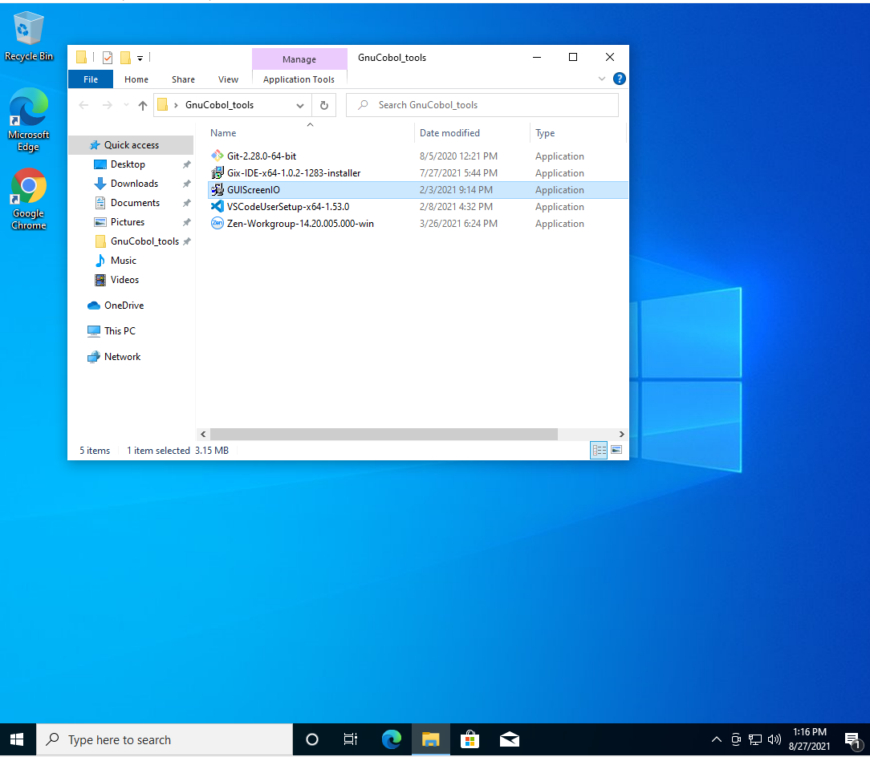

Install Git, using all the defaults.

Install Gix-Ide using all the defaults. Install Visual Studio 2019 tools, about 2GB download.

Install GUIscreenIO all defaults

Install VS code all defaults

Install Zen v14 SP2 Workgroup edition. Use all defaults.

At this point my VM is 23GB

My Visual Studio compiled GNUcompiler was installed here:

C:\Users\brant\AppData\Local\Gix\compiler-pkgs\gnucobol_3.1.2_vs_all_all

We are interested in 32bit tools so run this bat file and place short cut on desktop

C:\Users\brant\AppData\Local\Gix\compiler-pkgs\gnucobol_3.1.2_vs_all_all\ set_env_vs_x86.bat