Instructions

Steps to use Given script:

1. Check Varaibles and update in terraform.tfvars file.

Note: Uncomment desired variable. You can find default values from vars.tf

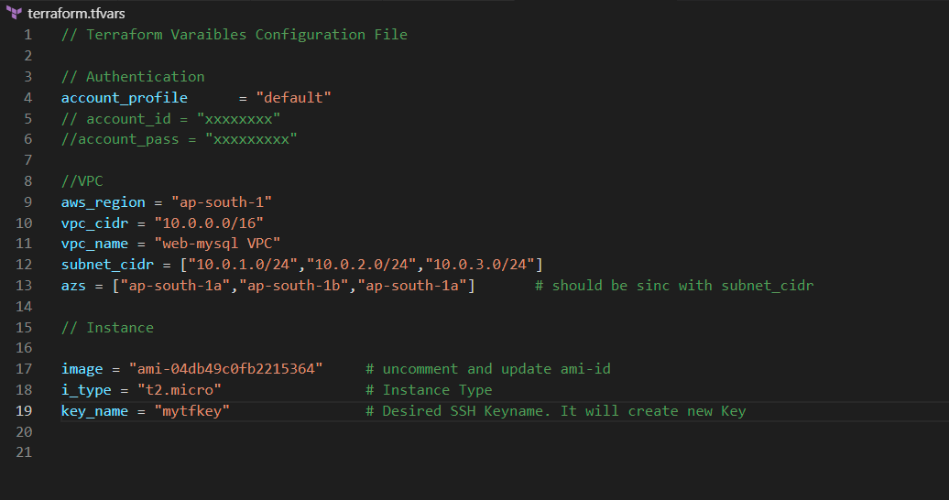

1. Initialize the Terraform by using “terraform init”.

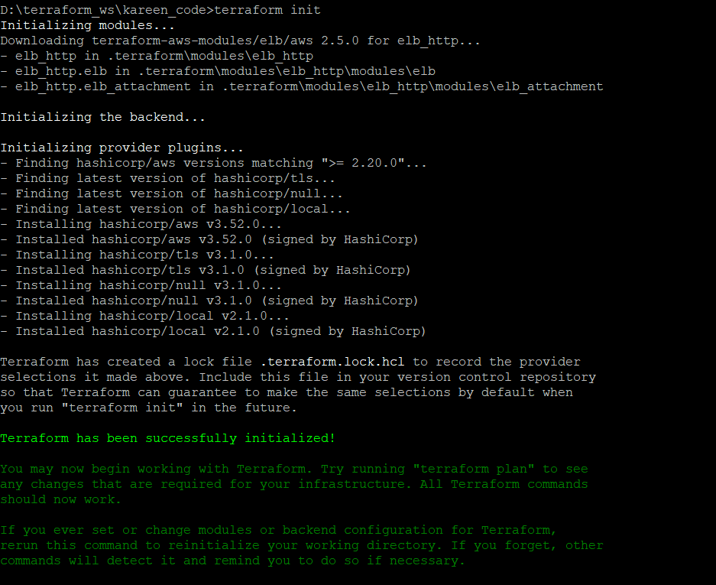

Before command workspace :

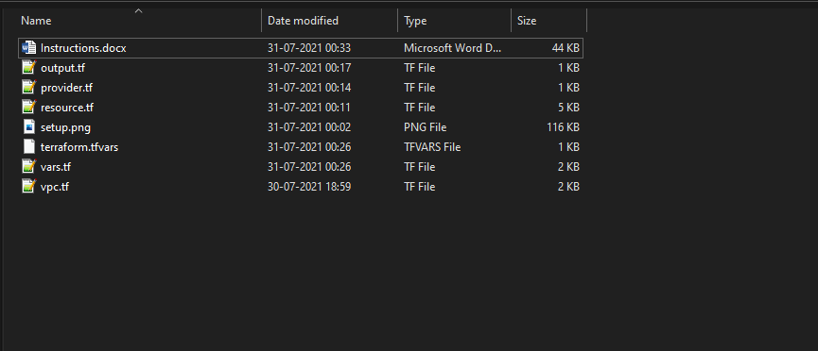

After Command Workspace :

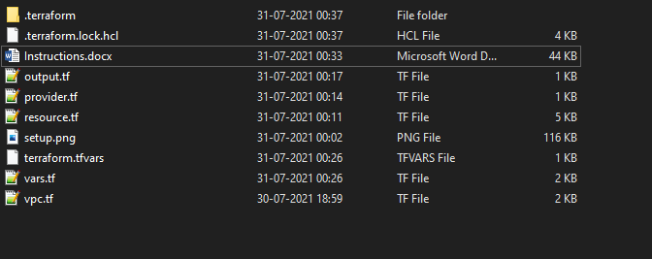

1. Apply terraform code using : “terraform apply” and confirm by “yes”.

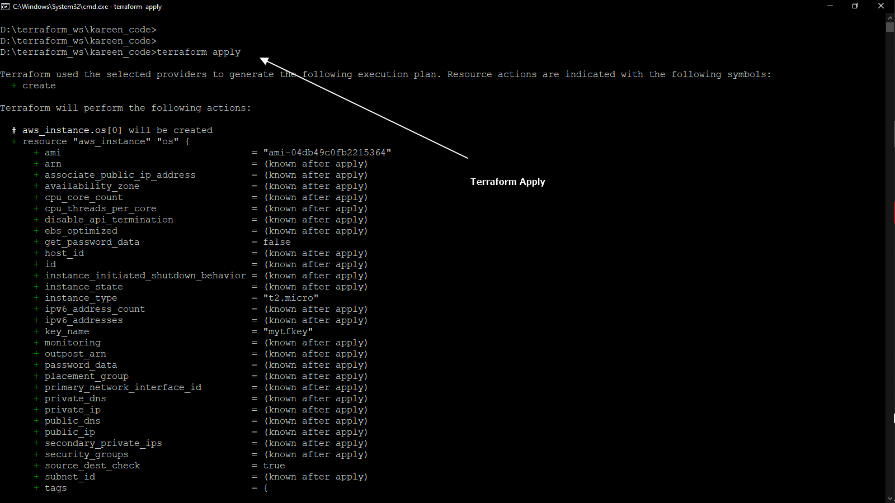

Confirm :

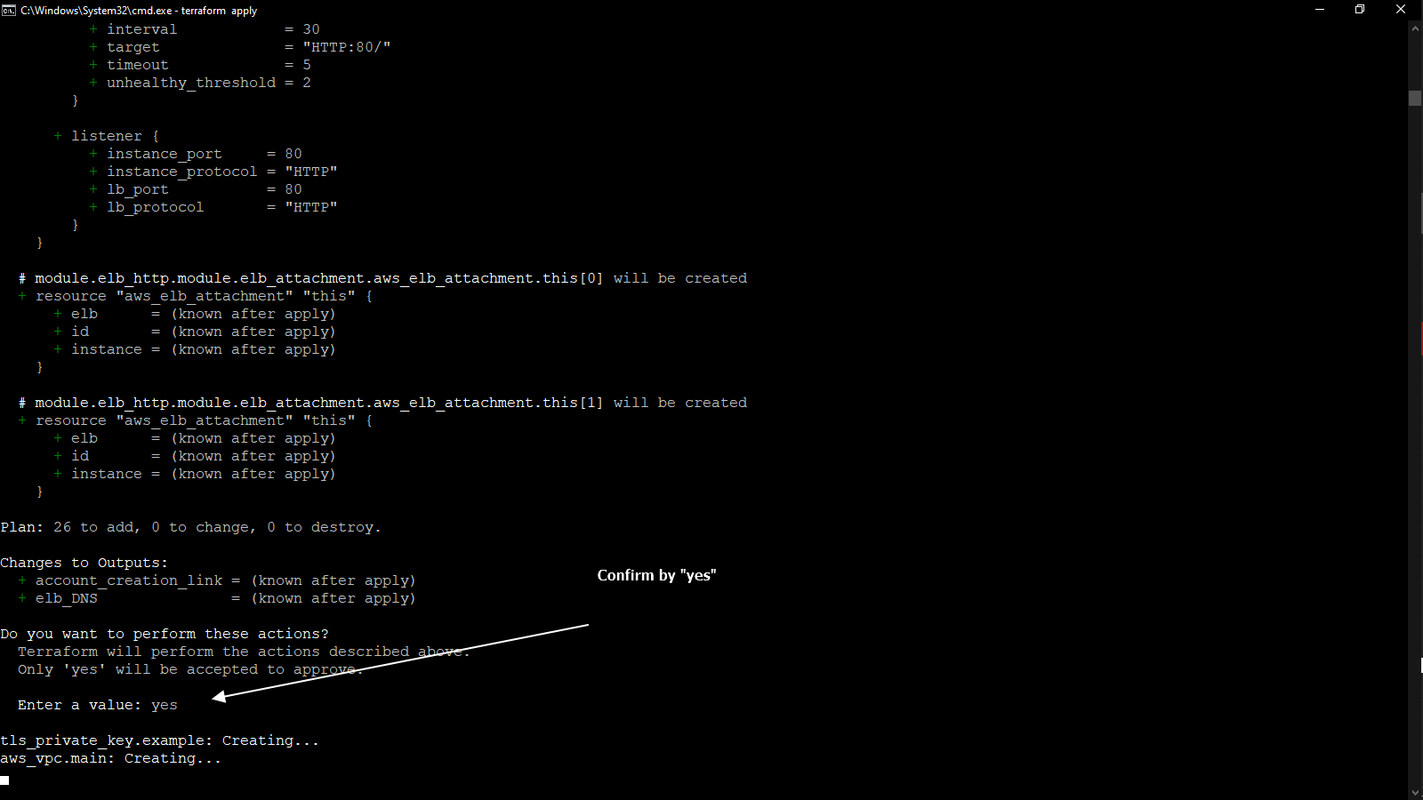

Configuration finish :

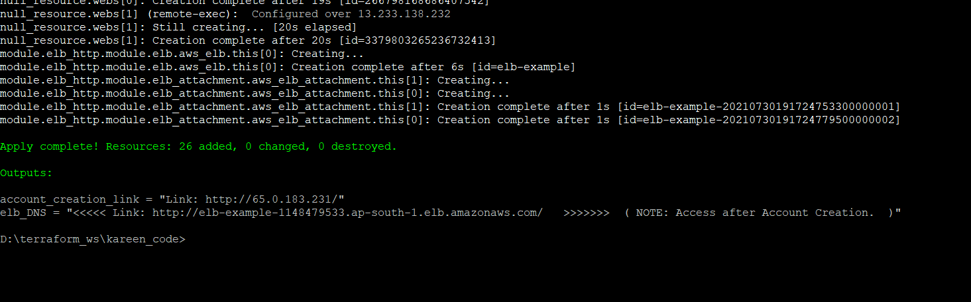

1. Now first login using account creation link and create account.
2. Copy link and open in browser :

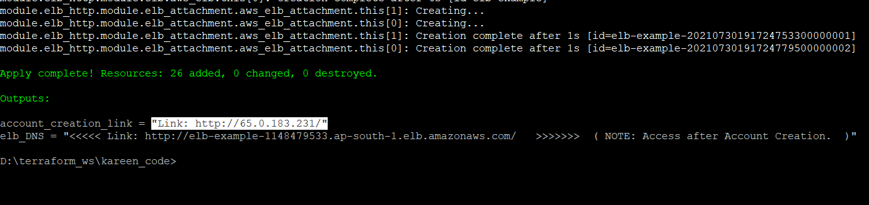

1. Configure User

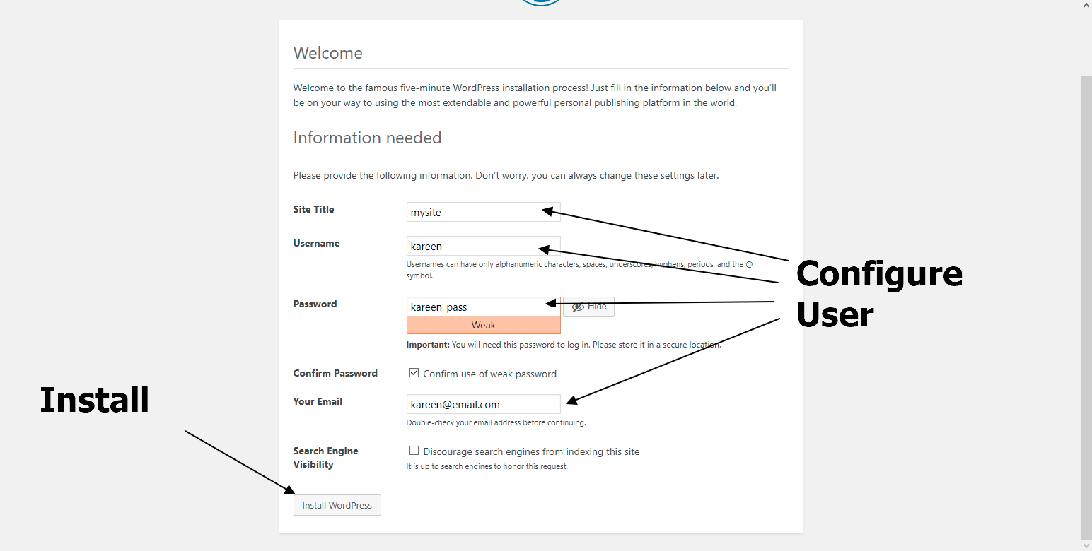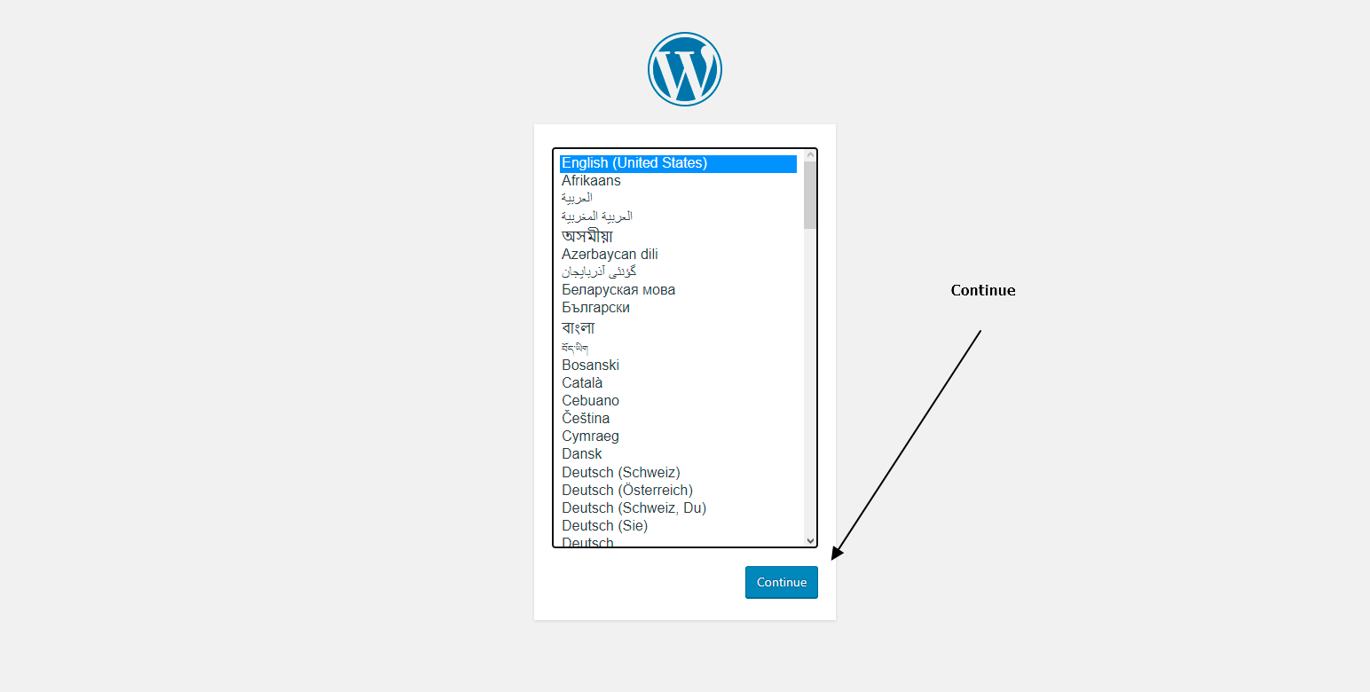

1. Login User

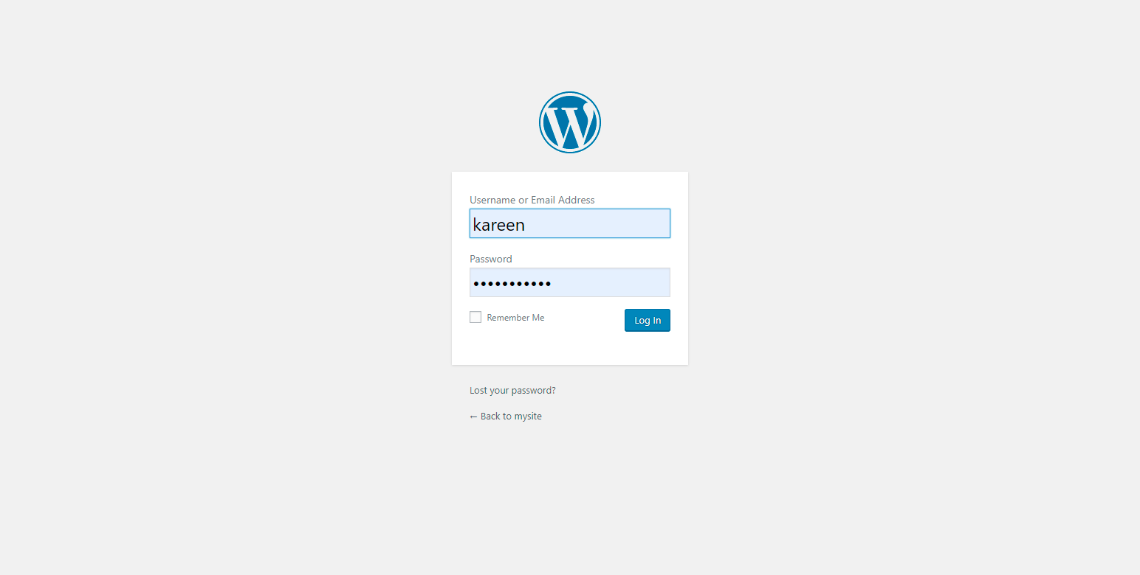

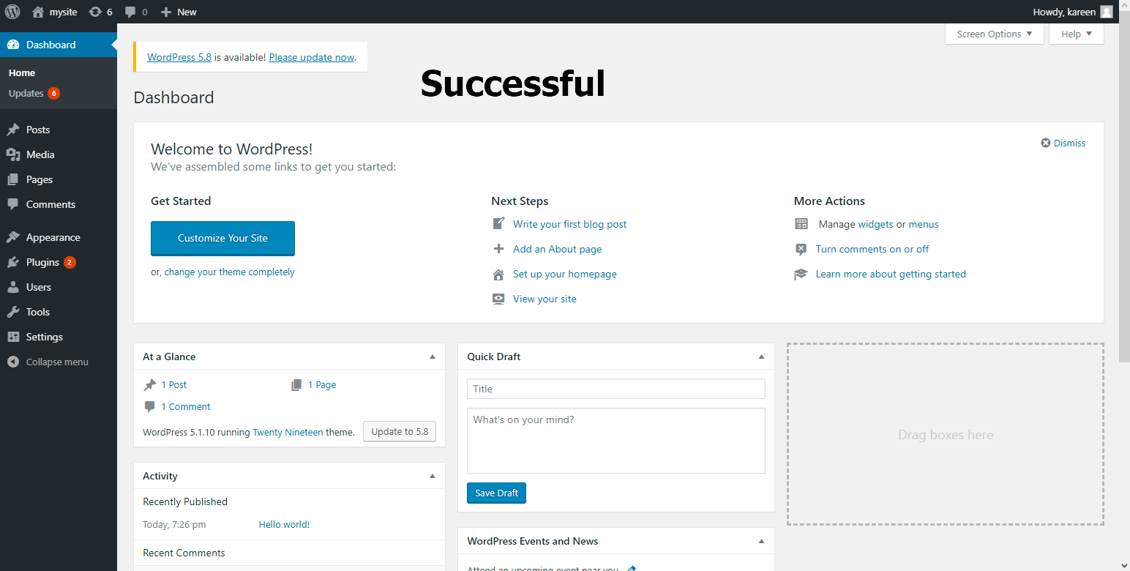

1. Now access using Loadbalancer DNS
2. Copy DNS Link from terraform output :

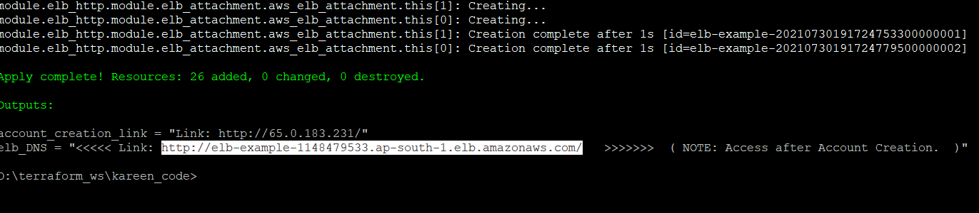

1. Access over browser

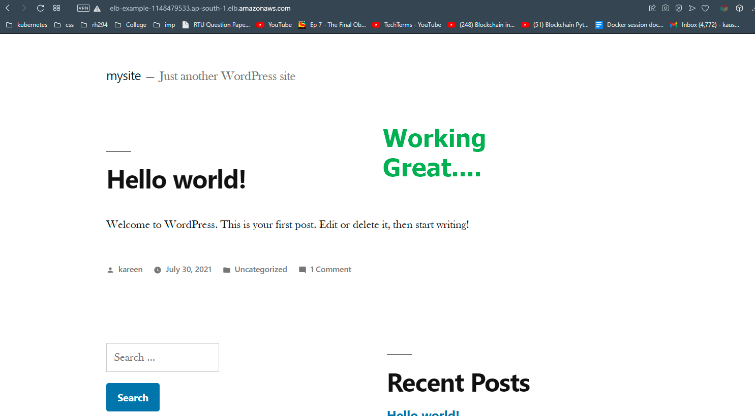

**NOTE:**

1. You can delete whole infrastructure using “terraform destroy” and confirm using yes.
2. **DNS Link will not work until user is not created.** So, first create user.
3. If code fail, then try again with “terraform apply” without changing anything in code.