ANKUR CHHEDA
SY IT
ROLL NO. - 8
EXP 11
Initially
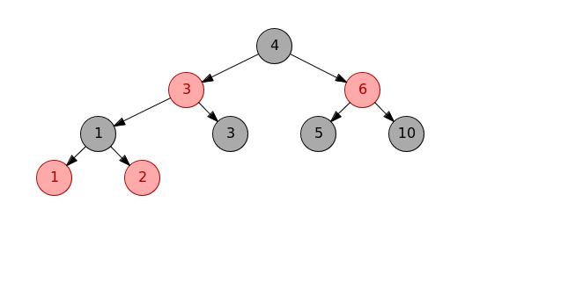

After Inserting

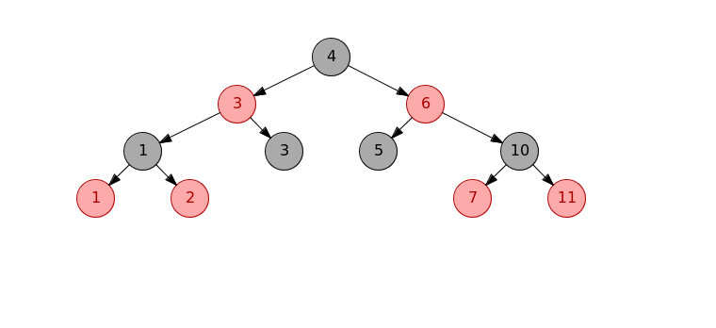

After deleting

