ANKUR CHHEDA
SY IT
ROLL NO. - 8
EXP 7

Program

#include<stdio.h>
#include<stdlib.h>

int source ,V , E,time,visited[20], G[20][20];
void DFS(int i){
int j;
visited [i] = 1;
printf("%d ->" , i+1);
for(int j = 0; j<V; j++){
if(G[i][j] == 1&&visited[j]==0){
DFS(j);
}
}
}

int main(){
int i , j , v1 , v2;
printf("Graphs\n");
printf("Enter the number of edges\n");
scanf("%d" , &E);
printf("Enter the number of vertices\n");
scanf("%d" , &V);
for(i = 0 ; i< V;i++){
for(j = 0 ; j < V ; j++){
G[i][j] = 0;
}
}
for(i = 0 ; i< E ; i++){
printf("Enter the edges(format : V1 V2) : ");
scanf("%d%d", &v1 ,&v2);
G[v1-1][v2-1] = 1;
}
for(i = 0 ; i< V;i++){
for(j = 0 ; j < V ; j++){
printf("%d" , G[i][j]);
}
printf("\n");
}
return 0;
}

Output

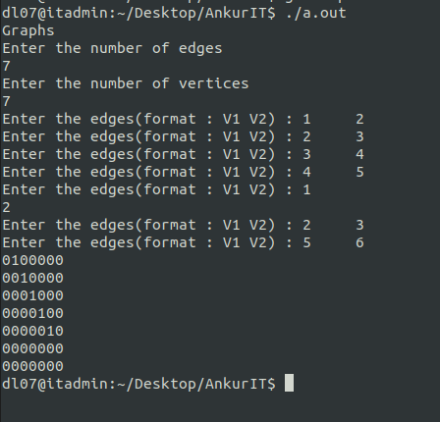

Program

#include<stdio.h>
#include<stdlib.h>
int a[20][20],q[20],visited[20],n,f=-1,r=-1;
void bfs(int v){
int i;
for(i=0;i<n;i++){
if(a[v][i] !=0 && visited[i]==0){
r=r+1;
q[r]=i;
visited[i]=1;
printf("%d",i);
}
}
f=f+1;
if(f<=r)
bfs(q[f]);
}
int main(){
int v,i,j;
printf("\nEnter number of vertices");
scanf("%d",&n);
for(i=0;i<n;i++){
visited[i]=0;}
printf("\nEnter graph data in matric from\n");
for(i=0;i<n;i++)
for(j=0;j<n;j++)
scanf("%d",&a[i][j]);
printf("\nEnter the starting vertex");
scanf("%d",&v);
f=r=0;
q[r]=v;
visited[v]=1;
printf("%d",v);
bfs(v);
if(r!=n-1)
printf("\nBFS not possible");
printf("\n");
return 0;
}

Output

