CODEX SPACE · CLIENT HANDOVER PACKAGE
DOCUMENT 00
Smoke Test
Checking every primitive renders.
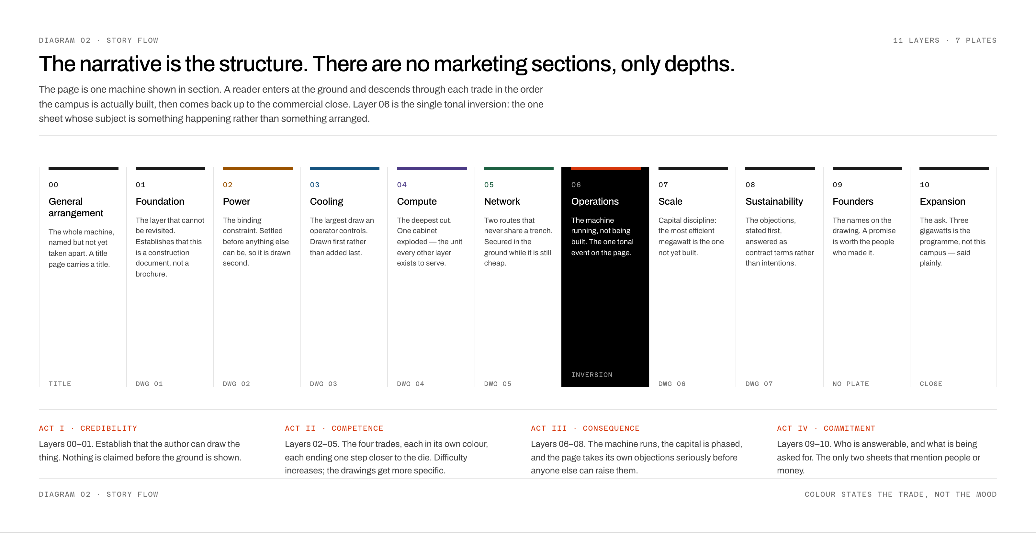

DOCUMENT | REVISION | DATE
00 | A | 29 July 2026

Contents
test
Contents are generated by Word. If this line is still visible, press Ctrl+A then F9 (Windows) or Cmd+A then Fn+F9 (Mac) to build it.

LAYER 01 · FOUNDATION

A section
Body copy at 9.5pt with a 1.32 line.
PURPOSE
Field text.
— Lead in. And the rest of the sentence.
— A plain one.
ENGINEERING NOTE
A title for the callout
First line.
Second line.

KEY TAKEAWAY
One concise summary.

COL A | COL B | COL C
a | b | c
d | e | f

FIRST CAMPUS | PROGRAMME | STATUS
550 MW | 3 GW | Phase 01

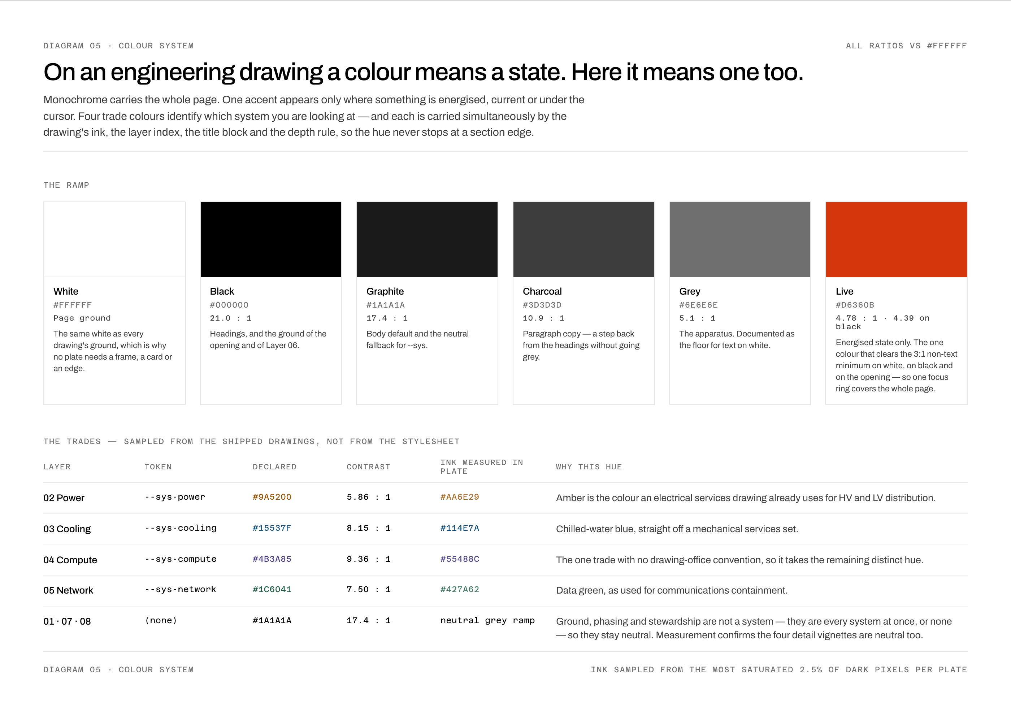
FIGURE 1 The colour system.
See Section 1

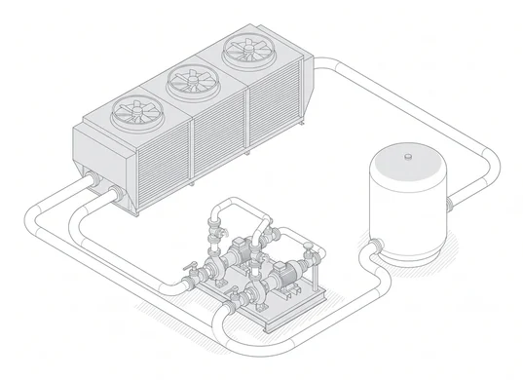 | 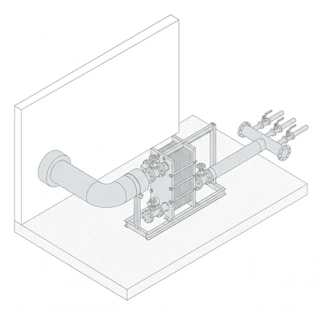
FIGURE 2 Water. | FIGURE 3 Heat.

