**Aim:**

To study and implement the compiling from the source.

**Description:**

**OPENTTD:**

OpenTTD is a business simulation game in which players try to earn money via transporting passengers and freight by road, rail, water and air. It is an open-source remake and expansion of the 1994 Chris Sawyer video game Transport Tycoon Deluxe.

**JFROG:**

 JFrog Artifactory is a universal DevOps solution providing end-to-end automation and management of binaries and artifacts through the application delivery process that improves productivity across your development ecosystem.

**SHOTCUT:**

Shotcut is a free and open-source cross-platform video editing application for FreeBSD, Linux, macOS and Windows. Started in 2011 by Dan Dennedy, Shotcut is developed on the MLT Multimedia Framework, in development since 2004 by the same author.

COMMANDS:

|  |  |  |
| --- | --- | --- |
| Sl. No. | COMMAND | DESCRIPTION |
| 1. | tar | tape archive |
| 2. | tar -c | Creates Archive |
| 3. | tar -x | Extract the archive |
| 4. | tar -f | creates archive with given filename |
| 5. | tar -t | displays or lists files in archive file |
| 6. | tar -u | archives and adds to an existing archive file |
| 7. | tar -v | Displays Verbose Information |
| 8. | tar -A | Concatenates the archive files |
| 9. | tar -z | zip, tells tar command that create tar file using gzip |
| 10. | zip | compression and file packaging |
| 11. | zip -d | Removes the file from the zip archive |
| 12. | zip -u | Updates the file in the zip archive |
| 13. | zip -m | Delete the original file |
| 14. | zip -r | Exclude the files in creating the zip |
| 15. | zip -x | Verbose mode or print diagnostic version info |

**Outputs:**

**OPENTTD**

1. Installing OPEDTTD

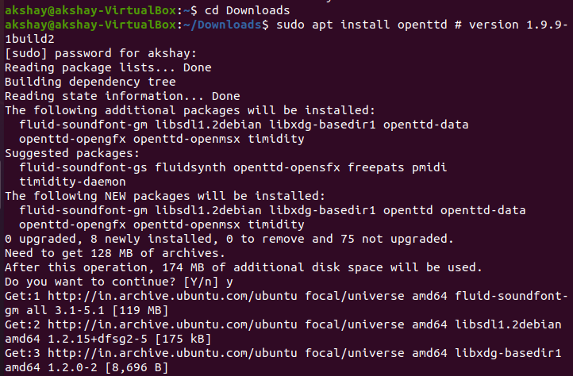

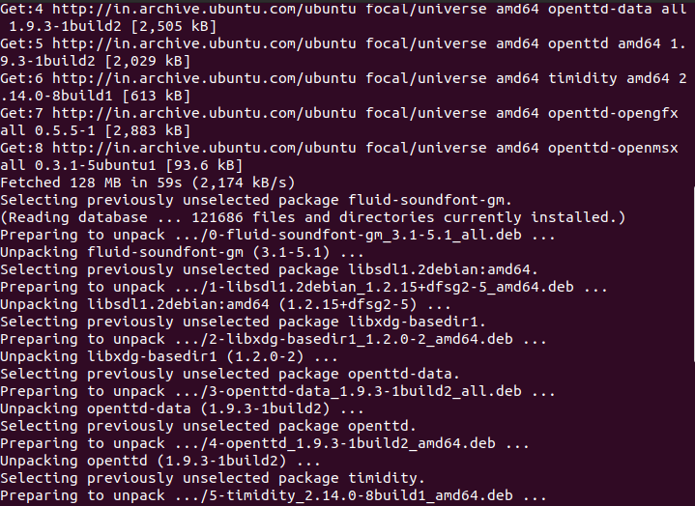

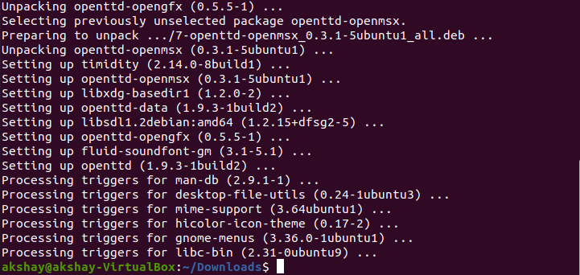

1. Opening OPENTTD

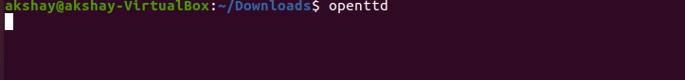

1. OPENTTD

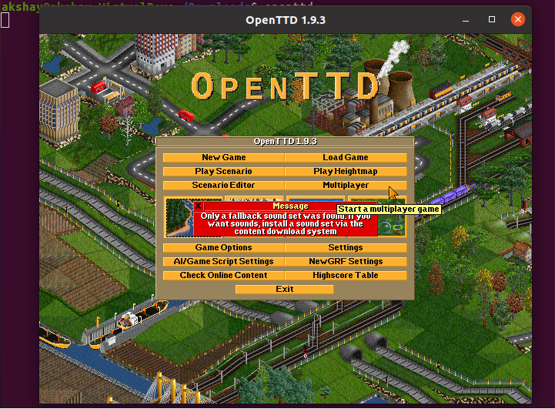

COMPILING C++ PROGRAM

1. Writing C++ program on editor

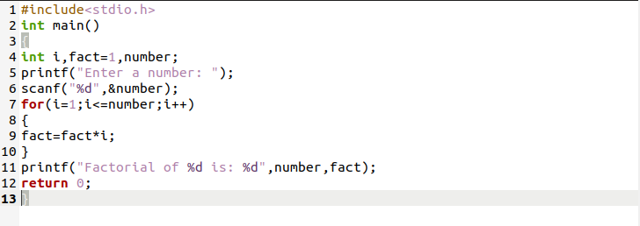

1. Running C++ program

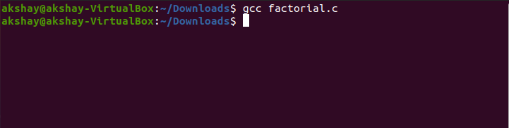

INSTALLING JFROG

1. Updating Ubuntu Server

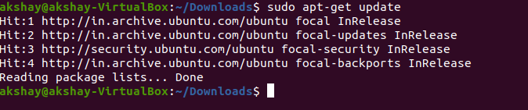

1. Install Java

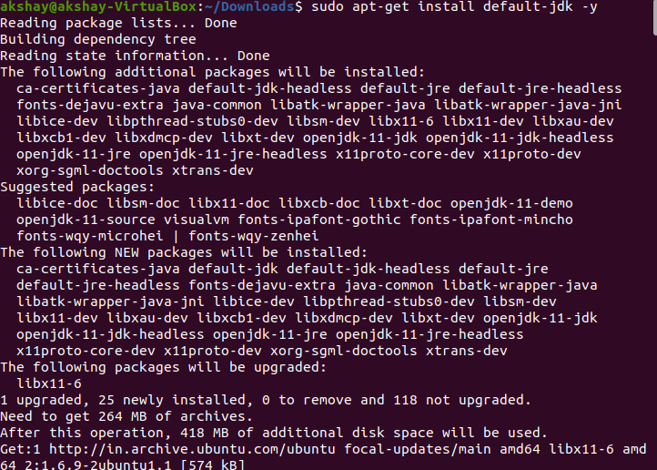

1. Download and install artifactory

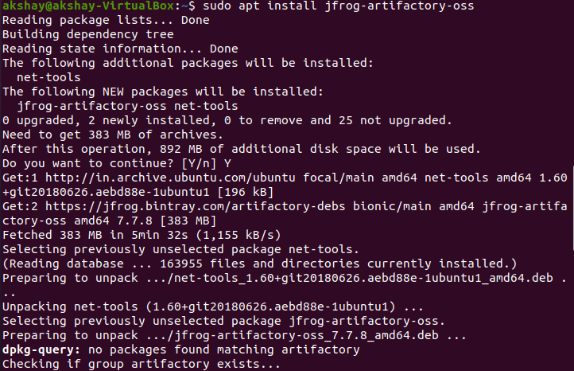

1. Running artifactory

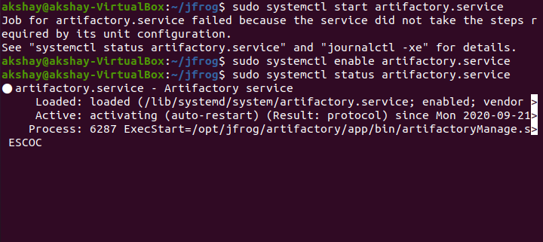

1. Check if it is running on port 8081

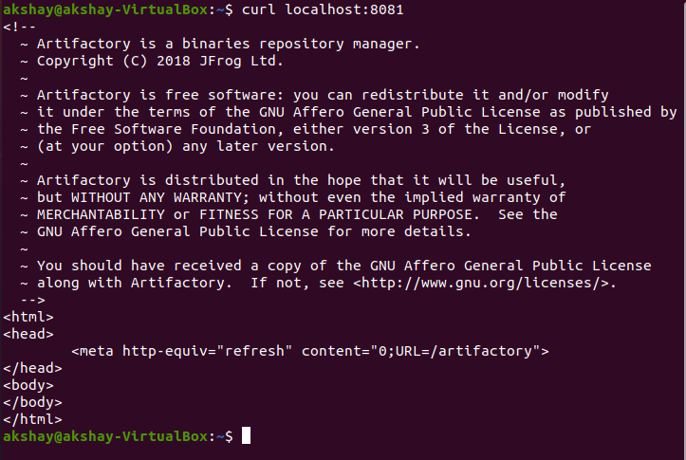

INSTALLING SHOTCUT

1. Downloading prerequisites

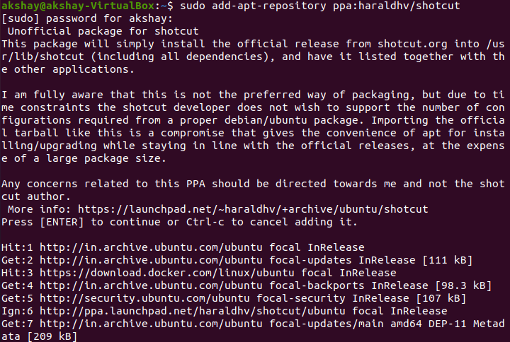

1. Add repository

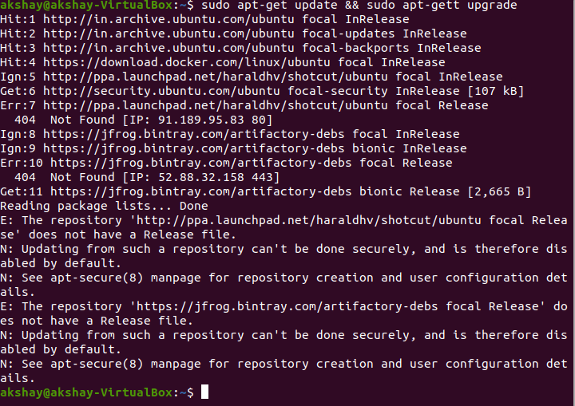

1. Update packages

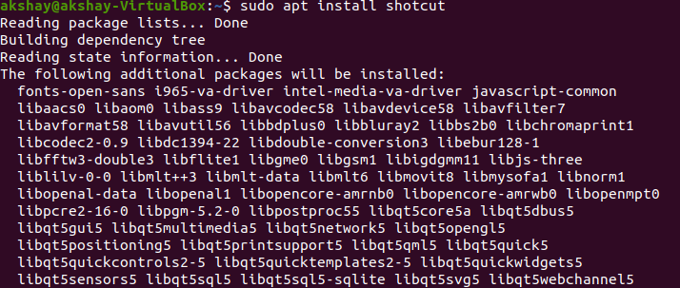

1. Install shortcut

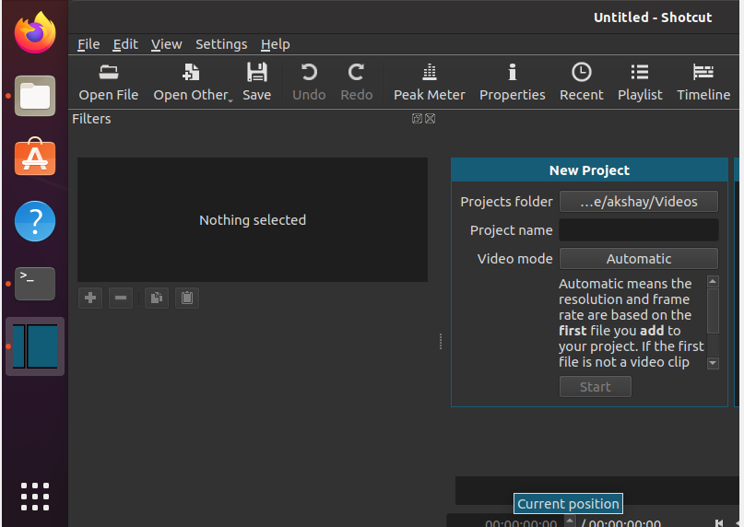

Video Link:

[https://drive.google.com/drive/folders/1MjNyibeVXCflduVx3OgtFX2h9KBsKK-y?usp=sharing](https://drive.google.com/drive/folders/1MjNyibeVXCflduVx3OgtFX2h9KBsKK-y?usp=sharing%20)

RESULT:

The software’s has been installed successfully.