**Aim:**

To study and install samba.

**Description:**

Samba is a free software re-implementation of the SMB networking protocol, and was originally developed by Andrew Tridgell. Samba provides file and print services for various Microsoft Windows clients and can integrate with a Microsoft Windows Server domain, either as a Domain Controller or as a domain member.

The samba server package includes the following daemons and associated services:

* **smbd**: The server daemon that provides file-sharing and printing services to Windows clients. It is also responsible for user authentication, resource locking, and data sharing through the SMB protocol.
* **nmbd**: The NetBIOS nameserver daemon replies to name-service requests produced by SMB/CIFS in Windows-based systems. It also provides browsing support in the Windows Network Neighborhood view.

COMMANDS:

|  |  |  |
| --- | --- | --- |
| Sl. No. | COMMAND | DESCRIPTION |
| 1. | apt install samba | tape archive |
| 2. | service smb status | Check samba status |
| 3. | service smb start | Start samba services |
| 4. | service smb restart | Start samba services |
| 5. | service iptables status | Display firewall |
| 6. | getenforce | Enforce Permissive State |
| 7. | setenforce | Enforce Permissive State |
| 8. | setenforce 0 | Targeted to permissive mode |
| 9. | useradd name | Creating user |
| 10. | passwd name | Create password |

**PROCEDURE:**

1. Installing samba using sudo apt install samba
2. Checking status using service smbd status
3. Start services using service smbd start
4. Restart services using service smbd restart
5. Enforce required permissive state
6. Add user using useradd
7. Set password using passwd
8. Run user using smbclirnt //localhost/name -U password

**Outputs:**

1. Installing samba

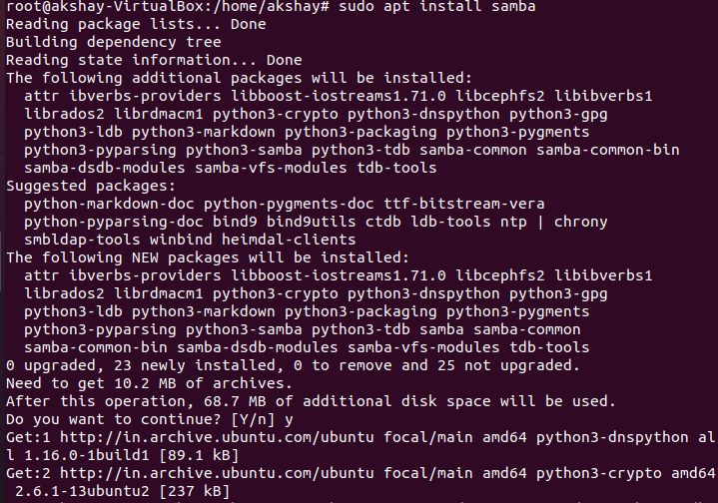

1. Check status

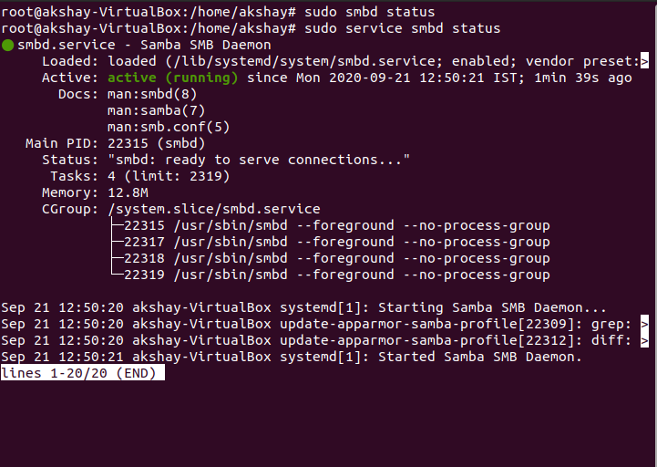

1. Start services

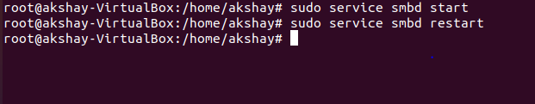

1. Enforce required permissive state

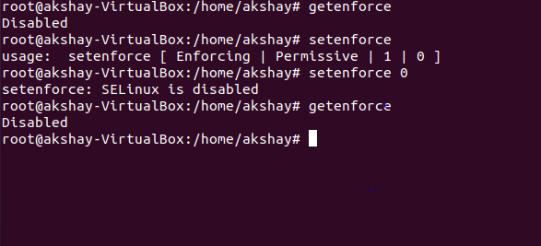

1. Create user

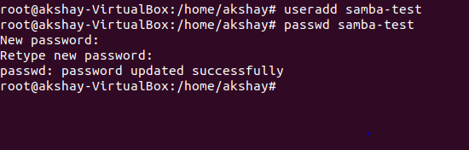

1. Set password

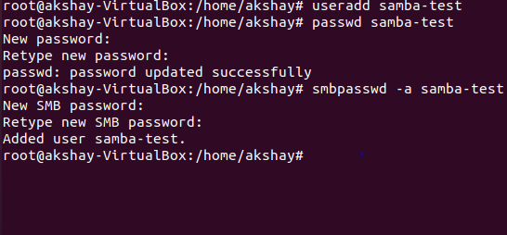

1. Run user

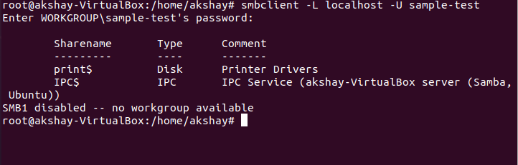

Video Link:

[https://drive.google.com/drive/folders/1MjNyibeVXCflduVx3OgtFX2h9KBsKK-y?usp=sharing](https://drive.google.com/drive/folders/1MjNyibeVXCflduVx3OgtFX2h9KBsKK-y?usp=sharing%20)

RESULT:

The software’s has been installed successfully.