Input.txt (from the HW/.pdf)

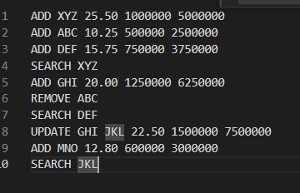

The Output like that.

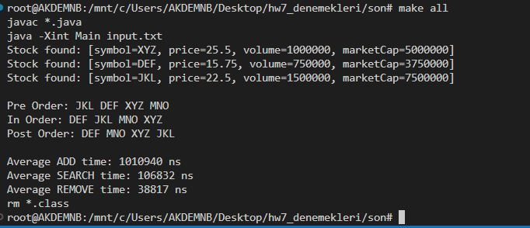

ADD GRAPH

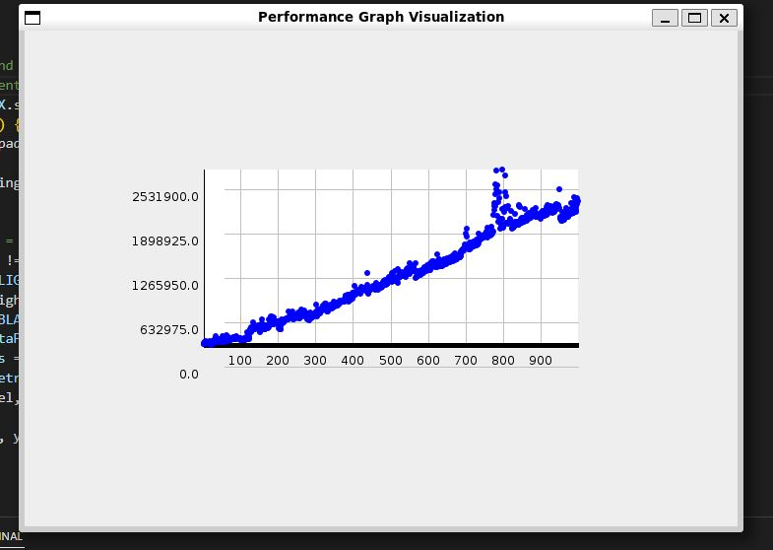

REMOVE GRAPH

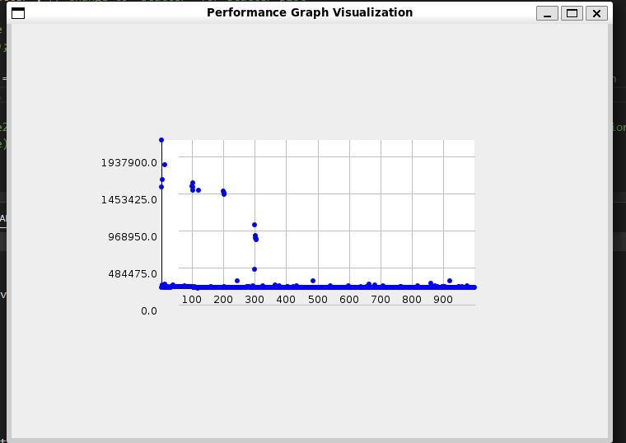

SEARCH GRAPH

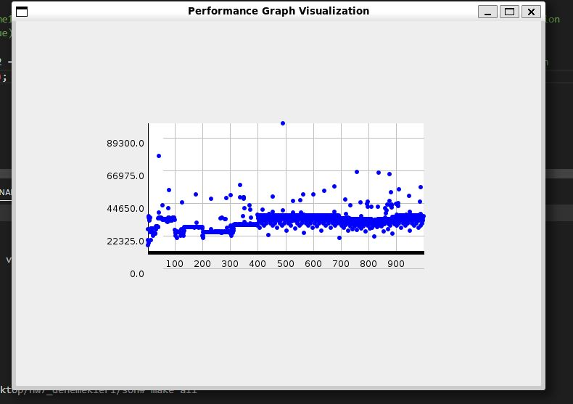

I forget to insert javadoc you can copy from there

javadoc \*.java