MAKEFILE

To compile :

make

To run:

make run

To clean javadoc and class file:

make clean

There is test part in main, when do make ,

You will see some people are added and also their friendship connection will be added, as well.

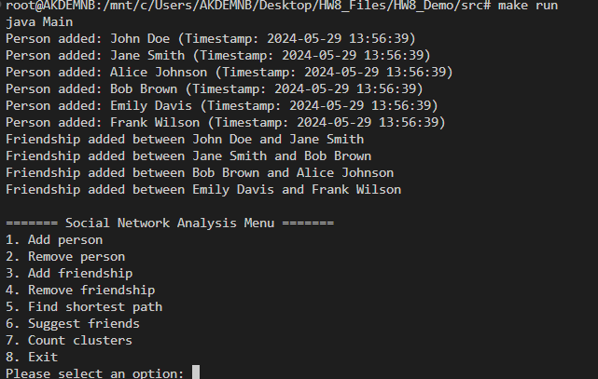

If user do not enter 0-1 , then

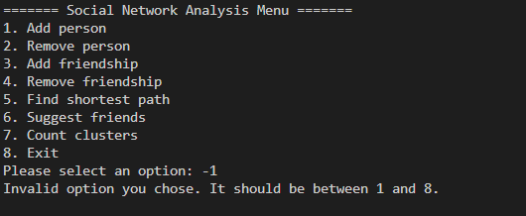

If user enter a string instead of integer,

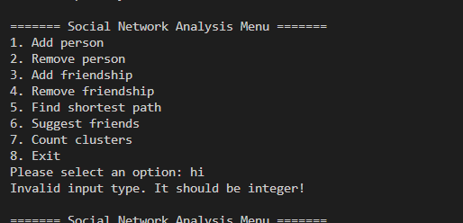

Add Person: 1) Option 7(to see cluster) then add person, Finally select option 7 to see added person.

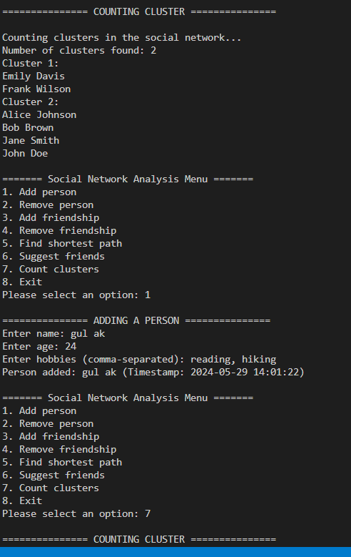

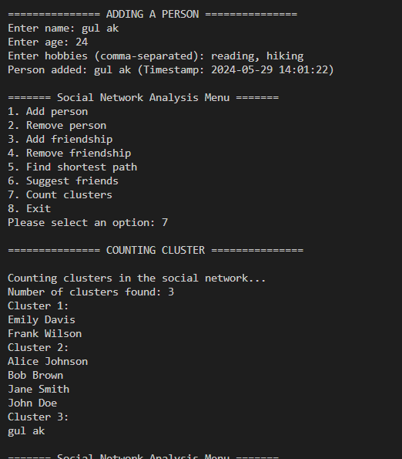

Remove a person (Tos how you, I deleted Alice Johnson).It is removed , you can see in cluster2 in the screenshot

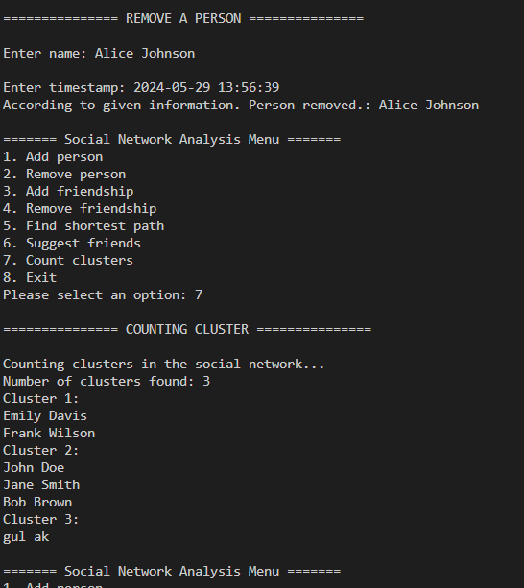

Adding a Friendship( “gul ak” person and Emily Davis ). So when see cluster, “gul ak” in cluster 1.

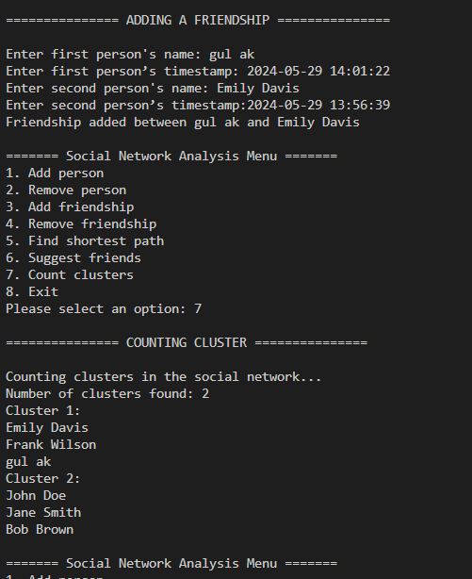

Removing a friendship (Emily Davis and Frank Wilson). Like you see Frank Wilson is in Cluster3 now.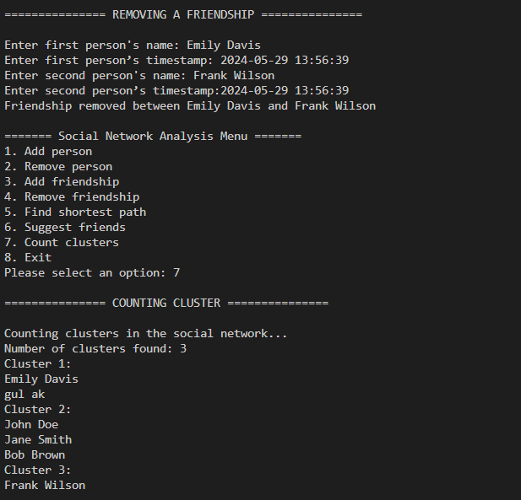

Finding shortest path. When enter wrong name. Of course not found the shortest path.

When typing correct inputs , you can see , it printed the shortest path.

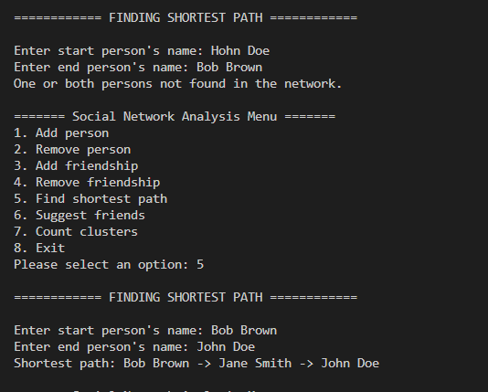

Suggesting Friends

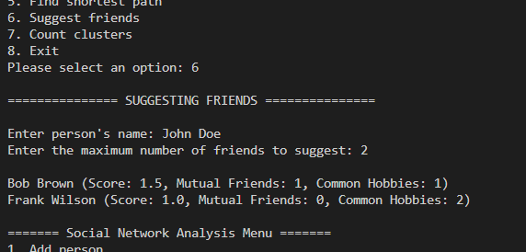

Count Cluster and then exit the program.

